Cardiometabolic Comparison of CAH Patients and Female Referents
Compare overall group differences first, then explore age related trends below

Select Biomarkers:
S
SBP

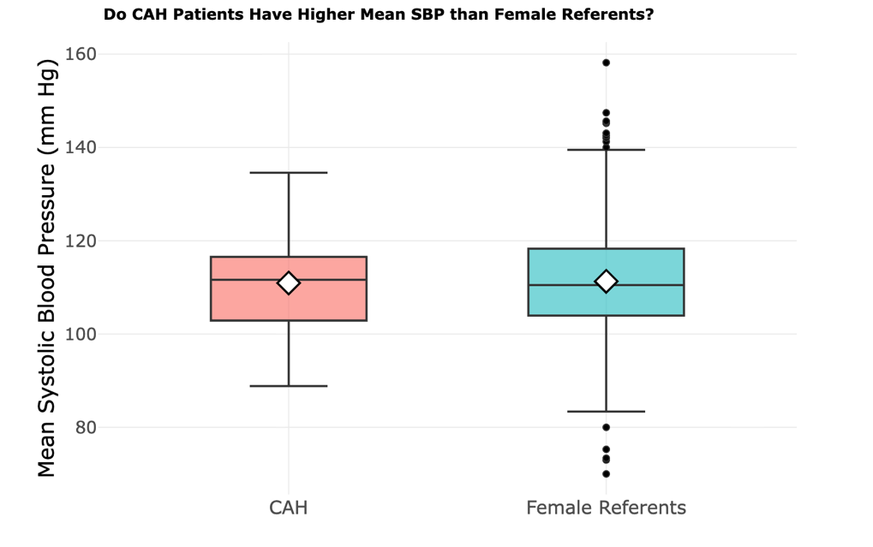
Main Comparison Plot:
Results for the selected biomarker:
- Female referents show more outliers than the CAH group
- The CAH group has a slightly lower mean than female referents
- Hovering over the plot provides additional summary statistics

- CAH group has a slightly lower mean than female referents
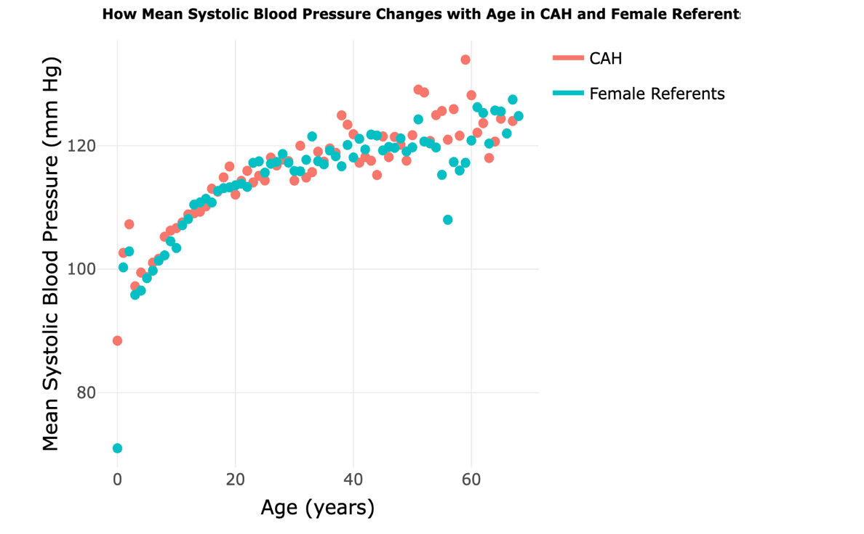
Age Trend Plot:
Results for selected biomarker:
- CAH appears to have a higher systolic blood pressure value around age 60
- The trend plot supports comparison of age-related patterns between groups
- Hovering over the points provides more detailed values for exploration

1. Why did you place the visualizations where you did?
I placed the biomarker dropdown near the top so that viewers can immediately choose which cardiometabolic indicator they want to examine. I placed the main comparison boxplot in the upper left because it provides the most direct and simple overview of group differences between CAH patients and female referents. I placed a short results summary to the right of the plot so that viewers can quickly connect the visual pattern with the main takeaway. I then placed the age trend plot below to support a more detailed follow-up question about how systolic blood pressure changes across age, with its interpretation box also placed on the right for easy reference.

2. How is System 1 thinking activated in your dashboard layout?
System 1 thinking is activated by making the top of the dashboard simple, visually clear, and easy to understand at a glance. The title and short guiding sentence introduce the story immediately, and the dropdown keeps the dashboard uncluttered by allowing the viewer to focus on one biomarker at a time. The main comparison plot is placed prominently near the top so that viewers can quickly form an intuitive impression of the group differences. The short text box beside the plot reinforces the main message without requiring the viewer to interpret every detail on their own.
3. How will your dashboard enable System 2 thinking?
The dashboard supports System 2 thinking by allowing viewers to move from a simple overall comparison to a more detailed exploration of the data. The dropdown menu enables users to switch between SBP and HDL, which allows them to examine more than one biomarker without overcrowding the layout. The interactive hover features also support deeper exploration: in the main comparison plot, hovering over the mean marker reveals the group mean, median, and number of participants, while in the age trend plot, hovering over each point reveals age, mean systolic blood pressure, and the number of observations. These features encourage viewers to go beyond the first visual impression and examine the data more carefully.

