**DIAGRAMS**

Kolli Meghana (EmpId:- 284717) , Garikapati Kausthub Rao (EmpId:- 284748)

August 2024

**Project Name:** Digital Learning Platform

**Architecture Diagram:-**

**Database Schema:-**

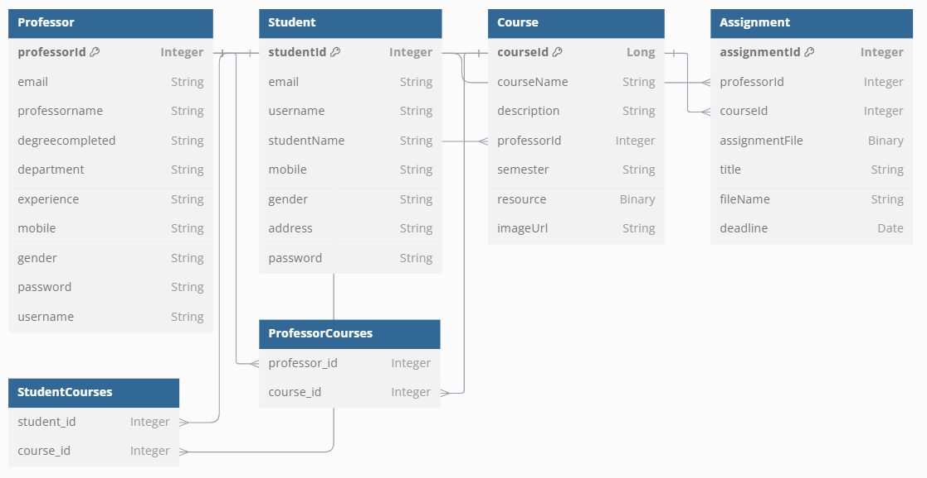

**UseCase Diagram:**

**Class Diagram:-**

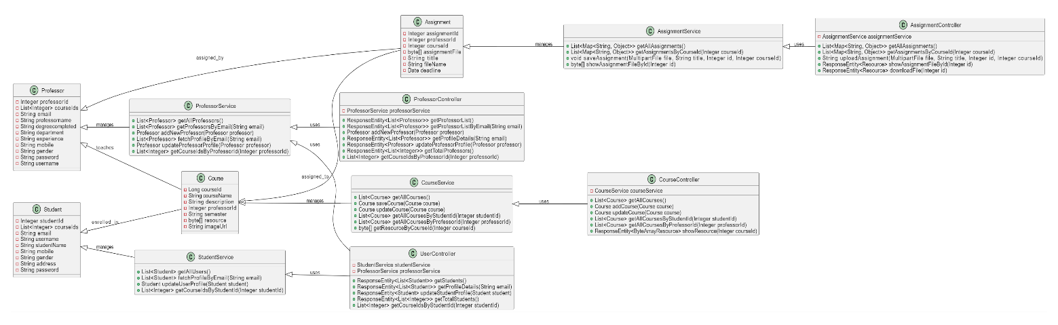

**Sequence Diagram: -**

