**[1] AI Intro**

**1. Expert System**

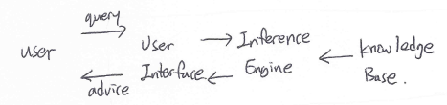Advantage:

Availability, Reliability, Response Time, Explanation, low Cost

**2. Knowledge Representation**

1) Formal Logic: concrete rule, no Ambigiuty (*Syntax=rule, Semantics=Logic)

Propositional Logic(명제논리학)

Ex) and(^), or(v), not(¬), if A then B(A=>B), if and only if(⬄)

Predicate Logic: Relation + Property

First Order Logic: [ all= ∀x(), at least= ∃x() ]

ex) Every rose has a thorn -> ∀x( rose(x) ->∃y( has(X,Y) ^ thorn(Y) ) )

Higher Order Logic

2) Production Rules: IF (condition) THEN (action)

3) Structured Objects

Semantic Networks: [Node(object,concept,event),Arcs(relationship))] -> Graph form

Advantage: visualization, ease of clustering formal knowledge, space efficient

Disadvantage: Inheritance problem, Nostandard at Node-Arcs

|  |
| --- |
| Frame: name |
| Slot: |
| values |

Frames: Semantic network + properties

Advantage: easy to control, Inheritance, easy to group related knowledge,

Disadvantage: No standard

Ontology: formal, explicit specification of shared conceptualization.

**3. Inference** = rule to make new knowledge from existing knowledge

1) Forward chain algorithm

2) Backward chain algorithm

**[2] Machine Learning : input(data) + output -> program**

**1. Framing a Learning Problem**

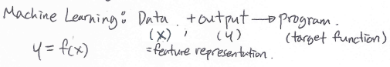*We have to choose learning algorithm for

Target function.

**2. Type of ML problems**

|  |  |  |
| --- | --- | --- |
|  | Supervised | Unsupervised |
| Discrete | Classification,,  Categorization | Clustering |
| Continuous | Regression | Dimensionality  Reduction |

Bias: difference between Training/True model

|  |
| --- |
| Bias↑ Variance↓ : underfitting |
| Bias↓ Variance↑ : overrfitting |

Variance: differences between training sets.

How to reduce variance? Use (simpler classifier, regularization, more training set)

1. Classifier= Yes/No problem *output: discrete value

Ex) SVM, K-nearest neighbor

1. Regression *output: real-value

Ex) Linear Regression, Logistic Regression

1. Clustering: intra-cluster distance ↑ , inter-cluster distance ↓ is good.

Ex) K-means clustering – flat algorithms, hierarchical algorithm

**3. Deep Learning = Machine Learning without human-designed features**

1) Convolutional Neural Network(CNN): compress information around with convolution

(choose best weighted) -> used at Image Processing

2) Recurrent Neural Network(RNN): choose one of sequential data by recurrent equation.

-> used at Natural Language Processing

3) Bi-directional RNN: consider back/forth words from sequential data.

**\*Conclusion: AI ⊃ Machine Learning ⊃ Deep Learning**

|  |
| --- |
| **\*Why NLP still very hard?**  1) Non-standard English  2) Segmentation issues: ex) New York  3) Idioms (숙어)  4) Neologisms: ex) unfollow, retweet  5) World knowledge  6) Tricky entity names: ex) Bug’s Life |

**[3,4] Natural Language Processing**

**1.NLP tasks**

Machine Translation: ex)Google Translator

Question-Answering system

Dialogue System: chit-chat system(ex-Woebot), Task-oriented dialogue system(ex-JARVIS)

**2.Task Oriented Spoken dialogue System**

1)**Architecture**

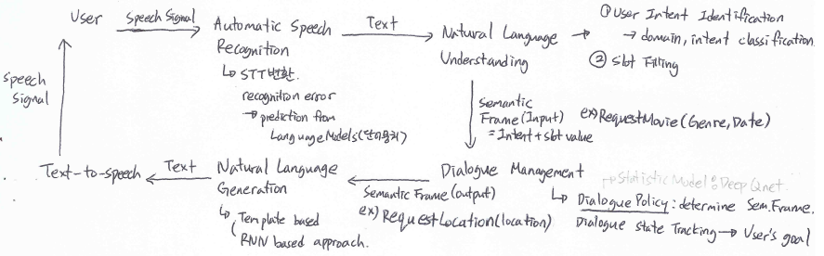

2)Natural Language Understanding

**Named Entity(고유명사) Recognition(NER)**:

1. find Named Entity (Person, Date, Location, Organization)

How? We have to design features for ML sequence model approach

Consider Capitalized, neighbor-words, label context

1. classify named entity by Classifiers:
2. encoding class for ML sequence model labeling: IOB encoding

**Part-of-Speech(품사) Tagging**: by closed/open class

Closed class(functionall) , Open class(lexical): ambiguity occurs

3)Parsing: Lexical Parsing, Syntactic Parsing(구문구조 분석: ex) 주격, 목적격, 수식관계)

Syntactic Parsing: use Context-Free Grammar for algorithm

**\* Context-Free Grammar(CFG)**=rules to set a well-performed sentence.

By CKY, dependency parsing

*Dependency Parsing(의존소 파싱): express relationship between 2 neighbor word pairs.

Advantage: accuracy, fast, language independent

Evaluation with big-O-notation of graph-based parsing.

**3.Word/Sentence Embedding**

1) Word Embedding: represent word into vector to compute their similarity

One-hot encoding:

Disadvantage: space inefficiency, Out-of-vocabulary problem

Embedding: represent themselves with their neighbor-words.

*word embedding method: word2vec, Glove, Elmo, BERT (consider context)

**4.Question Answering**

Question types: factoid Questions(ex- What,How,Who,Where at front), complex questions

1. IR-based Approach ex)Google

[IR-based Factoid QA sequence]

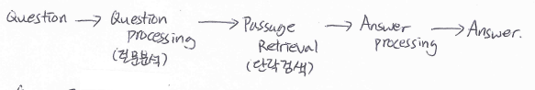

1)Question Processing: detect Question type, answer type, focus, relationship,

Make query for search engine

2)Passage Retrieval: search relevant documents and break into passages

3)Answer Processing: Ranking passages by features(answer type, NER, frequency),

Rank candidates and extract answer.

1. Knowledge-based Approach ex)Siri
2. Hybrid Approach ex)IBM Watson

**5.Machine Translation**

1) phrase based MT

2) Neural MT: sequence-to-sequence, end-to-end trained by supervised learning

3) Advanced NMT:

*problems: vocabulary size, sentence length, language complexity

**[5] Computer Vision**

Types of Image Processing: **Enhancement**(특징강조-Xray**), Restoration**(복원),

**Emphasis**(변형-highlighting), **Transformation**(feature 단계 수정**), Compression**(압축)

* Enhancement VS Emphasis: Emphasis extract some of useful feature, change whole image.

**1. Image Classification**

1) CV tasks: Object Detection, Localization, Instance Segmentation

2) Challenges**: view point variation** (left, right, back side), **Background Clutter**(배경구분),

**Illumination**(조명빨), **Deformation**(자세), **Occulation**(inference from part of object),

**Inter-class Variation**

-> ML data-driven approach (Linear Classifier)

3)Object Detection

Dataset: PascalVOC -> ImageNet -> MS COCO(2015~, multi-objects)

IOU:Intersection over Union(A,B) = A^B / AvB

If IOU>=50% then OK, If IOU=1 then A=B

Evaluation: use **Confusion Matrix**

*True Positive = number of (predicted Positive & really True) case

**2. Motion Estimation**: to adequatedly represent change, difference between 2 video frames

1. Block Matching: Compare and find Macro-block at block size
2. Residual Error Picture: To change Reference picture to Desired picture, change Reference

picture at block size, then modify Residual Error Picture by algorithms.

|  |
| --- |
| *Types to represent:  -point(특이점, 각, 관절)  -kernel: whole object(사각형,타원)  -silhouette(movement) |

**3. Action Tracking**

1) Object Representation: follow centroid/point

2) Object Tracking: first location selection is important

*Object Tracking Algorithm**: DMA(Different Motion Analysis)**

Obtain sum of Absolute Difference from 2 images by **Block Matching Algorithm**.

**4. Action Recognition**

*Task: 1) Action Classification: labeling action, target *result: handshake, answering phone

2) Action Localization: search location of action * result: 5 persons at video

Use CNN to train Action Recognition Model.