假论文

Markup

Original

Edited

### 如何写论文

根据**“广大科研工作者应该将论文写在大地上”**的号召。

* 论文可发表于网络
* 论文发表于期刊

#### 论文常用到的形式：

##### (一)文章评注标记critic-markup：

Don’t go around saying to people that the world owes you a living. The world owes you nothing. It was here first. OneOnly one thing is impossible for God: To find any sense in any copyright law on the planet. Truth is stranger than fictiontrue, but it is because Fiction is obliged to stick to possibilities; Truth isn’t.

##### （二）文章交叉引用Biblatex citation:

学术大咖陈见着[1]

爱因斯坦的理论研究[1]

智能车结构制作设计入门[2]

如何用markdown写论文[]

esp32引脚如图 1所示

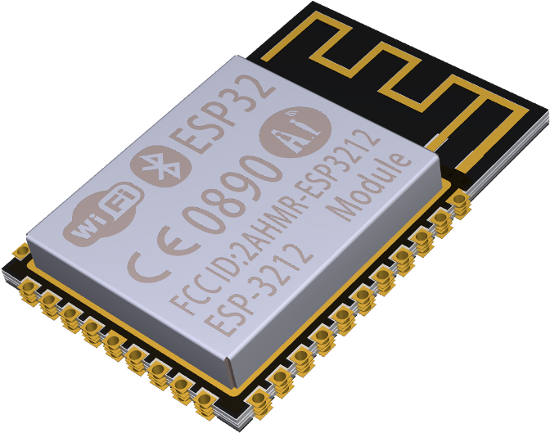

图 1: esp32引脚



图 2: 大数据海报

大数据海报如图 2所示

##### （三）PlantUML图表：

@startmindmap  
* Debian  
** Ubuntu  
*** Linux Mint  
*** Kubuntu  
*** Lubuntu  
*** KDE Neon  
** LMDE  
** SolydXK  
** SteamOS  
** Raspbian with a very long name  
*** <s>Raspmbc</s> => OSMC  
*** <s>Raspyfi</s> => Volumio  
@endmindmap

import matplotlib  
matplotlib.use('Agg')  
  
import sys  
import numpy as np  
import matplotlib.pyplot as plt  
  
# Fixing random state for reproducibility  
np.random.seed(19680801)  
  
dt = 0.01  
t = np.arange(0, 30, dt)  
nse1 = np.random.randn(len(t)) # white noise 1  
nse2 = np.random.randn(len(t)) # white noise 2  
  
# Two signals with a coherent part at 10Hz and a random part  
s1 = np.sin(2 * np.pi * 10 * t) + nse1  
s2 = np.sin(2 * np.pi * 10 * t) + nse2  
  
fig, axs = plt.subplots(2, 1)  
axs[0].plot(t, s1, t, s2)  
axs[0].set_xlim(0, 2)  
axs[0].set_xlabel('time')  
axs[0].set_ylabel('s1 and s2')  
axs[0].grid(True)  
  
cxy, f = axs[1].cohere(s1, s2, 256, 1. / dt)  
axs[1].set_ylabel('coherence')  
  
fig.tight_layout()  
plt.savefig("$DESTINATION$", dpi=300, format="png")

##### （四）数学公式：

# $a+b$ Recommended syntax!

#### 论文发表场合：

* 网络(wiki) ：markdown gollum[]

gollum -c config.rb

* 期刊： markdown 、pandoc[]

pancritic Home.md -t markdown -m m | pandoc -F pandoc-fignos -C --bibliography=papers.bib --csl=chinese-gb7714-2005-numeric.csl -s --metadata title="假论文" -o output.docx

##### 相关插件介绍：

* pandoc-fignos
* pancritic
* lua-filters

pandoc Home.md -f markdown -t docx --self-contained --standalone --lua-filter=diagram-generator.lua --metadata=plantumlPath:"plantuml.jar" --metadata=javaPath:"java" -o README.docx

pancritic Home.md -t markdown -m m | pandoc -f markdown -t docx --self-contained --standalone -F pandoc-fignos -C --bibliography=papers.bib --csl=chinese-gb7714-2005-numeric.csl -s --metadata title="假论文" --lua-filter=diagram-generator.lua --metadata=plantumlPath:"plantuml.jar" --metadata=javaPath:"java" --metadata=pythonPath:"/usr/bin/python3" -o README.docx

pandoc -s -o test.docx --resource-path=.:image README.html

# Refercnce

[1] EINSTEIN A. TAUB A. The Meaning of Relativity[J]. American Journal of Physics, 1950, 18(6): 403-404.

[2] 臧海波. 机器人制作入门[M]. 机器人制作入门, 2016.

1. 文章作者： 陈见着 ORCID -XX.XXXXX.XX