**ToFoo**

<https://github.com/teddygizachew/ToFoo>

Objective:

ToFoo is a food delivery platform. Users can create accounts, order food, and get it delivered to their house at the convenience of a touch.

Index page

On the index page, users can view all restaurants available on the website or they can filter their view by clicking one of the buttons under the navigation of the website by category. Each restaurant has its address displayed and a view button that will allow the user to view the restaurant’s menu.

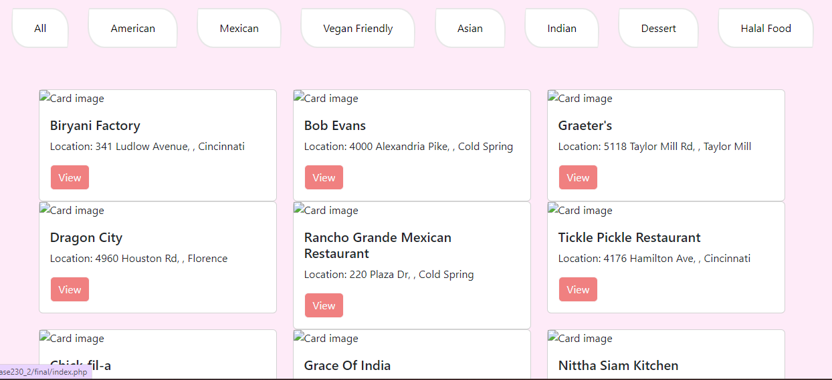

Detail/Menu page

To get to the menu of a particular website, the user clicks the view button on the restaurant card from the index page. The detail/menu page displays a picture (if available) for each item, the item’s name, the item’s price, and an add button to add the item to the cart.

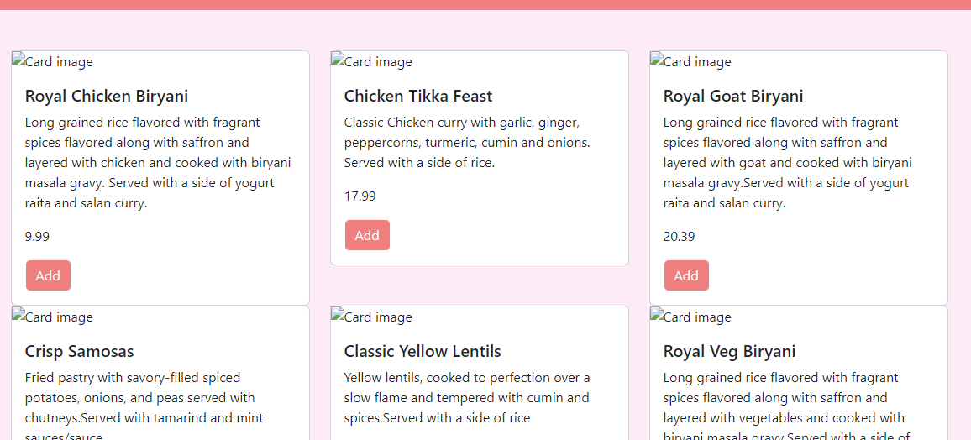

User Profile page

A unique profile page for each user that displays the user’s name, email, address, phone, and saved payments.

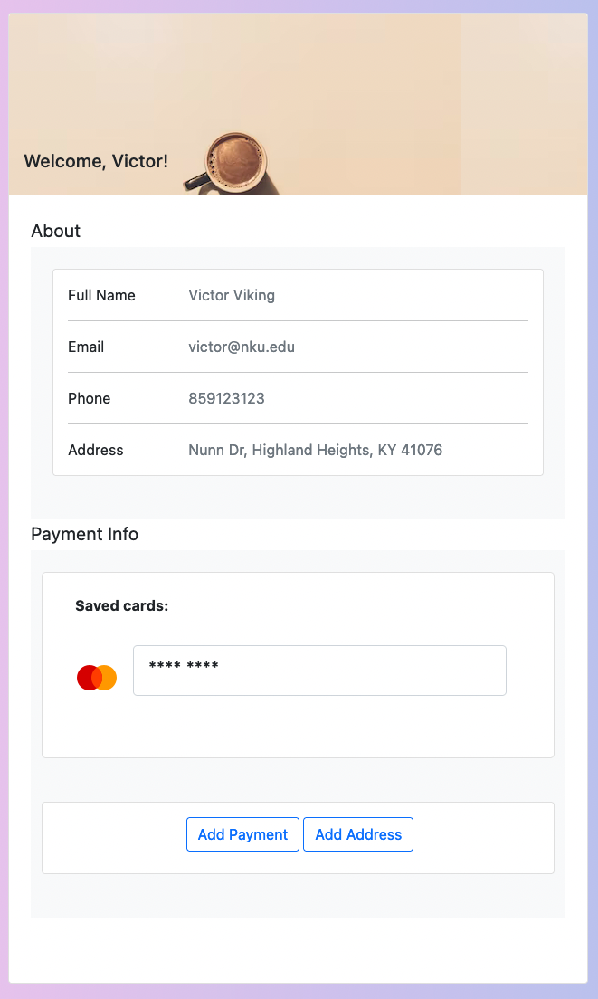

Shopping Cart page

Once logged in, the user has the option to view their shopping cart by clicking the “Shopping Cart” button located in the navigation bar.

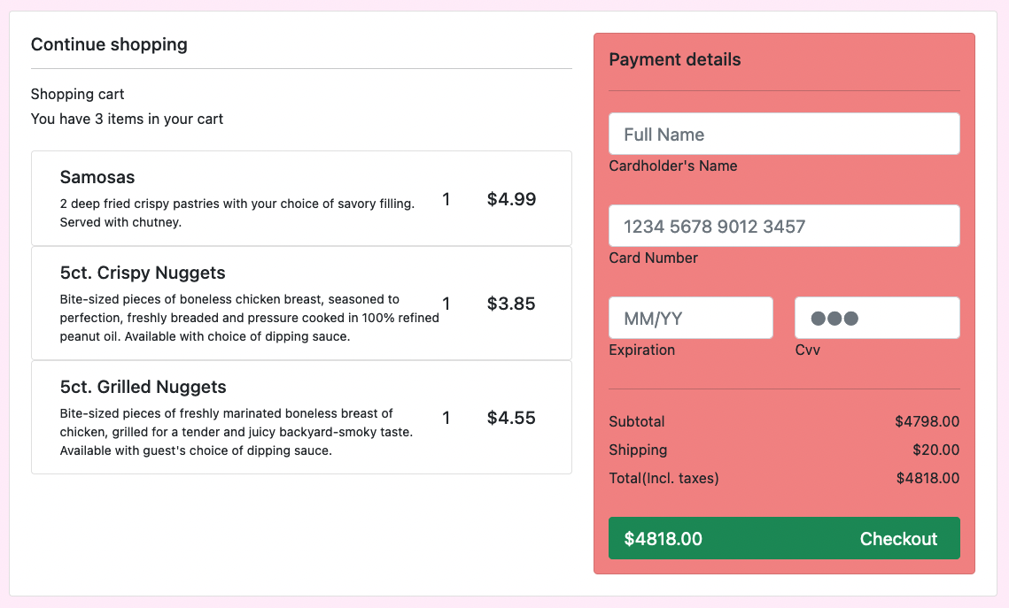

Database Designer View

In our database, we included addresses, users, payments, categories, restaurants, items, and carts in our structure. A user can filter restaurants based of their category (American, Mexican, Vegan Friendly, Asian, Indian, Dessert, and Halal food). Every restaurant has a list of items a user can choose to add to their cart and each item has a description, if necessary, price, and an option to add a picture if needed.

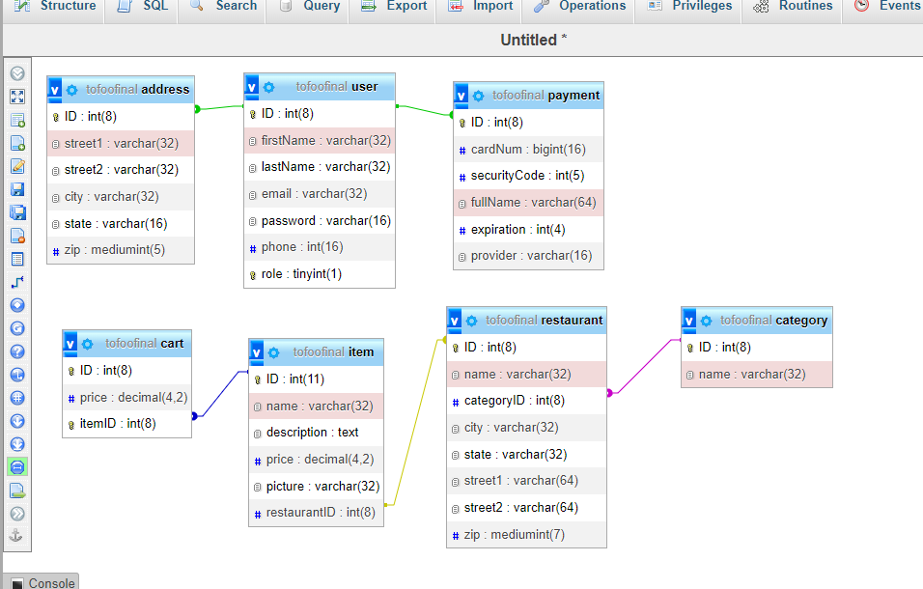

Setting up the database:

When creating the database, use the name “ToFoo.” Also, verify that the port number in xampp is the same as the variable $port, if not, make sure to change that.

