An example thermokinetic modelling problem

Table of contents

This document goes through an illustrative thermokinetic modelling problem. Instead of using our software Maud, everything is done from scratch using Julia. Unlike Maud, which does Bayesian inference, this example just solves the steady state problem for a given parameter assignment.

# The example problem

The reaction network looks like this:

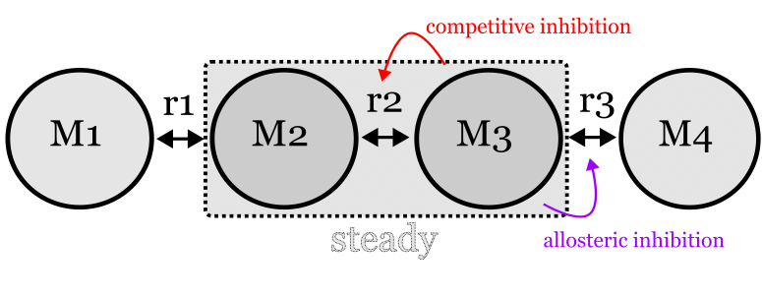

The box surrounded by a dotted line indicates which species should have constant concentration in order to consider the system in a steady state. Species M1 and M4 are considered ‘unbalanced’: in other words, the system is considered steady even if they are being created or consumed.

This graph can be summed up by the following stoichiometric matrix $S$:

$$\left[\begin{matrix}−1. & 0. & 0. \\ 1. & −1. & 0. \\ 0. & 1. & −1. \\ 0. & 0. & 1.\end{matrix}\right] \left(1\right)$$

Note that $S$ is less than full-rank, so we have the conservation relationship problem.

The aim here is to write some Julia functions for representing metabolic fluxes, use these functions to formulate the example network and then solve the steady state problem, i.e. find an assignment of concentrations to M1 and M2 that does not change.

# Julia functions for representing metabolic fluxes

To formulate the problem I wrote some Julia functions that can be found in the file thermokinetics.jl. These pretty faithfully copy their equivalents in Maud, which can be found [here](https://github.com/biosustain/Maud/blob/master/src/maud/stan/functions.stan). The main differences are that the Julia functions are much easier to read, mainly since the language supports ragged arrays, and that I didn’t bother to implement regulation by phosphorylation.

As a lightweight way of defining what a problem should look like for the purposes of this exercise, I also made two Julia structs: OdeUnknowns for unknown parameters, and OdeInfo for all the information required to solve a steady state problem (except the starting balanced species concentration).

@kwdef struct OdeUnknowns  
 enzyme::Vector{Float64}  
 conc_unbalanced::Vector{Float64}  
 kcat::Vector{Float64}  
 dgf::Vector{Float64}  
 km::Vector{Float64}  
 ki::Vector{Float64}  
 dc::Vector{Float64}  
 tc::Vector{Float64}  
end  
  
  
@kwdef struct OdeInfo  
 S::Matrix  
 ix_balanced::Vector{Integer}  
 subunits::Vector{Integer}  
 sp_to_km::Vector{Dict{Integer,Integer}}  
 sp_to_ki::Vector{Dict{Integer,Integer}}  
 sp_to_dc::Vector{Dict{Integer,Integer}}  
 allosteric_inhibitors::Vector{Vector{Integer}}  
 allosteric_activators::Vector{Vector{Integer}}  
 unknowns::OdeUnknowns  
end

# Formulating the example problem

The first step is to import the custom thermokinetics functions and import the DifferentialEquations and Plots libraries, which will be used later.

include("./thermokinetics.jl")  
using .Thermokinetics  
using DifferentialEquations  
using Plots

WARNING: replacing module Thermokinetics.  
WARNING: using Thermokinetics.OdeUnknowns in module Main conflicts with an existing identifier.  
WARNING: using Thermokinetics.OdeInfo in module Main conflicts with an existing identifier.  
WARNING: using Thermokinetics.Sv in module Main conflicts with an existing identifier.

Next I chose the following parameter configuration pretty arbitrarily and put them in an OdeUnknowns struct:

example_unknowns = OdeUnknowns(  
 enzyme=[0.5, 0.5, 0.5],  
 conc_unbalanced=[2., 1.],  
 kcat=[12., 1., 5.],  
 dgf=[25., 25., 50., 50.],  
 km=[1., 1., 1., 1., 1., 1.],  
 tc=[0., 0., 1.2], # NB all reactions must have a tc   
 ki=[1.5],  
 dc=[12.5]  
)

OdeUnknowns([0.5, 0.5, 0.5], [2.0, 1.0], [12.0, 1.0, 5.0], [25.0, 25.0, 50.0, 50.0], [1.0, 1.0, 1.0, 1.0, 1.0, 1.0], [1.5], [12.5], [0.0, 0.0, 1.2])

The next code cell represents the example problem using the OdeInfo struct:

example_S = Matrix(  
 [-1. 0. 0.;  
 1. -1. 0.;  
 0. 1. -1.;  
 0. 0. 1.;]  
)  
example_ode_info = OdeInfo(  
 S=example_S,  
 ix_balanced=[2, 3],  
 subunits=[1, 2, 1],  
 sp_to_km=[Dict(1=>1, 2=>2), Dict(2=>3, 3=>4), Dict(3=>5, 4=>6)],  
 sp_to_ki=[Dict([]), Dict(2=>1), Dict([])],  
 sp_to_dc=[Dict([]), Dict([]), Dict(3=>1)],  
 allosteric_inhibitors=[[], [], [3]],  
 allosteric_activators=[[], [], []],  
 unknowns=example_unknowns  
)

OdeInfo([-1.0 0.0 0.0; 1.0 -1.0 0.0; 0.0 1.0 -1.0; 0.0 0.0 1.0], Integer[2, 3], Integer[1, 2, 1], Dict{Integer, Integer}[Dict(2 => 2, 1 => 1), Dict(2 => 3, 3 => 4), Dict(4 => 6, 3 => 5)], Dict{Integer, Integer}[Dict(), Dict(2 => 1), Dict()], Dict{Integer, Integer}[Dict(), Dict(), Dict(3 => 1)], Vector{Integer}[[], [], [3]], Vector{Integer}[[], [], []], OdeUnknowns([0.5, 0.5, 0.5], [2.0, 1.0], [12.0, 1.0, 5.0], [25.0, 25.0, 50.0, 50.0], [1.0, 1.0, 1.0, 1.0, 1.0, 1.0], [1.5], [12.5], [0.0, 0.0, 1.2]))

To check that everything was working I tried calling the Sv function from thermokinetics.jl to see what the rate of change of the balanced species would be if their concentrations were 1.0 and 2.0 respectively.

Sv([1., 2.], example_ode_info, 0.1) # the 0.1 doesn't do anything

2-element Vector{Float64}:  
 12.039660056657224  
 -6.95840675480975

This seemed ok, so I tried choosing a starting concentration and timespan, then making an ODEProblem:

tspan = (0., 20.)  
example_starting_concentration = [0.4, 1.2]  
  
prob = ODEProblem(Sv, example_starting_concentration, tspan, example_ode_info)  
prob

ODEProblem with uType Vector{Float64} and tType Float64. In-place: false  
timespan: (0.0, 20.0)  
u0: 2-element Vector{Float64}:  
 0.4  
 1.2

Finally, I tried solving the problem and putting the results in a matrix:

sol = solve(prob, TRBDF2(autodiff=false))  
u = transpose(reduce(hcat, sol.u))  
u

17×2 transpose(::Matrix{Float64}) with eltype Float64:  
 0.4 1.2  
 0.401639 1.19902  
 0.418345 1.18929  
 0.618813 1.09847  
 0.994538 0.989472  
 1.40419 0.900338  
 1.80665 0.803208  
 2.01784 0.668918  
 2.0025 0.647219  
 1.99914 0.616281  
 1.99979 0.616863  
 1.99971 0.617088  
 1.99972 0.617041  
 1.99972 0.61705  
 1.99972 0.617049  
 1.99972 0.617049  
 1.99972 0.617049

This graph plots the simulated concentration timecourses on log-10 scale:[1]

plot(sol.t[2:end], u[2:end, :], xscale=:log10)

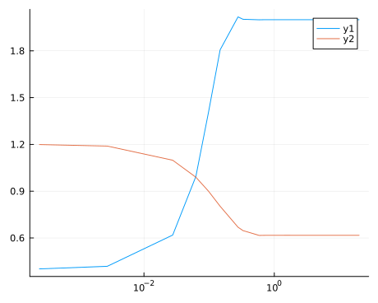

# What next?

Now we need to see how to solve this problem as fast as possible, for a range of different parameter values. We also need to find out the sensitivities of the steady state solution to the parameters.

1. The starting concentrations are excluded to avoid a zero on the x axis