**Description of the experimental data**

**Data collection.**

We collected four different types of data:

*1) Volume scan.*

Fluorescence from a volume of brain tissue, containing several vessels of interest, in time. We selected a brain volume of interest (*xyz*) and recorded 2D images (spanning *xy* range of the volume) at different *z*-coordinates (depth) within the *z*-span of the volume. Typically, individual images in the recorded stack are ~1-2 µm away from each other along the *z*-axis. Each time point (whole volume recorded one time) takes ~1-2 sec to collect. This type of data, therefore, can only be used to track a relatively slow changes of a vessel diameter (e.g. too slow to resolve 0.2-sec long single heartbeats). On the other hand, the volume scan allows to follow diameters of multiple vessels simultaneously even if their position changes substantially (e.g. by several µm, e.g. when inducing hypertension), because they will still be contained in the imaging volume (selected large enough to account for possible vessel drift).

We recorded two types of volume scans: (i) a volume scan during injection of ANG II (red in Figure 1) and (ii) a volume scan, during which we stimulated whiskers of the mouse (green in Figure 1). We haven’t yet (for now) included the results of (i) in our data and we don’t describe it here.

Volume scan (ii) is recorded as follows: Start imaging a volume of the brain in time, containing penetrating arteriole, precapillary sphincter, 1st-order and 2nd-order capillaries from the selected vessel tree. Stimulate infraorbital (whisker) region of the mouse. Estimates below are calculated for the four vessel types listed above.

Estimated quantities: (i) Mean vessel diameter before stimulation (diam_mean_before_stim) [µm]; (ii) Maximum vessel diameter after the stimulation (diam_max_after_stim) [µm]; (iii) Minimum vessel diameter after the stimulation (diam_min_after_stim) [µm].

*2) Line scan (diameter).*

Fluorescence along a line that goes perpendicular a vessel’s axis (vessel’s axis lies in the focal plane) in time. Compared to the volume scan, a line scan allows only to record one vessel at a time, but much faster ­­– with ~10 ms time resolution compared with ~1-2 sec for a volume scan. Line scan data allows to track diameter of a blood vessel during a single heartbeat (~200 ms long).

The Iine scan is recorded as follows: For each vessel in the vascular tree (including structures like precapillary sphincter and bulb, located between a penetrating arteriole and a 1st-order capillary), record a time series of line profiles of fluorescence intensity (*xt*-imaging = kymogram) perpendicular to the vessels axes.

Estimated quantities: (i) mean vessel diameter (diam_mean) [µm]; (ii) heartbeat frequency (pulse_freq) [Hz]; (iii) Power of the vessel diameter oscillation at up to three harmonics, h1-3 (power_diam_h1,2,3) [µm2]; (iv) Power of the vessel center position oscillation at up to three harmonics, h1-3 (power_center_h1,2,3) [µm2].

*3) Line scan (RBC speed).*

Fluorescence along a line (1D) that goes along a single vessel’s axis (vessel’s axis lies in the focal plane) in time.

The Iine scan is recorded as follows: For each vessel in the vascular tree (including structures like precapillary sphincter and bulb, located between a penetrating arteriole and a 1st-order capillary), record a time series of line profiles of fluorescence intensity (xt-imaging = kymogram) along the vessels axes.

Estimated quantities: (i) RBCs speed (speed) [µm/sec]; (ii) RBCs flux (flux) [RBCs/sec].

*4) Blood pressure.*

Blood pressure measured from a femoral artery as a function of time.

Estimated quantities: (i) mean arterial blood pressure (pressure_d) [mmHg] recorded simultaneously with *Line scan (diameter)*; mean arterial blood pressure (pressure_s) [mmHg] recorded simultaneously with *Line scan (speed).*

**Experimental protocol.**

We describe the experimental protocol (Figure 1) starting from placing an operated mouse under the objective of a two-photon microscope.

Figure : The experimental protocol consisting of five groups of measurements, which we denoted as "treatments" (black boxes). During each treatment, we recorded volume scans (green and red) and line scans (blue). The scheme doesn’t show the vessel selection part, which precedes the treatments and is done as follows: select a penetrating arteriole, from which one can easily trace branching capillaries down to the fifth order. This penetrating arteriole and five capillaries branching from it we denote as a vessel tree. We recorded only one vessel tree from a mouse. “Baseline” treatment is a control, to which the following treatments can be compared to. During the 1st and 2nd “hypertension” treatment, blood pressure of the mouse is increased by injection of angiotensin II (ANG II). The “after hypertension” treatment corresponds to the time when the blood pressure of the mouse returned back to values similar to “Baseline” (the blood pressure return back to “baseline” because we stop injecting ANG II). The “after hypertension” treatment serves as a control for the “after ablation” treatment, in which we ablated (destroyed) the precapillary sphincter (a structure located where a penetrating arteriole branches into a first order capillary) to test how it affects the vascular tree (“after ablation”). Finally, “2nd hypertension” treatment is done to test if ablation of the precapillary sphincter affects vascular response to an increasing blood pressure.

**How to read** *data.csv*

*mouse*: the date of the experiment (format: date month year)

*treatment*: baseline, hyper (during first hypertension), after_hyper (after first hypertension), after_ablation (after sphincter ablation), hyper2 (during second hypertension).

*vessel*: pen_art (penetrating arteriole), sphincter, bulb, cap1–5 (capillaries from first to fifth order).

*age*: adult or old mouse

*diam_mean*: mean vessel diameter, measured in µm; see *Line scan (diameter) in* **Data collection**.

f*_heart*: heartbeat frequency estimated from the power spectra measured in Hz; see *Line scan (diameter) in* **Data collection**.

*power_diam_h1(h2, h3):* Power of the vessel’s diameter fluctuations at the heartbeat frequency (h1), its second (h2) and third harmonic (h3), measured in µm2/Hz; see *Line scan (diameter) in* **Data collection**. Each individual power value is exponentially-distributed.

*power_center_h1(h2, h3):* Power of the vessel’s center fluctuations at the heartbeat frequency (h1), its second (h2) and third harmonic (h3), measured in µm2/Hz; see *Line scan (diameter) in* **Data collection**. Each individual power value is exponentially-distributed.

speed: RBCs speed measured in µm/sec; see *Line scan (speed) in* **Data collection**.

flux: RBCs flux measured in RBCs/sec; see *Line scan (speed) in* **Data collection**.

speed: RBCs speed measured in µm/sec; see *Line scan (speed) in* **Data collection**.

Pressure_d(s): blood pressure measured in mmHg; see *blood pressure in* **Data collection**.

diam_mean_before_stim: Mean diameter of a vessel before whisker stimulation, measured in µm; see *Volume scan in* **Data collection**.

diam_max_after_stim: Maximal diameter of a vessel after whisker stimulation, measured in µm; see *Volume scan in* **Data collection**.

diam_min_after_stim: Minimal diameter of a vessel after whisker stimulation, measured in µm; see *Volume scan in* **Data collection**.

An empty cell means either no experimental data was recorded (e.g. no data for 5th order capillaries or during hypertension) or because the data was discarded due to low quality (read below for the exclusion criteria). If there is an empty cell in column Pc_h2(h3), while there is a value in column Pc_h1, it means that the second (third) harmonic was essentially zero. See section “Methods” for how the power spectra were estimated.

**Biological questions for the data analysis:**

1. Does ageing affect diameter responses of blood vessels?
   1. Do vessels respond differently to whisker stimulation with aging (as has been previously shown for precapillary sphincters), after acute hypertensive response or after precapillary sphincter ablation?
2. Does aging affect pulsatility (estimated by power spectra analysis) of the diameter and center position in capillaries?
   1. Is pulsatility affected by an acute hypertensive challenge and/or after ablation of the precapillary sphincter?
   2. Does bulb have higher pulsatility than the capillaries (this may indicate a protective role of the bulb in absorbing potentially damaging pulsations)?
   3. Does the diameter of the PA or the precapillary sphincter affect pulsatility in capillaries?
3. Does aging affect the capillary RBC velocity/flux in capillaries?
   1. Does an acute hypertensive challenge and/or a precapillary sphincter ablation affect the capillary RBC velocity/flux?
   2. How deep into the capillary network (which capillary order) can this change be detected after a precapillary sphincter ablation?
   3. How do the diameter changes during an acute hypertensive challenge or after sphincter ablation relate to RBC velocity/flux changes?

**Methods (only Nikolay’s analysis; ask Søren for the rest)**

**Estimation of the position of the center, *xc*, and the diameter, *d*, of a blood vessel.**

Raw data used as input: a 2D image (kymogram) showing fluorescence intensity along a line (drawn perpendicular to a vessel’s axis) as a function of time.

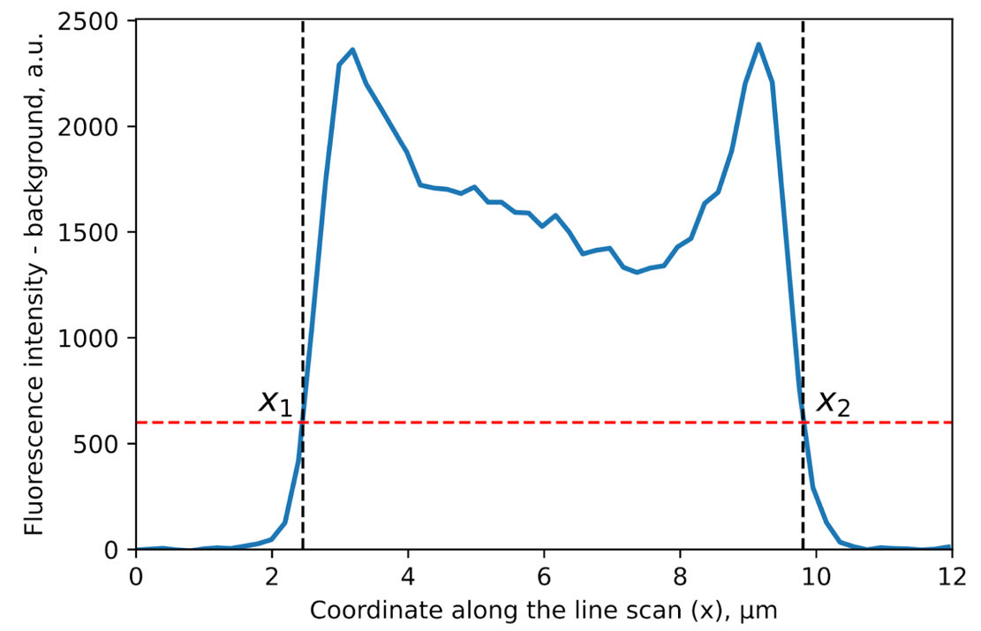

Figure : A simple approach to estimate vessels diameters and center positions from averaged line profiles of fluorescence intensity (blue curve). First, we subtracted the average fluorescence background estimated on both sides of the averaged profile, resulting in near-zero fluorescence outside of the vessel. Arbitrary chosen threshold is shown as a red dashed line. The vessel’s boarders, x1 and x2, are x-coordinates of intersections of the threshold line with the intensity profile. Diameter, d, and center position, xc, of the vessel are estimated as d = x2 - x1 and xc = (x1 + x2)/2, respectively.

First, we averaged line scans in kymograms over non-overlapping blocks of 16 profiles (~20 ms). For each averaged profile we estimated center position and diameter of a vessel as described in Figure 1. An example of calculated diameter and center trace is shown in Figure 2.

Figure : Diameter (black) and center position (red) fluctuation about their means (means are subtracted from the traces) of a capillary.

**Calculating power density spectra**

Figure : Power spectral density of the position of the center (red) and the diameter (black) of a first order capillary. The first and second harmonics of the heartbeat are at ~6 and ~12 Hz, respectively. The peak at ~3.5 Hz corresponds to the ventilation frequency. The white noise background noise was estimated by averaging spectral values between 13 and 15 Hz, away from any peaks.

We calculated power spectra of the diameter and center position traces using the fast Fourier transform (FFT). We didn’t split each time trace to average over spectra because of the already low frequency resolution (~0.1 Hz), corresponding to a typical trace duration of 10 sec. We minimized spectral leakage (Figure 4) by shortening the time series (from the end) before the FFT, which results in sharp and very localized along x-axis spectral peaks without “skirts” due to spectral leakage. Specifically, we removed the data points from the end of recorded time series (e.g. vessel diameter) until the ratio between the maximum spectral density value of the heartbeat peak (1st harmonic) and the average spectral density of the two neighboring points around was minimal.

Figure : Power spectra at the heartbeat frequency before (dashed) and after (solid) minimizing spectral leakage, seen in lin-lin coordinates (left) and lin-log coordinates (right). The dashed spectrum shows substantial spectral leakage, which we removed by simply shortening the time series before FFT.

A typical power spectra (Figure 3) contains: (i) low-frequency components (0-2 Hz), corresponding to slow spontaneous motion of a blood vessel; (ii) a peak corresponding to the ventilation frequency (around 3.5 Hz); and (iii) a peak corresponding to the heartbeat frequency with its second and third (sometimes) harmonics. From each power spectra we calculated spectral power at the heartbeat frequency and its two higher harmonics. We could do that because spectral peaks at these frequencies were essentially single-frequency-value peaks (Figure 4) after the spectra leakage removal.

We estimated white noise floor amplitude by averaging spectral density between 13 and 15 Hz, away from any peaks and found that its amplitude is typically 1-2 orders of magnitude lower than the amplitude of the peaks we analyzed. Figure 4 shows that the white noise background, the heartbeat peak stand on, is negligible compared to the peak height.

**Criteria for discarding recordings**

We excluded data from the analysis based on at least one of the following criteria:

1. Too short line scans (in space): Line scans do not cover enough of the background fluorescence; hence, not enough information to estimate a vessel’s diameter.
2. After a sphincter ablation the fluorescent dextran appeared in the extravascular space, distorting the fluorescence profile.
3. Highly distorted line profile of fluorescence, possibly due to non-cylindrical shape of a vessel or drawing a scan line across a non-straight region of a vessel.
4. Blocked blood flow in a vessel: pulsations may not propagate through a clotted vessel.

**Results (from Nikolay’s analysis)**

Figure : Comparison of average diameters (top row), power of diameter pulsations (Pd, middle row), and power of center pulsations (Pc, bottom row) for different vessels (x-axis) and treatments (four treatments in columns) for adult (black) and old (red) mice. X-axis in panels contains penetrating arterioles (pa), bulbs (b), and capillaries from 1st to 5th orders (c1-c5). Points with error bars show means ± s.e.m. (averaging over mice, minimum 5 points per average). The last treatment, 2nd hypertension, we show in Figure 6 with individual data points (no descriptive statistics) because of small number (< 5) of measurements. Dashed lines in panels of the bottom row show grand averages of Pc for all vessels for adult (black) and old (red) mice.

Figure : Comparison of average diameters (left), power of diameter pulsations (Pd, middle), and power of center pulsations (Pc, right) during 2nd hypertension for different vessels (x-axis) for adult (black) and old (red) mice. X-axis in panels contains penetrating arterioles (pa), bulbs (b), and first order capillaries (c1). Each data point corresponds to a single recording in one mouse. Because of only few recordings in adult mice, we don’t show any descriptive statistics

Figure : Comparison of heartbeat frequencies estimated from different vessels (x-axis) and treatments (four treatments in columns) for adult (black) and old (red) mice. X-axis in panels contains penetrating arterioles (pa), bulbs (b), and capillaries from 1st to 5th orders (c1-c5). Points with error bars show means ± s.e.m. (averaging over mice, minimum 5 points per average). Dashed lines show grand averages for all vessels for adult (black) and old (red) mice, for each treatment. Note how the heartbeat frequency is consistent for different vessels during a single treatment because the heartbeat frequency should not depend on the location where we measure it. We don’t show the data from the last treatment, 2nd hypertension, because of small number (< 5) of measurements.

**Two pulse pressure waves in the brain**

Diameter pulsations are caused by the pressure wave propagating along the vasculature, starting at the heart. Power of diameter pulsations, Pd, decreases as we move along the vascular tree (from penetrating arterioles to fifth order capillaries, see Figure 5) likely due to the decreasing blood pressure. Power of center position pulsations, P­c, are caused by pressure waves travelling in the brain, generated by large brain vessels (e.g. MCA, circle of Willis). Note how P­c is the same for different vessels along the same vascular tree (bottom row Figure 5), suggesting a pressure wave that perturbs the volume of the brain containing the vessels we follow, which is why their center move to the same extent. Note that, if the interpretation above is correct, P­c will also depend on the elastic properties of the brain tissue (not only vewsel walls), through which the pressure wave propagates.

**Sphincter ablation dilates vessels, maybe more so in adult than in old mice**

By comparing two treatments, *after hypertension* and *sphincter ablation*, we study how ablation of a sphincter affects individual blood vessels. From Figure 5 we can eyeball (no statistical tests were made) how diameters of penetrating arterioles, bulbs and first order capillaries (maybe other capillaries too) increases after sphincter ablation, which can be due to increased blood pressure (sphincter was increasing the resistance, thus lowering the blood pressure downstream).

During the *baseline* the diameters of the blood vessels of the same type are the same for adult and for old mice (top left panel of Figure 5) but after the *sphincter ablation* the vessels in adult mice seem to dilate more. This could be explained by the higher mean arterial blood pressure in adult mice (more force that drives the pulsations of vessel walls).

**Old mice have higher heartbeat frequency than adult mice and the heartbeat frequency increases after hypertension in both adult and old mice**

This follows from the *baseline* and *hypertension* treatments panels of Figure 7.