Jess | INFS3202 | April 13, 2016

Occhiolist

Website Proposal

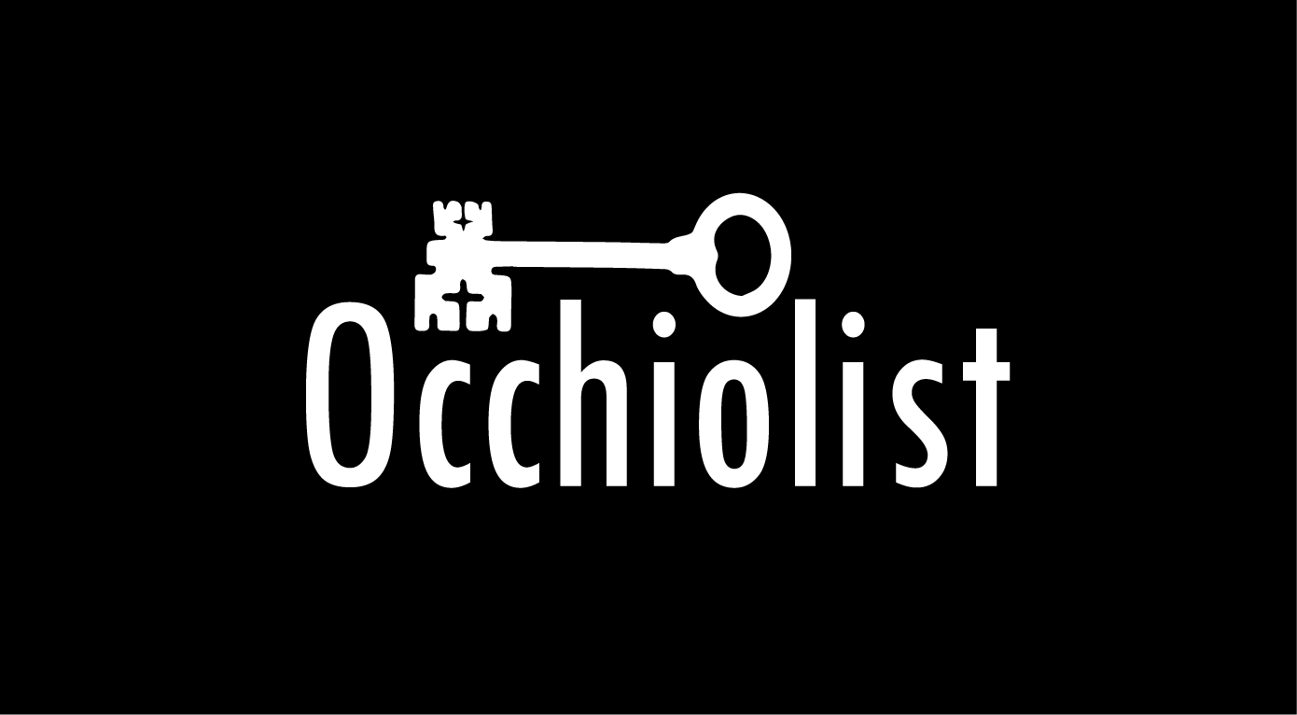

Design

Brief

Occhiolist is the name of the website being outlined in this proposal. Occhiolist is a cryptic puzzle web application in the form of a website that is designed for non-mobile modern day web browsers. Occhiolist will be in some ways a game as the motive for users of the website is to complete the riddle that some of the pages contain. The riddles are released as sets and each set focuses on a specific clue style. The riddles on each page are very unorthodox and force the users to interact with the website in ways that normally wouldn’t happen on other web pages. These interactions include actions like looking at the source code of the page itself to discover a clue or highlighting elements on the page to look for clues. The riddles are meant to be challenging and insightful as which each page the user must use what they’ve previously learnt to solve the next riddle. The name Occhiolist comes for the word “Occhiolism”, which currently, is not a documented English word, but is defined by some as “The awareness of the smallness of your perspective.”

Layout

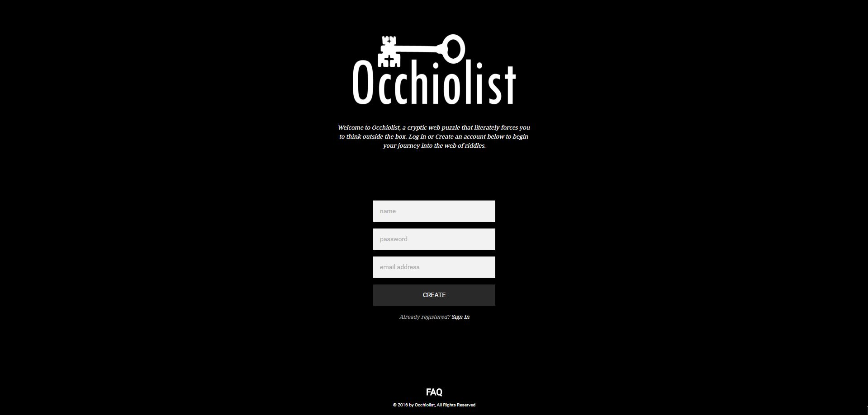The website layout will include a homepage/login page that will allow users to login and continue progress on the riddles. If a user doesn’t have an account, the form will allow them to create an account. Before users can login after creating an account, they must confirm their account creation by responding to an email that is sent to them. All login information is checked for authorization by using AJAX to communicate with a MySQL server containing login information. Once users have logged in they will be able to navigate a home screen that will contain information on new sets and progress with development of new riddles in the form of blog posts. The navigation bar on the top of the page contains links to all sections available on the page. The sections include the home page, pages for each set of riddles, pages for FAQ sections and a page for account settings. The navigation menu has a drop down design for each of the sections with multiple pages. This navigation is designed to make it easy for a user to navigate the website.

Login Screen

The riddle page will consist of a grid of pictures that link to each of the riddle sets. This page acts as a portal for the user to access the main pages for each of the sets. These main pages can also be found via the riddles drop down menu in the navigation bar. The separate riddles pages will contain information about each set and link to the starting page for each set. These pages are where the user can actually start the riddles. The website tracks the user’s progress on each riddle and lets the user know which riddle they are up to if they didn’t complete the set on the first time through. Users will have access to each riddle page they have completed from this page making it possible to quickly move between the riddles should they need to.

The FAQ section of the navigation bar links to 2 separate FAQ pages. One of these pages contains general questions on how the site functions while the other focuses on answers for the riddles. The general question page is laid out as a list of items grouped by which section they are relevant too. The second FAQ page consists of a table of hidden textboxes that open when clicked on. These textboxes contain the answers to each of the riddles and initially are hidden so that they do not spoil the user. Additionally there will be links to text files stored on the server that contain the answers for each set.

The account section of the navigation bar links to an account settings page where the use can change their account settings. There will be 2 forms that will allow the user to change both their password and their email address. Both forms require that the user put in both the old and new account password of email. In order for either of this forms to process the user must both confirm the change by interacting with an email that is sent to them on submission and also complete the captcha at the bottom of the form. This captcha will consist of having to drag and drop a key into a box and makes use of the new HTML5 drag and drop functionality.

Each page of the website will have a footer that sticks to the bottom. The footer contains both contact details and a copyright notice. For the login screen, there is an additional link to a separate FAQ page in the footer as well.

The design for the riddle pages will vary depending on which set they are part of. Every page however will contain 3 common elements which include a riddle number, the riddle text itself, and a help button located at the bottom of the page. The design is supposed to be extremely minimalistic because these pages are meant to be puzzling. These pages are the content that this website is built for.

Riddles

The goal of the user for this website is finish all the sets of riddles that can be attempted. The riddles themselves are actually web pages with hidden elements that the user must look for. To move forward in the set, the user must find the URL for the next riddle by investigating the page they are on. The riddle text and help button will be able to give them clues as to where the URL might be located. An example riddle might look a little like this:

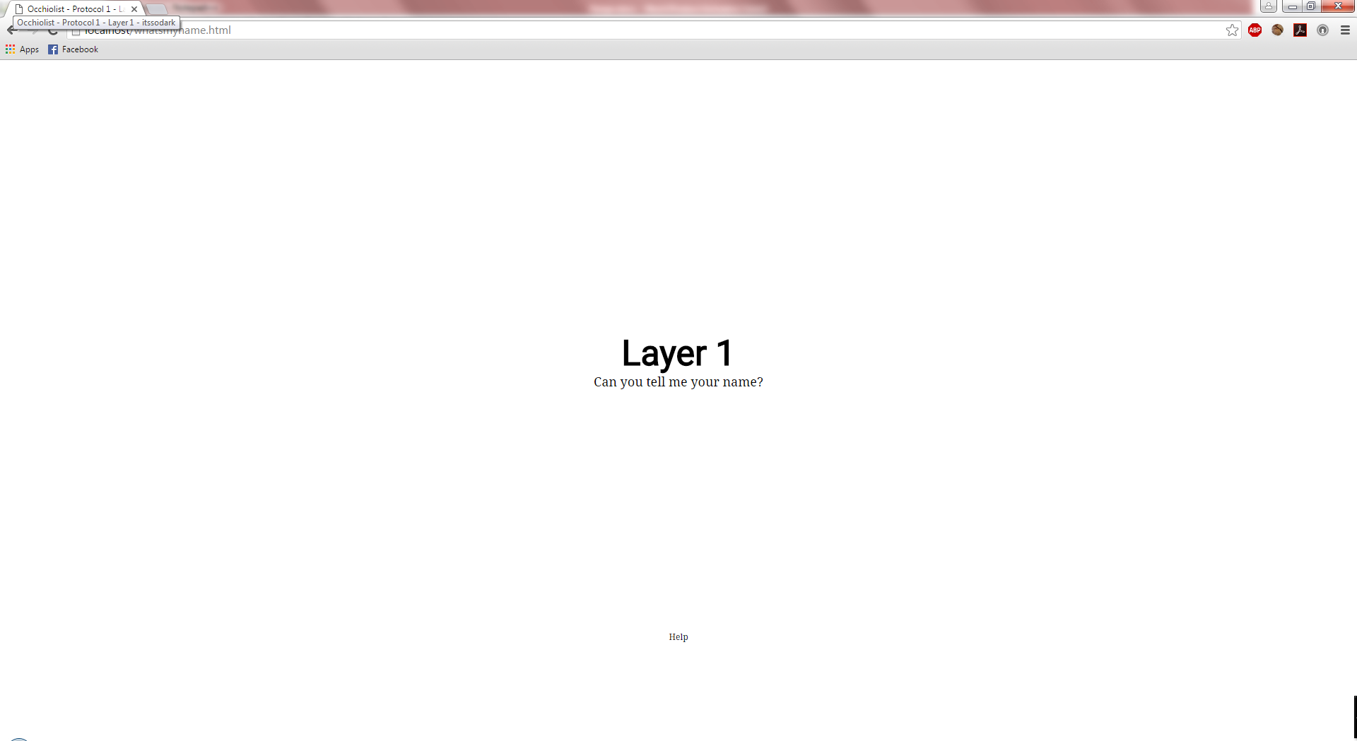

To solve this riddle the user must interpret the text given. In this case thext is “Can you tell me your name?” which in this case is referring to the name of the page. The URL for the page also tries to hint at this. By looking at the pages title the user can find a string of text that says “itssodark”. This string of text is actually the URL name for the next riddle. So in this case to solve the riddle the user must go to localhost/itssodark.html. This will lead them to the next riddle page.

Aesthetic

The website is designed to look minimalistic and simple. Because there isn’t too much content, shapes are used to decorate pages where they fit the visual style. The overall colour scheme for this website consists mainly of black and white with the backgrounds and text colour for pages switching between black and white between pages. Red is used for letting users know they have made a mistake in a form and grey is used for placeholder text in forms to indicate that text can be typed in. The website used two main fonts for its design which both can be located on Google Fonts. These fonts are “Roboto” and “Droid Serif”, with “Roboto” being a sans-serif style font and “Droid Serif” being a serif style font. The website design has a lot of “white-space” in either black or white as there is not too much content that needs to fit on each page. The overall design is supposed to feel both professional and mysterious, so it’s designed to look flush.

Technologies

The technologies used for this website include HTML5, CSS3, PHP, AJAX, SQL and Javascript. The website is accompanied by a database that uses MySQL as the DBMS. User information and user progress is stored on this database. PHP and AJAX is used for client-server communication with the database while Javascript is used for the client-side programming. jQuery is used as a 3rd party library with Javascript as it makes certain actions such as DOM traversal extremely easy.  
  
This website is designed to be used on desktop browsers only as some of the riddles would not be solvable on a mobile browser. Currently most desktop browsers will be enough to run the website, however users may need to go through different actions to solve the riddles depending on the browser they’re using.

Web Standards

The design of this website must comply with the current web standards in order for it to be effective. It’s important for any website to comply with these standards for a range of reasons. One of these reason is for technological compatibility. With the advent of smartphones, web browsing on mobile devices is becoming just as important as desktop browsing. This means that websites need to be both compatible with mobile and desktop platforms and web standards help make this compatibility exist. Another reason that web standards is important is that it makes it easier for non-human readers to understand the content. This is particularly important for services such as search engines that need to crawl websites in order to index them in their databases. Having a website that complies with standards mean that’s the website will be more easily identifiable to a search engine which means more users will be able to find it through search engines. Web standards are also important for backwards compatibility. If a website complies with standards, then a user should be able to view most of its content regardless of what they are viewing it on. This saves a lot of time for developers as it means they don’t need to create a different version of the website for each major browser or HTML standard.