SYSTEM DESIGN AND UML CLASS DIAGRAMS
DESIGN AND IMPLEMENTATION OF A LIBRARY MANAGEMENT SYSTEM USING OBJECT-ORIENTED PROGRAMMING PRINCIPLES IN JAVA
Course: Object-Oriented Programming with Java
Prepared by: Nakyejwe Teddy
Registration number: 24/BSE/BU/R/0017

1.0 PURPOSE OF THE DOCUMENT
This document shows the proposed structure of the Library Management System before implementation. It identifies the main Java classes, their responsibilities, and the relationships between them. The design follows the project proposal and requirements specification for a single library.

2.0 PROPOSED SYSTEM STRUCTURE

2.1 Main Parts of the Application
User interface. JavaFX screens will handle login, the book catalog, member records, borrowing, returns, and the librarian dashboard.
Models. Java classes will represent users, books, physical book copies, and loan records.
Services. Service classes will check rules before a book is issued or returned and will prepare information for the user interface.
Repositories and database. Repository classes will read and save records in SQLite through JDBC. This keeps SQL statements separate from JavaFX screens.

2.2 How the Main Operations Will Work
When a librarian issues a book, the interface sends the request to LoanService. The service checks that the member exists and the selected copy is available. If the checks pass, the loan and copy status are saved together. Returning a book follows the reverse process. A failed operation must not leave the copy status and loan record inconsistent.

2.3 Access to Features
The Librarian role can manage books, copies and members, issue or receive books, and view library reports. The Member role can search the catalog and view only their own borrowing records. Access checks must be enforced within the application logic, not only through visible buttons.

3.0 MAIN CLASSES AND RESPONSIBILITIES
The six domain classes below form the main part of the proposed design. Their relationships are shown in Figure 1.
Class | Main responsibility
User (abstract) | Stores information common to members and librarians, including account identity and login details.
Member | Represents a registered borrower and identifies the loans belonging to that member.
Librarian | Represents an authorized library staff account.
Book | Stores details of a book title, such as ISBN, title, author and category.
BookCopy | Identifies one physical copy and its current availability status.
Loan | Records a member borrowing a particular copy, with issue, due and return dates.

4.0 RELATIONSHIPS AND LIBRARY RULES
Inheritance. Member and Librarian extend the abstract User class. Each overrides getRole() to identify its account type.
Book and copies. One Book may have zero or more BookCopy objects. Each BookCopy belongs to exactly one Book.
Member and loans. A Member can have many Loan records over time. Every Loan belongs to exactly one Member.
Copy and loans. A BookCopy may appear in several historical Loan records, but it must have no more than one active loan at the same time.
Status values. CopyStatus will contain AVAILABLE, BORROWED and INACTIVE. LoanStatus will contain ACTIVE and RETURNED. Overdue is calculated from the due date and return status.
Record protection. A copy with past loans can be marked inactive rather than deleting its history. A copy on active loan must not be deactivated until its loan is resolved.

5.0 DATA STORAGE DESIGN
The SQLite database will have four main tables. The class names and identifiers below guide the detailed schema; the exact SQL will be implemented during the data persistence stage.
Table | Important fields | Relationship
Users | userId, fullName, username, passwordHash, role, active | Librarians and members share an account record.
Books | bookId, isbn, title, author, category | A book title has several physical copies.
BookCopies | copyId, bookId, status | bookId refers to Books.
Loans | loanId, memberId, copyId, issueDate, dueDate, returnDate, status | memberId refers to Users; copyId refers to BookCopies.
The database will use unique identifiers and foreign keys. Borrowing and returning will be carried out within database transactions, and the application will prevent two active loans for the same copy.

6.0 HOW THE DESIGN SUPPORTS OOP
The proposed design shows classes and objects, constructors, private attributes and controlled methods. Inheritance connects Member and Librarian to User. Overriding getRole() will demonstrate polymorphism, while BookService will overload its search method. User provides an abstract class and Searchable<T> provides an interface. Collections such as List<Book> and List<Loan> will support search results and record management. Validation and exceptions will protect important operations.

FIGURE 1: UML DOMAIN CLASS DIAGRAM
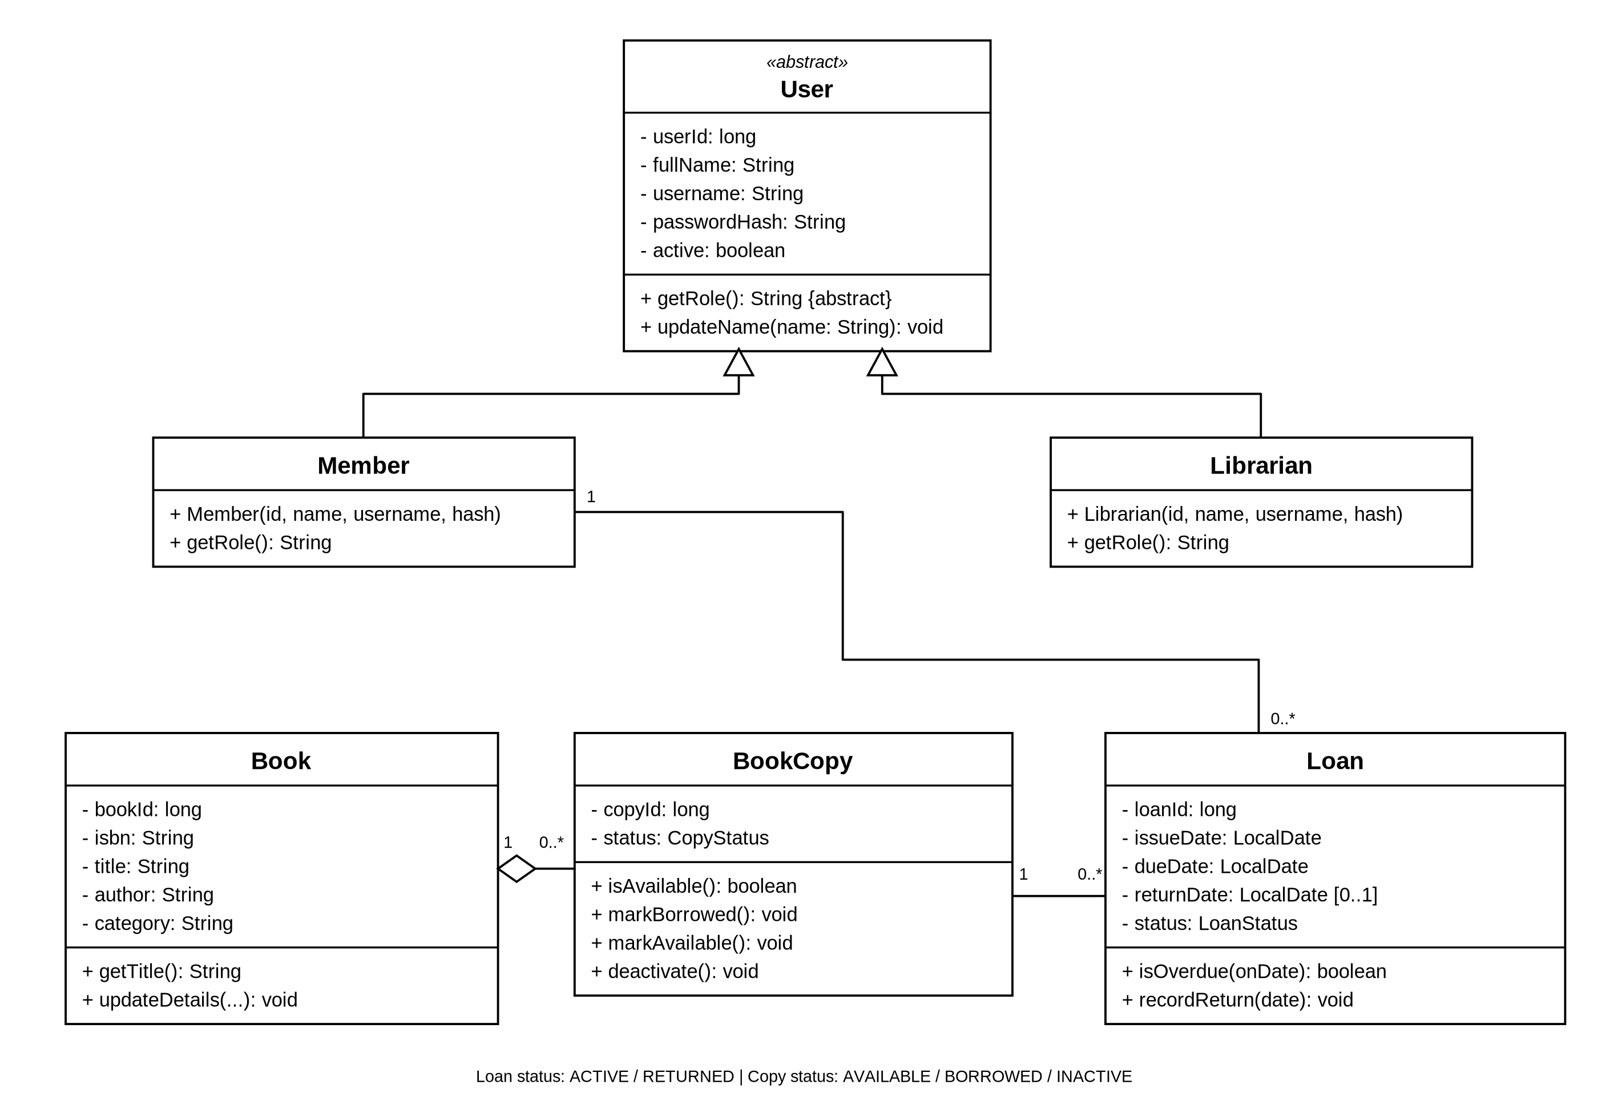

FIGURE 2: UML SERVICE AND INTERFACE DIAGRAM


