Library Management System Design
This document describes the implemented classes, application components and design changes for the Java Library Management System. The diagrams reflect the working single library desktop application.

Domain classes
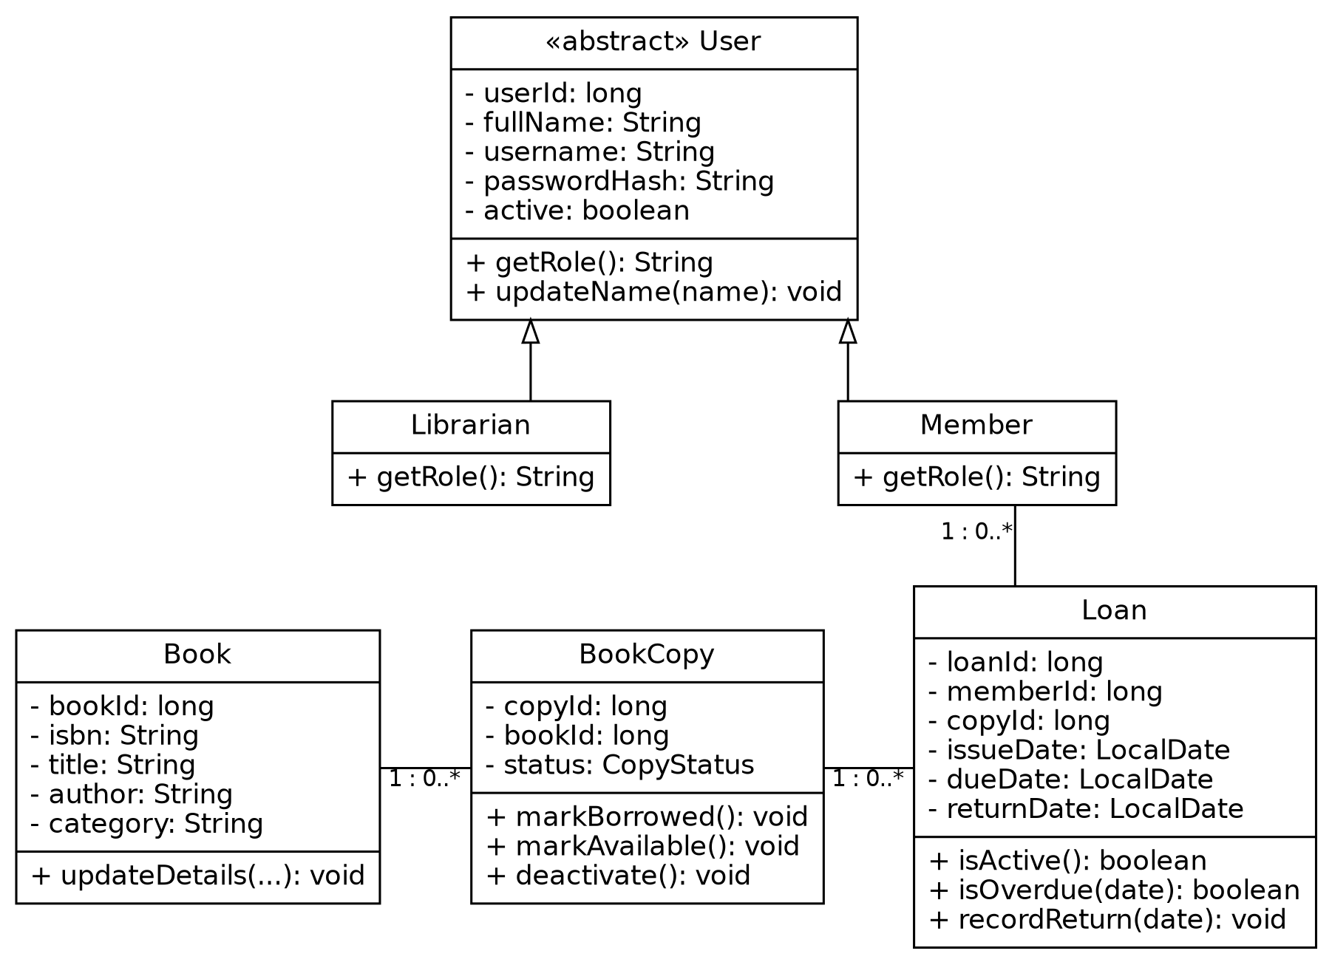
Figure 1 Domain class relationships
Associations are implemented through IDs and database foreign keys rather than duplicated in-memory lists on each model. Every loan belongs to one member and one copy. Historical loans can reference a copy repeatedly, but only one may be active. LoanStatus is derived from returnDate; there is no independently mutable status field in the Java model. The database stores status with a check constraint to keep it consistent.

Application components
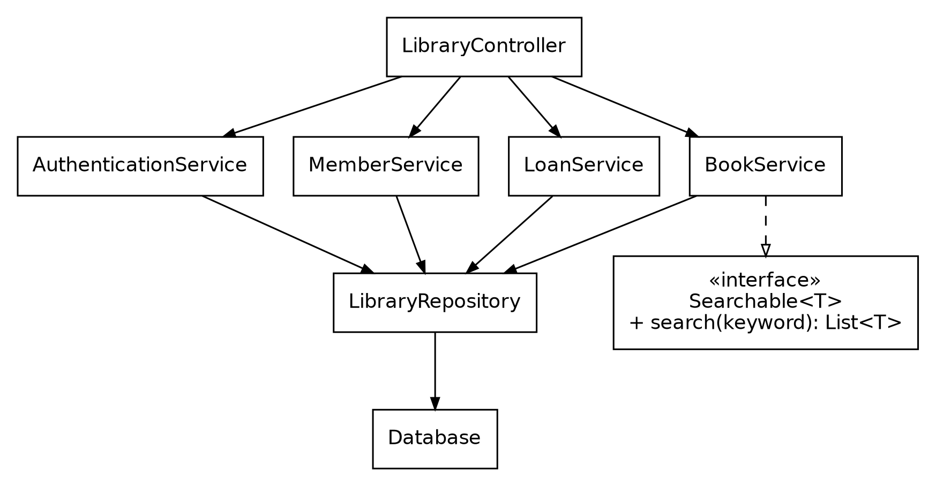
Figure 2 Application component relationships
BookService.search(String) delegates to overloaded search(String, Field). AuthenticationService creates session objects; book, member and loan services require a valid session. One shared repository performs the small project's JDBC mapping.

Changes from the supplied design
- The original service diagram proposed BookRepository, BookCopyRepository and LoanRepository interfaces. The implementation uses one concrete LibraryRepository to reduce repetitive files. Searchable<T> remains a purposeful interface.
- Loan explicitly includes member and copy IDs. It derives Java loan status from the return date to avoid conflicting model state.
- BookCopy holds bookId, making the persisted association explicit.
- CopyStatus.INACTIVE is used consistently, matching the original design document rather than the prompt's alternative example WITHDRAWN.
- Authentication, member management, UI and database classes are included in the component diagram; the supplied diagrams focused on domain, book and loan classes.
The original planning documents remain in reference/ for comparison. These changes preserve their functional requirements.

