# **DRED STATE**

## **High - Concept**

Dred State is a first person 3D role play game for PC where the player wakes up in a prison cell underground and must sneaks his way through different levels avoiding mentally ill convicts and solving puzzle to reach the world outside before the time runs out.

## **Mechanics**

The player have 3 stats that influence how levels and enemies are behave: Awareness, Calmness and Luck.

* **Awareness**, makes the player able to see in more detail the surroundings spotting with more ease traps that would otherwise past unnoticed, it will make the detection range of enemies more smaller. However, your enemies will get more anxious about your whereabouts and their behavior will be more erratic but with inclinations on being more stalkers.
* **Calmness**, even with everything that’s happening the player will manage to spot traps easily and with cool analytical thinking it will get more hints of how to solve puzzles and potentially spot alternative path to the goal of the level. Your enemies will take your steel nerves and adapt by adopting a more seeker behavior.
* **Luck**, not everything is skill and rational thinking, with luck you won’t even care about traps at all! You’ll get so lucky that your chances to encounter enemies is higher! Enemies will adopt a more stalker behavior

At the beginning of the game you’ll have to choose a class that have initial values: **Nerd** (Higher awareness, regular calmness and luck), **Hot Guy** (regular awareness and luck, Higher calmness), and **Blond Girl** (regular awareness and calmness, higher luck).

The enemies (mentally ill prisoners) have 2 characteristics: first they will insta-kill you if the get close to you and secondly they’ve 3 different behaviors that changes how they move on the level:

* **Seeker,** will spend more time searching different rooms in looking for the player and laying traps to hinder the player and possible get its location.
* **Stalker,** this enemy will “know” where the player currently is, it will spend his time searching rooms closer to the player and with more frequency the room where the player currently is.
* **Errant,** the more passive of the 3 enemy types, this type of enemy will search in rooms randomly like the seeker, but it will not spend much time on any of those additionally it will sometimes be stationary thinking about the next move.

The player **can’t beat** the prisoners he can only hide from them and wait for the best

The enemies behaviors is always changing Seeker can transform to Stalker and Stalker to Errant, the “timing” for this is influence on the stats of the player, not only timing but also the likeness to get the next behavior is heavy influence by the stats too. The following sheet shows how it happens:

|  |  |  |  |
| --- | --- | --- | --- |
| Stat/Behavior | Stalker | Seeker | Errant |
| Awareness | **0.75** | **0.15** | **0.1** |
| Calmness | **0.15** | **0.75** | **0.1** |
| Luck | **0.55** | **0.25** | **0.2** |

When the player enters in a new level this is the distribution (on %) of the types of enemies it will encounter at the very beginning:

|  |  |  |  |
| --- | --- | --- | --- |
| Time On Behavior | Stalker | Seeker | Errant |
| Awareness | **6-8 min** | **1-3 min** | **1-3 min** |
| Calmness | **1-3 min** | **6-8 min** | **1-3 min** |
| Luck | **5-6 min** | **3-5 min** | **2-4 min** |

Already on the level, enemies will change or try to change their every fixed amount of time based on the stats of the players, previously mention.

The following table shows the likeness of an enemy to switch from on state to another based on the highest stat the player currently have.

|  |  |  |  |  |  |  |  |  |  |
| --- | --- | --- | --- | --- | --- | --- | --- | --- | --- |
| With Higher Awareness | |  |  | With Higher Calmness | |  | With Higher Luck |  |  |
| FROM/TO | **Stalker** | **Seeker** | **Errant** | **FROM/TO** | **Stalker** | **FROM/TO** | **Stalker** | **Seeker** | **Errant** |
| Stalker | **1** | **0.15** | **0.15** | **Stalker** | **1** | **Stalker** | **1** | **0.45** | **0.15** |
| Seeker | **0.85** | **1** | **0.15** | **Seeker** | **0.35** | **Seeker** | **0.9** | **1** | **0.1** |
| Errant | **0.85** | **0.15** | **1** | **Errant** | **0.35** | **Errant** | **0.75** | **0.65** | **1** |

The enemy can place two types of traps**: Noise Traps** and **Immobilization traps**, the noise traps as the name suggest its purposes is to reveal the location of the player to nearby enemies to start a hunt, and example of this is empty bottles at the entrance of the next room that the player have to move manually one by one to clear the path or wind chime will make noise when there is wind blowing or on contact, in this case the player will have to move more carefully if they don’t want to trigger it and alert the nearby enemies. For the immobilization traps, again like the name suggest are traps designed to stop the player movement for a short time, Bear traps are an example of this kind of trap.

Much like the enemies, the levels would be influence by the stats of the players, they’re a set of rules that goes like this:

1. The base number of rooms per level is 14 with a maximum of 21.
2. There must be a path to the goal.
3. There must be more Large rooms than medium rooms, and more mediums rooms than small rooms
4. The player is placed no more than 9 rooms away from the goal room.
5. There is a 50-50 chance of a room having a trap with a minimum of 10 rooms having traps
6. No enemy is placed on the adjacent rooms of the start position, and the maximum the number of enemies on the levels is equal to the shortest distance to the end room times 2

With those rules on consideration, this is how the player stats influence the level:

|  |  |  |  |
| --- | --- | --- | --- |
| Level | # of extra rooms | # of extra Traps | Extra |
| Awareness | **1-3 room** | **7-9 traps** | **Less Time to finish the level** |
| Calmness | **2-5 room** | **7-9 traps** | **More connections to Goal room** |
| Luck | **6-7 room** | **1-4 traps** | **More time to finish levels** |

When the level is generated, it will roll a D4 to change the base number of rooms, after that it will roll a number based on the highest stat of the player to get the extra numbers of rooms, and finally it will roll another dice for the traps and start the placement of them.

For character control the player will use the WASD keys and the mouse to rotate the camera on a First person view, additionally using CTRL key to crouch and Left Mouse click to interact with objects on the levels.

## **Dynamics**

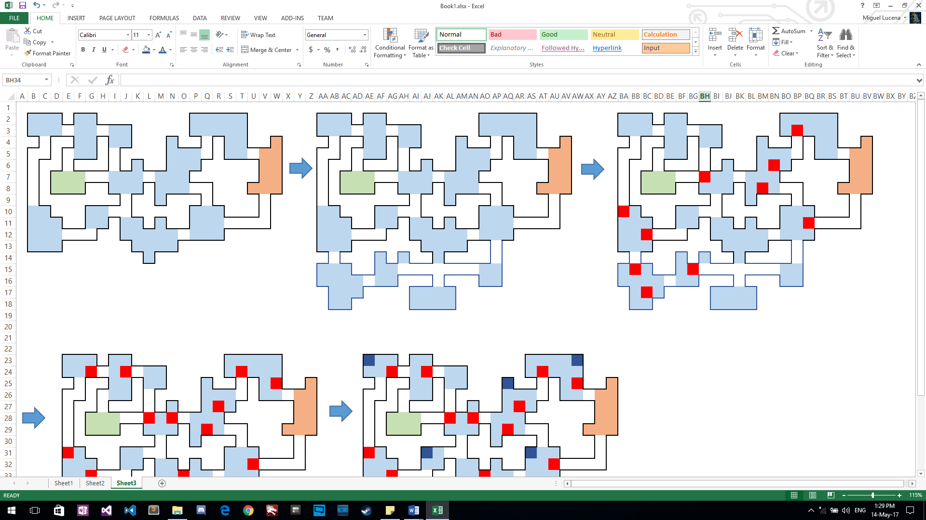The player starts the game and chooses his class, **Hot Guy** (Higher calmness). The game starts the generation of the base map, the green room it’s the player start position and the orange room is the goal room.

After this base map is generated, we roll to check how many extra rooms we add, because we have higher calmness the number is going to be between 2 and 5

*Img#1 Initial Map*

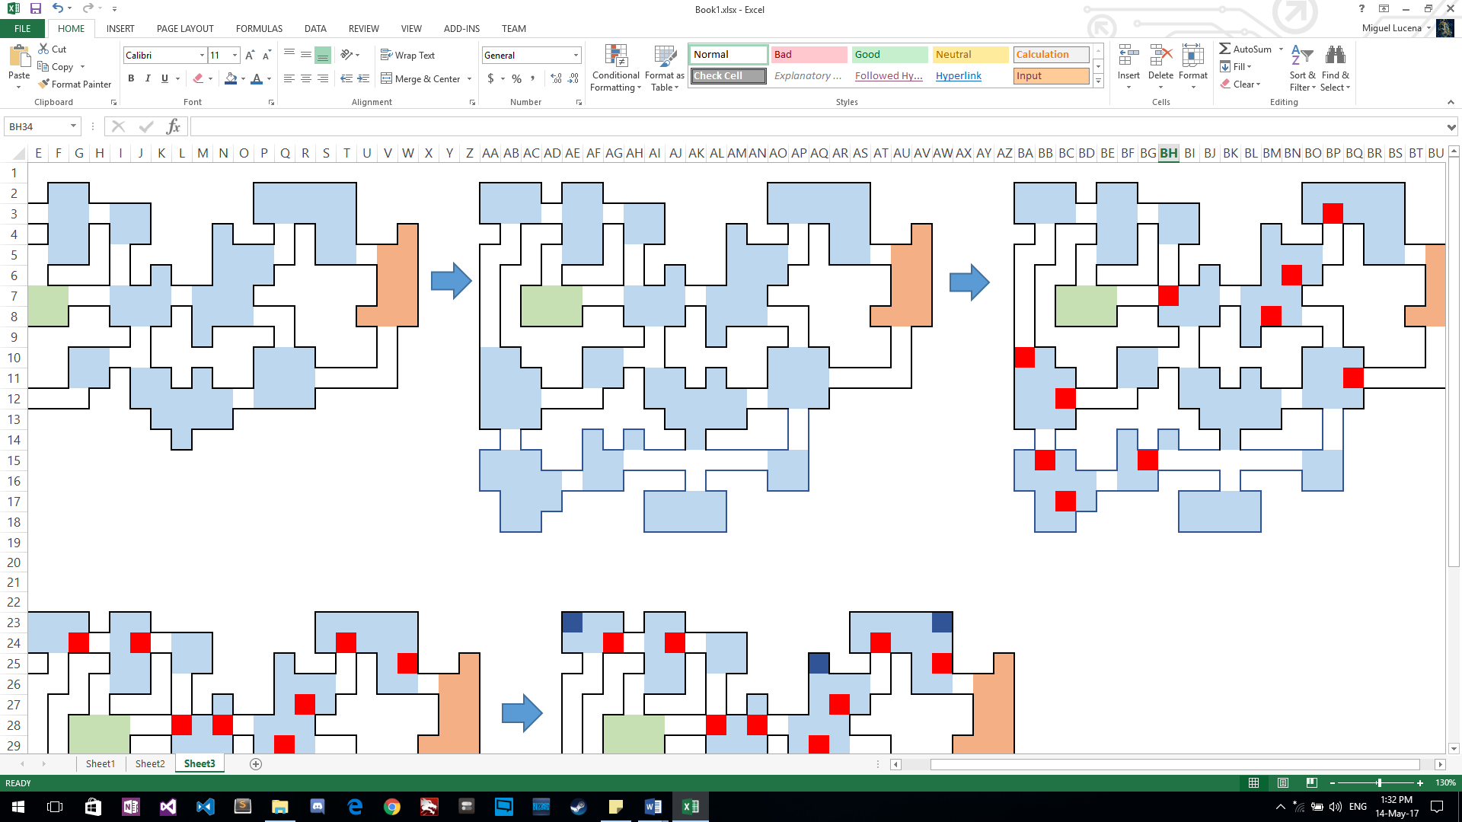

When the extra rooms are added, we proceed to add the traps with a bare minimum of 10 with some extra, and after that because the player have a high calmness stat we roll between 7 – 9 extra traps to place on rooms(Black square noise traps – Red Square Immobilization traps).

And when that is complete we add some collectibles and place enemies equal to the shortest distance between start location of the player and the goal room times 2 to finish the level

*Img#2 Initial Map with extra rooms*

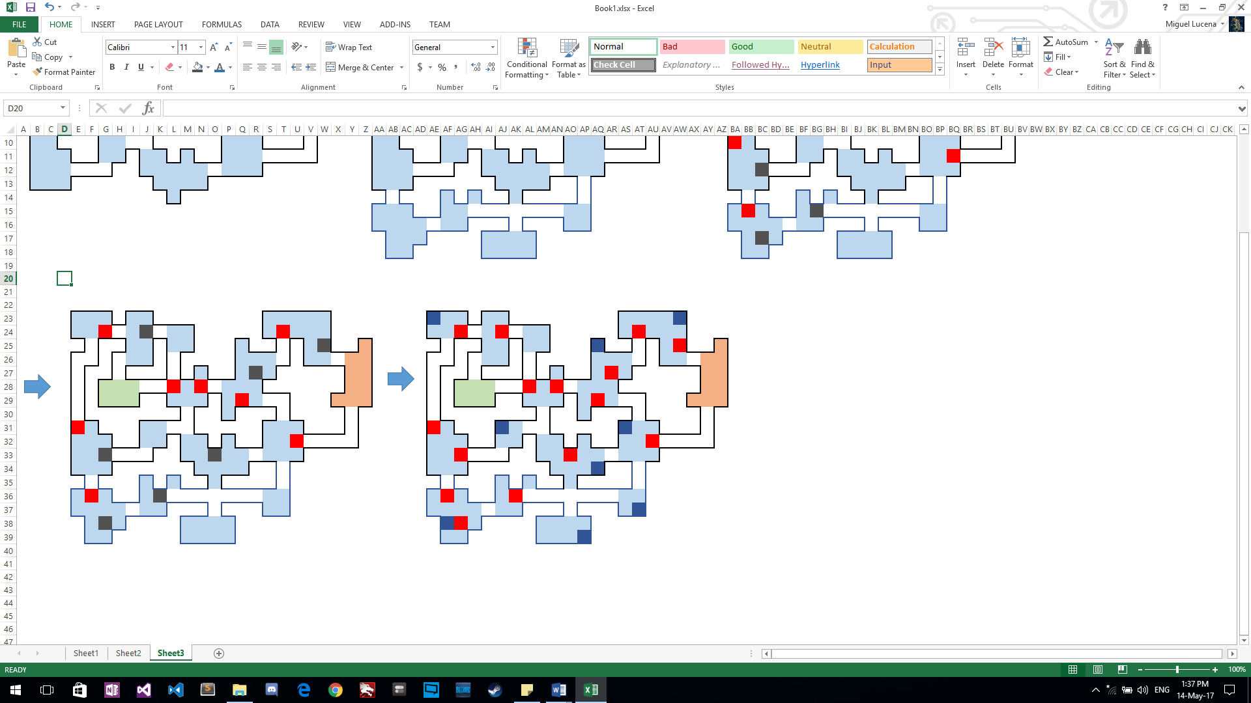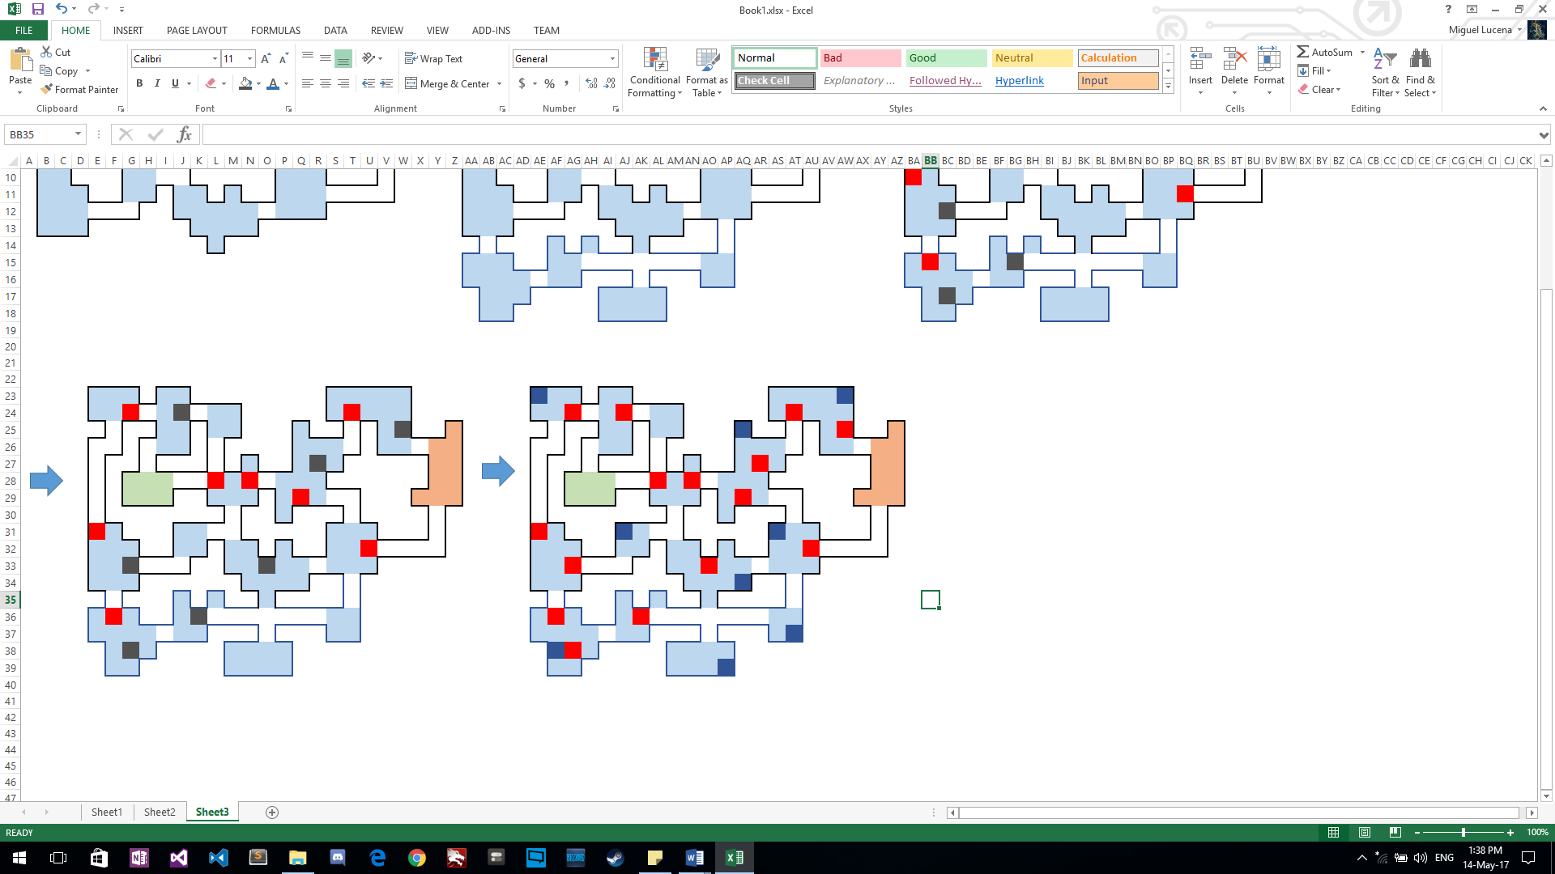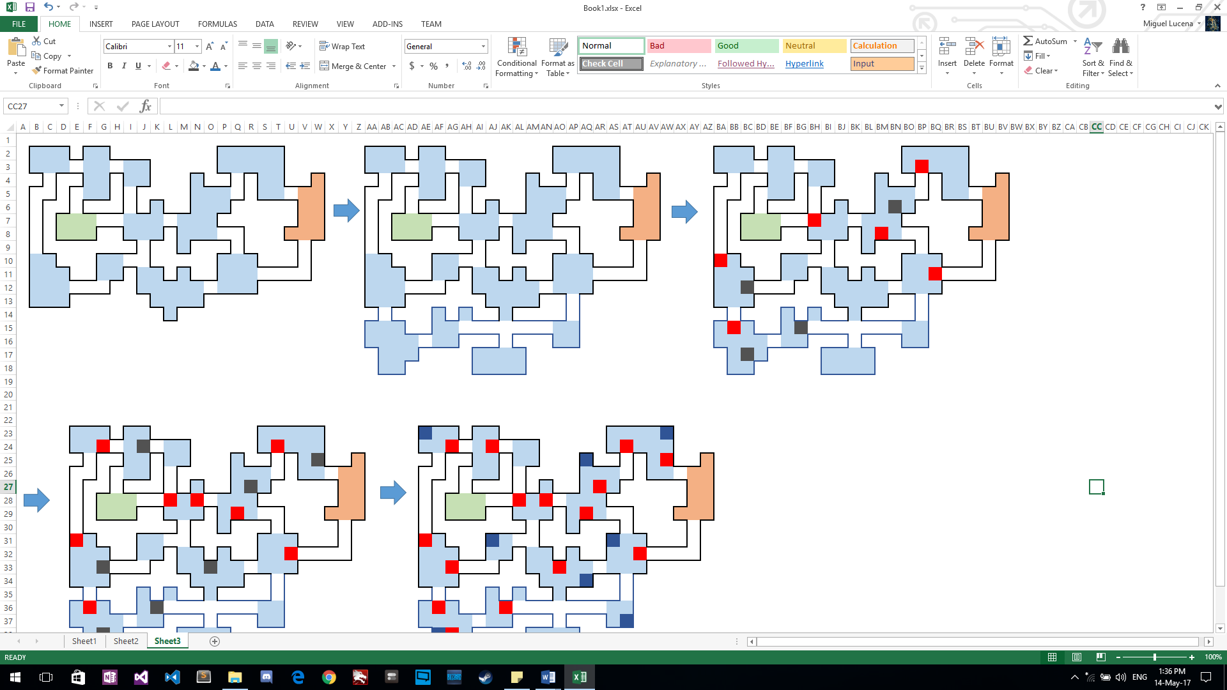

*Img#3 Trap location*

*Img#5 Collectibles*

*Img#4 More Traps!*

## **Target Audience**

The game will be well receive on fans of the game The Binding of Isaac with the procedural generated levels and enemies with focus on exploring room, but Dred State will strongly focus on avoiding combat using stealth mechanics to reach the destination much like Alien Isolation where the mouse-cat game against the Xenomorph is one of the key aspects of the game, and Dread State will emulate that feeling of being prey on by placing multiple enemies with different behaviors that changes over time.