# **The Hunted Survivor**

## **High - Concept**

The Hunted Survive is online sandbox survival third/first person shooting game setting in a world that alien starting to seize a planet which the world and all the elements created by procedural generator. Player will have to survive from alien and other players too.

## **Mechanics**

Player have 3 stats that need to maintain health in order to survive in the game:

* **Food** – is the energy stat of the player, it represents in the game as a player’s hunger. Hunger will decrease when player using their energy and player will need to eat foods which they can get foods from several ways such as cooking meat, eating fruit, or stealing from other players.
* **Water** – is the hydration stat of the player, it represents in the game as player’s thirst. Thirst will decrease similar to hunger but for increasing it player have to consume water at the lake, river or water well
* **Toxication** - is the toxic stat in player’s body this can be caused by radiation in some places or eating raw meats. Player will lose health over time depend on how much toxic the player have in their body, and it can be prevented by wearing a special equipment or mask.

At the beginning of the game, player will spawn randomly to some field in a world but it will never spawn in the city. Then, player will have to survive in the world by using following elements:

* **Location** – in every location in a game, it will have different elements, obstacles, and benefits. Player can create their own strategy depend on the location they wanted to go or settle their base.
* **Crafting** – allows player to craft items such as tools, weapons, equipment, armors, and construction items.
* **Base** – player can build their own shelters or bases by using construction items for building a blocks to become a base based on the sandbox system.
* **Clan** – player can choose to play solo or team, and clan system allow player to team up with other players and they can build their large base.

The enemies of the player are other player and the alien’s army which is the main obstacles for player. The alien’s army has high technology weapons and equipment that player must be careful and trying to destroy them and player can get a special materials for crafting special items from alien’s base.

## **Dynamics**

The world is generated by procedural generated with random seeds number between 10,000,000 and 16,000,000 with a world of size 4000 by 4000, random amount of each places from 1 to 10. World generated from an array board of seeds there will be 16,000,000 blocks

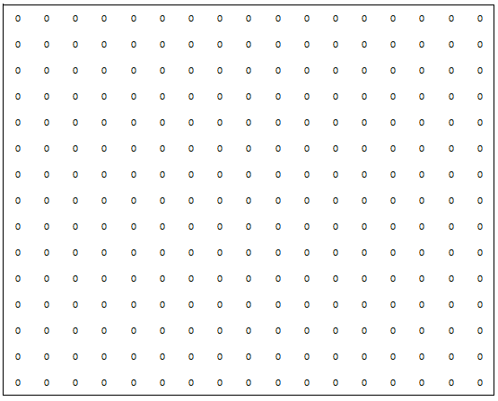Example

Then the generator will random number of 0 in certain amount then if it reach the end of that then it will random number from 1 to 9 and its will generates an area for that place, which this will loop this until it reached the max amount of each places that random before.

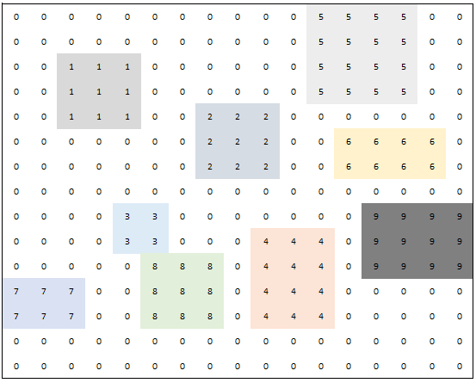

The random result from the seeds between 10,000,000 and 16,000,000 will uses that number and subtract with 16,000,000, then we use subtracted result to represents amount of the blocks that will contains places.

The aliens will randomly spawn in every places except grass fields or lakes. Alien’s bosses will spawn in alien’s bases only and if it get killed it will respawn 2 hours after it died. Each places will have different amount of aliens and bosses depend on the size of the place. It can be calculated by amount of a blocks. For the spawn items, each place will have their set of items spawn randomly in its area such as alien’s base will spawn special items, village will spawn tools items, forest will spawn fruits and animal and etc.

Challenge Quests is one of the dynamic features of the game that is randomly generated depend on how large player’s bases and how big is the clan. The quest could be killing some aliens, collecting items or crafting something.

## **Gameplay Example**

When player joined a server, player will spawned randomly in the world but will not near to the city or alien bases, and then player will have a tutorial in the way of tips popup to the screen which will show player how to do stuffs such as open inventory, collecting item, movements, eating food and crafting item. After player finished tutorial, player can decide what to do next. Generally, survival sandbox type of game player usually go farming (cutting trees or collecting craft materials) for building shelter, and player will go hunting animals after that for foods. Then, player will have larger base or multiple bases or maybe go or get destroyed other player bases. Alien’s bases is like a dungeon from MMORPG game that player can loot a special items after killed bosses.

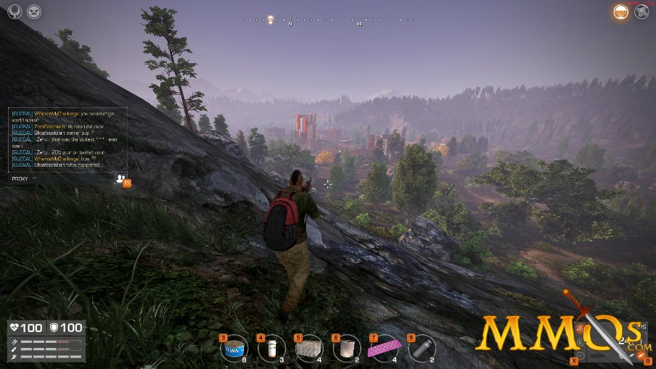Art Mockup:

## **Target Audience**

The Hunted Survive will focus players who like to play sandbox, survival and shooting game, and ages more than 13. The game is time consuming but it creates a community because it is multiplayer and it has a clan system that created socialize of the game.