Summary post
by Todd Edge - Saturday, 25 January 2025, 2:55 PM
Number of replies: 0
After reflecting on feedback, the below improvements have been proposed to amend Fortino et al.’s (2015) highest-level metamodel. These amendments seek to address an area of Fortino et al.’s (2015) metamodel that the researchers acknowledge as being in need of development: security. The proposed suggestions focus on two important areas of IoT security: digital forensics and access control.

IoT forensic metamodels aid digital forensic investigations that are integral to bringing cybercriminals to justice (Saleh et al., 2023). Among various recommendations for simplifying how the coordination of this is achieved across the complex layers of IoT device functionality, Scheidt (2020, as cited in Saleh et al., 2023: 523) identifies the need for a globally unique identifier that will make each individual IoT devices will be identifiable. The development of such a feature would make for improved traceability of information pertaining to cyberattacks on IoT devices (Scheidt, 2020, as cited in Saleh et al., 2023: 523). Clem’s globally unique identifier number is detailed in the extended model below, under the ‘Forensics’ class.

In their review of current access control methods and existing metamodels that detail them, Kashmar et al. (2021) acknowledge the need to achieve access control interoperability between IoT devices within a reformed metamodel. In this study, it is acknowledged that such a model would need to take into account dynamic attributes such as time, location and users (Kashmar et al., 2021). The below model includes an access control class - AccessControl - that is an extension of the metamodel proposed by Kashmar et al. (2021); at this high-level of abstraction, a number of dynamic attributes are detailed so that lower level metamodels can apply the appropriate access control policies, as per Kashmar et al.’s (2021) suggestion.

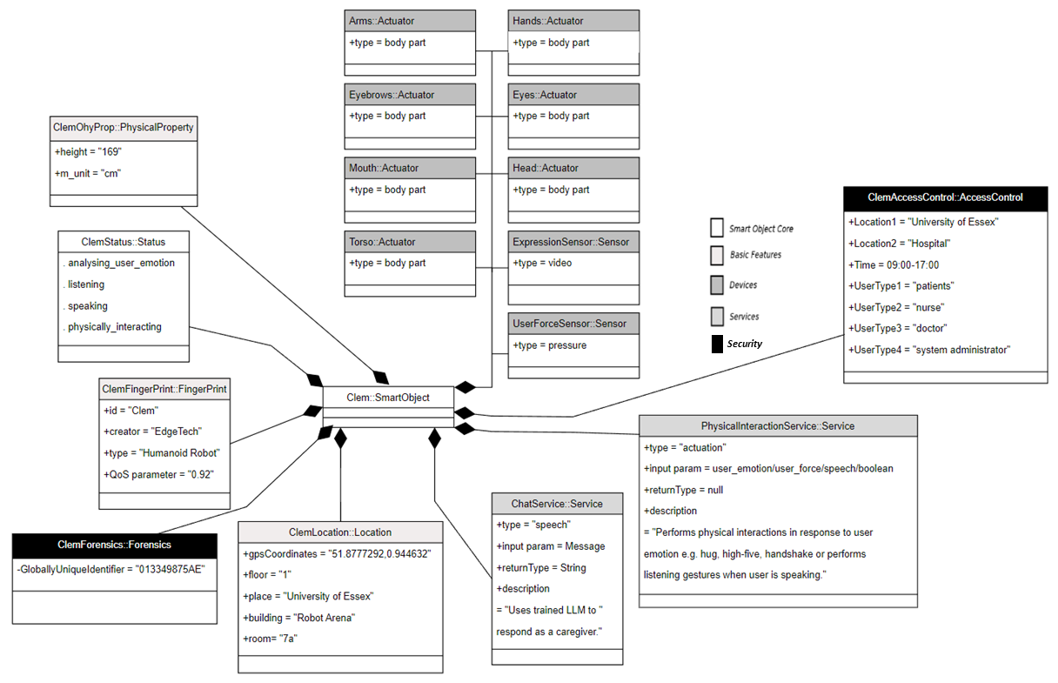

Due to the vast number of security challenges for IoT devices (Meneghello et al., 2019), the proposed metamodel requires further extension to account for planned security measures against additional dangers such as Denial of Service attacks.

References
Fortino, G., Guerrieri, A., Russo, W. & Savaglio, C. (2015). Towards a Development Methodology for Smart Object-Oriented IoT Systems: A Metamodel Approach. IEEE International Conference on Systems, Man, and Cybernetics 1297-1302. DOI: 10.1109/SMC.2015.231.

Kashmar, N., Adda, M., Atieh, M., & Ibrahim, H. (2021). A Review of Access Control Metamodels. Procedia Computer Science 184: 445–452. https://doi.org/10.1016/j.procs.2021.03.056.

Saleh, M. et al., 2023. A Metamodeling Approach for IoT Forensic Investigation. Electronics 12(3): 524-562. DOI: https://doi.org/10.3390/electronics12030524.

