Report
Evidence of logging into account and activating secure mode, using admin privileges:
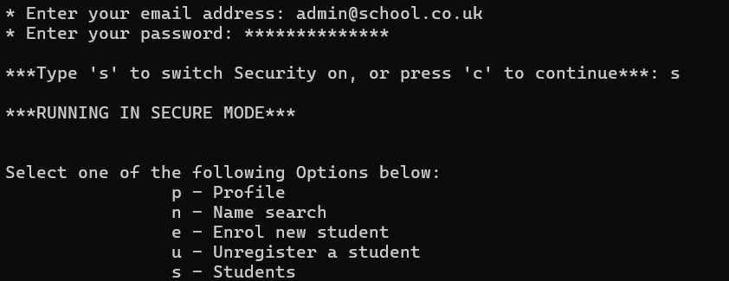

Evidence of logging onto account without admin privileges:
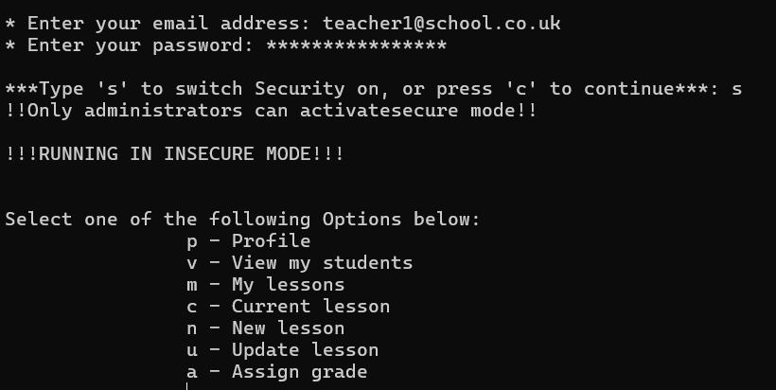

Enrolling a new student in insecure mode (security off):
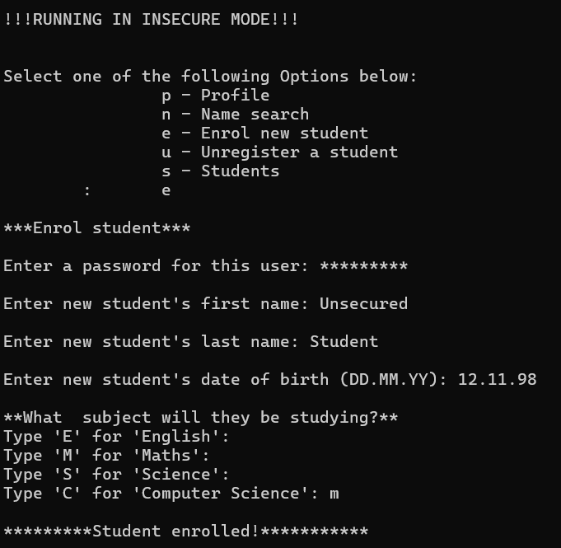

Saved student details in ‘student_list.json’ (password has not been hashed):
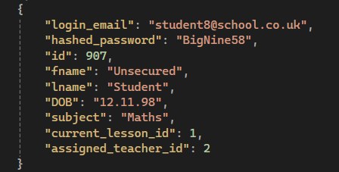

Enrolling a new student in ‘secure mode’ (security on):
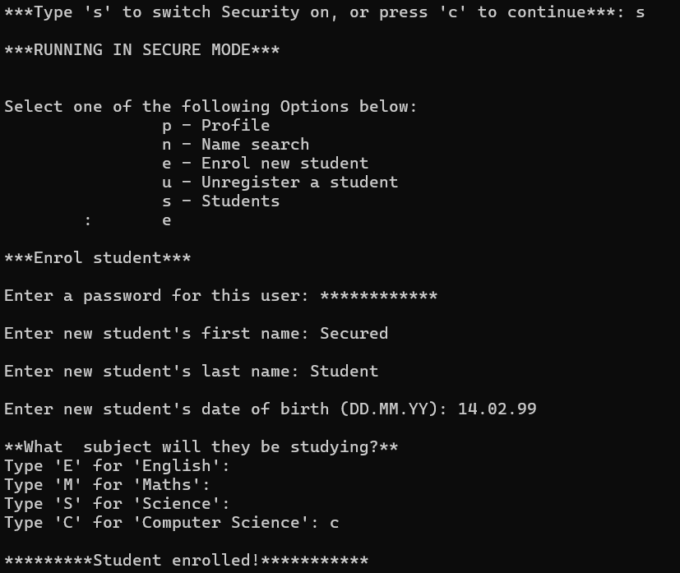

Saved student details in ‘student_list.json’ (password is has been hashed):
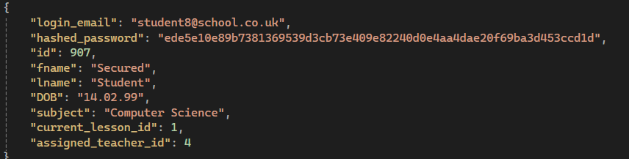

Hacker requirements
Evidence of attempted Brute Force attack:
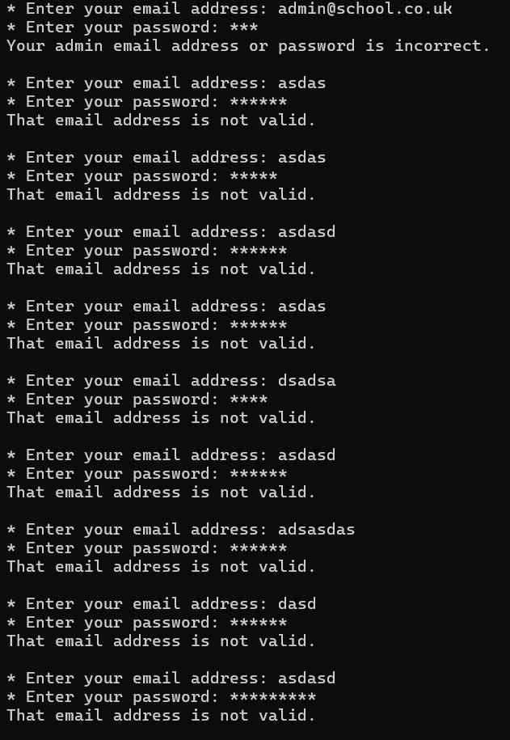

Evidence of security stopping Brute Force attack by timing out:
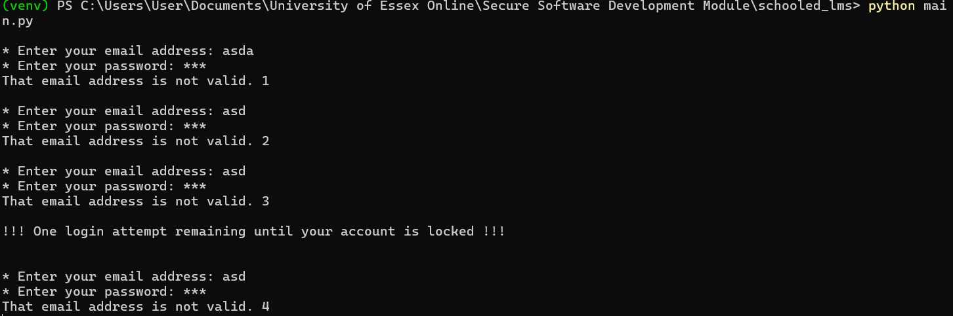

Evidence of DOS attack:
With security turned on, the sanitise_input() method reduces any characters entered over 20 characters, to just 20:
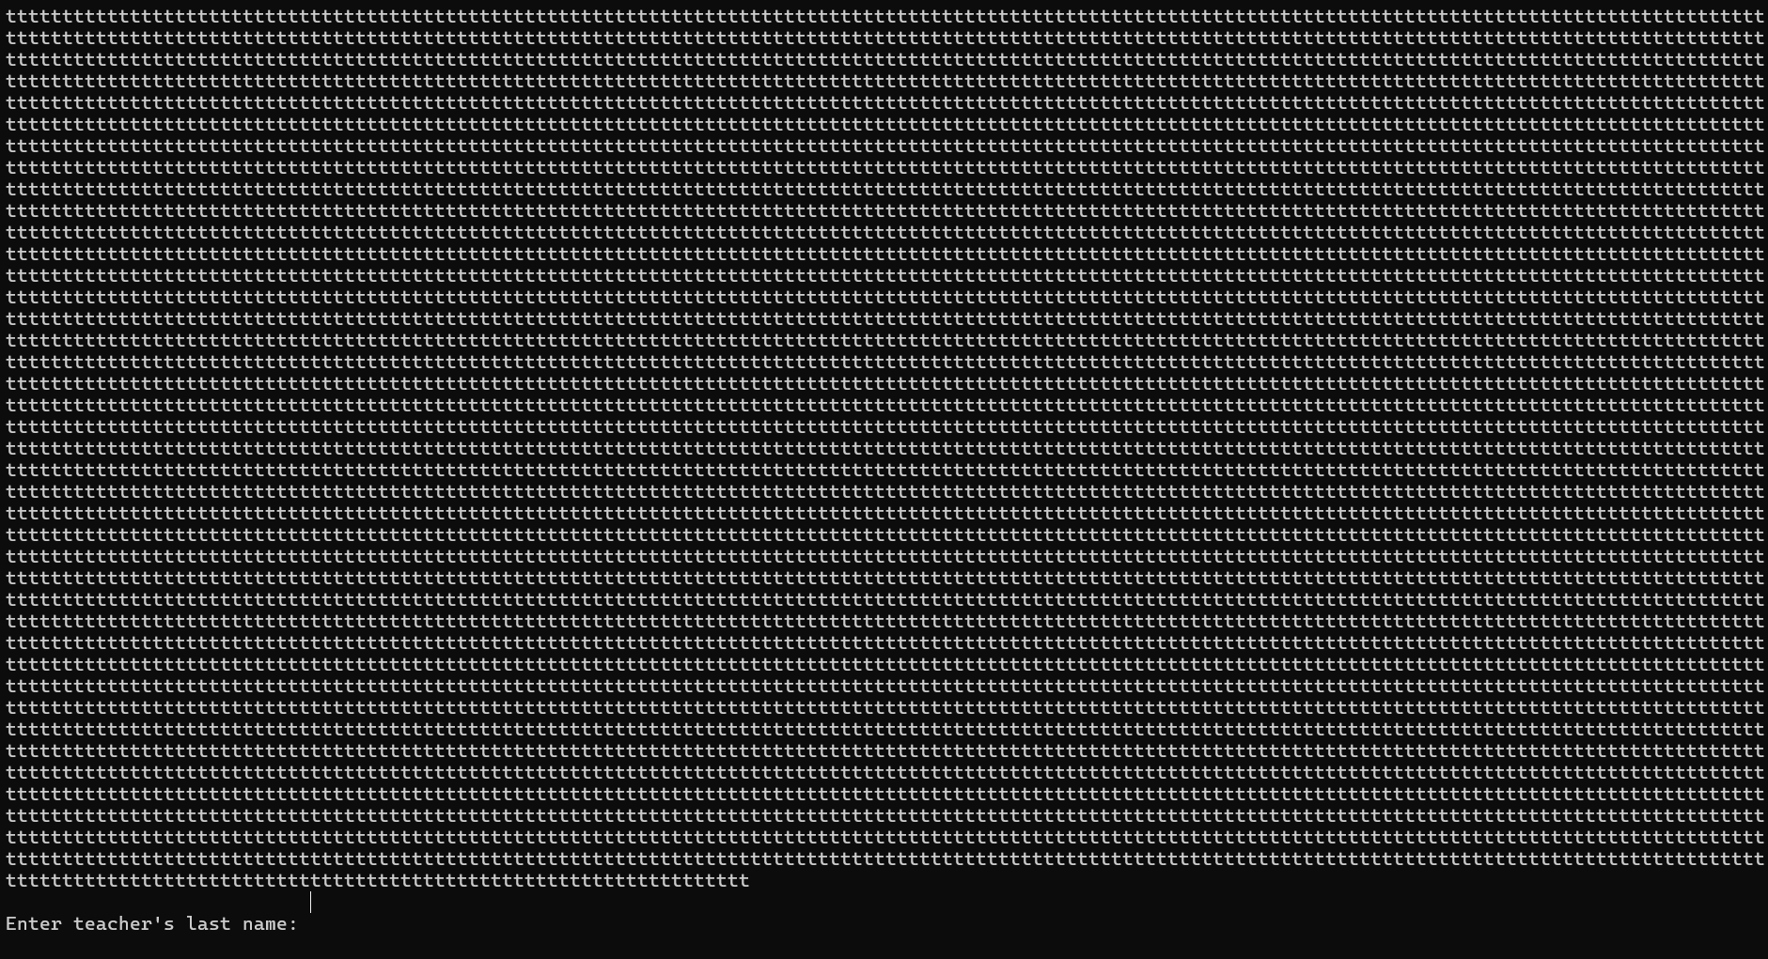

With security off, such large inputs hang the code:


Evidence of API Injection:
Without security on, any file, including a ‘.py’ file can be uploaded as homework.
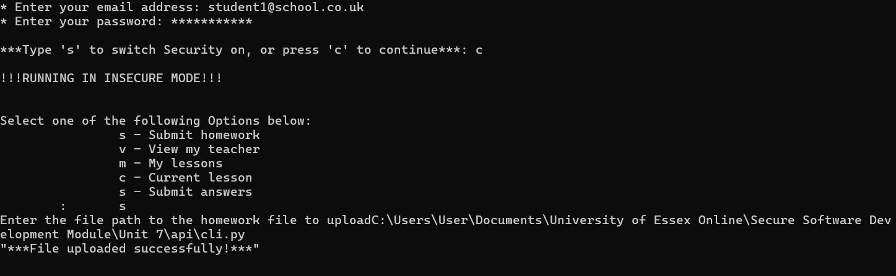

With security on, only Word files are allowed to be uploaded.
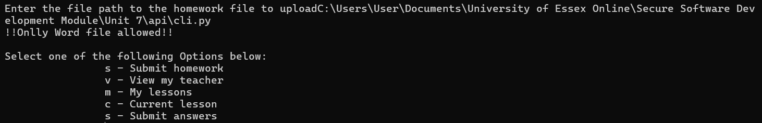
The conforms_to_max_file_size security method ensures file size is 5MB or below when security is activated.

Evidence of testing

Unit Tests:
TEST 1
Method being tested:
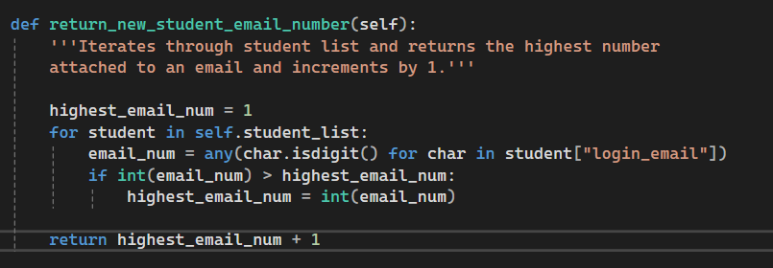
Test 1a:
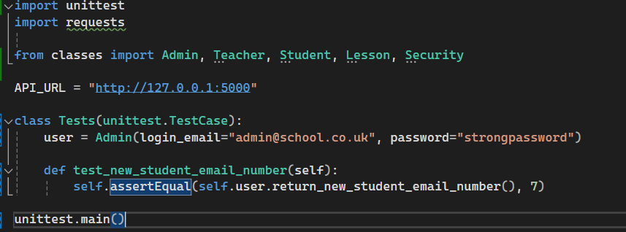
Test 1a outcome:
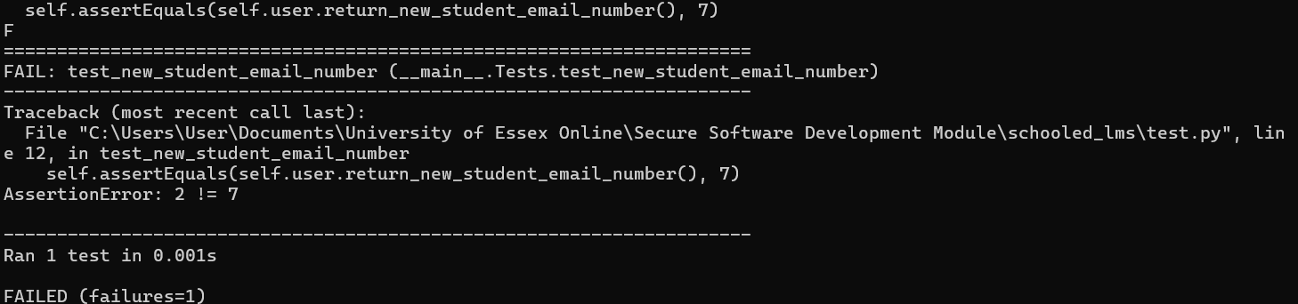

Rectification: 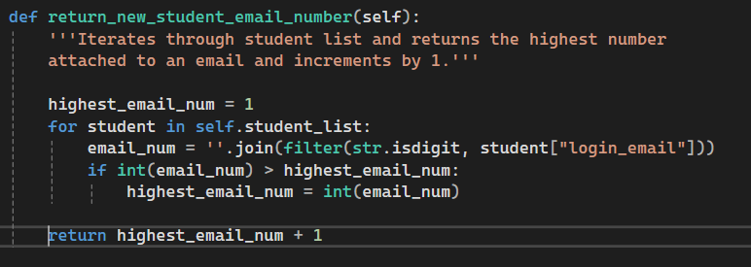
Test 1b outcome:
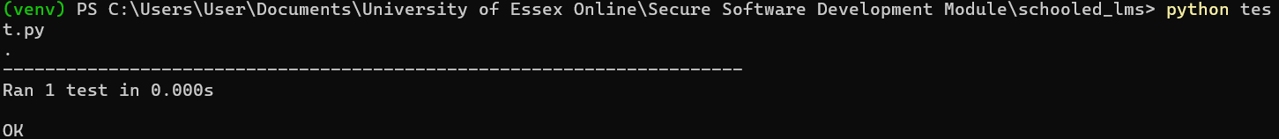

TEST 2
Method being tested:
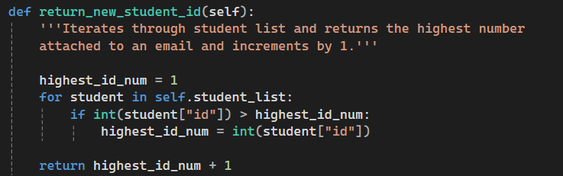

Test 2a
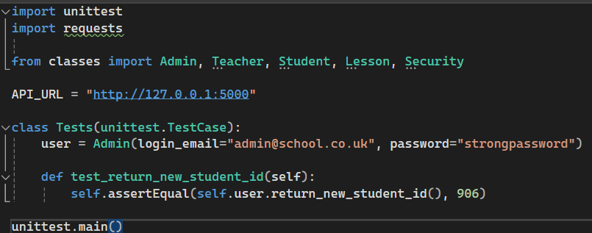
Test 2a outcome:
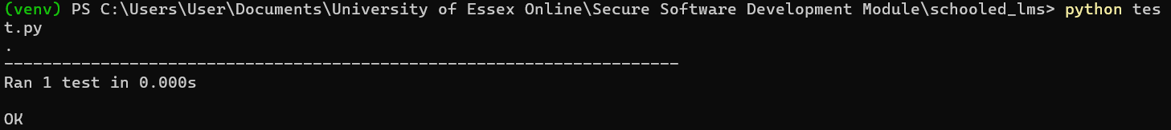

Test 3
Method being tested:
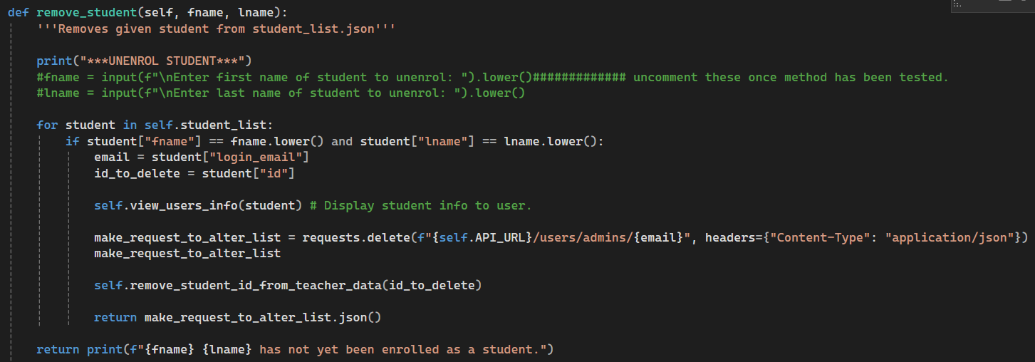

Test 3a outcome:
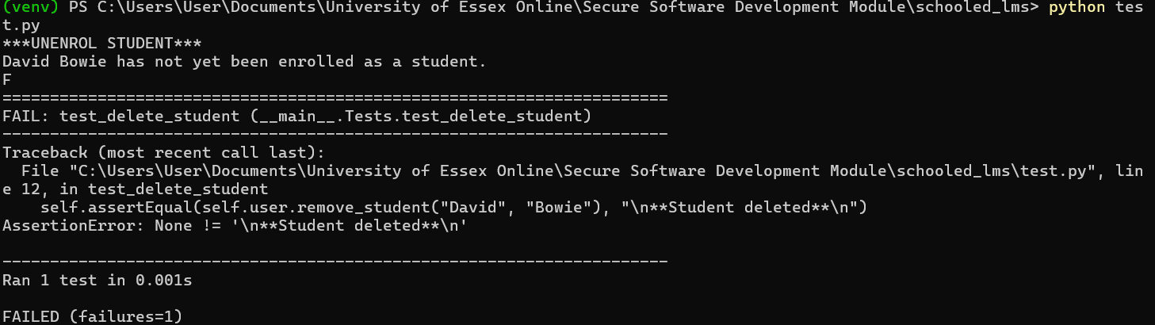

Rectification:
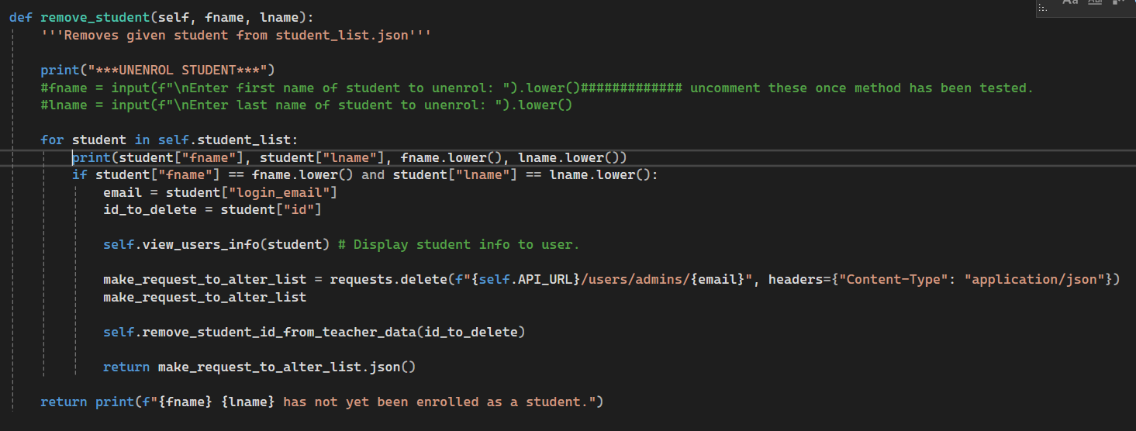

Test 3b outcome:
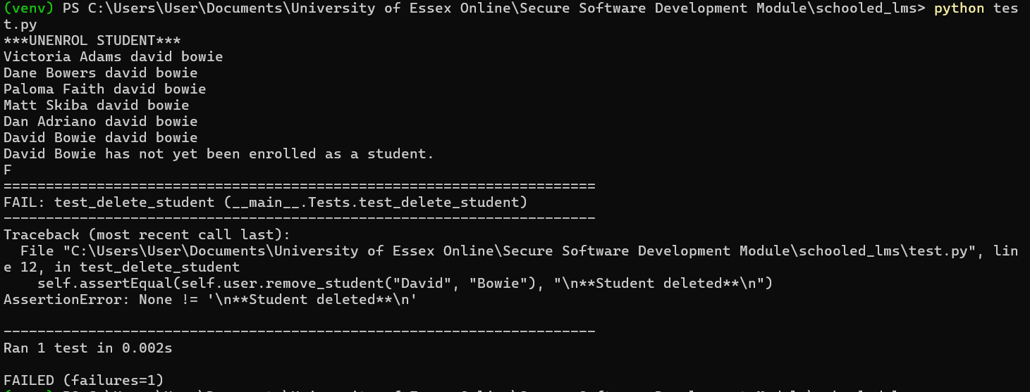

Rectification:
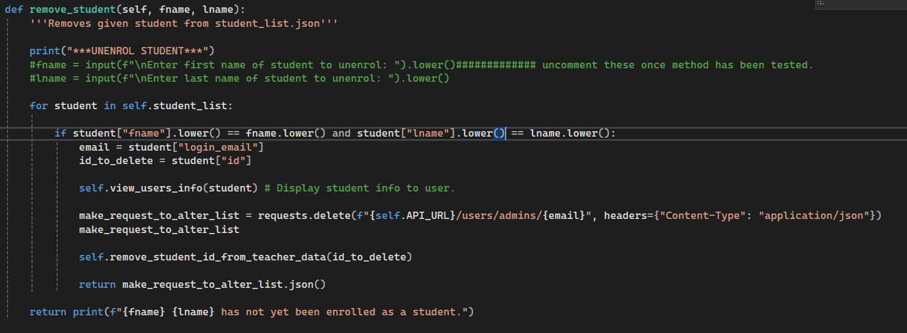

Test 3d outcome:
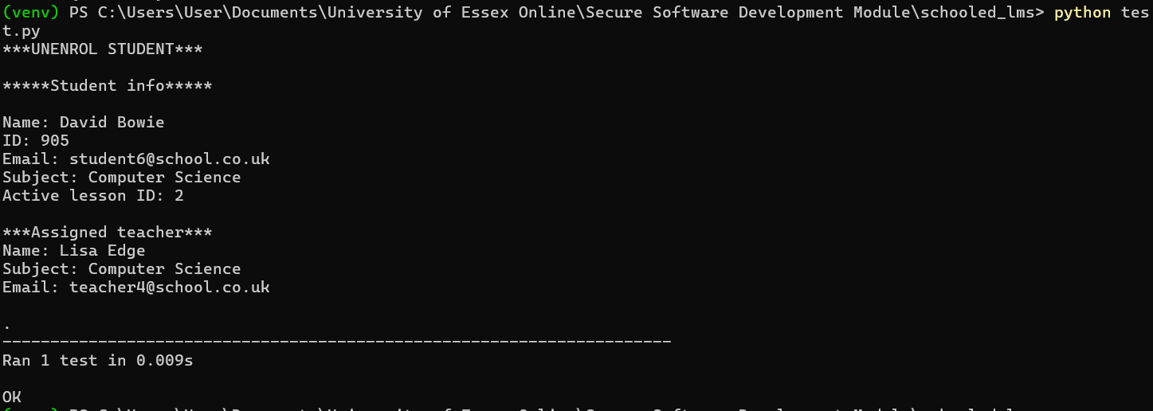

Linters
Issue:
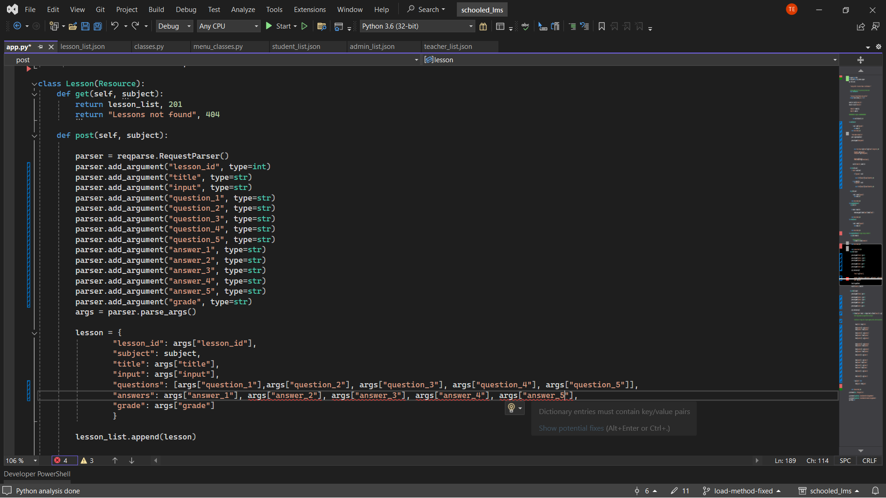

Fix:
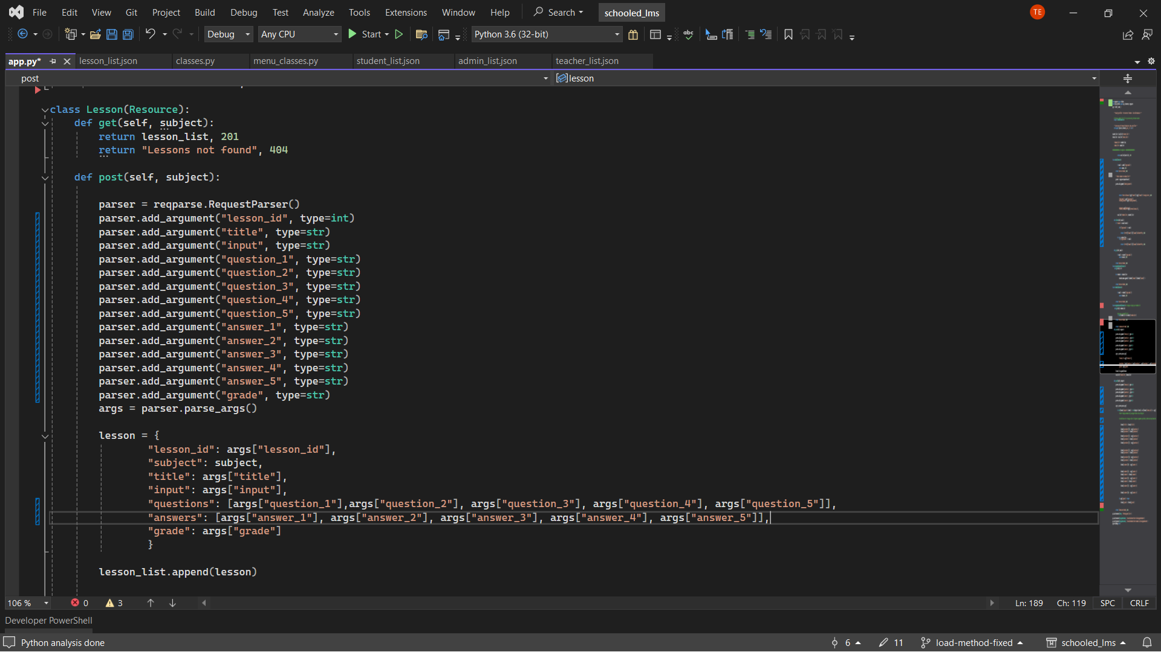

Issue:
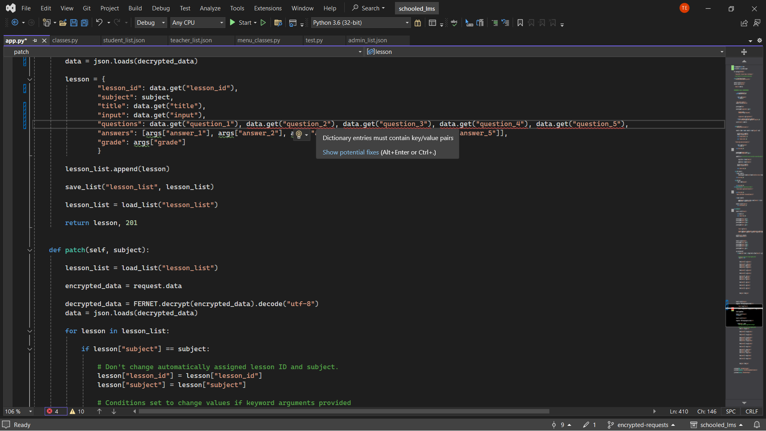

Fix:
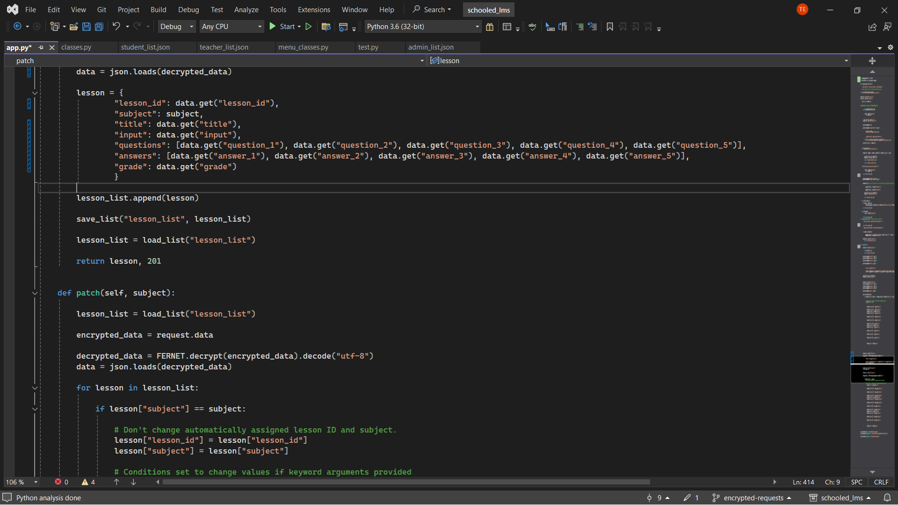

References
Code (line 1084 in main.py): Svenheim (2020) https://shorturl.at/R7zUG

