Pull The Pin: Level Design

# Table of Contents

Table of Contents

Objective

Game Overview

Victory Condition

Defeat Condition(s)

Level 1

Setup

Player Interactive Features

Other Features

Asset List

Level 2

Setup

Player Interactive Features

Other Features

Asset List

Level 3

Setup

Player Interactive Features

Other Features

Asset List

Marketing Scene

Asset List

# 

# Objective

This document will detail the gameplay and level designs of a 2D mobile “Pull the Pin” game. It will describe the “Pull the Pin” game mechanics: what they are, how they function, and what the necessary assets are for each level. It will also include additional assets required for a scene needed in a marketing simulation clip.

# Game Overview

“Pull the Pin” is a style of puzzle game where players pull pins so that the hero can collect the treasure or save the princess while overcoming enemy obstacles.

## Victory Condition

Players win the game by pulling pins in the correct order so that the hero can reach the treasure/princess safely.

## Defeat Condition(s)

Players lose the game when an Enemy or Damaging Obstacles touch the treasure, princess or hero.

# Level 1

## Setup

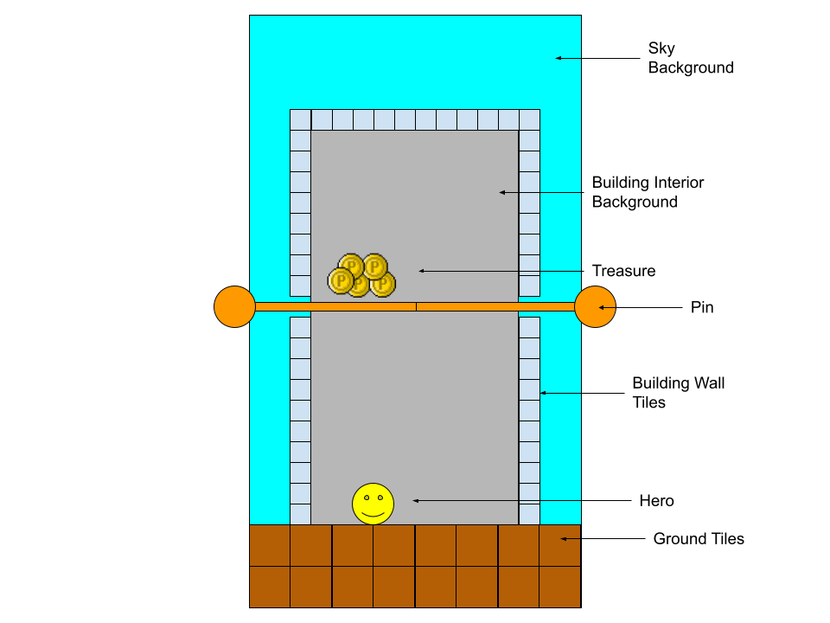

**Figure 1:** Level 1 Setup

## Player Interactive Features

These are features that the players will interact with.

### Pins

* These are interactable objects that are locked in place at the start of a level.
  + They should be easily placeable to make level editing easy for designers.
* Players can move pins by swiping them in certain directions.
  + Pins can only be moved in the direction that the head of the pin is facing at some constant speed X (designers should be able to adjust X easily).
    - In the image below, the pin’s head is outlined in red. It’s facing the right, so it can only be swiped to the right.

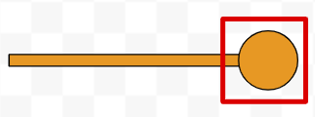

**Figure 2:** Pin Example

* + Current supported swipe directions should be “Left Swipe” and “Right Swipe;” may later need to support Up, Down, and Diagonal Swipes (TBD).

## Other Features

Players do not directly interact with these features, but they have their own functionality.

### Treasure

* This is a pile of X treasure sprites that the player wants the Hero to collect (designers should be able to adjust the number X).
  + It should be easily placeable to make level editing easy for designers.
* Treasures are physics-based objects.
  + E.g. If Treasures are on a pin, and the pin is removed from underneath, the Treasures would fall due to gravity.
* If the Hero touches a piece of Treasure, a “collection” SFX, like Mario collecting coins, will occur and the Treasure will disappear.
  + Additionally this will trigger the screen to darken slightly and a Victory Panel to appear on the screen after a delay of X seconds (designers should be able to adjust the seconds X).
* If a Treasure touches an Enemy or Damaging Obstacle, a “popping-destruction” SFX will occur and the Treasure will disappear.
  + Additionally this will trigger the screen to darken slightly and a Defeat Panel to appear on the screen after a delay of X seconds (designers should be able to adjust the seconds X).

### Hero

* This is a sprite of a hero, the game’s protagonist.
  + It is physics-based.
  + It should be easily placeable to make level editing easy for designers.
  + It needs Idle, Run, Disappointed, Die, and Celebrate animations.
    - Idle
      * Plays when the Hero is not moving.
    - Run
      * Plays when the Hero is moving.
      * If the Hero is on a similar ground level to the Treasure / Princess, and there are no Pins blocking their lines of sight, the Hero should Run towards the Treasure / Princess.
    - Disappointed
      * Plays when Princess Dies or Treasure touches an Enemy / Damaging Obstacle; animation and SFX will express disappointment.
    - Die
      * When the Hero touches an Enemy / Damaging Obstacle, he’ll do a dying animation and make a dying grunt SFX.
        + The screen will darken and a Defeat Panel will appear on the screen after a delay of X seconds (designers should be able to adjust the seconds X).
    - Celebrate
      * When the Hero finishes moving to collect all the Treasures or when the Hero touches the Princess, he’ll do a celebration animation and make a celebratory exclamation SFX.
        + The screen will darken and a Victory Panel will appear on the screen after a delay of X seconds (designers should be able to adjust the seconds X).

### Victory Panel

* A postgame panel for player navigation through the game.
  + Text
    - Top center; “VICTORY!”
  + Buttons
    - When Buttons are tapped, they play a “Button Tapped” SFX.
    - “Home” Icon
      * Bottom left; navigates to the game's main menu.
    - “Play” Icon
      * Bottom right; navigates to the next game level.

### Defeat Panel

* A postgame panel for player navigation through the game.
  + Text
    - Top center; “DEFEAT!”
  + Buttons
    - “Home” Icon
      * Bottom left; navigates to the game's main menu.
    - “Play Again” Icon
      * Bottom right; reloads the same game level.

## Asset List

This is the list of art/media assets needed to complete the Level.

### Pin

* Pin Sprite
  + Reference:

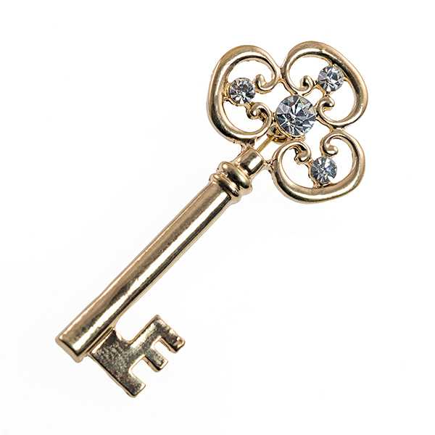

### Treasure

* Treasure sprites
  + Reference:

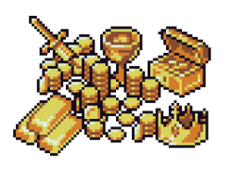

* “Collection” SFX (similar to Mario coin collection)
* “Popping-destruction” SFX

### Hero

* Hero sprite
  + Reference:

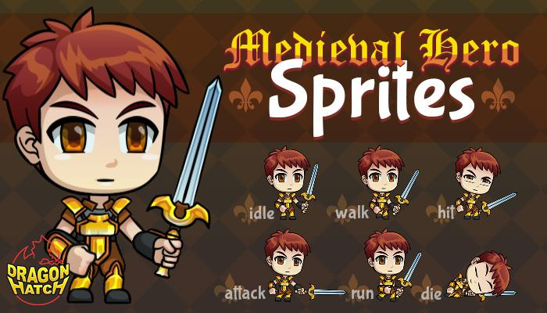

* Idle, Run, Disappointed, Die, and Celebrate Animations
* “Disappointment,” “Dying-grunt,” Exclamatory “Celebration” SFXs

### Victory Panel

* Stylized Background Panel
* Stylized Text Font
* Home, Play Icon Buttons
* “Button Tapped” SFX (generic, to be used across all buttons)

### Defeat Panel

* Stylized Background Panel
* Stylized Text Font
* Home, Replay Icon Buttons

### Environment

This is a 2D game. Need a tileset and background images to paint/create game levels.

* Backgrounds
  + Outdoor/Sky Background
  + Building Interior/Dungeon Background
* Tileset
  + Outdoor ground tiles
  + Building Interior/Dungeon
    - Platform tiles (flat & diagonals)
    - Ceiling/Walls
    - Pin slot tiles (horizontal, diagonals, vertical orientations)
* References:
  + 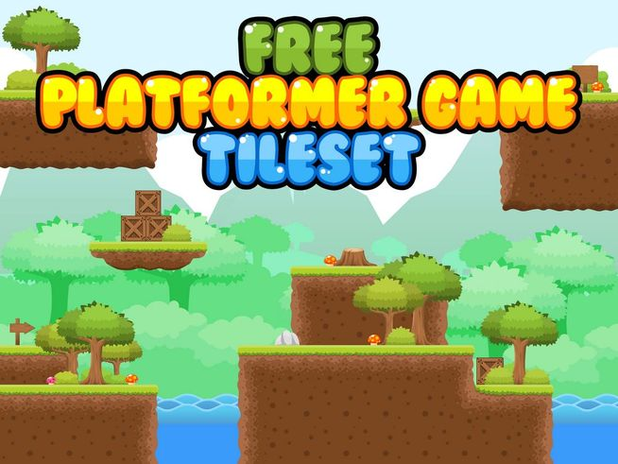
  + 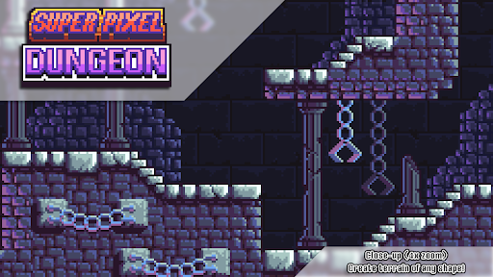
* Music
  + Will need to discuss with Music team about song style/theme that we want throughout the entirety of the game (TBD)

# Level 2

## Setup

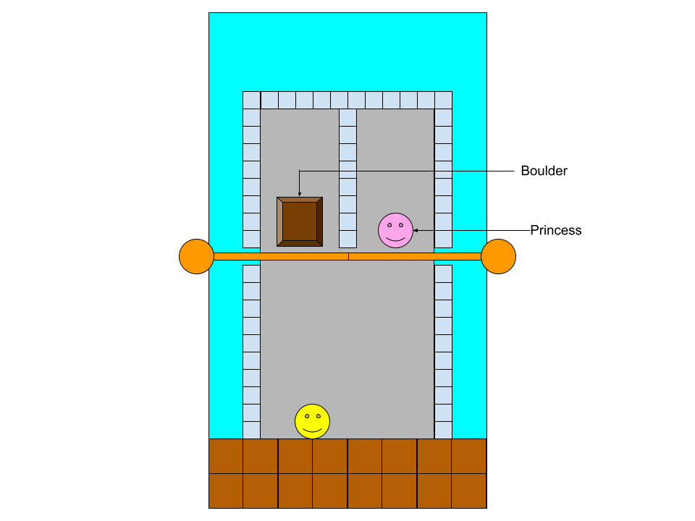

**Figure 3:** Level 2 Setup

## Player Interactive Features

### Pins

## Other Features

### Hero

### Princess

* This is a sprite of a princess, the person the Hero wants to rescue.
  + It is physics-based.
  + It should be easily placeable to make level editing easy for designers.
  + It needs Idle, Disappointed, Die and Celebrate animations
    - Idle
      * Plays when the Princess isn’t moving.
    - Disappointed
      * Plays when the Hero dies or Treasure touches an Enemy / Damaging Obstacle, animation will express disappointment.
    - Die
      * If the Princess touches an Enemy or Damaging Obstacles, she does a dying animation and a “sadness” SFX.
        + The screen will darken and a Defeat Panel will appear on the screen after a delay of X seconds (designers should be able to adjust the seconds X).
    - Celebrate
      * When the Hero touches the Princess, she’ll do a celebration animation.
        + The screen will darken and a Victory Panel will appear on the screen after a delay of X seconds (designers should be able to adjust the seconds X).

### Boulder

* This is a boulder sprite that is a Damaging Obstacle.
  + It is physics based.
  + It should be easily placeable to make future level editing efficient.
  + If it touches the Hero or the Princess
    - The screen will darken and a Defeat Panel will appear on the screen after a delay of X seconds (designers should be able to adjust the seconds X).

## Asset List

### Pin

### Hero

### Princess

* Princess sprite
* Idle, Disappointed, Die, and Celebrate Animations
* “Dying” sadness SFX
* Reference:
  + 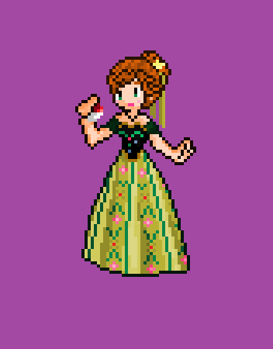

### Boulder

* Boulder Sprite
* Reference:
  + 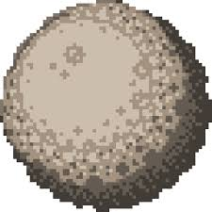

### Victory Panel

### Defeat Panel

### Environment

# Level 3

## Setup

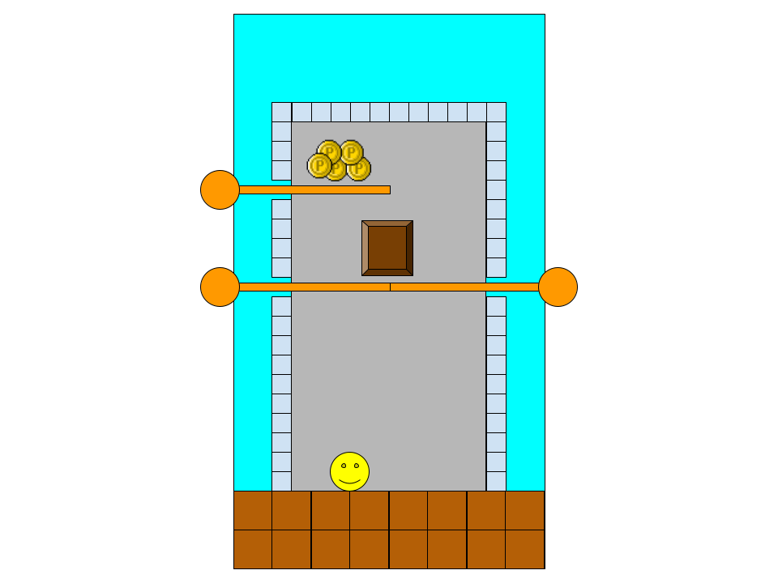

**Figure 4:** Level 3 Setup

## Player Interactive Features

### Pins

## Other Features

### Hero

### Treasure

### Boulder

## Asset List

### Pin

### Hero

### Treasure

### Boulder

### Victory Panel

### Defeat Panel

### Environment

# Marketing Scene

This is a scene to help with marketing the game. This scene will display at the end of a game simulation clip. It will show the game's name along with a stylized background and an App Store icon for where to get the game in a centered, vertical alignment.

## Asset List

### Game Title, “Play Now” Button Icon, App Store Icon

* These components will appear on screen in a bold animated manner (animations TBD after consulting with marketing and art team)

### Stylized Game Background

* This will need further discussion with marketing and artists.