**Final Test**

1. **Choose the present simple or the present continuous. Watch out for stative verbs:**

1. Julie is reading in the garden.

2. What are we having for dinner tonight?

3. She has two daughters.

4. I am stay in Spain for two weeks this summer.

5. He often comes over for dinner.

6. The class begins at nine every day.

7. What are you eating at the moment?

8. What is Susie doing tomorrow?

9. I do not work on Sundays.

10. She is not studying now, she is watching TV.

11. How often do you go to restaurants?

12. I am not going on holiday this summer.

13. I'm sorry, I do not understand.

14. She is working as a waitress for a month.

15. She takes a salsa dancing class every Tuesday.

16. It is cold here in winter.

17. Take your umbrella, it is raining.

18. This cake tastes delicious.

19. The bag belongs to Jack.

20. When are you arriving tonight?

1. **Choose the past simple or past continuous:**

1. He was sleeping when the doorbell rang.

2. We were eating dinner at 8pm last night (we started eating at 7:30).

3. Yesterday I went to the post office, bought

some fruit at the supermarket and read a book in the park in

the afternoon.

4. We were watching TV when we heard a loud

noise.

5. Julie was in the garden when Laurence arrived.

6. A: What were you doing at 3pm yesterday?

B: I was cleaning my house.

7. Last year I visited Paris and Rome.

8. They were having dinner when the police came to the door.

9. He was working in the garden when he found

the money.

10. Laura was studying at 11pm last night.

11. I was walking along the road when I met an

old friend.

12. It was a day in December. Snow was falling,

children were singing carols and people were doing

their Christmas shopping.

13. My ex-boyfriend was so annoying! He was always missing the bus and arriving late.

14. When I called Julie, she was working.

15. Why were you crying when I arrived?

16. When he got home, we started to eat dinner.

17. At 10am yesterday I was sitting on a bus.

18. I was enjoying my book so much that I did not notice the train had stopped.

19. David was not sleeping when I arrived, he was studying!

20. Mr Black was not working in the garden at 10pm last night.

1. **Make the past simple, positive, negative or question:**

1. I did not drink any beer last night.

2. She got on the bus in the centre of the city.

3. What time did he get up yesterday?

4. Where did you get off the train?

5. I did not change trains at Victoria.

6. We woke up very late.

7. What did he give his mother for Christmas?

8. I received £300 when my uncle died.

9. We did not use the computer last night.

10. Did she make good coffee?

11. They lived in Paris.

12. She read the newspaper yesterday.

13. I did not watch TV.

14. He did not study for the exam.

15. Did he call you?

16. Did I forget something?

17. What time did the film start?

18. He had a shower.

19. Why did you come?

20. Did he go to the party?

1. **Read the text and answer the questions**

g

K

1. Where are Nokia and Acer already competing? both sell smartphones
2. How much will the Sakshat cost? 20 dollars
3. How will users access the Gdrive? through the Internet
4. What is the total VoIP market share for international voice? 31%
5. How long has it taken Apple to generate one billion downloads? nine months
6. For how many months in row has Alcatel-Lucent made a loss? 24 months
7. **Match the words from columns A and B to make pairs.**

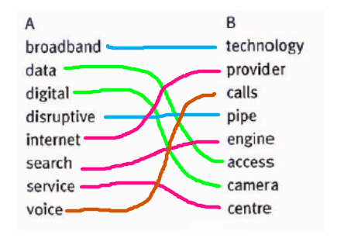

1. **Complete the sentences with words pairs from task V**

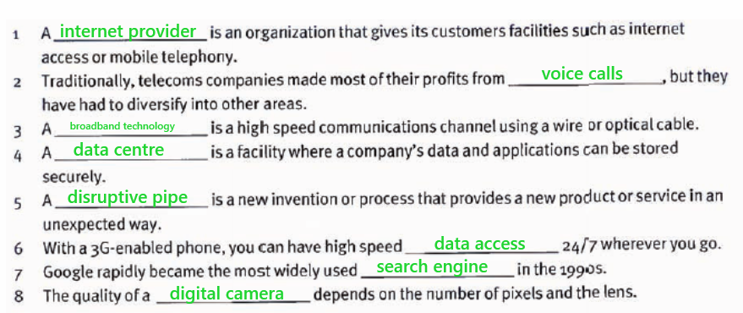

1. **Read the article and answer the questions.**



