Teds Tremendous Data Generator
V1.0.0

The Free, Graphical, Cross-Platform,
Arbitrary Data Generator for Developers and Benchmarkers

User Manual : v1.0.0 (Dec 2017)
Copyright (c) 2017 Ted Smith
All rights reserved

1.0 Pre-amble

This manual is designed as a user-aid only. It is not an authority on the subject matter of data generation, randomness, disk I\O or anything else. The software comes without any warranty. Use it at your own risk. There are many free and commercial data generation tools available.

Constructive feedback is encouraged and welcomed but complaints will not be tolerated. If the user is unhappy with the software, s/he is encouraged to use something else.

1.1 License Agreement

There are no restrictions. Users can run it on as many computers as they wish, as many times as they wish, for as long as they wish. There are no dongles, no DLL's, no installation wizards or license files – just click and go. All that is asked of the users is that they share their thoughts and help contribute ideas back to the developer (tedsmith28@yahoo.co.uk).

Supported Platforms: Tested on Microsoft Windows (7 and 10), Linux Mint 17, Apple Mac OSX (Sierra).

Teds Tremendous Data Generator is made available under the GPL license as follows.

Teds Tremendous Data Generator is free software: you can redistribute it and/or modify it under the terms of the GNU General Public License as published by the Free Software Foundation, either version 3 of the License, or (at your option) any later version.

This program is distributed in the hope that it will be useful, but WITHOUT ANY WARRANTY; without even the implied warranty of MERCHANTABILITY or FITNESS FOR A PARTICULAR PURPOSE. See the GNU General Public License for more details.

A copy of the GNU General Public License, see https://www.gnu.org/licenses/old-licenses/gpl-2.0.en.html

1.2 Acknowledgements

Teds Tremendous Data Generator is written and compiled using the Lazarus Project IDE and the Freepascal language using the Freepascal Compiler. Thanks are therefore expressed to the developers and contributors of both Lazarus and FPC, without which the tool would not have existed.

The logo is from a blog article on DataToValue.co.uk

1.3 Development Team

Lead Developer: Ted Smith
Contact: tedsmith@quickhash-gui.org
GitHub Repository https://github.com/tedsmith/TedsTremendousDataGenerator

2.0 Introduction

Teds Tremendous Data Generator is quite simply a free, open source, cross platform, fast and easy-to-use arbitrary data generation tool for Microsoft Windows, Desktop GNU/Linux distributions like Mint and Ubuntu, and Apple Mac Yosemite and above.

It does not require installation and can simply be executed from a USB drive or other removable device (though on Linux, the software has to have executable permissions assigned and the external device would require a filesystem that can store executable permissions – so EXT4 or something and not FAT32).

The interface is deliberately simple and comes as a tabbed system to enable generation of text data, or files data.

The utility came about to help with the development of QuickHash-GUI (www.quickhash-gui.org). With version 3.0.0 of that tool, I frequently needed to have sample data to test out many of the newer features. Manually creating files quickly became frustrating, so ‘Teds Tremendous Data Generator’ was born to address the need. And having created it, it seemed daft to not allow others to benefit from it.

2.1 What does it do?

Two things : it generates text and it generates files.

Text Generator : It enables you to generate lots of lines (as many as you wish) of text in one of three ways : Random strings, your own string repeated, or numbered lines. The last two are obvious so an explanation is not added here for those. A description of the random string generation is below.
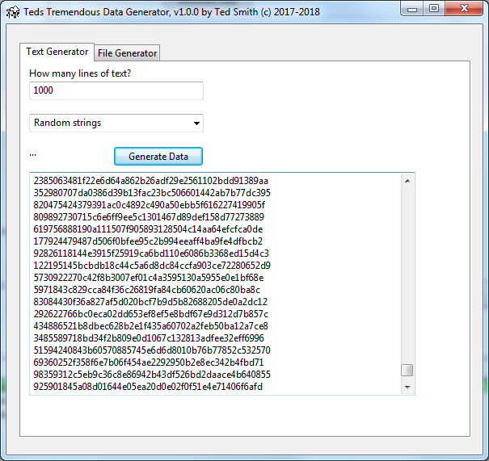
The random strings are made by an initial seeding value, followed by the selection of a random value between 1 and 100,000,000. That value is then converted to a string and SHA-1 hashed. The original string is then pre-pended to the resulting hash value and that is the generated string that is output. That is repeated for every line requested by the user. So it’s not perfectly random but it should be random enough for most.

File Generator : It enables you to generate lots of files (as many as you wish) of whatever size you specify to wherever you specify (including network paths) as either random or non-random files.

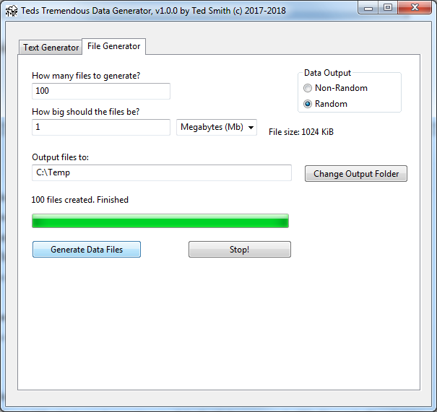
The random files are made by the creation of a memory buffer filled with a range of bytes chosen between 0 and 255 which are then written to disk. So if the user needs 1Kb files, a buffer of 1024 bytes is created, and for each of those 1024 bytes, a byte value between 0 and 255 is selected at random. This continues for files up to an including 1Mb in size, so a buffer of 1 million bytes is chosen and populated at random in the same way. For files larger than 1Mb, the 1Mb buffer is repeatedly emptied and refilled and then written to the new file, until the resulting file is the same size as that requested by the user.

The files are named by date stamp with a numeric counter (to allow for multiple files to be created within the same one second and be saved to the same location).

Caution : Be careful with this utility. If you start writing 10 million tiny 10byte files to a drive that is tired, or that has a large cluster (block) size like 32Kb or 64Kb, the program will (may) go into a state of apparent non-responsiveness while it waits for the filesystem and the operating system to catch up. It does usually continue even if it seems to have crashed. Equally, though it does allow you to write 1 million 1Tb files to your network server, you may want to avoid such acts of lunacy!

2.2 Cross Platform

The tool is cross platform so should run the same on both Windows, Linux and Apple Max OSX.

3.2 Unicode
The tool can output files to folders containing Unicode characters and text data can be generated comprising Unicode characters if the user inserts one as part of their own string. It will not generate Unicode data by default at the moment.

3.4 Donations

The data generator, like most of my tools, are created in my spare time, which is very tight with a full time job and a family.

If you value the program, or if your organisation, company or agency has found that it has helped them, then please do consider making a donation using my more regular Paypal account which https://paypal.me/QuickHash.

To donate : https://paypal.me/QuickHash


