Final Course Website Documentation

05/14/2018

9352A 4:00 – 5:00 TF

Members:

Domaoa, Jeane Cris

Ramos, Tatum Eiffel Dodge

Calines, Carla

Catayao, Roxanne

Dayrit, Aika Vien

Site Map

Member Information

**About Us**

HOME

**Github Repository**

**Quiz**

**Lecture Notes**

**Easy**

**Intermediate**

* JAVA SERVLETS
* Node.JS
* Hypertext Preprocessor
* Java Server Pages
* Critical Web Application Security Risk

**OVERVIEW OF THE TECHNOLOGIES USED IN THE PROJECT**



We used HTML to structure the elements of the website, the lecture notes, the quizzes, and the other content. We also used this technology to embed the images used in the website such as the code snippet, developers’ profile, and logos.

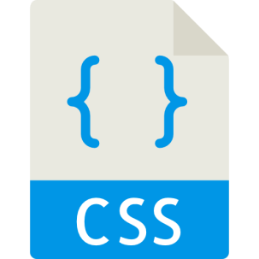

We used CSS to basically not just to beautify our website but also to give layout to it. We used Cascading Stylesheets to every website we created. We also used frameworks such as bootstrap to easily add styles in our HTML elements just by using class.



We used Javascript to add additional functionalities to our navigation bar such as adding a style to the navigation bar when the user scrolls into webpages. We also used frameworks like the bootstrap js, popper, and jquery which are dependencies for the bootstrap css to add additional functions to designs.



JSON text files were created to store the different information for the quizzes in the website, the questions and their corresponding choices and correct answer.



We used the PHP technology to administer the quizzes that are implemented on the website. It was used display the quiz items form the JSON text files to the website and it was also used to evaluate the answers of the users against the correct answer to the quiz items.

WEBSITE INTERFACE

Home Page

* Landing Screen



* Lecture Notes Section

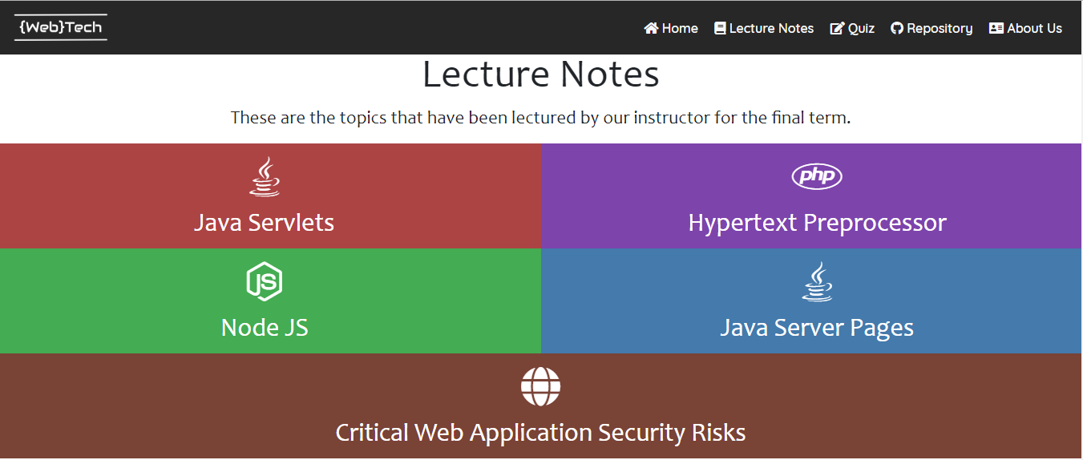

The section contains the links to the pages containing the lecture topics covered in the Finals period of the course. Clicking on the different topics will redirect you to their corresponding pages:

* Java Servlets

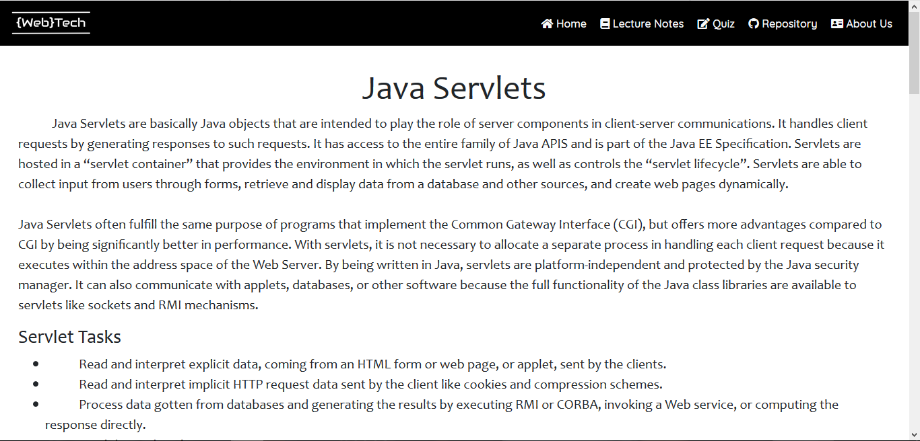

* PHP

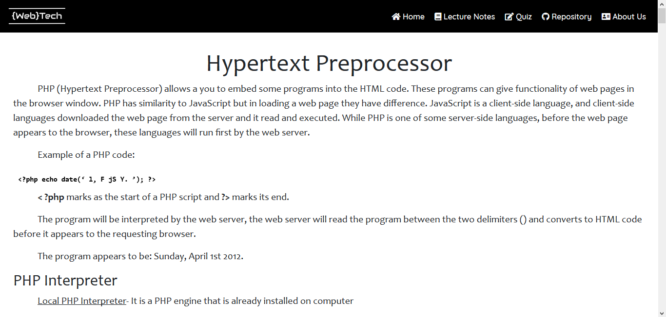

* Node JS

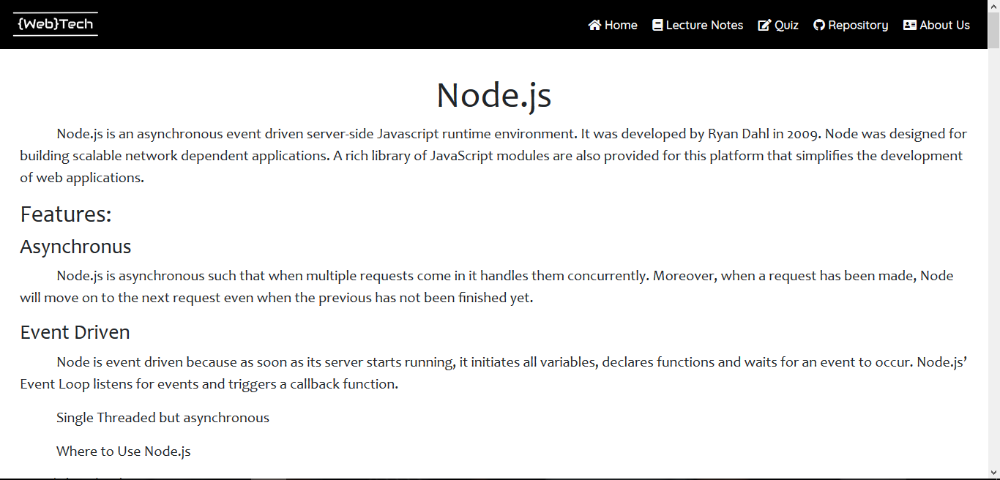

* OWASP 2017

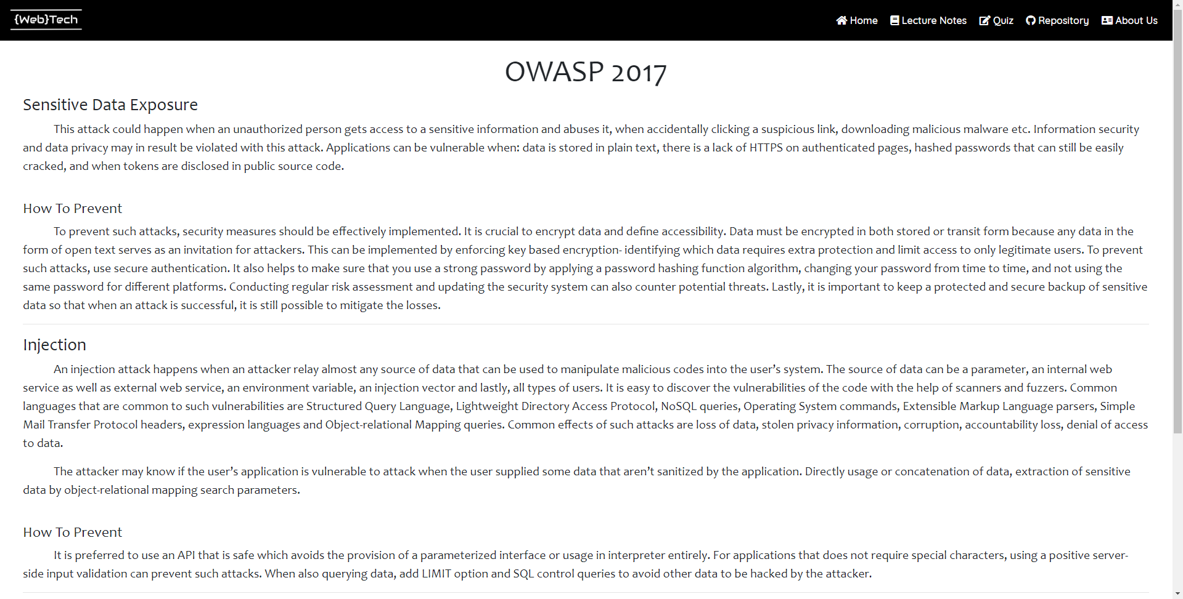

* Quizzes Section

Clicking on the buttons in the Quizzes section will redirect you to quiz administration page. The user will answer all of the questions and click on the submit button to see his/her score. A pop-up alert will appear and when the user clicks the “OK” button it will redirect him/her to the landing page.



* Basic Level Quiz

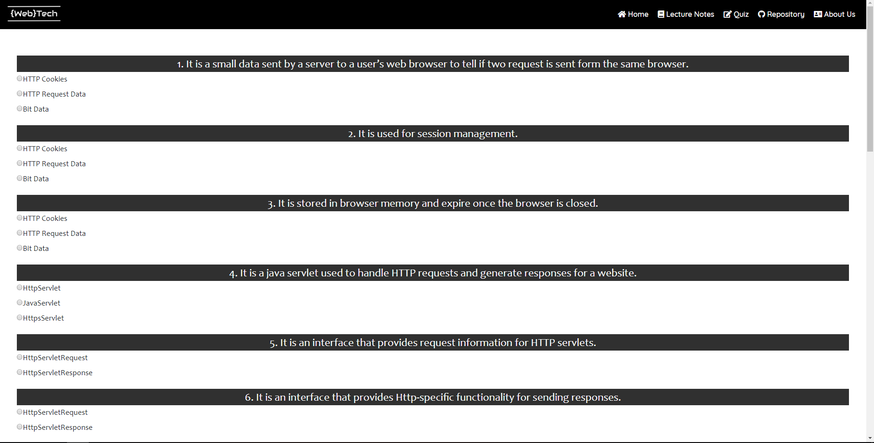

* Advance Level Quiz

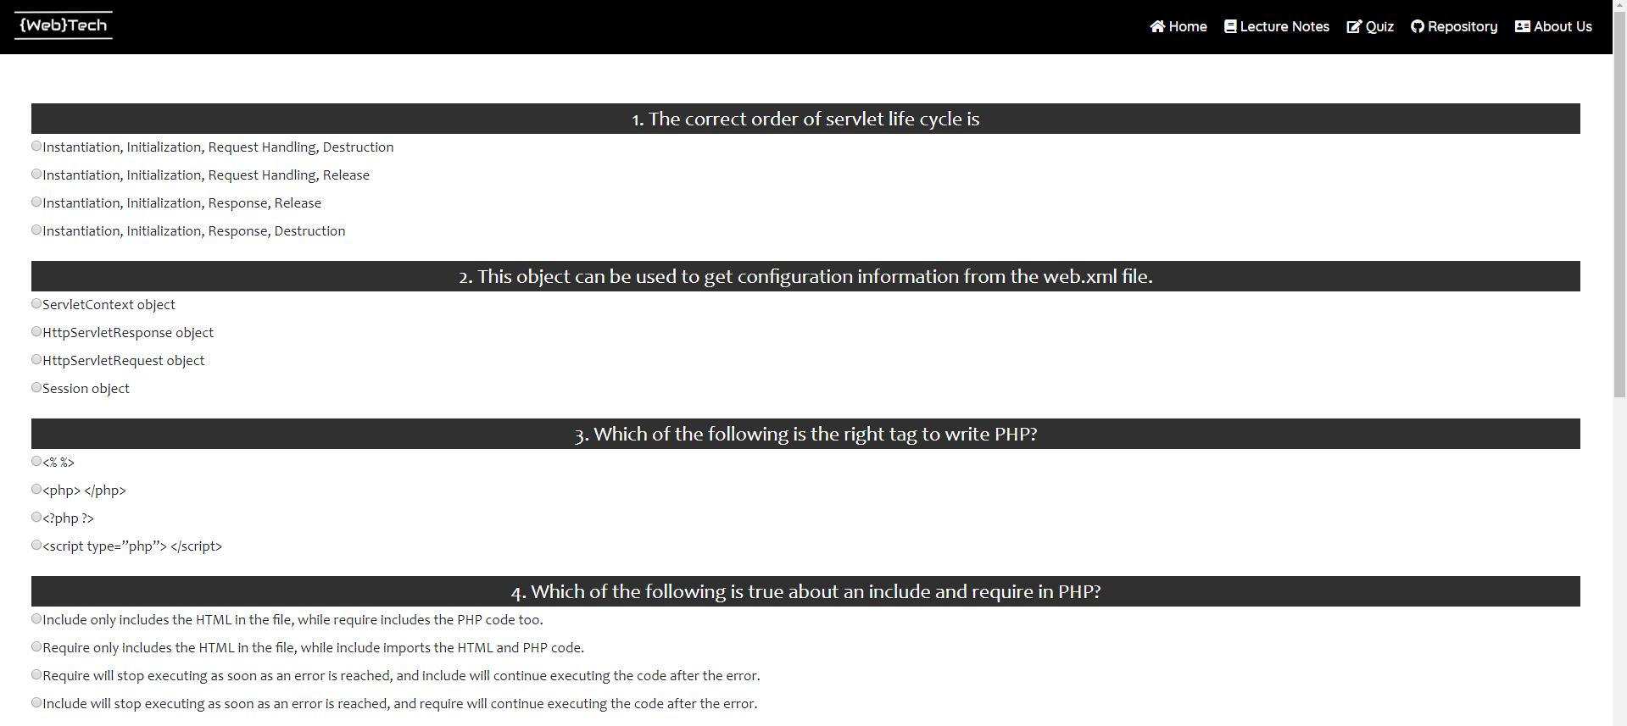

* Submit Button

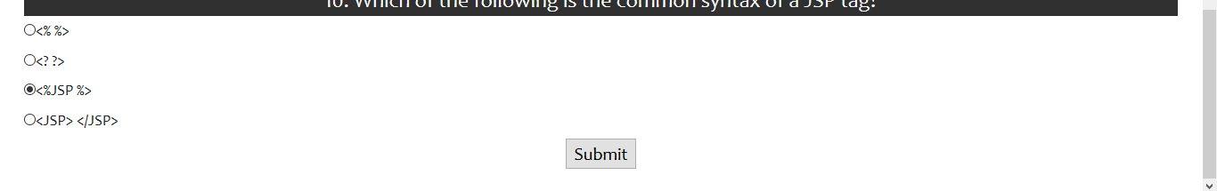

* Score



* Repository Information Section

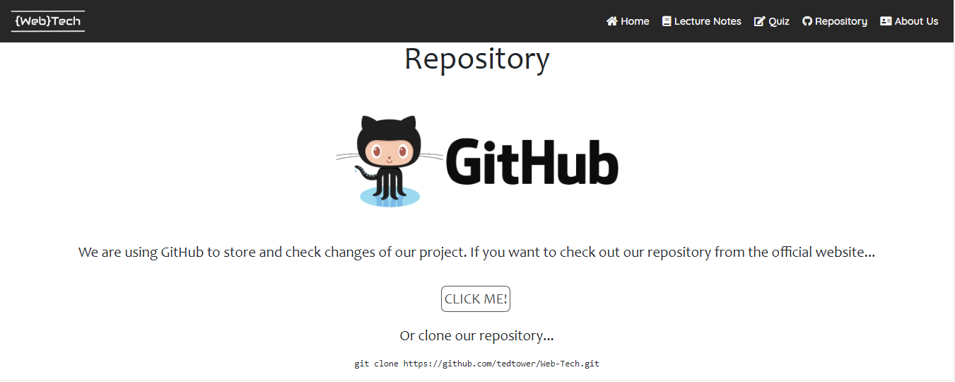

Clicking on the “CLICK ME!” button will redirect the user to our github repository to the link provided below the button.

* About Us Section

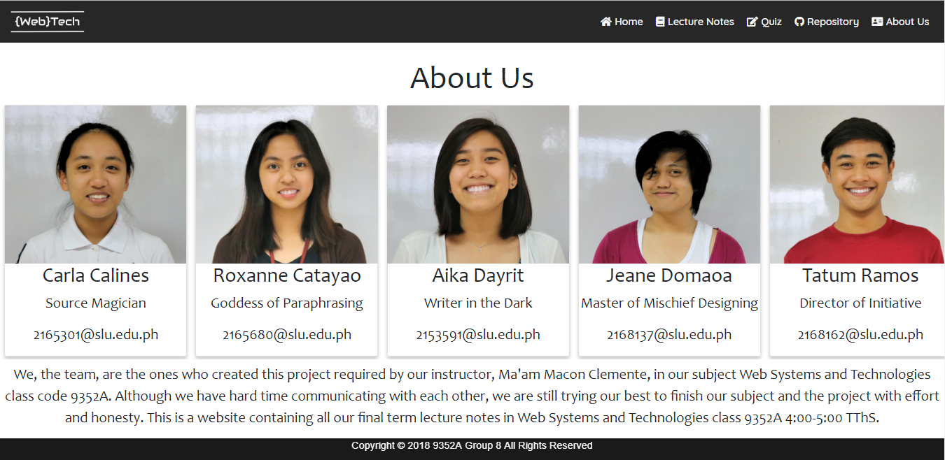

The About Us section shows the group members of the project. The group member profiles contain the names of the members, a nickname and their contact information. Also included in this section are the description of the website and its purpose.

**WEBSITE FEATURES**

**Responsive**

On the screen of a laptop computer the website will look like this



But when the screen size decreases the style of the website changes

Tablet



Mobile Phone

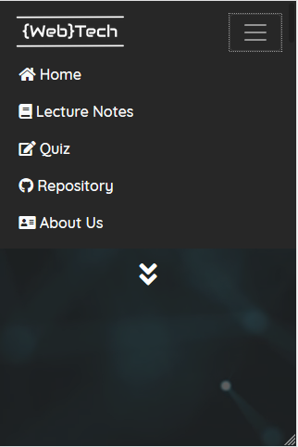

**@media Rule**

With the use of the @media rule we are able to change how different elements on the website will look like depending on the screen width. We optimized the website such that it can be viewable in a more aesthetic way in different devices. As evidenced by the screenshots provided above as the screen width narrows, the style of the navigation bar changes. The navigation links will only appear once you click the “Navigation Collapsible Icon” as shown above.

**Server-side Quiz Administration**

Instead of doing the quiz administration processes on the client-side, we used the PHP technology. It will first read the contents of the JSON text files that contains the quiz items for each quiz, the Basic and Intermediate quizzes, and it will parse them as associative arrays.

Like so:

