Final Course Website Documentation

    Members:

Domaoa, Jeane Cris

Ramos, Tatum Eiffel Dodge

Calines, Carla

Catayao, Roxanne

Dayrit, Aika Vien

Site Map

**Advance**

Member Information

**About Us**

HOME

**Github Repository**

**Quiz**

**Lecture Notes**

**Easy**

**Intermediate**

* JAVA SERVLETS
* Node.JS
* Hypertext Preprocessor
* Java Server Pages
* Critical Web Application Security Risk

Screenshots of the website’s main pages (wala pang description)

Home Page



Lecture Notes

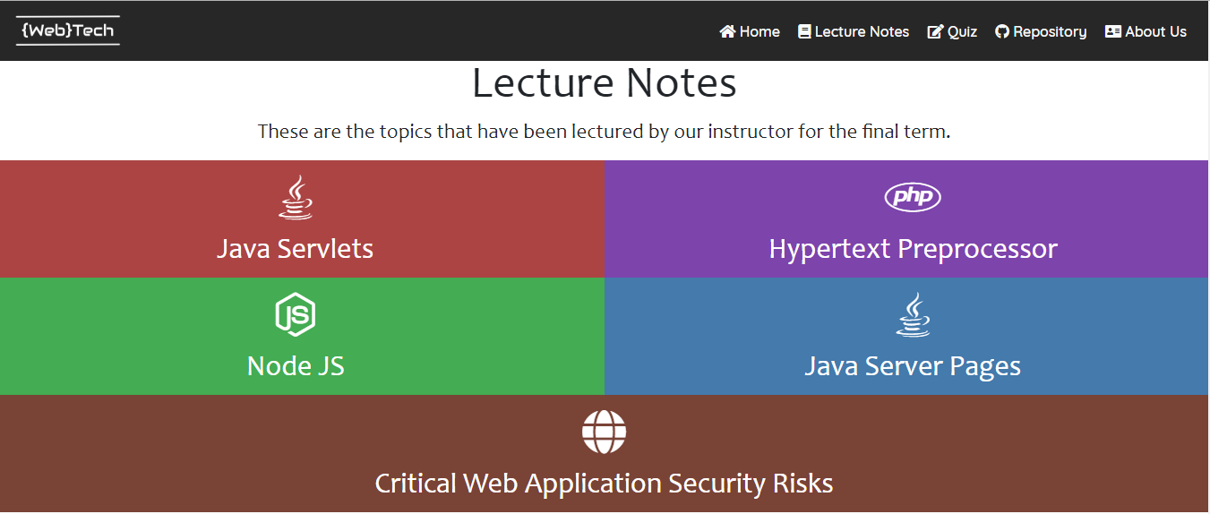

Quiz

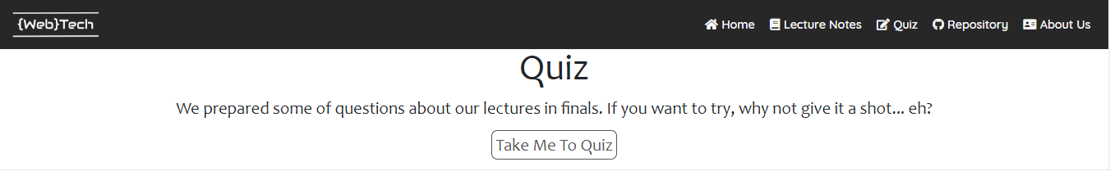

Repository

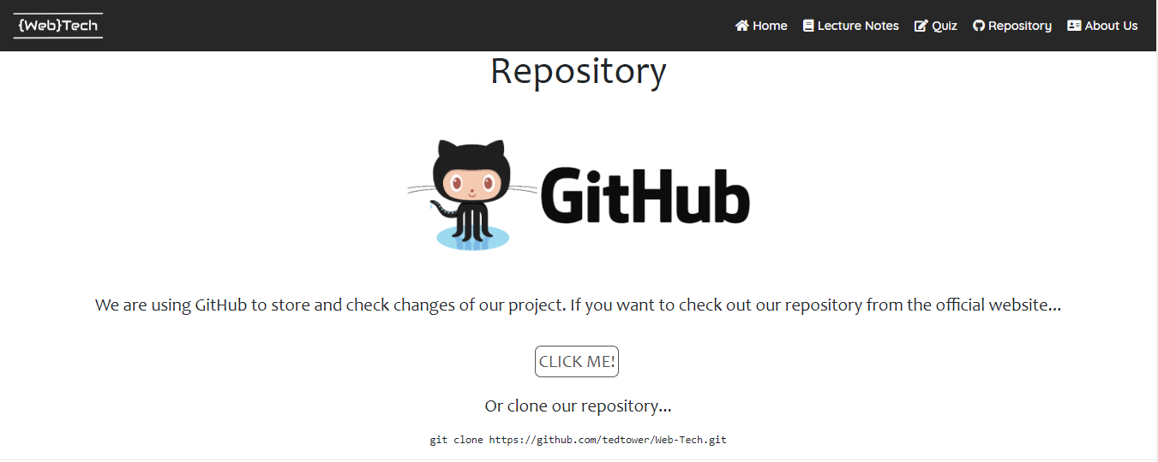

About Us

