LAST SUMMER HOLIDAY

Last holiday I went to Cuzco, I went with my friends for two weeks. The pla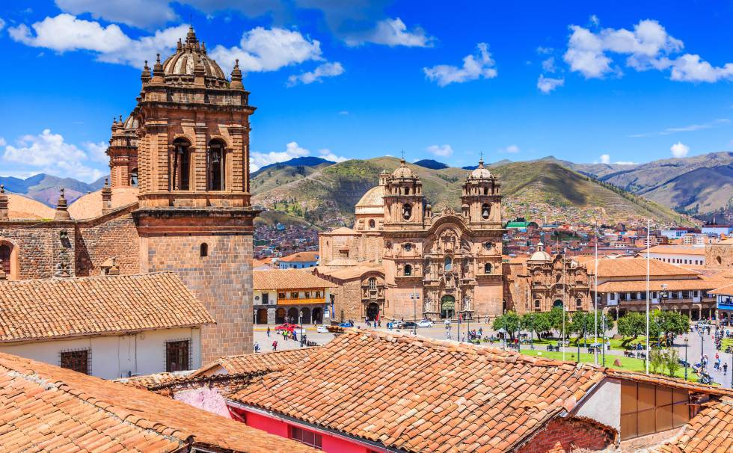ce was very comfortable and a bit quiet, at night it was very cold.

The people were very friendly. There were many people between foreigners and Peruvians obviously.

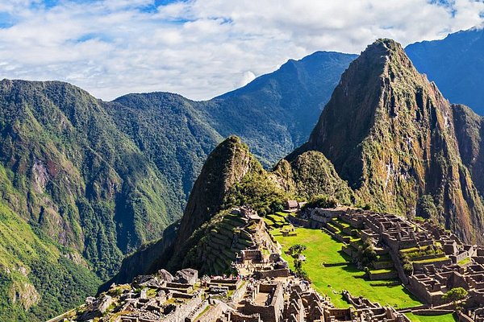We went to Macchu Picchu but that day it was raining. We also went to Sacsayhuaman where we saw many impressive things. Then we went to Puno where it was very cold.

Finally, we arrived in Bolivia, it was a very exciting experience.