NORTHEASTERN UNIVERSIY  
MIE Department  
IE 3425 DB

# Research Assignment

# Submitted Contents

1. Main report, titled ‘research_assignment.docx’
2. Supplementary description of website deployment (this document), titled ‘website_deploy.docx’
3. A comment in the canvas submission noting that I have completed the Bonus and this link to access the live site: <https://tedyee114.github.io/websites/>
4. All files, including python, HTML, images, and reports in ‘files.zip’ -note that the .css file and .js file are that of the root website and located in the root folder
5. A copy of the retail_app.db as it exists upon this project’s completion, titled ‘research.db’

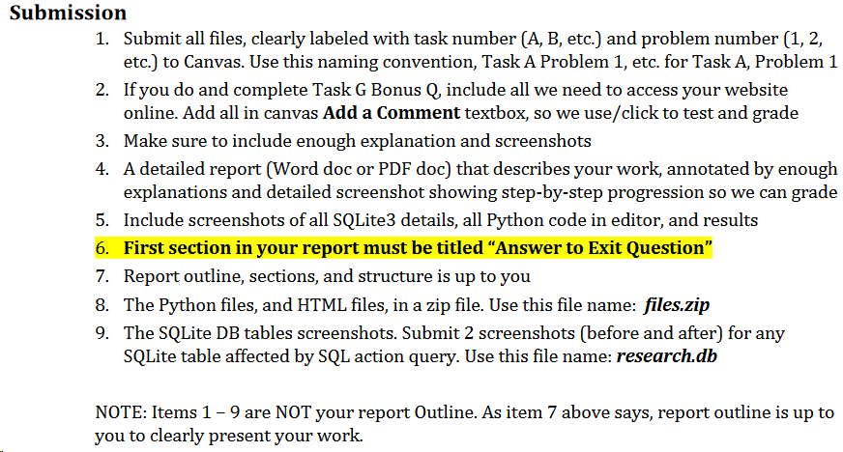

Please note that the above screenshotted list of requested submission documents is unclear and best guess is made at which files are required to be submitted directly. However, all other files are directly available upon request or via GitHub codebase accessible through linked website. Lots of tedious HTML, JavaScript, and CSS code screenshots are omitted from this report on the grounds that their result is all visible in the live website and that all code is provided as an appendix and on the site itself.

# Tasks

1. BONUS Q: (5% of your final points you score): Deploy the website you created in Task B on the web, so anyone can access it, like amazon.com. submit a separate detailed document in Word to canvas that describes the steps/instructions with clear screenshots. Use this name for the doc: website deploy NOTE: Do NOT attempt this question unless you are completely finished b/c there is NO partial credit.

The live site can be accessed here: <https://tedyee114.github.io/websites/>

To host the site live on the web, I created a git repository and deployed the site through GitHub Pages. The process is very simple, as once a page is set to be deployed, everything in the repository is accessible via formatted URLs. Because GitHub only allows one hosted repository per user account, I have created on large repository containing all websites that I host and use subfolders for each separate project. GitHub individual file limits are 50MB, but a repository can hold up to 5GB total before users typically run into issues, so I can practically host as many as I want as long as they’re through in the same root repository. I have considered using an alternate location for static content storage, even in other repositories (as the content can be accessed through links formatted as [https://raw.githubusercontent.com/tedyee114/[repository]/[content.fileextension](https://raw.githubusercontent.com/tedyee114/%5brepository%5d/%5bcontent.fileextension)]).

I wanted to host my final project site like this and learned how to do it before I submitted that. I’ve been adding and working on my site to make it a portfolio since then and will keep adding to it as time permits. It was very useful since I already had the whole framework and process worked out so that by the time I did this research project, I simply added it to my repository, pushed the commit, and it was live.

One note about GitHub live site deployment that is important to know when developing sites is that GitHub does not use relative filepaths, so ‘static/image.png’ is parsed as a GitHub repository called ‘static’, not a subfolder called static. As such, I recommend using absolute URLs instead of filepaths for all static content. This allows pages to be rendered both locally and on the web. It was an issue I initially tried to work around via evaluations when I submitted my final project, but as GitHub sites are fully static, it does not work. GitHub does support JavaScript interactive elements, such as the rotating homepage access in my sites, but obviously is not structured to support python connections to SQLite3 and databases or Flask connections, and the sites are limited in that manner.