**Student ID:** _________986559___________________________

**Full Names:** _______Theodros Mebratu Ocbazghi____________

Software Engineering

(CS425)

(August 2018)

Professor: O. Kalu

Midterm Makeup Quiz

1. The quiz duration is 1 hour.
2. The exam is computer-based; so you may use a computer for both the coding and theory parts.
3. Make sure to switch-off your cell-phones or simply turn the ringer off.
4. **This exam is a copyrighted material and must not be copied or reproduced or transferred**.
5. You are expected to use an IDE or any Code Editor tool to implement your solutions for the questions in the Coding part. Take screenshots of your result(s) and add them into this document, for submission. Upon completing the quiz, put your project(s), **(source code only)** in a single zip file named **quiz.zip**, including your completed/finished quiz paper (i.e. this document – **in Microsoft Word or PDF format, only**), and submit to Sakai.

--------------------------------------------------------------------------------------------------------------------

Type your answers to the theory questions in the following pages.

--------------------------------------------------------------------------------------------------------------------

(CS425 - SWE)

(August 2018)

Midterm Makeup Quiz (70 points)

**Software Engineering Problem-solving, Coding skills:** (70 points)

**Note:** *For this question, upon completing your solution, you are expected to take screenshot(s) of your result(s), add them to this document or save them into a .png or .jpg image file and include these in the quiz.zip file, you submit.*

1. (70 points) **Data Modeling and Persistence using JPA and a Database**:

The Department of Transportation needs a system to help it collect data on Vehicles and their Manufacturers. They have hired you to design and implement a simple, command-line (console/terminal) application for this purpose.

Here is the simple solution model for the system:

A Vehicle is produced by a Manufacturer.

And a Manufacturer produces zero or many Vehicles.

In a basic UML class diagram, this model is given as:

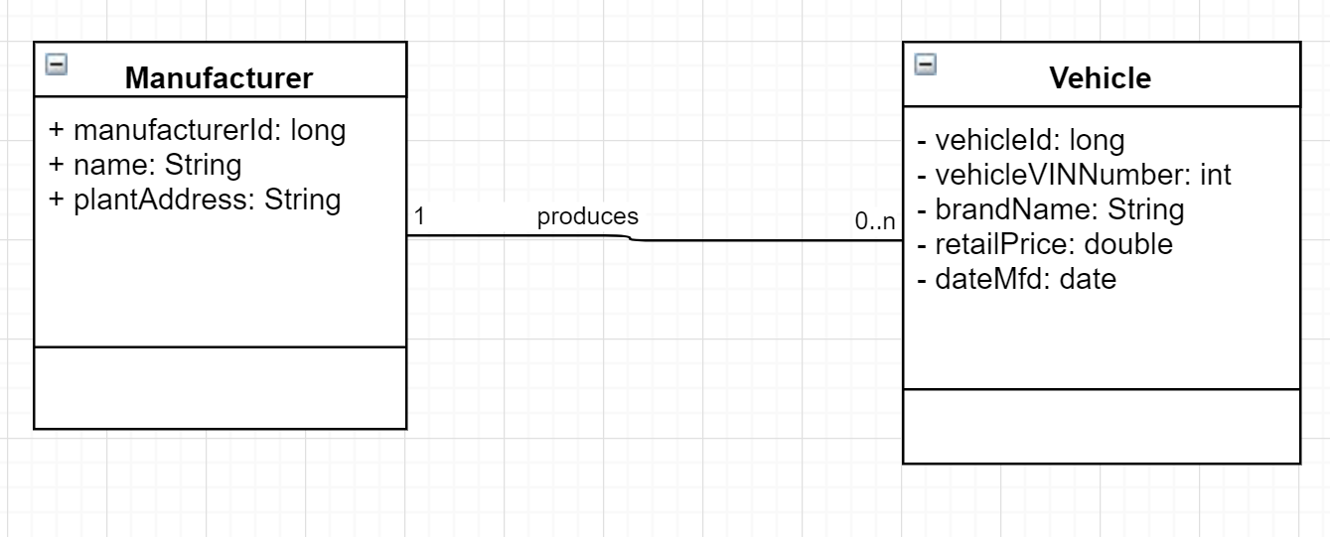

Create a Java console (command-line) application named, MyDOTApp. And in it, implement code for the persistent entities/classes, Vehicle and Manufacturer, including the data fields as has been specified in the class model above, and the accessor (getter) methods and mutator (setter) methods, and including any needed constructor(s). Make the classes be inside a package named, *edu.mum.cs.cs425.midtermquiz.dotapp.model*.

In the package named, *edu.mum.cs.cs425.midtermquiz.dotapp*, create an executable Java class named, DOTApp. And in this class, implement a method named, saveManufacturerAndVehicles(), which takes as input a Manufacturer object and it saves/persists it to your database. Add code to the main method, that creates a Manufacturer object and its associated Vehicle objects using the following data and invokes the saveManufacturerAndVehicles () method to save the data to the database.

Manufacturer data: m1: {name:”Ford Motors, Inc.”, plantAddress: “100 North Central Ave., Detroit, Michigan”}

Vehicle data: v1: {vehicleVINNumber:1001, brandName:Ford Explorer, retailPrice:31,000.00, dateMfd:2018/6/30, manufacturer: m1}

Vehicle data: v2: {vehicleVINNumber:1002, brandName:Ford Escape, retailPrice:22,995.00, dateMfd:2018/4/15, manufacturer: m1}

Note: You may use any database of your choice.

//-- The End --//