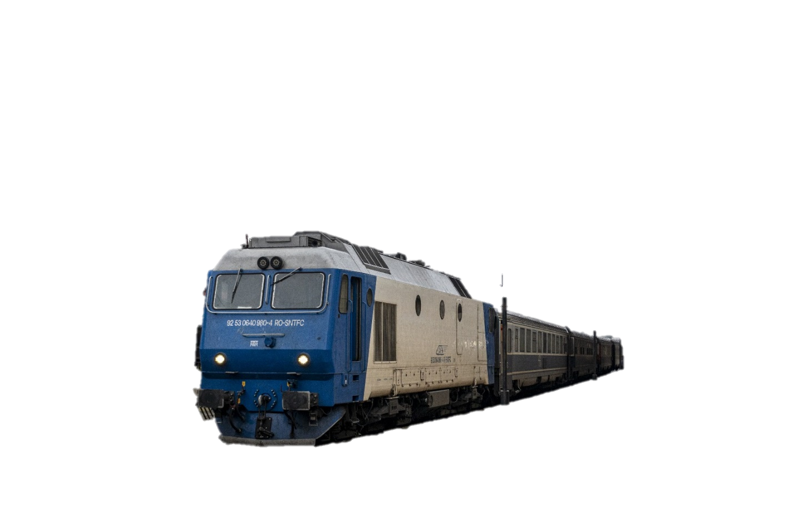 MANAGING TRAINS

*©Adrian Zărnoianu*

This project represents a database that manages the trains, their delays (if necessary), the reasons for the potential delays and the users who have the responsibility to report which stations the train reached and when.

It is inspired by the database CFR and other train companies use (Cronos), but simplified. The reason why I chose this subject is the high frequency students and people depend on these means of transport, and maybe the frustration we all have when the trains we go by have unexpected delays, without having any explanation.

Thus, I hope that by doing this project, it can explain briefly the process behind those delays and their actual explanations.

The database consists of 7 tables, from train and user details to routes and stations.

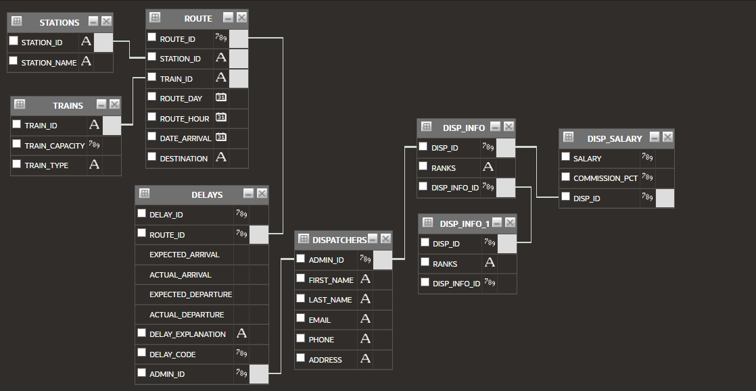The database query (using Query Builder from Oracle APEX):

The tables’ syntaxes:

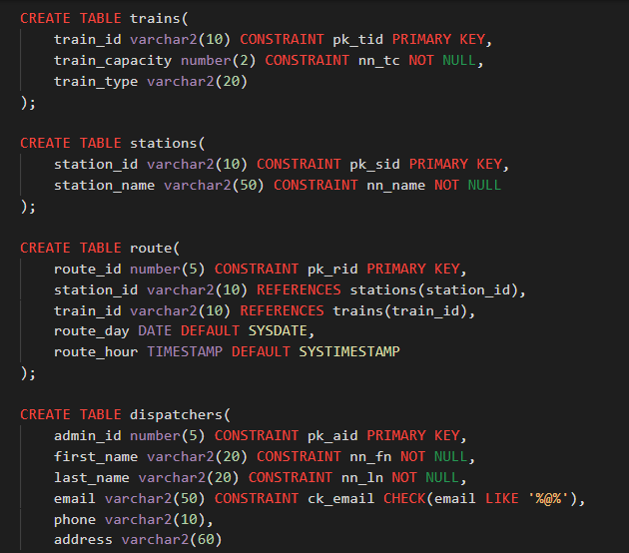

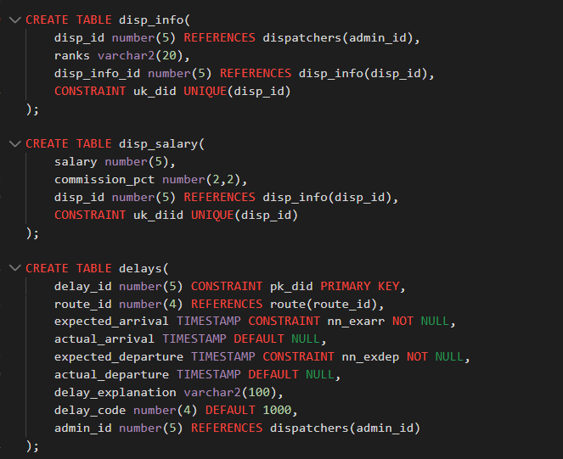

The values I inserted (some of them):

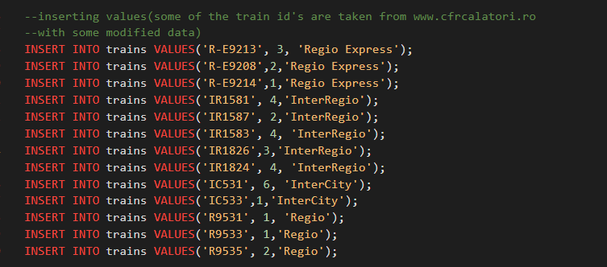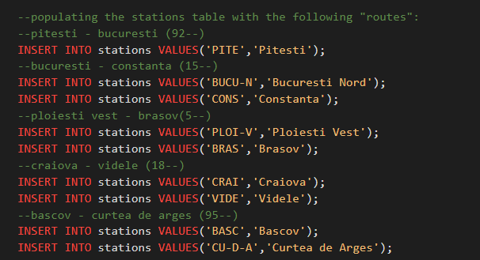

And some modifications I did to the route table before adding data:

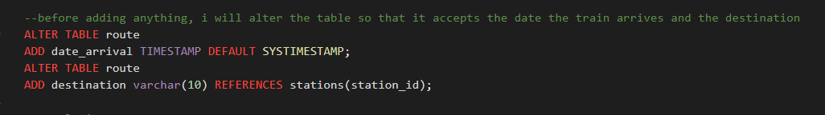

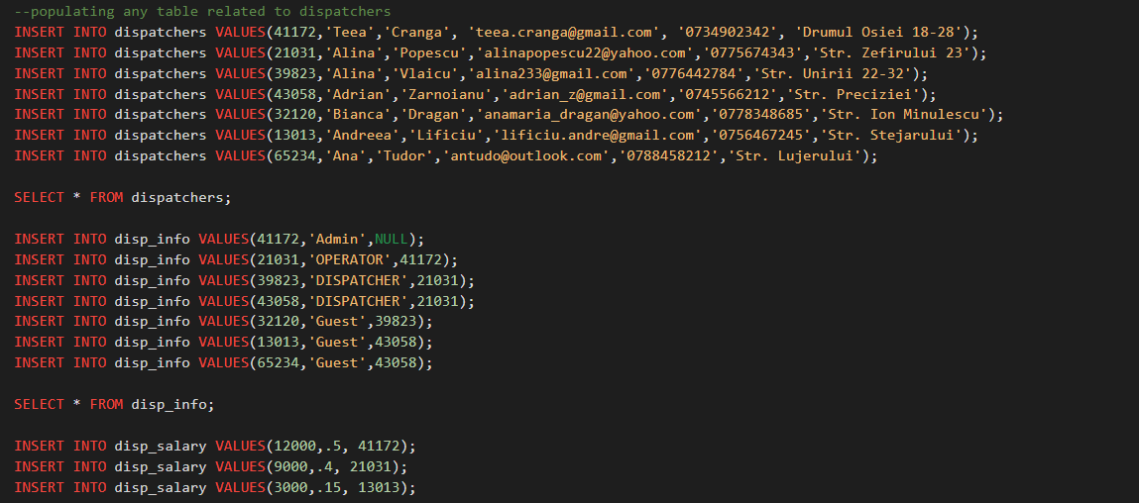

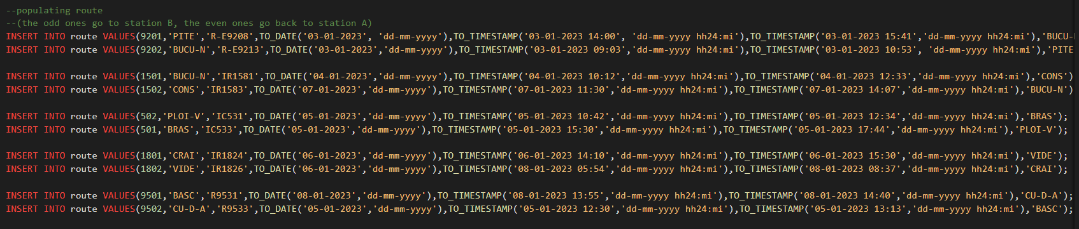

Before working with statements, I copied the first and last names after altering the table and deleted the columns from dispatchers:

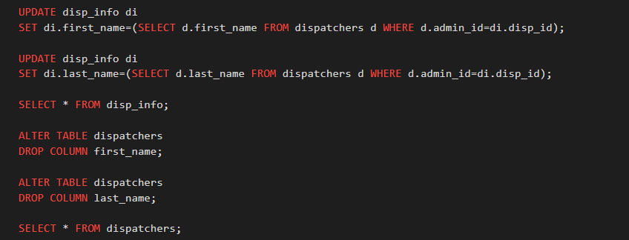

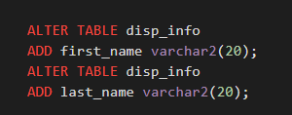

USING DML STATEMENTS:

UPDATE:

I used UPDATE in order to modify data related to trains or dispatchers. For example:

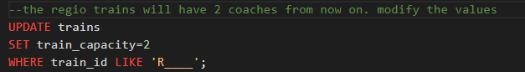

The results: 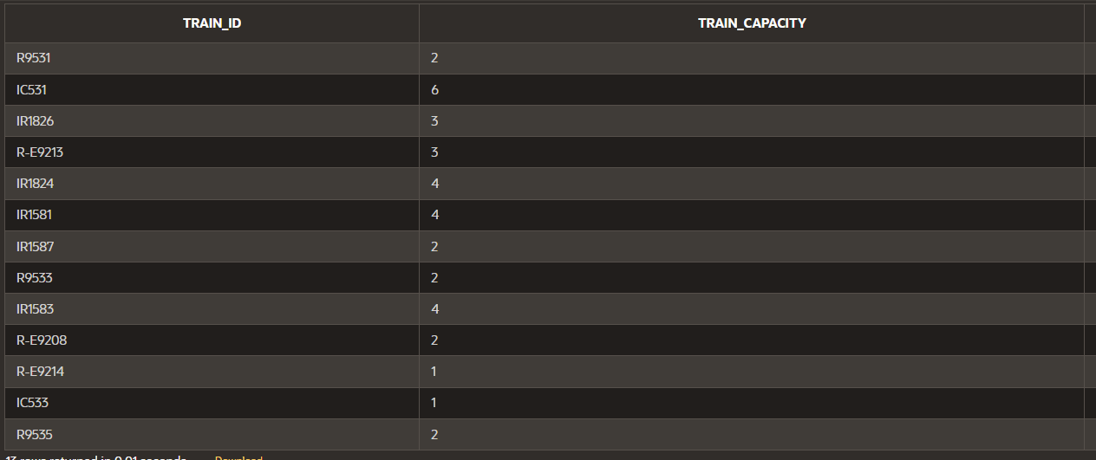

OR



Where the input for the delay with id 13 was:

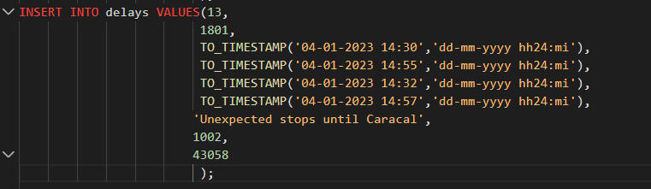

The result:



DELETE:

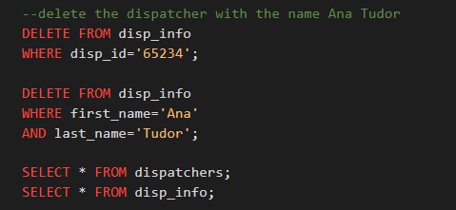

The results:

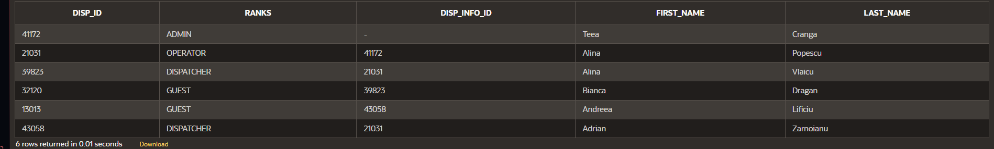

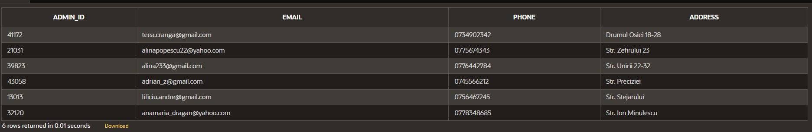

MERGE:

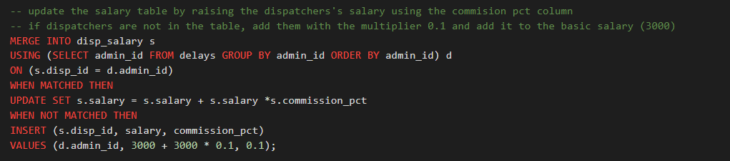

The result:

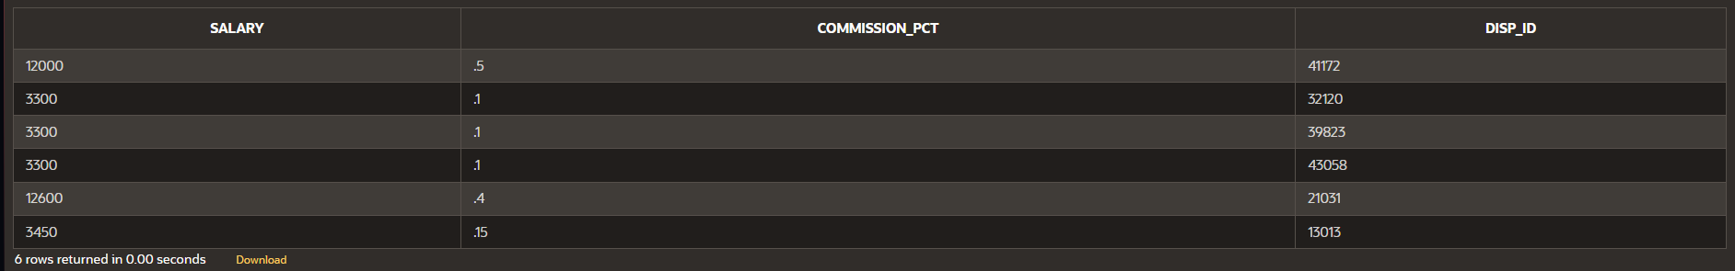

SELECT STATEMENTS:

I will start with some simple statements that filter the trains by some of their properties (coaches, train type, train name):

Example no. 1:

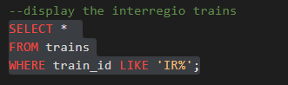

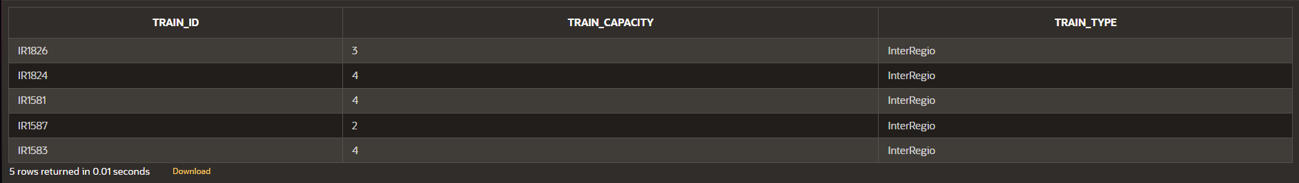

Example no.2:

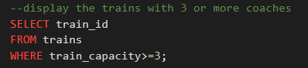

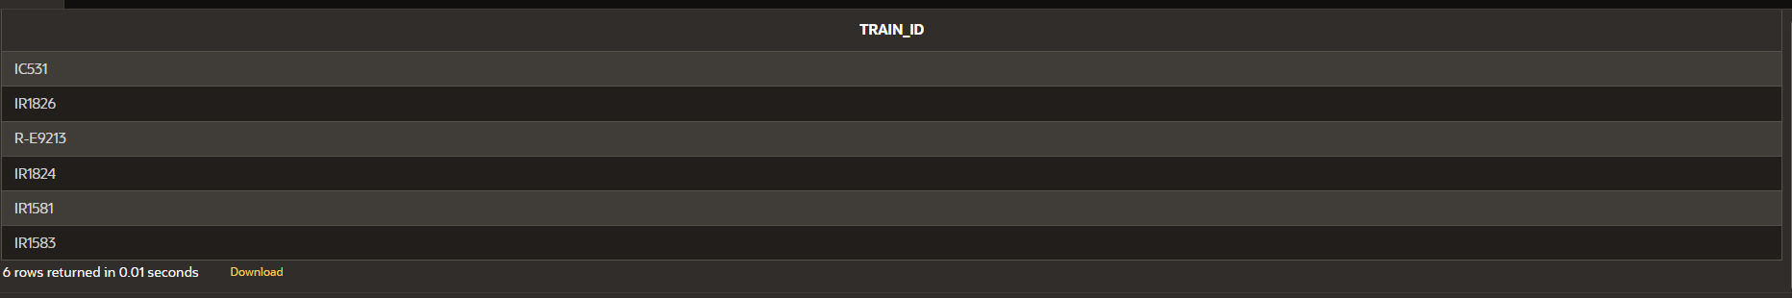

Example no. 3:

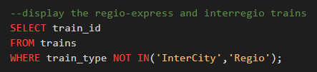

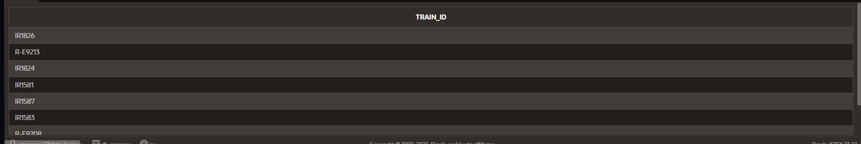

The following commands contain single/group functions:

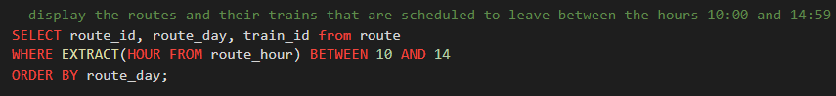

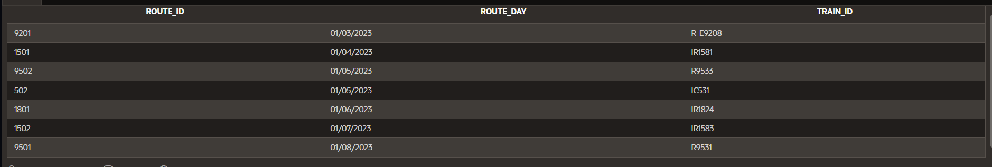

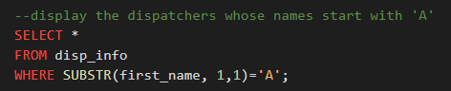

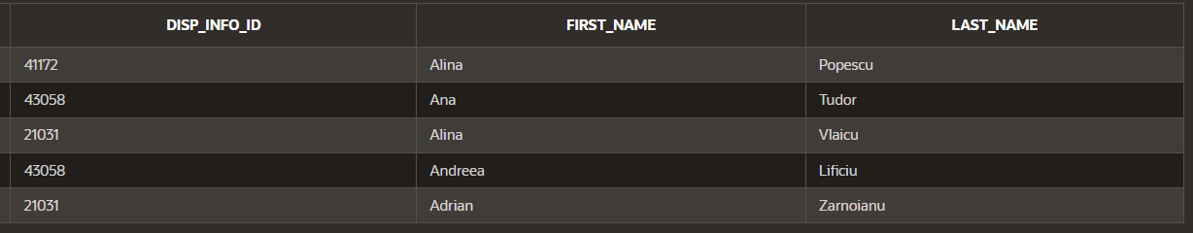

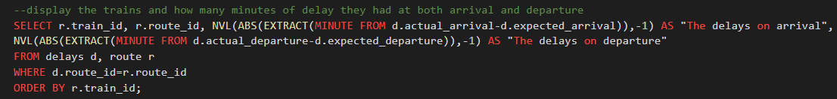

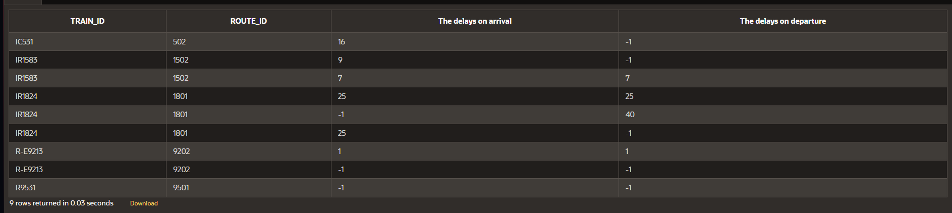

JOINS, MINUS AND UNION:

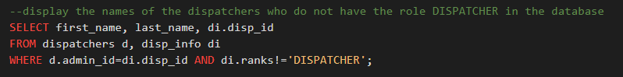

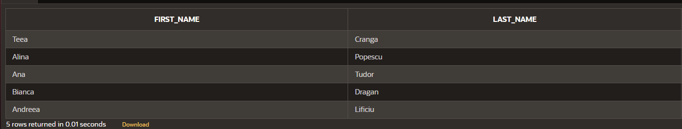

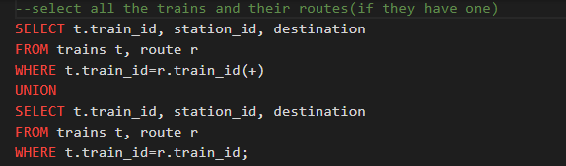

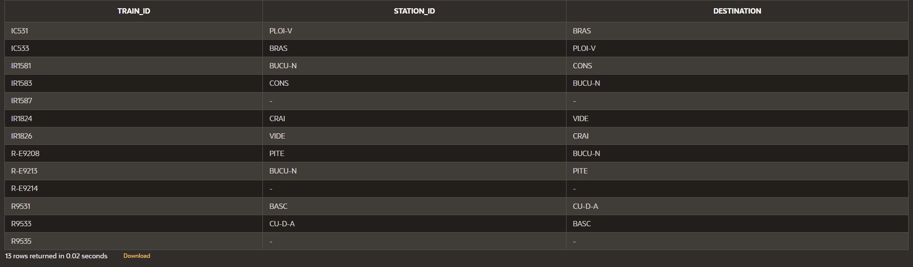

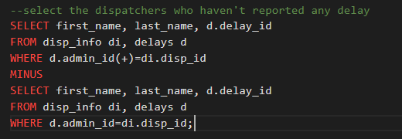

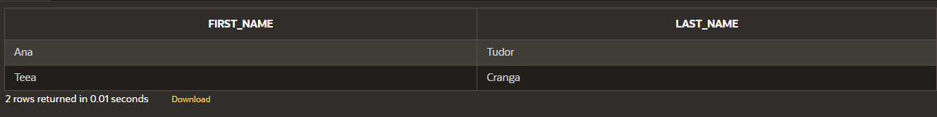

DECODE AND CASE:

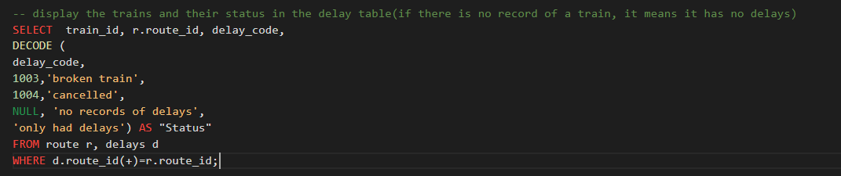

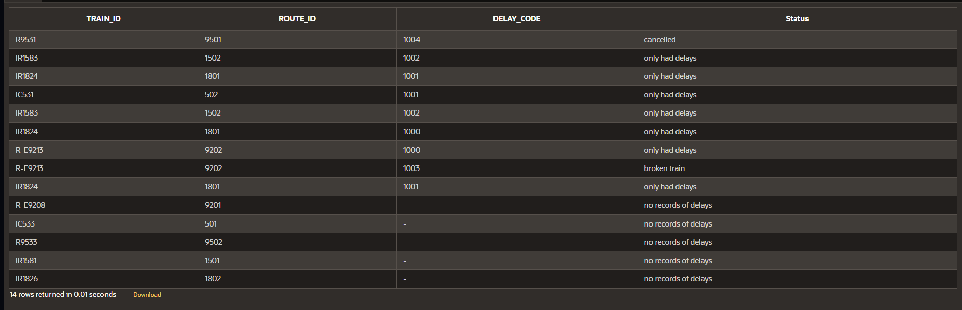

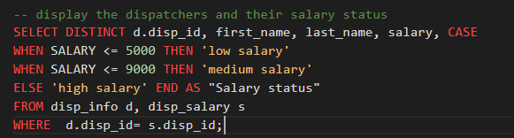

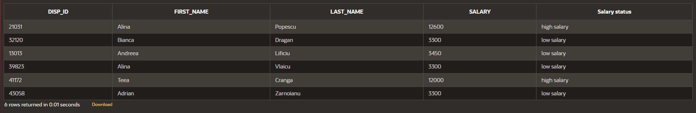

SUBQUERY:

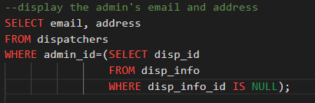



VIEW:

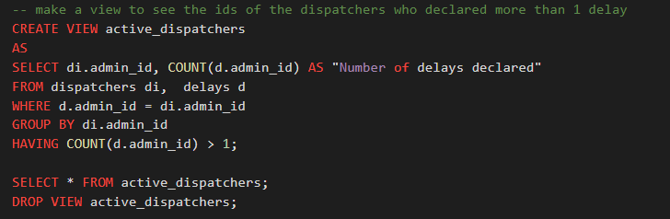

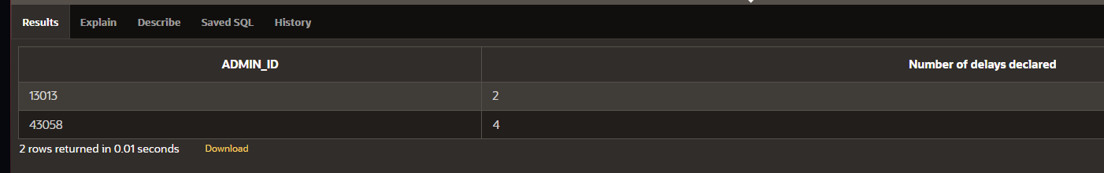

INDEX:

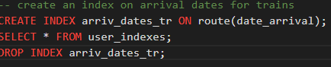



SYNONYM:

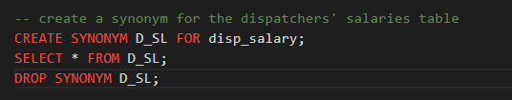

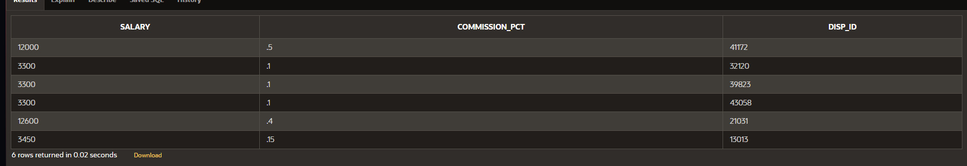

SEQUENCE:

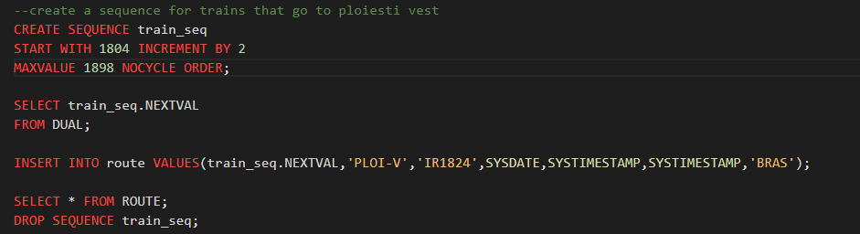

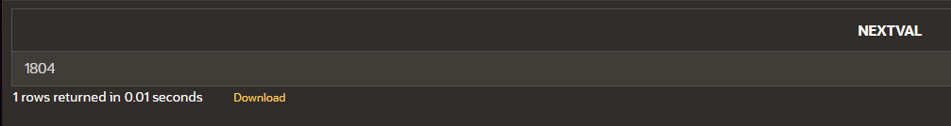

The value inserted using the sequence:



HIERARCHICAL QUERY:

