Trendyol Bootcamp Network Case

**1. Why is the OSI layered architecture?**

**2. Why are different types of addresses used in Layers 2 and 3? Why do you think one address type was not enough?**

**3. Is the packet sent by ping TCP or UDP?**

**4. What is the response when you send an icmp echo request packet (ping) with TTL (time-to-live) 1 to the 1.2.3.4 IP address from your computer? Why is this message coming and what is the connection between traceroute and this event?**

**5. How is it determined which application will receive the packets incoming to a device in the network? For example, how does the operating system decide which applications will receive ping, ssh, and http packets from a web server? Can we run a web server on TCP 22 port in this context?**

**6. Which of the following does the router change in the frame header before forwarding a packet? (Multiple Choice)**

a. Source IP Address

b. Source MAC Address

c. Destination IP Address

d. Destination MAC Address

**7. If the source MAC address of the incoming packet is not in the switch's MAC address table, which of the following actions does the switch perform regarding this frame? (Multiple Choice)**

a. Discards the frame

b. Forwards the frame from all ports

c. Stores the source MAC address in the table

d. Sends to its Gateway

e. Starts an ARP request

**8. What is the protocol in the area marked with red areas that you see in the attached Wireshark screenshot?**

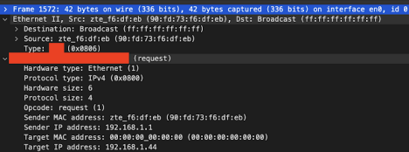

a. IPv4

b. ARP

c. Ethernet

d. ICMP

e. Broadcast