ENCE 3501 – VLSI
Lab 4 – Inverters: Report
Name: Teeb Alroshood DU ID: ______________ Section: ____
Assigned: October 9, 2026 Due: October 16, 2026

1. Introduction
This lab covers the design of two CMOS inverters in Electric VLSI: Inverter 1 with a 12µ/6µ PMOS and a 6µ/6µ NMOS, and Inverter 2 with a 48µ/6µ PMOS and a 24µ/6µ NMOS, which is four times larger. For each inverter a schematic, a symbol and a layout were drawn. The schematics were simulated in LTspice to find the switching point and to study the response to a pulse driving 100 fF, 1 pF, 10 pF and 100 pF loads. The layouts were checked with DRC and NCC.

2. Schematic

2.1 Inverter schematics and symbols
Inverter 1 uses a single PMOS of width 12 and length 6 above a single NMOS of width 6 and length 6, with both gates joined to the input and both drains joined to the output. The PMOS source goes to the power symbol and the NMOS source to ground. The PMOS is made twice as wide as the NMOS because holes have a lower mobility than electrons, so the wider PMOS brings the pull-up strength closer to the pull-down strength. All sizes are in lambda, which Electric converts to 0.2 µm per lambda, so a 6/6 device appears in the SPICE netlist as L = 1.2 µm and W = 1.2 µm.
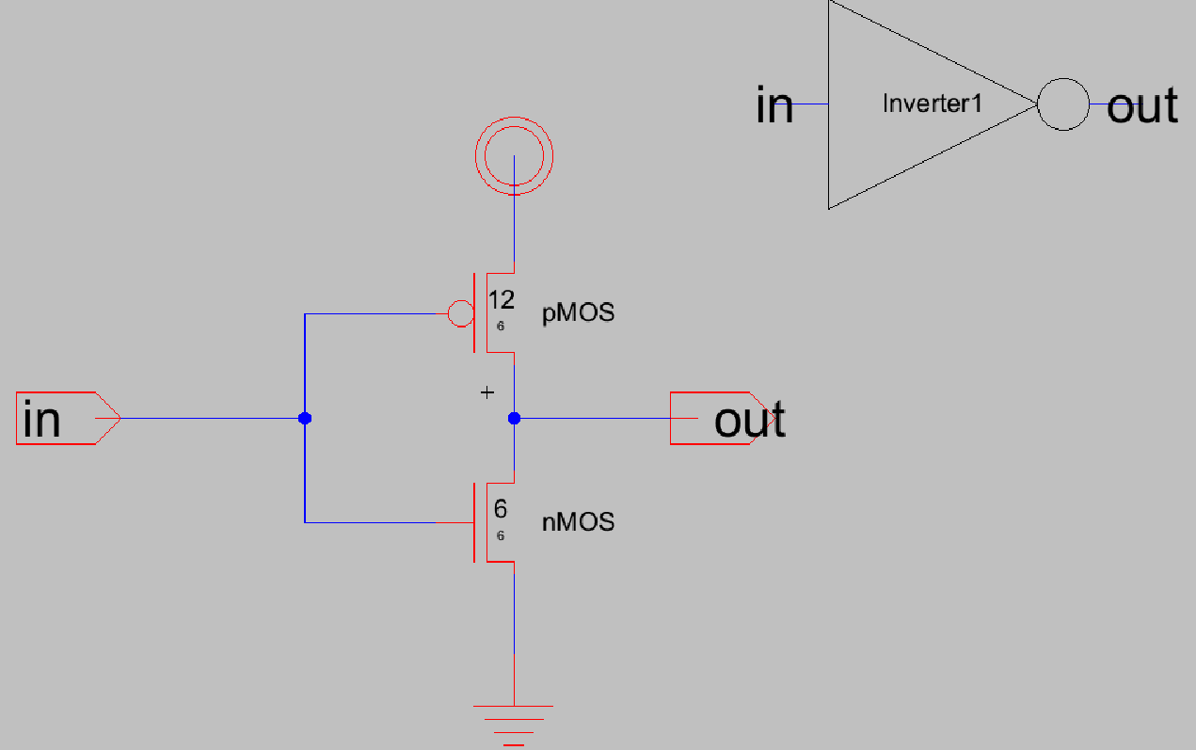
Figure 1: Inverter 1 schematic (PMOS 12/6, NMOS 6/6) and its symbol.
Inverter 2 keeps the same 2:1 PMOS to NMOS ratio but is four times larger, with a 48/6 PMOS and a 24/6 NMOS. The lab requests the multiplier to be 4 times the multiplier. The two numbers (48 and 24) were simply added directly into the schematic, and the 4 times was realised physically in the layout by four parallel fingers of 12/6 (PMOS) and 6/6 (NMOS). Both methods state the same transistor, and NCC verified that the sizes of the schematic and layout agree. The ratio would be the same, with the larger inverter having a similar switching point, but with roughly four times the drive current.
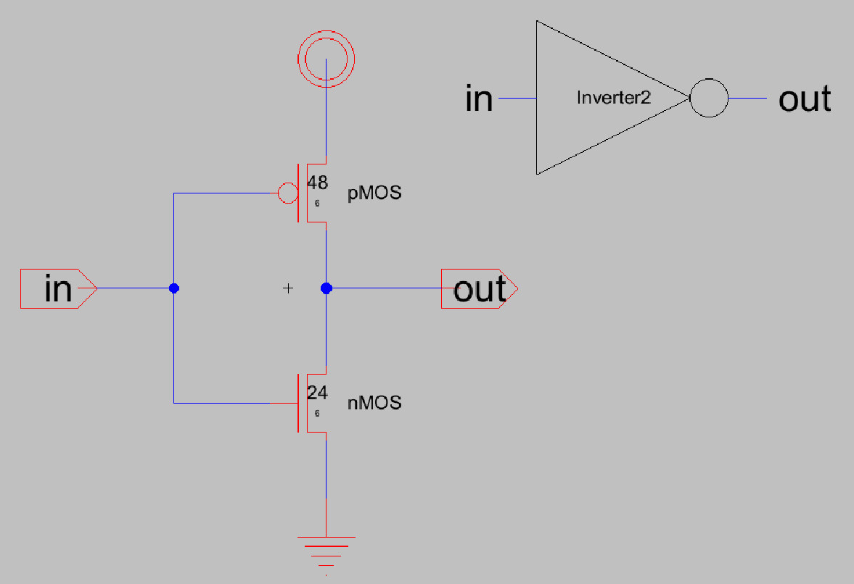
Figure 2: Inverter 2 schematic (PMOS 48/6, NMOS 24/6) and its symbol.

2.2 Switching point
Both symbols were placed in a test schematic with a shared input vin, outputs vout1 and vout2, a 5 V supply and a DC sweep of vin from 0 to 5 V in 1 mV steps (vdd vdd 0 DC 5, vin vin 0 DC 0, .dc vin 0 5 1m). Electric exported the SPICE deck and it was simulated in LTspice.
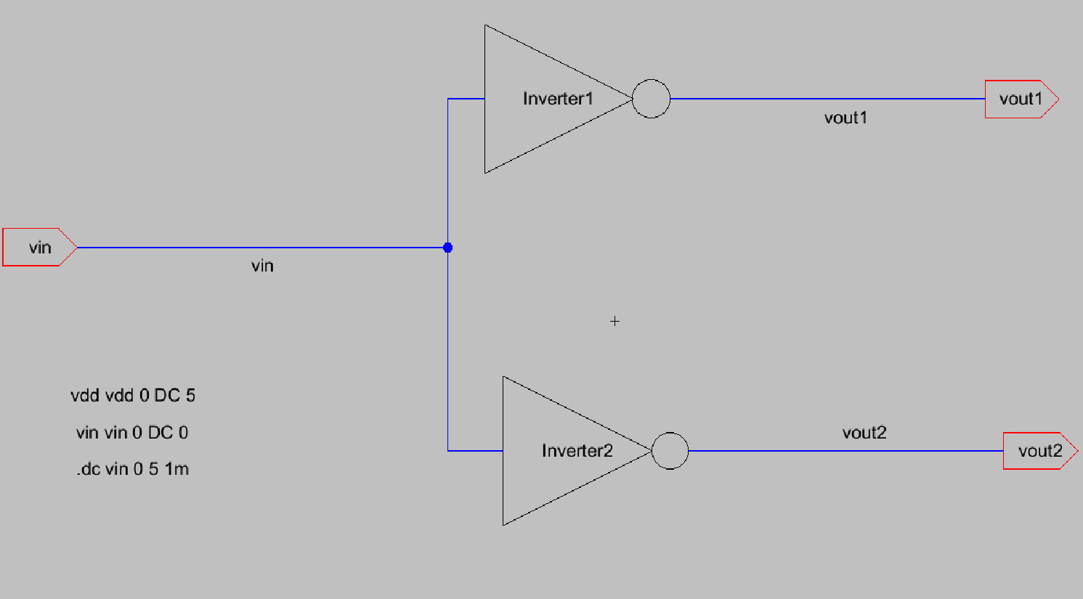
Figure 3: Test schematic for the DC sweep.
The C5 model file was not available for this lab, so the MOSIS CMOS models that Electric writes at the top of its SPICE deck were used instead. They were edited slightly so that LTspice accepts them: the capacitance units in the CJ and CJO parameters were replaced by plain numbers (2e-4) and the lateral diffusion LD was reduced to 0.05 µm, because the original values made the effective PMOS channel length zero. As a result, the absolute voltages and delays below will differ from those of the C5 process, but the trends are the same.
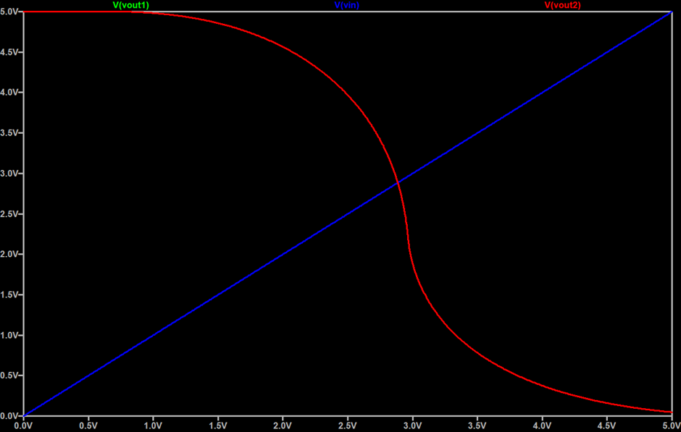
Figure 4: DC transfer curves of vout1 and vout2 against vin.
The switching point, where the output equals the input, is at about 2.9 V for both inverters. The two curves lie on top of each other, so only one is visible in Figure 4. This is expected, because the switching point depends on the ratio of PMOS to NMOS strength and not on the absolute size, and both inverters have the same 2:1 width ratio. The value is above VDD/2 because in these models the NMOS transconductance parameter is 60 µA/V² and the PMOS one is 20 µA/V², a 3:1 ratio. The PMOS is therefore weaker than the 2:1 width ratio compensates for, and the input must rise further before the NMOS dominates. The transition is also very sharp around this point, which shows the high gain of the inverter.

2.3 Pulse response with capacitive loads
For the transient test, a capacitor was added from each output to ground and its value was set to the parameter {x}. The input is a pulse from 0 to 5 V with a 5 ns delay, 1 ns rise and fall times, a 12 ns width and a 25 ns period, and a .step command sweeps x over 100 fF, 1 pF, 10 pF and 100 pF while a transient analysis runs for 25 ns.
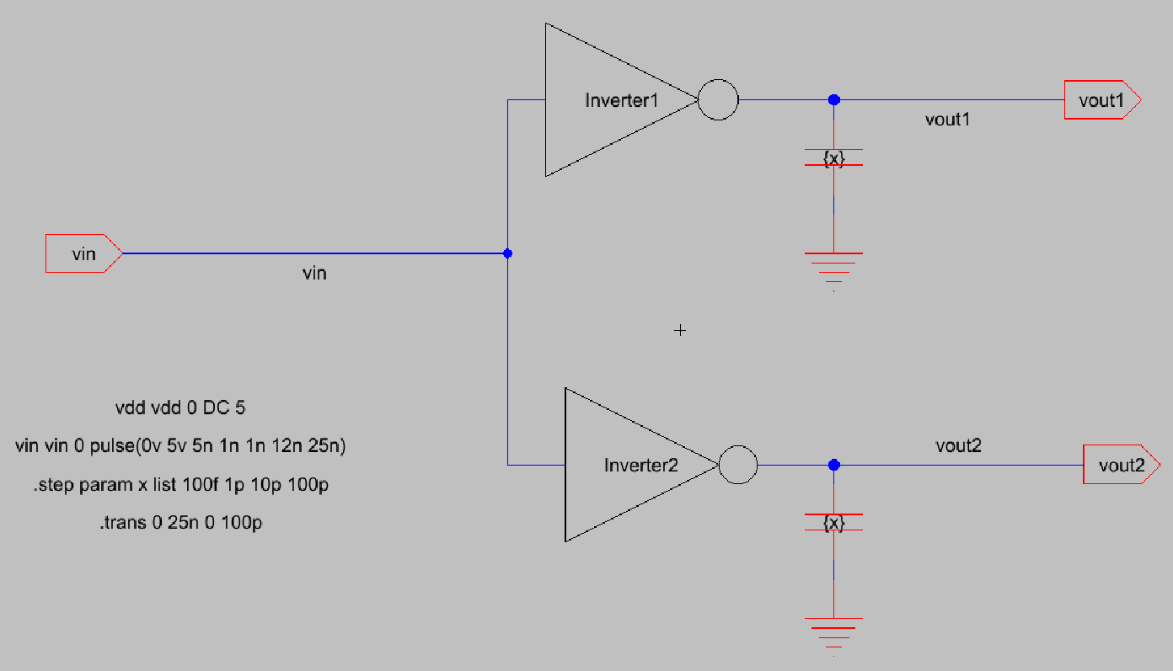
Figure 5: Test schematic with the capacitive loads and pulse source.
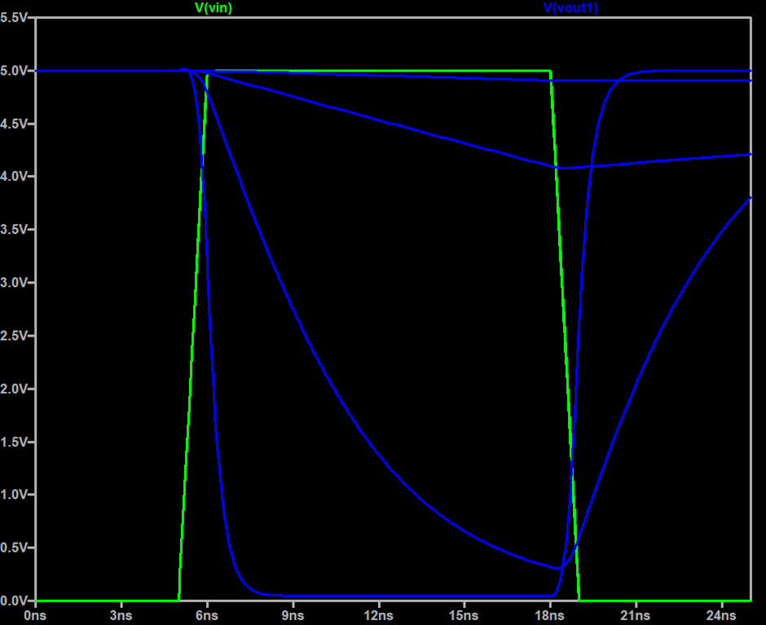
Figure 6: Inverter 1 output (vout1) for the four loads, with the input pulse.
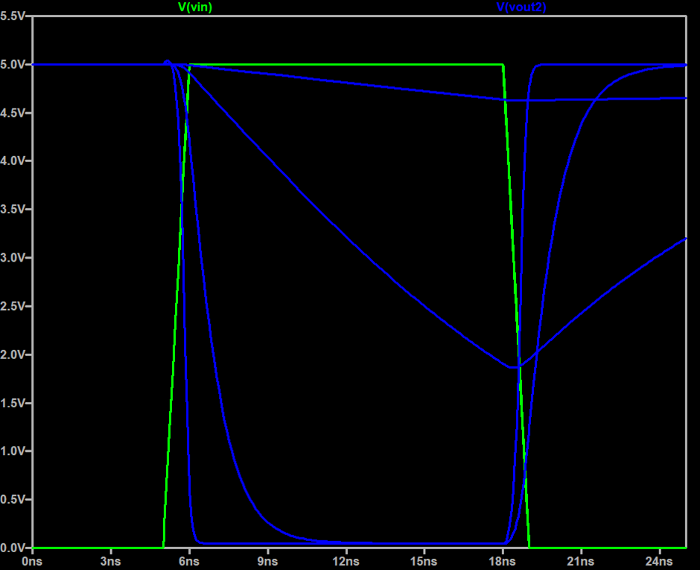
Figure 7: Inverter 2 output (vout2) for the four loads, with the input pulse.
The four curves are all blue in both figures, the first of which shows four different load values and the output moves slower when the load is higher. This makes Inverter 1 to reach approximately 0 V after the input edge and back up rapidly when the input drops, making it like an unloaded gate with 100 fF capacitance. The fall takes up the bulk of the 12 ns high time (the output is 0.3 V by 18 ns) and the output does not regain the 3.8 V value until 25 ns. These loads are too much for this inverter to switch in one pulse as the output drops to about 4.1 V with a 10 pF load and 4.9 V with a 100 pF load. The transition is approximately ten times slower for each tenfold increase in capacitance as one would expect from t ≈ 0.69·R·C.
For the large loads, the output falls as a straight line instead of an exponential. It is obvious that the output slope of the NMOS is I/C, while that of the inverter with transistors 4 times wider is approximately 4*I/C, for all loads, which means that at the same slope, the inverter is about 4 times faster at all loads. It takes more than 6 ns to reach 0 V with 1 pF, but it is completely recovered to 5 V before 25 ns; with 10 pF it takes 35.1 ns to reach 0 V, and Inverter 1 recovers to 4.1 V (a drop of 0.9 V). The disadvantage of the bigger inverter is that the capacitance of its gate is approximately four times greater, thus loading the circuit driving it, and it requires increased area and power.

3. Layout

3.1 Inverter 1 layout
Inverter 1 was drawn with a pMos transistor of width 12 and length 6 in an n-well at the top and an nMos transistor of width 6 and length 6 in the p-well at the bottom. Active contacts were placed at the source and drain of each transistor. The top contact of the PMOS goes to the vdd rail and the bottom contact of the NMOS goes to the gnd rail, as required, and both rails run in Metal-1, vdd at the top of the cell and gnd at the bottom. The two drain contacts are joined by a Metal-1 line that is exported as out. The two polysilicon gates are joined by a vertical polysilicon strip on the left, which ends in a polysilicon-to-Metal-1 contact exported as in. An n-well contact tied to vdd and a p-well contact tied to gnd were added so that both bodies are properly biased.
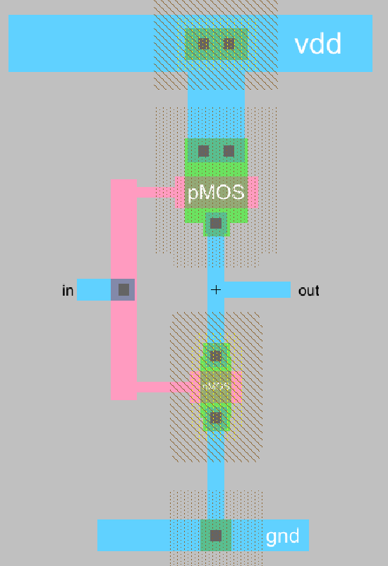
Figure 8: Inverter 1 layout.

3.2 Inverter 2 layout
Inverter 2 uses four parallel fingers for each device: four PMOS fingers of 12/6 (48/6 in total) and four NMOS fingers of 6/6 (24/6 in total). Every finger has a contact on each side of its gate. In the PMOS row the top contacts connect to the vdd rail and the bottom contacts connect to the out line. In the NMOS row the top contacts connect to the out line and the bottom contacts connect to the gnd rail. All eight polysilicon gates are chained together into a single polysilicon line connected to the in contact. Power is again Metal-1 on top and ground Metal-1 on the bottom, and each finger has its own well contact tied to the rail. Using fingers instead of one wide transistor keeps the cell compact and gives the same drive as a single 48/6 and 24/6 device.
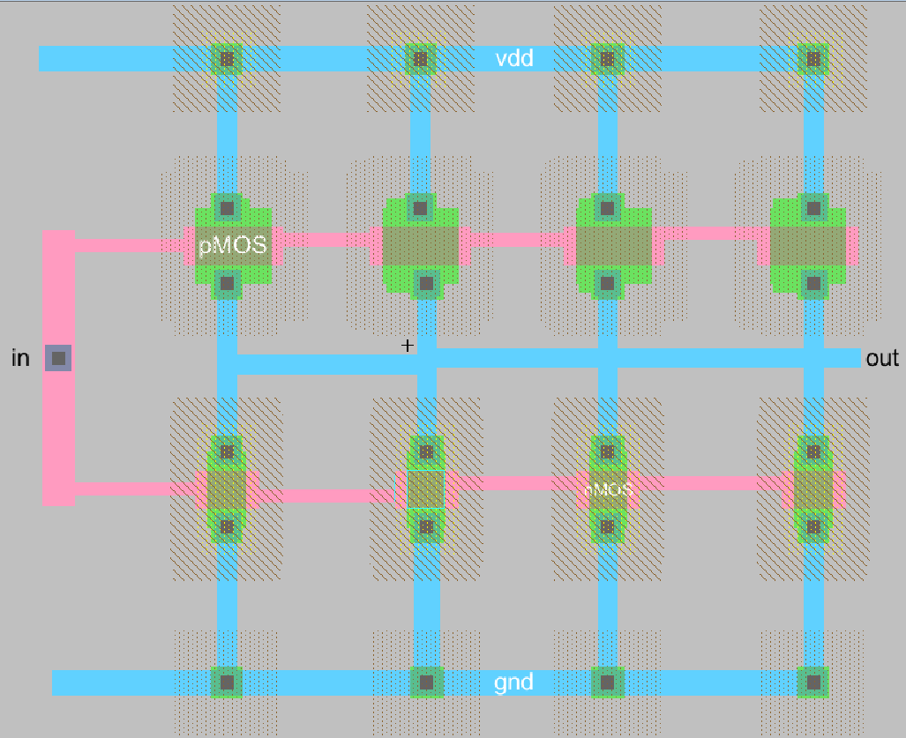
Figure 9: Inverter 2 layout with four fingers per transistor.

3.3 Verification
Both layouts were checked with DRC (Tools > DRC > Check Hierarchically). The main violation found during Inverter 2 was the MOSIS n-well spacing rule 1.3, which requires at least 6 lambda between wells of the same type. The spacing between neighbouring PMOS fingers was slightly too small, and it was solved by increasing the spacing and adjusting the contacts. The final DRC reports for both cells are:
Checking cell 'inverter_1{lay}': 0 errors and 0 warnings found
Checking cell 'inverter_2{lay}': 0 errors and 0 warnings found
The layouts were then compared with their schematics using NCC (Tools > NCC > Schematic and Layout Views), with the option to check component sizes turned on. The first NCC run on Inverter 2 reported that the vdd and gnd exports were missing from the layout, and adding them fixed this. The final results are:
inverter_1: exports match, topologies match, sizes match
inverter_2: exports match, topologies match, sizes match
The size match for Inverter 2 confirms that the four 12/6 and 6/6 fingers in the layout correspond to the 48/6 and 24/6 transistors of the schematic.

4. Conclusion
Two inverters with a 2:1 PMOS to NMOS ratio were designed, simulated and laid out. Both switch at about 2.9 V with the models used, because the switching point depends on the strength ratio and not on the size. The larger Inverter 2 drives capacitive loads roughly four times faster, at the cost of higher input capacitance, area and power. Both layouts pass DRC with no errors and match their schematics in NCC for exports, topology and sizes.

