EQUITY RESEARCH · THAILAND · IPO MARKET
Chasing Thai IPOs Was a Losing Trade
The class of 2025–26 underperformed the market by a median of 51 points

Across the 19 companies that listed on the Stock Exchange of Thailand (SET) and mai between January 2025 and April 2026, buying the typical IPO and holding it was a decisively worse trade than simply buying the index. As of 24 July 2026, the median IPO had trailed the SET by 51 percentage points since its debut, and only 4 of the 19 (21%) beat the market. Strikingly, this happened during a strong tape: the SET rallied between roughly 12% and 44% over the same windows, so IPO buyers lost ground precisely while the broad market was compounding gains.

Key findings
• Median return since listing: −23%; 63% of IPOs now trade below their offer price.
• Median excess return vs SET: −51% (average −31%, lifted by one large outlier).
• Only 21% beat the index; the remaining 79% would have done better in a plain SET tracker.
• Debut pop was real but fleeting: 58% rose on day one (median +2.6%), yet most gave it all back and more.

The spread
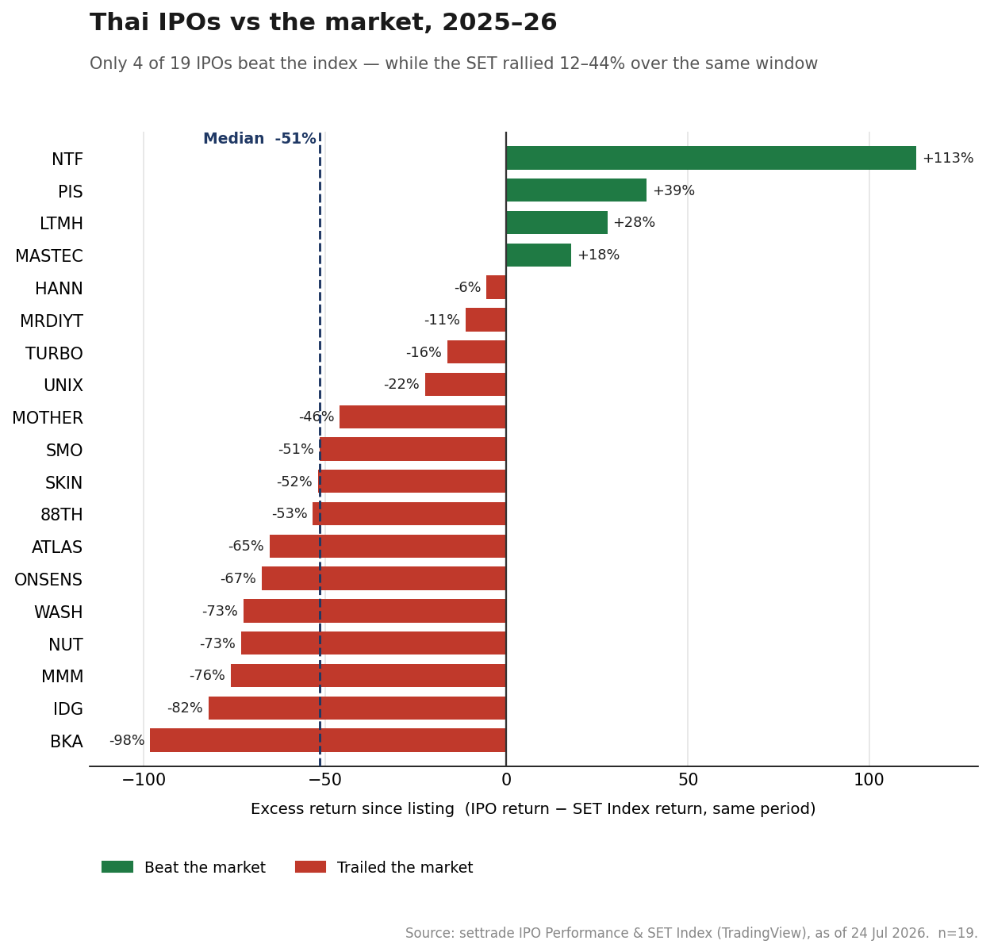

Standout names
A handful of debuts rewarded investors, but the losers lost far more than the winners won:
 | Beat the market |  | Trailed the market
NTF | +113% | BKA | −98%
PIS | +39% | IDG | −82%
LTMH | +28% | MMM | −76%
MASTEC | +18% | NUT / WASH | −73%

NTF (+113%) is the lone blockbuster and the reason the average is milder than the median; the honest read leads with the median. At the other end, BKA fell 98 points behind the market and IDG 82 — capital-destroying outcomes against a rising index.

Method
Universe: all 19 SET/mai IPOs listed Jan 2025–Apr 2026 (the range covered by settrade's IPO Performance tool). Offer prices, first-day and current prices are from settrade IPO Performance; SET Index levels at each listing date are from TradingView (daily close). Excess return = the IPO's return since listing minus the SET Index's return over the identical window, isolating stock-specific performance from the market move. All figures as of 24 July 2026.

Limitations
Small, recent sample (n=19) covering a single downturn-and-recovery window — a snapshot, not a multi-cycle study. Returns are measured to one common date rather than a fixed per-stock horizon, and use simple prices (dividends excluded). One large winner (NTF) skews the average, which is why the median is the headline. These are disclosed deliberately: the direction of the result is robust, but the precise magnitudes would tighten with a longer sample.

Bottom line
For the 2025–26 cohort, the Thai IPO market transferred wealth from post-listing buyers to issuers and early holders. The median new listing didn't just underperform — it underperformed a rising market by roughly half. Absent a specific, differentiated thesis, the default stance toward this cohort of Thai IPOs is skepticism, not participation.
Prepared as an independent research exercise. Source data: settrade IPO Performance and SET Index (TradingView), as of 24 July 2026. Not investment advice.

