Project Forest Indicator

PROJECT PLAN

THE VERSION HISTORY OF THE DOCUMENT

VERSION NUMBER | DATE | REASON FOR CHANGE | AUTHOR/ACCEPTOR
0.1 | 15.03.2018 | First version | TH, TP

Contents

PROJECT PLAN 1
1. INTRODUCTION 3
1.1 The Aim of the Document 3
2. THE CONTENTS OF THE PROJECT 4
2.1 Background Information and Starting Points of the Project 4
2.2 Subject 4
3 ORGANIZING THE PROJECT 5
3.1 Supervising Group 5
3.2 Project group 5
4 DELIVERABLES 6

INTRODUCTION

The Aim of the Document

This document is a project plan for the project called Forest Indicator. The purpose of this document is to give a reader an overview of what this project is about and how it relates to outside world. The project work is a part of Web Programming Project module (ID00BO87).

2. THE CONTENTS OF THE PROJECT

Background Information and Starting Points of the Project
In 2017 Oulu University of Applied Sciences started working with the Natural Resources Institute Finland (LUKE) to make an web application that would enable the user to browse forest related data.
LUKE was presented with several different student projects from which they chose the most suitable for further development. This project aims to implement those changes.

Subject
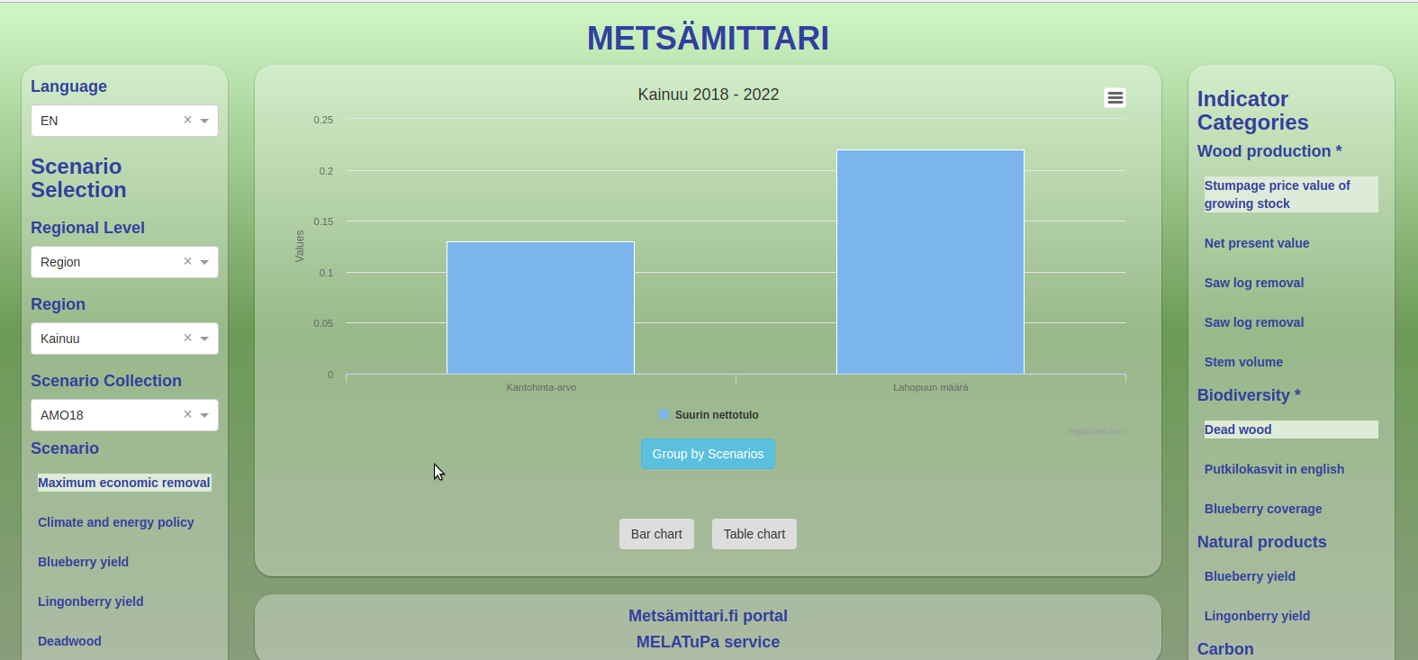
Illustration 1: The starting point of project.
The starting point of this project is shown in Illustration 1. All the menus will be placed on left side to make it easier for tablet users. At the moment the number of bars on screen is limited to 20. This limitation will be removed. In this application the data can be shown in column and table charts. The option to view data in polar and bar charts will be added.

The table data button shows data in a table form and in line plot. That will be changed so that the line plot will be removed and the data is displayed in new tab.

In the current version of the application the user is able to select only one time period at a time. The ability to select multiple time periods and display that data in separate graphs will be added.

The back button is not implemented in the current version. The back button functionality will be added if it’s possible.

Additional info buttons will be added. The current user guide will be updated to include detailed instructions for the user.

ORGANIZING THE PROJECT

Supervising Group
The supervising group of the project consists of the following persons.
Supervisors’ names and contact information will be filled in the table below.

NAME: Pekka Alaluukas
ROLE | Supervising group member
CONTACT INFORMATION | Organization: OUAS  E-mail address: pekka.alaluukas@oamk.fi  Phone: 040 141 5079

NAME: Kari Laitinen
ROLE | Supervising group member
CONTACT INFORMATION | Organization: OUASkari.laitinen@oamk.f  E-mail address: kari.laitinen@oamk.fi  Phone: 050 3174664

Project group
The project group consists of the following persons.

NAME: Teemu Halmi
ROLE | Software designer
CONTACT INFORMATION | Organization: OUAS  E-mail address: t7hate00@students.oamk.fi  Phone: 044 2689670

NAME: Tapio Paloniemi
ROLE | Software designer
CONTACT INFORMATION | Organization: OUAS  E-mail address: t7pari00@students.oamk.fi  Phone: 050 3595394

DELIVERABLES

The source code and documentation can be found at github. The original version can be seen at http://diga2017-team8.appspot.com/.

