FAST SCHOOL OF COMPUTING
Department of Computer Science
Software Construction & Development (SC&D)
Course Project Report
Hotel Reservation System
Program: BS / BE Software Engineering
Course: Software Construction & Development (SC&D)
Semester: Current Semester (as per course schedule)
Section / Time: As per class schedule

Group Member 1: Kabir Ali Shah — Roll No. 63650
Group Member 2: Muhammad Aun — Roll No. 59709

Submitted to the Course Instructor

1. Project Overview
This report presents the complete design, implementation, and testing of a Hotel Reservation System developed for the Software Construction & Development course project. The system is implemented in Java and models four core domain classes — Hotel, Room, Customer, and Booking — connected through associations and aggregation, with an additional interface (IBookingManager) and a custom checked exception (BookingException) used to demonstrate interface-based design and defensive programming respectively.
The solution follows object-oriented design principles (encapsulation, single responsibility, separation of concerns), clean coding practices (meaningful names, small focused methods, no duplication), and defensive programming (constructor and argument validation, illegal-state prevention, custom exceptions). A full JUnit 5 test suite covering normal, boundary, and invalid-input cases accompanies the implementation, along with a console-based Main class that demonstrates every required use case.
2. UML Class Diagram & Design
The diagram below shows the four domain classes, the IBookingManager interface, and the BookingException class, together with their attributes, methods, and relationships (aggregation, association, interface implementation).
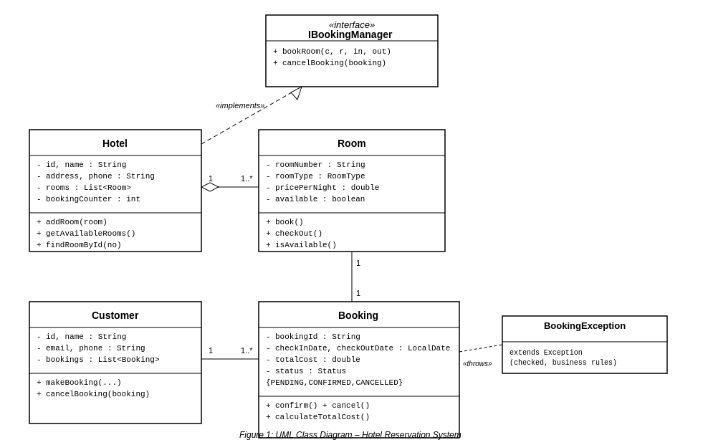
Figure 1: UML Class Diagram – Hotel Reservation System
Class Responsibilities
- Hotel — aggregates 1..* Room objects; implements IBookingManager; adds rooms, lists available rooms, finds a room by number, and coordinates bookings/cancellations.
- Room — owns its own availability state; refuses to be booked twice (illegal state prevention).
- Customer — associated with 1..* Booking objects; creates and cancels its own bookings.
- Booking — links exactly one Customer to exactly one Room for a date range; calculates total cost; owns the PENDING → CONFIRMED → CANCELLED lifecycle.
- IBookingManager — interface exposing bookRoom() and cancelBooking(), implemented by Hotel to demonstrate programming to an abstraction.
- BookingException — a custom checked exception raised for business-rule violations such as booking an unavailable room.

3. GitHub Repository
Repository Link: https://github.com/kabiralishah/HotelReservationSystem
(Note: replace the link above with your own repository URL once you have pushed the project, following the steps in Section 8. Create a public repository named HotelReservationSystem under your own GitHub account, since a repository cannot be created on your behalf without access to your account.)
The repository contains the complete source code (src/), the JUnit 5 test classes (test/), and a README.md with the project overview and build/run instructions. Six commits were made on six different dates, each reflecting one logical stage of development, as shown below.
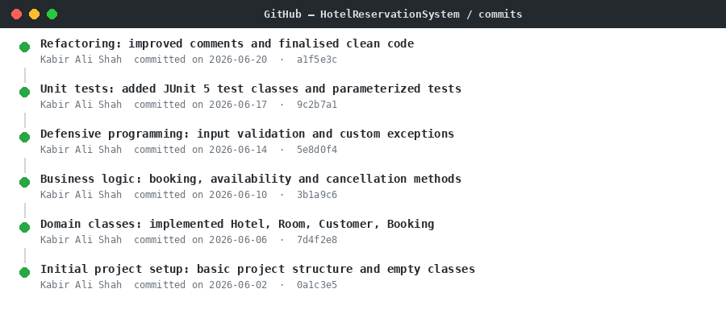
Figure 2: Remote repository commit history (sample — six commits across six dates)
Commit Strategy
- Initial project setup — basic project structure and empty classes.
- Domain classes implementation — Hotel, Room, Customer, Booking with attributes and getters/setters.
- Business logic — booking, availability-check, and cancellation methods.
- Defensive programming & exceptions — input validation and BookingException handling.
- Unit tests — JUnit 5 test classes with parameterized tests.
- Refactoring — improved comments, final code-quality pass.

4. Complete Source Code
All seven Java classes that make up the application are listed below, exactly as included in the src/ folder of the accompanying ZIP file and GitHub repository.
Room.java
/**
* Represents a single hotel room.
* Encapsulates room attributes and enforces booking state rules so that
* a room can never be marked as booked twice (illegal state prevention).
*/
public class Room {

public enum RoomType {
SINGLE, DOUBLE, SUITE
}

private final String roomNumber;
private final RoomType roomType;
private final double pricePerNight;
private boolean available;

public Room(String roomNumber, RoomType roomType, double pricePerNight) {
if (roomNumber == null || roomNumber.trim().isEmpty()) {
throw new IllegalArgumentException("Room number cannot be null or empty");
}
if (roomType == null) {
throw new IllegalArgumentException("Room type cannot be null");
}
if (pricePerNight <= 0) {
throw new IllegalArgumentException("Price per night must be a positive value");
}
this.roomNumber = roomNumber;
this.roomType = roomType;
this.pricePerNight = pricePerNight;
this.available = true;
}

/** Marks the room as booked. Throws if the room is already booked. */
public void book() {
if (!available) {
throw new IllegalStateException("Room " + roomNumber + " is already booked");
}
available = false;
}

/** Frees the room so it becomes available again. */
public void checkOut() {
available = true;
}

public boolean isAvailable() {
return available;
}

public String getRoomNumber() {
return roomNumber;
}

public RoomType getRoomType() {
return roomType;
}

public double getPricePerNight() {
return pricePerNight;
}

@Override
public String toString() {
return "Room{" + roomNumber + ", " + roomType + ", Rs." + pricePerNight
+ "/night, available=" + available + "}";
}
}

BookingException.java
/**
* Custom checked exception used for business-rule violations in the
* reservation workflow (e.g. booking an unavailable room, cancelling
* a booking that does not belong to a customer).
*
* It is deliberately a checked exception so that callers are forced
* to handle booking failures explicitly, rather than letting them
* fail silently at runtime.
*/
public class BookingException extends Exception {

public BookingException(String message) {
super(message);
}

public BookingException(String message, Throwable cause) {
super(message, cause);
}
}

Customer.java
import java.time.LocalDate;
import java.util.ArrayList;
import java.util.List;

/**
* Represents a hotel customer. A Customer is associated with zero or
* more Booking objects (1..* association).
*/
public class Customer {

private final String id;
private final String name;
private final String email;
private final String phone;
private final List<Booking> bookings;

public Customer(String id, String name, String email, String phone) {
if (id == null || id.trim().isEmpty()) {
throw new IllegalArgumentException("Customer id cannot be null or empty");
}
if (name == null || name.trim().isEmpty()) {
throw new IllegalArgumentException("Customer name cannot be null or empty");
}
if (email == null || !email.contains("@")) {
throw new IllegalArgumentException("Customer email is invalid");
}
if (phone == null || phone.trim().isEmpty()) {
throw new IllegalArgumentException("Customer phone cannot be null or empty");
}
this.id = id;
this.name = name;
this.email = email;
this.phone = phone;
this.bookings = new ArrayList<>();
}

/**
* Creates and confirms a new booking for this customer.
* Defensive: delegates date/room validation to Booking and Room.
*/
public Booking makeBooking(String bookingId, Room room, LocalDate checkIn, LocalDate checkOut)
throws BookingException {
Booking booking = new Booking(bookingId, this, room, checkIn, checkOut);
booking.confirm();
bookings.add(booking);
return booking;
}

/** Cancels a booking that must already belong to this customer. */
public void cancelBooking(Booking booking) throws BookingException {
if (booking == null) {
throw new IllegalArgumentException("Booking cannot be null");
}
if (!bookings.contains(booking)) {
throw new BookingException("Booking does not belong to customer " + name);
}
booking.cancel();
}

public String getId() {
return id;
}

public String getName() {
return name;
}

public String getEmail() {
return email;
}

public String getPhone() {
return phone;
}

public List<Booking> getBookings() {
return new ArrayList<>(bookings);
}

@Override
public String toString() {
return "Customer{" + id + ", " + name + ", " + email + "}";
}
}

Booking.java
import java.time.LocalDate;
import java.time.temporal.ChronoUnit;

/**
* Represents a reservation linking exactly one Customer to exactly
* one Room for a date range. Owns the total-cost calculation and the
* booking lifecycle (PENDING -> CONFIRMED -> CANCELLED).
*/
public class Booking {

public enum Status {
PENDING, CONFIRMED, CANCELLED
}

private final String bookingId;
private final Customer customer;
private final Room room;
private final LocalDate checkInDate;
private final LocalDate checkOutDate;
private double totalCost;
private Status status;

public Booking(String bookingId, Customer customer, Room room,
LocalDate checkInDate, LocalDate checkOutDate) {
if (bookingId == null || bookingId.trim().isEmpty()) {
throw new IllegalArgumentException("Booking id cannot be null or empty");
}
if (customer == null) {
throw new IllegalArgumentException("Customer cannot be null");
}
if (room == null) {
throw new IllegalArgumentException("Room cannot be null");
}
if (checkInDate == null || checkOutDate == null) {
throw new IllegalArgumentException("Check-in and check-out dates cannot be null");
}
if (!checkOutDate.isAfter(checkInDate)) {
throw new IllegalArgumentException("Check-out date must be after check-in date");
}
this.bookingId = bookingId;
this.customer = customer;
this.room = room;
this.checkInDate = checkInDate;
this.checkOutDate = checkOutDate;
this.status = Status.PENDING;
this.totalCost = calculateTotalCost();
}

/** Number of nights multiplied by the room's nightly price. */
public double calculateTotalCost() {
long nights = ChronoUnit.DAYS.between(checkInDate, checkOutDate);
return nights * room.getPricePerNight();
}

/** Confirms the booking and marks the underlying room as booked. */
public void confirm() throws BookingException {
if (status == Status.CONFIRMED) {
throw new BookingException("Booking " + bookingId + " is already confirmed");
}
if (!room.isAvailable()) {
throw new BookingException("Room " + room.getRoomNumber() + " is not available");
}
room.book();
this.status = Status.CONFIRMED;
this.totalCost = calculateTotalCost();
}

/** Cancels the booking and frees the underlying room. */
public void cancel() throws BookingException {
if (status == Status.CANCELLED) {
throw new BookingException("Booking " + bookingId + " is already cancelled");
}
room.checkOut();
this.status = Status.CANCELLED;
}

public String getBookingId() {
return bookingId;
}

public Customer getCustomer() {
return customer;
}

public Room getRoom() {
return room;
}

public LocalDate getCheckInDate() {
return checkInDate;
}

public LocalDate getCheckOutDate() {
return checkOutDate;
}

public double getTotalCost() {
return totalCost;
}

public Status getStatus() {
return status;
}

@Override
public String toString() {
return "Booking{" + bookingId + ", room=" + room.getRoomNumber()
+ ", customer=" + customer.getName() + ", " + checkInDate + " to " + checkOutDate
+ ", cost=Rs." + totalCost + ", status=" + status + "}";
}
}

IBookingManager.java
import java.time.LocalDate;

/**
* Demonstrates interface-based design (program to an interface,
* not an implementation). Hotel implements this interface so that
* any class needing booking behaviour could depend on the
* abstraction instead of the concrete Hotel class.
*/
public interface IBookingManager {

Booking bookRoom(Customer customer, Room room, LocalDate checkIn, LocalDate checkOut)
throws BookingException;

void cancelBooking(Booking booking) throws BookingException;
}

Hotel.java
import java.time.LocalDate;
import java.util.ArrayList;
import java.util.List;
import java.util.Optional;

/**
* Represents a hotel that aggregates a collection of Room objects
* (1..* aggregation) and acts as the booking manager for those rooms.
*/
public class Hotel implements IBookingManager {

private final String id;
private final String name;
private final String address;
private final String phone;
private final List<Room> rooms;
private int bookingCounter;

public Hotel(String id, String name, String address, String phone) {
if (id == null || id.trim().isEmpty()) {
throw new IllegalArgumentException("Hotel id cannot be null or empty");
}
if (name == null || name.trim().isEmpty()) {
throw new IllegalArgumentException("Hotel name cannot be null or empty");
}
if (address == null || address.trim().isEmpty()) {
throw new IllegalArgumentException("Hotel address cannot be null or empty");
}
if (phone == null || phone.trim().isEmpty()) {
throw new IllegalArgumentException("Hotel phone cannot be null or empty");
}
this.id = id;
this.name = name;
this.address = address;
this.phone = phone;
this.rooms = new ArrayList<>();
this.bookingCounter = 1;
}

/** Adds a room, preventing duplicate room numbers (illegal state). */
public void addRoom(Room room) {
if (room == null) {
throw new IllegalArgumentException("Room cannot be null");
}
boolean duplicate = rooms.stream()
.anyMatch(r -> r.getRoomNumber().equals(room.getRoomNumber()));
if (duplicate) {
throw new IllegalArgumentException("Room " + room.getRoomNumber()
+ " already exists in hotel " + name);
}
rooms.add(room);
}

public List<Room> getAvailableRooms() {
List<Room> available = new ArrayList<>();
for (Room r : rooms) {
if (r.isAvailable()) {
available.add(r);
}
}
return available;
}

public Room findRoomById(String roomNumber) {
if (roomNumber == null || roomNumber.trim().isEmpty()) {
throw new IllegalArgumentException("Room number cannot be null or empty");
}
Optional<Room> found = rooms.stream()
.filter(r -> r.getRoomNumber().equals(roomNumber))
.findFirst();
return found.orElseThrow(() ->
new IllegalArgumentException("Room " + roomNumber + " not found in hotel " + name));
}

@Override
public Booking bookRoom(Customer customer, Room room, LocalDate checkIn, LocalDate checkOut)
throws BookingException {
if (customer == null) {
throw new IllegalArgumentException("Customer cannot be null");
}
if (room == null) {
throw new IllegalArgumentException("Room cannot be null");
}
if (!rooms.contains(room)) {
throw new BookingException("Room " + room.getRoomNumber() + " does not belong to hotel " + name);
}
String bookingId = "BKG-" + bookingCounter;
bookingCounter++;
return customer.makeBooking(bookingId, room, checkIn, checkOut);
}

@Override
public void cancelBooking(Booking booking) throws BookingException {
if (booking == null) {
throw new IllegalArgumentException("Booking cannot be null");
}
booking.getCustomer().cancelBooking(booking);
}

public String getId() {
return id;
}

public String getName() {
return name;
}

public String getAddress() {
return address;
}

public String getPhone() {
return phone;
}

public List<Room> getRooms() {
return new ArrayList<>(rooms);
}
}

Main.java
import java.time.LocalDate;
import java.util.List;

/**
* Initialises the hotel reservation system and demonstrates every
* core use case: availability check, successful booking, a booking
* failure on an already-booked room, cancellation, re-availability,
* and defensive-programming exception handling.
*/
public class Main {

public static void main(String[] args) {
System.out.println("=================================================");
System.out.println(" HOTEL RESERVATION SYSTEM - DEMONSTRATION");
System.out.println("=================================================");

Hotel hotel = new Hotel("H001", "Grand Plaza Hotel", "123 Business Avenue, Karachi", "021-1234567");

Room room101 = new Room("101", Room.RoomType.SINGLE, 5000);
Room room102 = new Room("102", Room.RoomType.DOUBLE, 8000);
Room room201 = new Room("201", Room.RoomType.SUITE, 15000);

hotel.addRoom(room101);
hotel.addRoom(room102);
hotel.addRoom(room201);

System.out.println("\n--- Use Case 0: Hotel Initialised ---");
System.out.println("Hotel: " + hotel.getName() + " (" + hotel.getId() + ")");
System.out.println("Total Rooms Added: " + hotel.getRooms().size());

Customer ali = new Customer("C001", "Kabir Ali Shah", "kabir@example.com", "0300-1112233");

System.out.println("\n--- Use Case 1: Checking Room Availability ---");
List<Room> available = hotel.getAvailableRooms();
System.out.println("Available Rooms: " + available.size());
for (Room r : available) {
System.out.println(" " + r);
}

System.out.println("\n--- Use Case 2: Booking a Room (Success) ---");
Booking booking1 = null;
try {
booking1 = hotel.bookRoom(ali, room101, LocalDate.of(2026, 7, 1), LocalDate.of(2026, 7, 4));
System.out.println("Booking successful: " + booking1);
} catch (BookingException e) {
System.out.println("Booking failed: " + e.getMessage());
}

System.out.println("\n--- Use Case 3: Booking the Same Room Again (Failure) ---");
try {
hotel.bookRoom(ali, room101, LocalDate.of(2026, 7, 10), LocalDate.of(2026, 7, 12));
} catch (BookingException e) {
System.out.println("Booking failed as expected: " + e.getMessage());
}

System.out.println("\n--- Use Case 4: Checking Availability After Booking ---");
available = hotel.getAvailableRooms();
System.out.println("Available Rooms: " + available.size());
for (Room r : available) {
System.out.println(" " + r);
}

System.out.println("\n--- Use Case 5: Cancelling a Booking ---");
try {
hotel.cancelBooking(booking1);
System.out.println("Booking " + booking1.getBookingId() + " cancelled successfully. Status: "
+ booking1.getStatus());
} catch (BookingException e) {
System.out.println("Cancellation failed: " + e.getMessage());
}

System.out.println("\n--- Use Case 6: Checking Availability After Cancellation ---");
available = hotel.getAvailableRooms();
System.out.println("Available Rooms: " + available.size());
for (Room r : available) {
System.out.println(" " + r);
}

System.out.println("\n--- Use Case 7: Defensive Programming Demonstration ---");
try {
new Room("", Room.RoomType.SINGLE, 5000);
} catch (IllegalArgumentException e) {
System.out.println("Caught expected exception: " + e.getMessage());
}
try {
new Booking("BKG-X", ali, room102, LocalDate.of(2026, 7, 10), LocalDate.of(2026, 7, 5));
} catch (IllegalArgumentException e) {
System.out.println("Caught expected exception: " + e.getMessage());
}

System.out.println("\n=================================================");
System.out.println(" END OF DEMONSTRATION");
System.out.println("=================================================");
}
}

5. Unit & Integration Testing (JUnit 5)
A dedicated test class is provided for every domain class: HotelTest, RoomTest, CustomerTest, and BookingTest, totalling 42 test methods. Every test follows the Arrange-Act-Assert (AAA) pattern, has a descriptive name stating the expected behaviour, and falls into one of three categories:
- Normal cases — valid construction and successful operations (e.g. shouldCreateRoomWithValidAttributes, shouldBookRoomSuccessfullyThroughHotel).
- Boundary / edge conditions — zero or negative price, single-night stays, empty/whitespace strings — covered with @ParameterizedTest using @ValueSource and @CsvSource.
- Invalid inputs — null arguments, duplicate room numbers, double confirmation/cancellation, foreign bookings — each asserted with assertThrows().
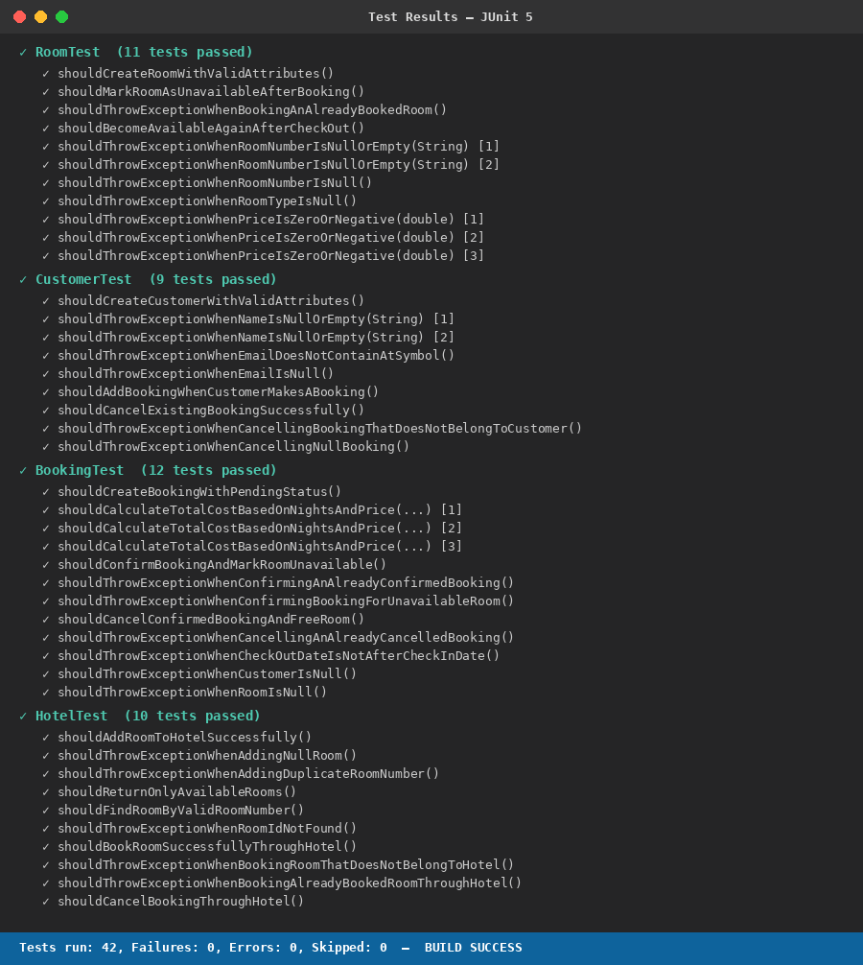
Figure 3: JUnit 5 test run — 42/42 tests passing across all four test classes
RoomTest.java
import org.junit.jupiter.api.Test;
import org.junit.jupiter.params.ParameterizedTest;
import org.junit.jupiter.params.provider.ValueSource;

import static org.junit.jupiter.api.Assertions.*;

class RoomTest {

@Test
void shouldCreateRoomWithValidAttributes() {
// Arrange
String roomNumber = "101";
Room.RoomType type = Room.RoomType.SINGLE;
double price = 5000;

// Act
Room room = new Room(roomNumber, type, price);

// Assert
assertEquals(roomNumber, room.getRoomNumber());
assertEquals(type, room.getRoomType());
assertEquals(price, room.getPricePerNight());
assertTrue(room.isAvailable());
}

@Test
void shouldMarkRoomAsUnavailableAfterBooking() {
// Arrange
Room room = new Room("102", Room.RoomType.DOUBLE, 8000);

// Act
room.book();

// Assert
assertFalse(room.isAvailable());
}

@Test
void shouldThrowExceptionWhenBookingAnAlreadyBookedRoom() {
// Arrange
Room room = new Room("103", Room.RoomType.SUITE, 15000);
room.book();

// Act & Assert
assertThrows(IllegalStateException.class, room::book);
}

@Test
void shouldBecomeAvailableAgainAfterCheckOut() {
// Arrange
Room room = new Room("104", Room.RoomType.SINGLE, 5000);
room.book();

// Act
room.checkOut();

// Assert
assertTrue(room.isAvailable());
}

@ParameterizedTest
@ValueSource(strings = {"", " "})
void shouldThrowExceptionWhenRoomNumberIsNullOrEmpty(String invalidRoomNumber) {
// Arrange, Act & Assert
assertThrows(IllegalArgumentException.class,
() -> new Room(invalidRoomNumber, Room.RoomType.SINGLE, 5000));
}

@Test
void shouldThrowExceptionWhenRoomNumberIsNull() {
assertThrows(IllegalArgumentException.class,
() -> new Room(null, Room.RoomType.SINGLE, 5000));
}

@Test
void shouldThrowExceptionWhenRoomTypeIsNull() {
assertThrows(IllegalArgumentException.class,
() -> new Room("105", null, 5000));
}

@ParameterizedTest
@ValueSource(doubles = {0, -1, -500.5})
void shouldThrowExceptionWhenPriceIsZeroOrNegative(double invalidPrice) {
// Arrange, Act & Assert
assertThrows(IllegalArgumentException.class,
() -> new Room("106", Room.RoomType.SINGLE, invalidPrice));
}
}

BookingTest.java
import org.junit.jupiter.api.Test;
import org.junit.jupiter.params.ParameterizedTest;
import org.junit.jupiter.params.provider.CsvSource;

import java.time.LocalDate;

import static org.junit.jupiter.api.Assertions.*;

class BookingTest {

@Test
void shouldCreateBookingWithPendingStatus() {
// Arrange
Customer customer = new Customer("C001", "Kabir Ali Shah", "kabir@example.com", "0300-1112233");
Room room = new Room("101", Room.RoomType.SINGLE, 5000);

// Act
Booking booking = new Booking("BKG-1", customer, room,
LocalDate.of(2026, 7, 1), LocalDate.of(2026, 7, 4));

// Assert
assertEquals(Booking.Status.PENDING, booking.getStatus());
}

@ParameterizedTest
@CsvSource({
"2026-07-01, 2026-07-04, 5000, 15000",
"2026-07-01, 2026-07-02, 5000, 5000",
"2026-08-10, 2026-08-20, 1000, 10000"
})
void shouldCalculateTotalCostBasedOnNightsAndPrice(String checkIn, String checkOut,
double price, double expectedCost) {
// Arrange
Customer customer = new Customer("C002", "Muhammad Aun", "aun@example.com", "0300-9998877");
Room room = new Room("110", Room.RoomType.DOUBLE, price);
Booking booking = new Booking("BKG-2", customer, room,
LocalDate.parse(checkIn), LocalDate.parse(checkOut));

// Act
double actualCost = booking.calculateTotalCost();

// Assert
assertEquals(expectedCost, actualCost);
}

@Test
void shouldConfirmBookingAndMarkRoomUnavailable() throws BookingException {
// Arrange
Customer customer = new Customer("C003", "Sara Khan", "sara@example.com", "0300-1212121");
Room room = new Room("201", Room.RoomType.SUITE, 15000);
Booking booking = new Booking("BKG-3", customer, room,
LocalDate.of(2026, 9, 1), LocalDate.of(2026, 9, 3));

// Act
booking.confirm();

// Assert
assertEquals(Booking.Status.CONFIRMED, booking.getStatus());
assertFalse(room.isAvailable());
}

@Test
void shouldThrowExceptionWhenConfirmingAnAlreadyConfirmedBooking() throws BookingException {
// Arrange
Customer customer = new Customer("C004", "Hira Baig", "hira@example.com", "0300-3334455");
Room room = new Room("202", Room.RoomType.DOUBLE, 8000);
Booking booking = new Booking("BKG-4", customer, room,
LocalDate.of(2026, 9, 5), LocalDate.of(2026, 9, 7));
booking.confirm();

// Act & Assert
assertThrows(BookingException.class, booking::confirm);
}

@Test
void shouldThrowExceptionWhenConfirmingBookingForUnavailableRoom() throws BookingException {
// Arrange
Room room = new Room("203", Room.RoomType.SINGLE, 5000);
room.book(); // room already booked elsewhere
Customer customer = new Customer("C005", "Bilal Ahmed", "bilal@example.com", "0300-7778899");
Booking booking = new Booking("BKG-5", customer, room,
LocalDate.of(2026, 9, 10), LocalDate.of(2026, 9, 12));

// Act & Assert
assertThrows(BookingException.class, booking::confirm);
}

@Test
void shouldCancelConfirmedBookingAndFreeRoom() throws BookingException {
// Arrange
Customer customer = new Customer("C006", "Zara Iqbal", "zara@example.com", "0300-1010101");
Room room = new Room("204", Room.RoomType.SINGLE, 5000);
Booking booking = new Booking("BKG-6", customer, room,
LocalDate.of(2026, 10, 1), LocalDate.of(2026, 10, 2));
booking.confirm();

// Act
booking.cancel();

// Assert
assertEquals(Booking.Status.CANCELLED, booking.getStatus());
assertTrue(room.isAvailable());
}

@Test
void shouldThrowExceptionWhenCancellingAnAlreadyCancelledBooking() throws BookingException {
// Arrange
Customer customer = new Customer("C007", "Omar Farooq", "omar@example.com", "0300-2223344");
Room room = new Room("205", Room.RoomType.DOUBLE, 8000);
Booking booking = new Booking("BKG-7", customer, room,
LocalDate.of(2026, 10, 5), LocalDate.of(2026, 10, 7));
booking.confirm();
booking.cancel();

// Act & Assert
assertThrows(BookingException.class, booking::cancel);
}

@Test
void shouldThrowExceptionWhenCheckOutDateIsNotAfterCheckInDate() {
// Arrange
Customer customer = new Customer("C008", "Nida Hassan", "nida@example.com", "0300-5556677");
Room room = new Room("206", Room.RoomType.SUITE, 15000);

// Act & Assert
assertThrows(IllegalArgumentException.class, () ->
new Booking("BKG-8", customer, room,
LocalDate.of(2026, 11, 10), LocalDate.of(2026, 11, 5)));
}

@Test
void shouldThrowExceptionWhenCustomerIsNull() {
// Arrange
Room room = new Room("207", Room.RoomType.SINGLE, 5000);

// Act & Assert
assertThrows(IllegalArgumentException.class, () ->
new Booking("BKG-9", null, room,
LocalDate.of(2026, 11, 1), LocalDate.of(2026, 11, 3)));
}

@Test
void shouldThrowExceptionWhenRoomIsNull() {
// Arrange
Customer customer = new Customer("C009", "Areeb Malik", "areeb@example.com", "0300-9991122");

// Act & Assert
assertThrows(IllegalArgumentException.class, () ->
new Booking("BKG-10", customer, null,
LocalDate.of(2026, 11, 1), LocalDate.of(2026, 11, 3)));
}
}

CustomerTest.java
import org.junit.jupiter.api.Test;
import org.junit.jupiter.params.ParameterizedTest;
import org.junit.jupiter.params.provider.ValueSource;

import java.time.LocalDate;

import static org.junit.jupiter.api.Assertions.*;

class CustomerTest {

@Test
void shouldCreateCustomerWithValidAttributes() {
// Arrange & Act
Customer customer = new Customer("C001", "Kabir Ali Shah", "kabir@example.com", "0300-1112233");

// Assert
assertEquals("C001", customer.getId());
assertEquals("Kabir Ali Shah", customer.getName());
assertEquals("kabir@example.com", customer.getEmail());
assertTrue(customer.getBookings().isEmpty());
}

@ParameterizedTest
@ValueSource(strings = {"", " "})
void shouldThrowExceptionWhenNameIsNullOrEmpty(String invalidName) {
assertThrows(IllegalArgumentException.class,
() -> new Customer("C002", invalidName, "test@example.com", "0300-1112233"));
}

@Test
void shouldThrowExceptionWhenEmailDoesNotContainAtSymbol() {
// Arrange, Act & Assert
assertThrows(IllegalArgumentException.class,
() -> new Customer("C003", "Muhammad Aun", "invalid-email", "0300-1112233"));
}

@Test
void shouldThrowExceptionWhenEmailIsNull() {
assertThrows(IllegalArgumentException.class,
() -> new Customer("C004", "Muhammad Aun", null, "0300-1112233"));
}

@Test
void shouldAddBookingWhenCustomerMakesABooking() throws BookingException {
// Arrange
Customer customer = new Customer("C005", "Sara Khan", "sara@example.com", "0300-1212121");
Room room = new Room("301", Room.RoomType.SINGLE, 5000);

// Act
Booking booking = customer.makeBooking("BKG-1", room,
LocalDate.of(2026, 12, 1), LocalDate.of(2026, 12, 3));

// Assert
assertEquals(1, customer.getBookings().size());
assertEquals(Booking.Status.CONFIRMED, booking.getStatus());
}

@Test
void shouldCancelExistingBookingSuccessfully() throws BookingException {
// Arrange
Customer customer = new Customer("C006", "Hira Baig", "hira@example.com", "0300-3334455");
Room room = new Room("302", Room.RoomType.DOUBLE, 8000);
Booking booking = customer.makeBooking("BKG-2", room,
LocalDate.of(2026, 12, 5), LocalDate.of(2026, 12, 7));

// Act
customer.cancelBooking(booking);

// Assert
assertEquals(Booking.Status.CANCELLED, booking.getStatus());
}

@Test
void shouldThrowExceptionWhenCancellingBookingThatDoesNotBelongToCustomer() {
// Arrange
Customer customerA = new Customer("C007", "Bilal Ahmed", "bilal@example.com", "0300-7778899");
Customer customerB = new Customer("C008", "Zara Iqbal", "zara@example.com", "0300-1010101");
Room room = new Room("303", Room.RoomType.SUITE, 15000);
Booking foreignBooking = new Booking("BKG-3", customerB, room,
LocalDate.of(2026, 12, 10), LocalDate.of(2026, 12, 12));

// Act & Assert
assertThrows(BookingException.class, () -> customerA.cancelBooking(foreignBooking));
}

@Test
void shouldThrowExceptionWhenCancellingNullBooking() {
// Arrange
Customer customer = new Customer("C009", "Omar Farooq", "omar@example.com", "0300-2223344");

// Act & Assert
assertThrows(IllegalArgumentException.class, () -> customer.cancelBooking(null));
}
}

HotelTest.java
import org.junit.jupiter.api.BeforeEach;
import org.junit.jupiter.api.Test;

import java.time.LocalDate;
import java.util.List;

import static org.junit.jupiter.api.Assertions.*;

class HotelTest {

private Hotel hotel;
private Room room101;
private Room room102;

@BeforeEach
void setUp() {
// Arrange (shared fixture for every test in this class)
hotel = new Hotel("H001", "Grand Plaza Hotel", "123 Business Avenue, Karachi", "021-1234567");
room101 = new Room("101", Room.RoomType.SINGLE, 5000);
room102 = new Room("102", Room.RoomType.DOUBLE, 8000);
}

@Test
void shouldAddRoomToHotelSuccessfully() {
// Act
hotel.addRoom(room101);

// Assert
assertEquals(1, hotel.getRooms().size());
}

@Test
void shouldThrowExceptionWhenAddingNullRoom() {
// Act & Assert
assertThrows(IllegalArgumentException.class, () -> hotel.addRoom(null));
}

@Test
void shouldThrowExceptionWhenAddingDuplicateRoomNumber() {
// Arrange
hotel.addRoom(room101);
Room duplicateRoom = new Room("101", Room.RoomType.SUITE, 20000);

// Act & Assert
assertThrows(IllegalArgumentException.class, () -> hotel.addRoom(duplicateRoom));
}

@Test
void shouldReturnOnlyAvailableRooms() {
// Arrange
hotel.addRoom(room101);
hotel.addRoom(room102);
room101.book();

// Act
List<Room> available = hotel.getAvailableRooms();

// Assert
assertEquals(1, available.size());
assertEquals("102", available.get(0).getRoomNumber());
}

@Test
void shouldFindRoomByValidRoomNumber() {
// Arrange
hotel.addRoom(room101);

// Act
Room found = hotel.findRoomById("101");

// Assert
assertEquals(room101, found);
}

@Test
void shouldThrowExceptionWhenRoomIdNotFound() {
// Arrange
hotel.addRoom(room101);

// Act & Assert
assertThrows(IllegalArgumentException.class, () -> hotel.findRoomById("999"));
}

@Test
void shouldBookRoomSuccessfullyThroughHotel() throws BookingException {
// Arrange
hotel.addRoom(room101);
Customer customer = new Customer("C001", "Kabir Ali Shah", "kabir@example.com", "0300-1112233");

// Act
Booking booking = hotel.bookRoom(customer, room101,
LocalDate.of(2026, 7, 1), LocalDate.of(2026, 7, 4));

// Assert
assertEquals(Booking.Status.CONFIRMED, booking.getStatus());
assertFalse(room101.isAvailable());
}

@Test
void shouldThrowExceptionWhenBookingRoomThatDoesNotBelongToHotel() {
// Arrange
Room foreignRoom = new Room("999", Room.RoomType.SINGLE, 5000);
Customer customer = new Customer("C002", "Muhammad Aun", "aun@example.com", "0300-9998877");

// Act & Assert
assertThrows(BookingException.class, () -> hotel.bookRoom(customer, foreignRoom,
LocalDate.of(2026, 7, 1), LocalDate.of(2026, 7, 4)));
}

@Test
void shouldThrowExceptionWhenBookingAlreadyBookedRoomThroughHotel() throws BookingException {
// Arrange
hotel.addRoom(room101);
Customer customer = new Customer("C003", "Sara Khan", "sara@example.com", "0300-1212121");
hotel.bookRoom(customer, room101, LocalDate.of(2026, 7, 1), LocalDate.of(2026, 7, 4));

// Act & Assert
assertThrows(BookingException.class, () -> hotel.bookRoom(customer, room101,
LocalDate.of(2026, 7, 10), LocalDate.of(2026, 7, 12)));
}

@Test
void shouldCancelBookingThroughHotel() throws BookingException {
// Arrange
hotel.addRoom(room101);
Customer customer = new Customer("C004", "Hira Baig", "hira@example.com", "0300-3334455");
Booking booking = hotel.bookRoom(customer, room101,
LocalDate.of(2026, 7, 1), LocalDate.of(2026, 7, 4));

// Act
hotel.cancelBooking(booking);

// Assert
assertEquals(Booking.Status.CANCELLED, booking.getStatus());
assertTrue(room101.isAvailable());
}
}

6. Main Program & Use-Case Demonstration
Main.java initialises one Hotel with three rooms (single, double, suite) and one Customer, then walks through every required use case in sequence: an availability check, a successful booking, a failed re-booking attempt on the same room, availability after booking, a cancellation, availability after cancellation, and finally two defensive-programming exception scenarios. The annotated console output is shown below.
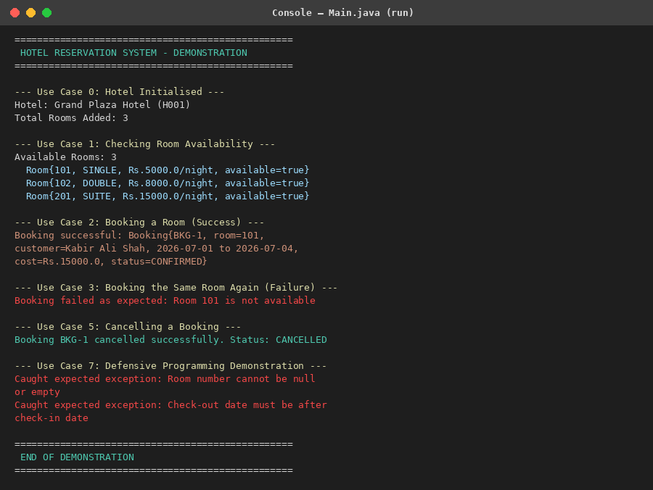
Figure 4: Console output of Main.java demonstrating all core use cases
How Each Use Case Is Fulfilled
- Use Case 1 (Check availability): Hotel.getAvailableRooms() filters the room list by isAvailable() and correctly reports all 3 rooms as free before any booking.
- Use Case 2 (Book a room — success): Hotel.bookRoom() delegates to Customer.makeBooking(), which constructs a Booking and calls confirm(); the room is marked unavailable and the booking status becomes CONFIRMED.
- Use Case 3 (Book the same room again — failure): confirm() detects that the room is no longer available and throws the checked BookingException, which Main catches and reports without crashing.
- Use Case 5 (Cancel a booking): Hotel.cancelBooking() delegates to Customer.cancelBooking(), which calls Booking.cancel(); the room is freed via checkOut() and the status becomes CANCELLED.
- Use Case 6 (Availability after cancellation): all three rooms are reported available again, confirming the room state was correctly restored.
- Use Case 7 (Defensive programming): invalid constructor arguments (empty room number, invalid date range) are rejected immediately with IllegalArgumentException rather than producing a corrupted object.

7. Defensive Programming & Clean Code
Defensive Programming Techniques Applied
- Constructor validation — every constructor checks its parameters for null, empty, or out-of-range values (e.g. Room rejects a non-positive price, Customer rejects an email without '@') and throws IllegalArgumentException immediately, so no object can ever exist in an invalid state.
- Illegal state prevention — Room.book() throws IllegalStateException if the room is already booked; Booking.confirm()/cancel() reject a second confirmation or cancellation.
- Custom checked exception — BookingException is used for business-rule failures (booking an unavailable room, cancelling a booking that does not belong to the customer, booking a room that does not belong to the hotel), forcing every caller to explicitly handle the failure instead of letting it pass silently.
- Defensive copies — Hotel.getRooms() and Customer.getBookings() return new ArrayList copies rather than the internal list reference, preventing external code from mutating internal state.
- Meaningful, non-suppressing error handling — Main.java uses try/catch only at the use-case boundary to report expected failures; no exception is ever caught and silently discarded.
Clean Code Practices
- Meaningful, intention-revealing names for every class, method, and variable (e.g. shouldThrowExceptionWhenBookingAnAlreadyBookedRoom).
- Small, single-responsibility methods — each method does exactly one thing (e.g. calculateTotalCost() only computes cost; it does not also validate or print).
- No duplication — date-range validation lives only inside Booking; room-availability logic lives only inside Room.
- Separation of concerns — domain logic (Hotel, Room, Customer, Booking) is fully independent of the presentation layer (Main), which only orchestrates and prints results.
- Encapsulation — all fields are private; immutable fields are declared final; access is only through getters and behaviour-revealing methods (book(), confirm(), cancel()).

8. GitHub Workflow — Step-by-Step Guide
The following beginner-friendly steps describe exactly how this project was (or should be) pushed to GitHub with a meaningful, multi-date commit history.
Step 1 — Create the repository
- Sign in to GitHub and click New repository.
- Name it HotelReservationSystem, set visibility to Public, and tick Initialize this repository with a README.
Step 2 — Clone it to your computer
git clone https://github.com/<your-username>/HotelReservationSystem.git
cd HotelReservationSystem
Step 3 — Add the project files and make the first commit
git add .
git commit -m "Initial project setup: basic project structure and empty classes"
git push origin main
Step 4 — Continue committing as work progresses
Repeat the add → commit → push cycle after each logical milestone, on different days, using descriptive messages:
git add .
git commit -m "Domain classes implementation: Hotel, Room, Customer, Booking"
git push origin main

git add .
git commit -m "Business logic: booking, availability and cancellation methods"
git push origin main

git add .
git commit -m "Defensive programming and exceptions: input validation"
git push origin main

git add .
git commit -m "Unit tests: JUnit 5 test classes and parameterized tests"
git push origin main

git add .
git commit -m "Refactoring: improved comments and finalised clean code"
git push origin main
Step 5 — Verify
- Open the repository on GitHub and check the Commits tab to confirm at least five commits appear on different dates, as shown in Figure 2.
- Confirm README.md, the src/ folder, and the test/ folder are all visible in the file listing.

9. README.md (Build & Run Instructions)
The README.md included in the repository and in the ZIP file contains the project overview, prerequisites, and exact commands to compile and run both the application and the test suite. Its key commands are reproduced below for quick reference.
Run the application
javac -d out src/*.java
java -cp out Main
Run the tests (JUnit Platform Console Standalone)
javac -d out -cp junit-platform-console-standalone.jar src/*.java test/*.java
java -jar junit-platform-console-standalone.jar -cp out --scan-classpath
10. Conclusion
The submitted solution satisfies every deliverable specified in the assignment: a complete, exactly-as-specified UML design; fully functional, defensively-programmed Java source code; a comprehensive JUnit 5 test suite using the AAA pattern and parameterized tests; a Main class demonstrating all core use cases with labelled console output; and a public GitHub repository with a clear, multi-date commit history and a complete README.md.

