Unit One Exam
Population Ecosystems/Health
8th Grade Science
Name: _______________________________________
Date: ________________________________________

I can design the components of a valid experiment involving a testable question, variables and the tools necessary.
I can predict how ecosystems are affected by changes in organisms and human impacts.
I can diagram and describe the transfer of energy in a food web.
I can illustrate the oxygen/carbon dioxide cycles including photosynthesis and cellular respiration.
I can relate adaptations of an organism to its ability to survive in a specific environment.
I can understand the organization of life from cells to organ systems.
I can understand the interactions between organ systems.
I can explain how reproduction can occur sexually or asexually.
I can explain how genetic material is passed on in sexual and asexual reproduction.

Session 1
Constructed Response

Go On►

Hits both objectives|
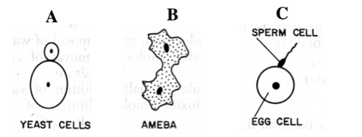
- The diagram below represents organisms reproducing.
(a) Classify each as either sexual or asexual reproduction.
______________________________________________________________________
______________________________________________________________________
______________________________________________________________________
(b) What are the advantages and disadvantages of sexual and asexual reproduction?
______________________________________________________________________
______________________________________________________________________
______________________________________________________________________
how ecosystems are affected
- A chemical spill has just occurred in the Florida Keys ecosystem. This ecosystem is dominated by algae, _____ fish and _________. This chemical is known to decrease the growth of algae. How will this spill affect the food webs in that ecosystem?
______________________________________________________________________
______________________________________________________________________
______________________________________________________________________
______________________________________________________________________
______________________________________________________________________
- Some cells have structures called chloroplasts, which contain the green pigment chlorophyll.
(a) Explain the role of chloroplasts in these cells.
__________________________________________________________________
__________________________________________________________________
__________________________________________________________________
(b) Name two things from the environment that chloroplasts must have to perform this role.
1. ________________________________________________________________
2. ________________________________________________________________
I can understand the interactions between organ systems.
- Describe how the nervous system and the muscular system work together when an organism responds to a stimulus.
Add picture?
________________________________________________________________
________________________________________________________________
________________________________________________________________
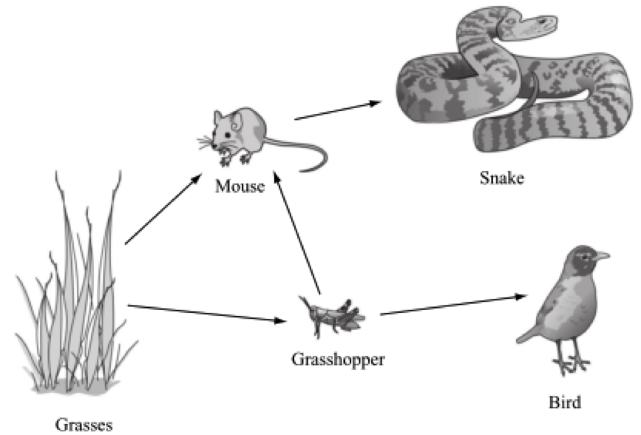
I can diagram and describe the transfer of energy in a food web.
Use the following food web to answer the next two questions.
- Identify each organism in this food web as a producer, a primary consumer or a secondary consumer.
____________________________________________________________________________
____________________________________________________________________________
____________________________________________________________________________
I can predict how ecosystems are affected by changes in organisms and human impacts.
- Using only the organisms from this food web, describe one change in this grassland ecosystem that would result in a decrease in the grasshopper population. Explain the reasoning for your answer.
____________________________________________________________
____________________________________________________________

Stop!!!

Session 2
Selected Response

Go On►

Selected Responses
Fill in the circle for the response that best answers the statement or question.
I can design the components of a valid experiment involving a testable question, variables and the tools necessary.

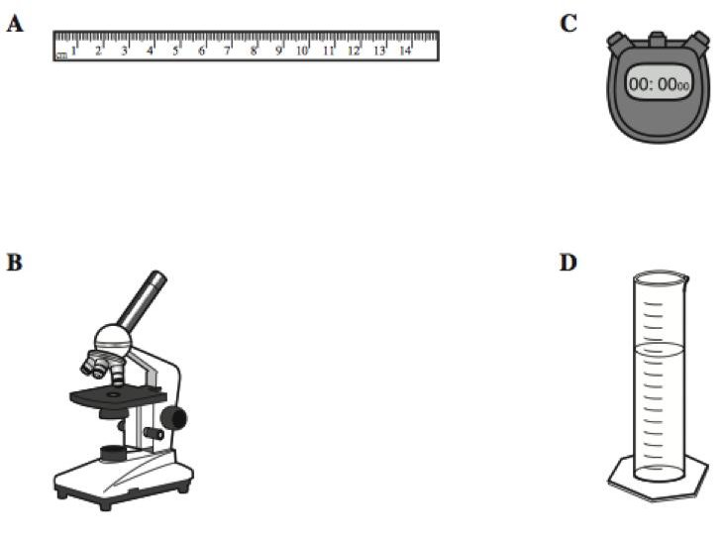
- A student wants to see the xylem of the plant stem. Which instrument should the student use?
○ A
○ B
○ C
○ D
Go On►
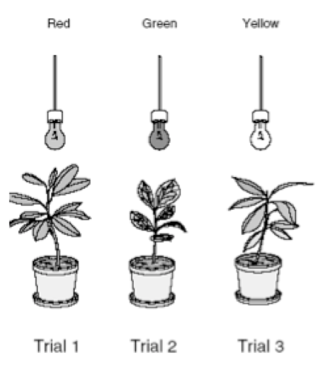
- The experiment above was set up to test the hypothesis that plants grow faster in green light. The same amount of water and fertilizer were added to each pot. Which of these would improve the experiment?
○ use different pots for each plant
○ use the same kind of plant in all trials
○ add more types of plants
○ use green lights for all three plants
- A student hypothesizes that green algae will grow fastest when exposed to blue light. To test this hypothesis, the student should design an experiment with which independent variable?
○ color of algae
○ amount of time per day that algae are exposed to light
○ color of light that algae are exposed to
○ rate of algae growth
I can predict how ecosystems are affected by changes in organisms and human impacts.
- Which of the following human activities might endanger some plants and animals?
○ planting trees after a a forest fire
○ recycling paper and aluminum cans
○ causing oil spills in the Gulf of Mexico
○ tagging birds to discover patterns of migration
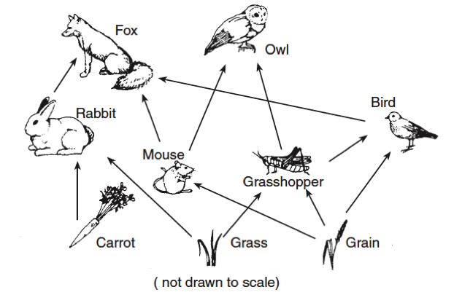
- Which three organisms are competing for the same food resource?
○ carrot, rabbit, and fox
○ grain, bird, and owl
○ fox, owl, and rabbit
○ bird, mouse, and grasshopper
- According to the chart, what would most likely happen in an ecosystem if there were a sudden decrease in the number of bacteria and fungi?
○ The number of plants would increase.
○ The number of bees would increase.
○ The amount of nutrients in the soil would decrease.
○ The amount of water in the air would decrease.
I can diagram and describe the transfer of energy in a food web.
- The diagram below shows a food web in a large park. Each circle represents a different species in the food web. Which of the organisms in the food web could be referred to as primary consumers?j
○ 7 only
○ 5 and 6 only
○ 2, 3, and 4 only
○ 2, 5, and 7 only
- Which of the following living things in an aquatic ecosystem uses the sun’s energy to turn water and carbon dioxide into food molecules?
○ insect
○ frog
○ water lily
○ small fish
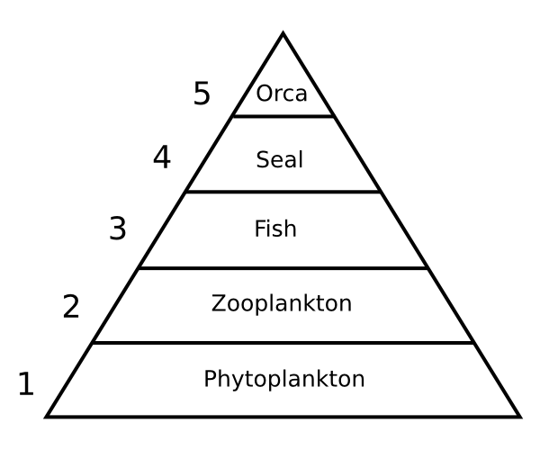
- At which level of this energy pyramid is the most energy available?
○ Level 1
○ Level 2
○ Level 3
○ Level 4
○ Level 5
I can illustrate the oxygen/carbon dioxide cycles including photosynthesis and cellular respiration.
- Susan had begun to describe how oxygen and carbon dioxide are cycled through the Earth’s atmosphere. She knows that plants take in carbon dioxide from the air and release oxygen. What happens next as oxygen and carbon dioxide are cycled through the atmosphere?
○ Animals breathe in oxygen and release oxygen.
○ Animals breathe in oxygen and release carbon dioxide.
○ The oxygen goes into the ground, where plant roots absorb it.
○ Decomposers in the ground turn the oxygen into carbon dioxide.
- Which activity occurs at X?
○ Plants are eaten by animals for food.
○ Carbon dioxide and water are used to make sugar.
○ Plants release water into the soil.
○ Animals breathe out carbon dioxide.
- How do plants and animals depend on each other?
○ Plants and animals both produce carbon dioxide during photosynthesis and respiration.
○ Plants and animals both produce oxygen during photosynthesis and respiration.
○ During photosynthesis, animals give off oxygen that plants need, and during respiration, plants give off carbon dioxide that animals need.
○ During photosynthesis, plants give off oxygen that animals need, and during respiration, animals give off carbon dioxide that plants need.
- An increase in the average level of carbon dioxide in the atmosphere is most likely caused by an increase in the —
○ extinctions of animals
○ plant life on Earth
○ number of large forest fires
○ number of solar-powered homes
I can relate adaptations of an organism to its ability to survive in a specific environment.
- Animals usually have physical features that help them live in certain places. Look at the picture shown above. This animal lives in a hot desert. What physical feature does the animal have that helps it lose heat?
○ a thick coat of fur
○ a bushy tail
○ small eyes
○ large ears
- Some types of bacteria can only live where oxygen is not present. These bacteria were well adapted to life on Earth over 2 billion years ago. Which of the following changes caused many of these bacteria to become extinct?
○ the slow movement of tectonic plates
○ the varying temperatures of each season
○ an increase in volcanic activity under the oceans
○ an increase in the number of photosynthetic organisms
- Which statement best explains what adaptation allows mammals to live in very cold regions of the world while lizards can not?
○ Both mammals and lizards are cold-blooded, but mammals have fur to keep them warm.
○ Both mammals and lizards are warm blooded but lizards get too cold when they shed their skin.
○ Since mammals but not lizards are warm blooded their body temperature will adjust tomatch the external temperature.
○ Since mammals but not lizards are warm-blooded, they will maintina their body temperature using heat from metabolic processes.
I can understand the organization of life from cells to organ systems.
- Of all the known organisms, the majority of them are
○ animals
○ plants
○ multicellular
○ unicellular
- Which picture depicts a single-celled organism?
THERE IS NO PICTURE HERE!!!!!
○ (bacteria picture)
○ (cactus picture)
○ (fly picture)
○ (mushroom picture)
- A student prepared the following list of characteristics about a part of the cell
- present in animal cells
- present in plant cells
- regulates what substances go in and come out of the cell
Which of the following cellular structures is the student describing?
○ cell wall
○ chloroplast
○ mitochondria
○ nucleus
I can understand the interactions between organ systems.
- The possible movement represented by the arrows in the diagram is coordinated by the
○ circulatory system
○ excretory system
○ nervous system
○ reproductive system
- The process that changes food into cellular energy involves several body systems. How is the digestive system involved in this process?
○ It delivers a simple sugar to cells that they use to produce energy during cellular respiration.
○ It captures oxygen and carbon dioxide gases and holds them until they can be delivered to cells.
○ It changes food into simple compounds through a series of physical and chemical changes.
○ It produces white blood cells that fight food poisoning and other diseases caused by food.
- When carbon dioxide and other waste products are released by cells, they are carried away from the cells by the bloodstream. What becomes of the wastes after they enter the bloodstream?
○ They are carried to the organs in the respiratory and excretory systems that release the wastes from the body.
○ They are carried to tissues in the nervous system that change the wastes into harmless substances.
○ They stay in the bloodstream and are sometimes recycled by organs in the digestive system.
○ They are used to strengthen the bones and other tissues in the skeletal system.
I can explain how reproduction can occur sexually or asexually.
- Which of the following takes place during fertilization in animals?
○ production of sperm and egg
○ joining of sperm and egg
○ division of egg
○ development of embryo
- The diagram below illustrates asexual reproduction.
Yeast produce offspring that usually have
○ genes that are different from those of the parent
○ genes that are identical to those of the parent
○ half of the genetic information of the parent
○ organelles that are not found in the parent
- Look at the picture of a cross section of a flower.
What part of the flower traps pollen and delivers it to the ovary?
○ petal
○ stamen
○ sepal
○ pistil
- The diagram below shows a green plant.
What is the main function of the plant structure that is labeled A?
○ reproduction
○ release of minerals
○ absorption of water
○ support
I can explain how genetic material is passed on in sexual and asexual reproduction.
- Chromosomes contain segments of DNA that code for specific traits. What are these segments called?
○ proteins
○ mitochondria
○ genes
○ chloroplast
- Hereditary information is contained in _______________ .
○ genes which are located on the chromosomes of each cell
○ cell, which are located in genes
○ genes, which are located in the membrane of each cell
○ specialized cells, which are located in organelles
- How do animals that reproduce sexually differ from animals that reproduce asexually?
○ They have a larger number of offspring.
○ They have more genetic variation among their offspring.
○ They have offspring that are identical to their parents.
○ They only need one parent for reproduction.
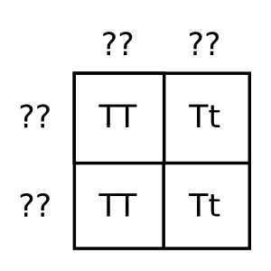
- The Punnet square shows a combination of alleles for pea plant height. Tall (T) is dominant over short (t). Given the combinations shown, what are the genotypes of the parents?
○ TT and tt
○ TT and Tt
○ Tt and Tt
○ TT and TT
STOP!!!

Section 3
Performance Events

Add performance event about breathing rate and pulse

STOP !!!

