Multimedia Class

Introduction
About the class.

Copyright
Original Text in this document is Copyrighted 2010 by Thomas Kent. Significant portions of this document were created by other people and used under various Creative Commons and Open Source licenses. See the references section at the end for attribution.
This document is freely available under a Creative Commons Attribution-ShareAlike 3.0 license.

http://creativecommons.org/licenses/by-sa/3.0/

About this Material
This material was originally developed for the Instituto San Jose in Montero, Bolivia for a course covering an introduction to multimedia design. The original course was in Spanish, but as the teacher was a native English speaker, the materials were first prepared in English, then translated to Spanish.

Free Software
Why free software is important.
Tools we'll be using

Ubuntu










Other interesting tools

References for Spanish Doc
http://es.wikipedia.org/wiki/Archivo:Mapa_conceptual_del_software_libre.svg
http://es.wikipedia.org/wiki/Software_libre
http://es.wikipedia.org/wiki/Codigo_abierto

English and Spanish Usage (only in Spanish document)
Because all of the tools we will be using in this course are written and primarily used by English speaking people, many important resources in print and on the Internet are only available in English. For this reason, we will make a concerted effort to teach the english vocabulary for these tools along side the spanish as we go through the course.

Unit One – Photos
Tools: Gimp, Photoshop, Picasa
Goals: Cropping/Re-sizing, Red-Eye removal, Layers, Image Contrast, Skin Corrections
Time: 15hrs

For this unit we will learn some basics about digital images and photos, then some simple photo editing in the GNU Image Manipulation Program (Gimp), finally we will explore Photoshop to see how to do the same things, where available.

Photos
Photo files are stored in what is called a “raster” format. This means that the image is composed of a grid of points (in rows and columns). These points are called pixels, and they contain the color for that point. The number of rows and columns that make up the grid are called the dimensions. A picture that has 33 Columns (width) and 22 Rows (height) has dimensions of 33x22, and has a total of 726 pixels. In general the dimensions of digital images are always written in the form of “width x height”.
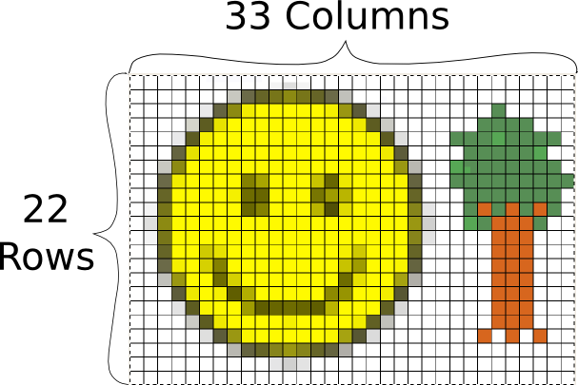

Modern digital cameras have much, much higher dimensions. They are often referred based on how many millions of pixels or “megapixels” they have. Some examples are:
640x480 = 307200 pixels = 0.3 megapixels
1024x768 = 786432 pixels = 0.8 megapixels
1280x960 = 1228800 pixels = 1.2 megapixels
1600x1200 = 1920000 pixels = 1.9 megapixels
2842x2136 = 6070512 pixels = 6 megapixels
4000x3000 = 12000000 pixels = 12 megapixels
Looking at all these, they have something in common, if the first number is divided by the second number, they all approximately equal 1.33. The lowest ratio that equals 1.33 is 4/3, so this format of images is said to have a 4:3 ratio.

This is usually the standard for photography, other resolutions will be looked at more in the video unit.
http://en.wikipedia.org/wiki/2D_computer_graphics
The reason that cameras have grown the number of megapixels they use, is because that (with everything else being equal) larger dimensions make the image look better, especially when you print it out. A good printer can print photographs at 4800 dots per inch or dpi. In this case “inches” (1in = 2.45cm) and “dots” (equal to a pixel) are used because of their history in the printing industry.
This means that a 12 megapixel image (4000x3000) could be printed out to a 2.1x1.6cm image and every pixel would be visible.

However, if it were printed to a 4.2x3.2cm image, then every pixel would be represented by four dots on the paper. If the sizes were doubled again to 8.4x6.4cm then every pixel would be represented by 16 dots on the paper. This starts to become a problem when you have an image without that many pixels in it and want to print (or display it on a screen) as a large image. At some point, the individual pixels become easily visible on the printed image, and that can give it a very blocky and unnatural feeling.
The pictures below are both the same piece of an large image taken of a tortoise. The photo on the top is from the full size 12 megapixel (4000x3000) image. The photo on the bottom was taken at a much lower dimension of 640x480. Notice how the pixels of the image are clearly visible in the lower image and it doesn't look clear.
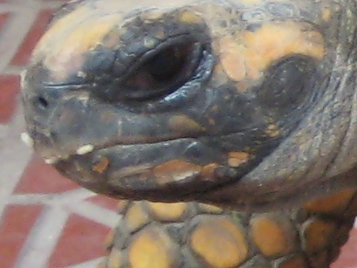

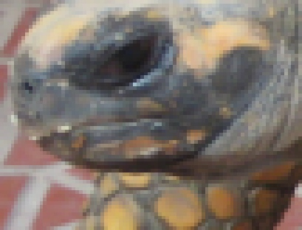

As a rule of thumb, it is important to keep the best possible image (most pixels), at least while working with it to edit. The section on cropping and re-sizing will cover more of the trade-offs that can be made when getting a picture ready to print or put on the Internet.

Channels
In a photograph, one pixel can represent many different colors. To express this in a computer, pixels are represented with different “channels” for the different colors. A typical image will have three channels: Red, Green, and Blue, for images without color, they will have a single channel (different shades of grey). Each channel states how strong that color is, for example a pixel that has very strong red channel and very weak green and blue channels would show up as red. A pixel where all three channels are very strong would be close to white, and where they are all weak, close to black.
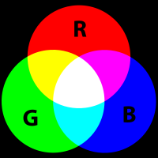

The following image is an example of pixels and color channels. The original image is the tiny face in the upper left corner. In the second, enlarged version of the face, you can see the individual pixels of the image, arranged in rows and columns, that make up the image. Then in the bottom, even more enlarged segment, you can see three pixels that make up a small area in the bottom-left corner of the image. This segment has the values for the Red, Green, and Blue channels written over the top of each pixel.
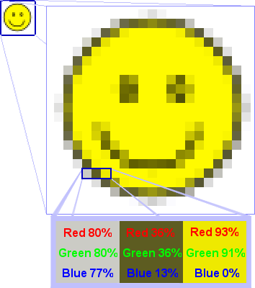

In this case we can see that to make a medium-grey color we turn the Red channel up to 80% of its full intensity, the Green channel also up to 80%, and the Blue channel to 77%. Notice that all three of these are above 50%, so in all the channel is fairly bright....this grey color is a lot closer to white than it is to black. Next, to get a dingy brown, we would put the red and green channels to 36% and the blue channel only to 13%. Because all these are significantly less than 50%, the overall color is dark and getting closer to black. Finally, to get a yellow, we turn the red and green channels almost all the way up (if we wanted a “true” yellow we would turn them all the way up) and leave the blue set at zero.

Try out for yourself adjusting the amounts of Red Green and Blue in each channel and see what colors you can come up with.
http://developer.yahoo.com/yui/examples/slider/slider-rgb_clean.html

Some raster formats also have a channel called “Alpha” that specifies how bright the pixel is. If the alpha channel is low, then it would be possible for an image that is stacked behind the one being show to show through. This is called transparency. If there is nothing behind the image, then the default is usually black.

File Types
An Aside – Bits and Bytes
In computer terminology the basic unit of data is the bit. It is either a 1 or a 0, and enough bits put together can represent any data in the computer.
A byte is a collection of bits, 8 bits to be precise. This is the standard unit that will be used to say how much space a piece of data takes up. (e.g. that text file is 300 Bytes large, that picture is 2 million bytes, etc)
Because computers can use HUGE numbers of bytes for different things, we have a set of prefixes that we use to talk about groups of bytes:
1 Byte
100 Bytes
1,000 Bytes = 1 Kilo Byte (KB)
1,000,000 Bytes = 1,000 KB = 1 Mega Byte (MB)
1,000,000,000 Bytes = 1,000 MB = 1 Giga Byte (GB)
1,000,000,000,000 Bytes = 1,000 GB = 1 Tera Byte (TB)
1,000,000,000,000,000 Bytes = 1,000 TB = 1 Peta Byte (PB)
However, it is important to note that computers don't think of things in terms of even powers of 10. Instead the computer uses powers of two, and it just so happens that 2^10 (two to the power of 10) is approximately equal to 1,000 (actually 1024) and 2^20 is approximately equal to 1,000,000 (actually 1,048,576). Although for our human heads, its generally easy to think in the simple powers of ten, just remember that these are not exact!
Photo Size
For a typical photograph, each of the three (Red, Green, and Blue) channels are represented by one byte of data for each pixel. This means that it requires three bytes of data for each pixel, this is often referred to as 24 bit color (24 bits, because 8 bits equals 1 byte and there are three bytes). Because each byte can hold 2^8 or 256 different values, each channel can have 256 different levels of that color (1/256 or 0.39% change per level if everything is done evenly). You may have noticed that the R G and B values on the demonstration we used in the channels section only had 256 different options, if you don't remember, go back and check it out now:
http://developer.yahoo.com/yui/examples/slider/slider-rgb_clean.html
Because there are three different channels, that means each pixel can represent 256x256x256 colors or over 16 million different color combinations. That's a lot more than even the largest box of crayons.
For an 12 megapixel image from a modern camera, this means that it would require 36 Megabytes (MB) of storage space! That's a lot when you go out with your camera and want to take a bunch of pictures. If you have a 1 Gigabyte (GB) memory card for your camera, that would only allow you to store about 30 images.
Because of the huge size of files that just contain the pixels, people have come up with various ways of compressing images into smaller files. These can be put into two different groups: Lossless and Lossy.
Lossless Compression
Lossless compression takes the files and finds ways to mathematically make them smaller, in a way that can be completely un-done. The easiest way to do this is to run the image through a general compression tool like zip. Zip is a tool that is available on all computers, that goes through any file (not just images) and finds ways to make it smaller. One simple way this is done is if there are many pixels in an area that are the same color, there can be an instruction that when the image is drawn to color that whole area in the correct color. That instruction telling what the computer to do can be hundreds of times smaller than the amount of space it would require to store all the pixels in the area. There are many other ways to do this, but they are generally very complicated and beyond the scope of this material.
http://en.wikipedia.org/wiki/Lossless_data_compression
Lossy Compression
Lossy compression is different in that once a file is compressed there is no way to get back the exact same file, some detail is always lost. Since images are made of millions of pixels each possible of representing millions of different colors, there is some room for removing detail before the human eye would notice any difference. This can be done with a combination of the lossless compression methods, as well as things like assuming that a color of one pixel is similar to the pixels surrounding it, and many more complicated methods. Also beyond the scope of this material.
Below are three examples which illustrate lossy compression. The example on the left is the original and was compressed with loss-less compression. The middle picture was compressed with lossy compression, which was set to not loose very much data. The image on the right used lossy compression with very aggressive settings. It made a much smaller file size than the middle one (1.1KB vs 9.4 KB) but obviously the compression removed parts of the image that are important for making it look good.
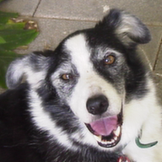
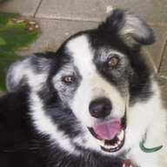
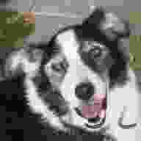

http://en.wikipedia.org/wiki/Lossy_compression
File Storage
There are many different types of files that are used for images, most of which support one or more specific lossless or lossy compression methods. Below is an overview of them, there are many less-used formats in addition that aren't listed here. See: http://en.wikipedia.org/wiki/Image_file_formats (verified at: http://en.wikipedia.org/w/index.php?title=Image_file_formats&oldid=396980331 ) or http://en.wikipedia.org/wiki/Comparison_of_graphics_file_formats (verified at: http://en.wikipedia.org/w/index.php?title=Comparison_of_graphics_file_formats&oldid=392146069) for more information.
Bitmap (.bmp, others) – Contains all the pixels of the image, without compression. The .bmp format specifically is used by Microsoft in their programs for displaying images, but similar methods are used in all types of computers. As it stores all the pixels, this is a lossless format, in fact by default it is not compressed at all.
JPEG (.jpg, .jpeg) – Stands for Joint Photographic Experts Group, was developed specifically for storing images taken by digital cameras, and is by far the most used format for digital photographs. This is a lossy format, however with typical settings it is very difficult to detect and image degradation.
PNG (.png) – Portable Network Graphics is better at storing images that don't have a lot of detail, such as graphics on websites. This is a lossless format.
GIF (.gif) – Graphics Interchange Format is similar to but older than PNG. In general PNG should be used instead, however there is one feature that it has that PNG currently does not, which is to be able to have multiple images stored inside it, which can be played back as a simple animation.
JPEG2000 (.jp2) – This was an attempt at creating a better version of the JPEG format, however it has not been very successful, and is mostly used in professional situations such as medical imaging. This format has options that can make it lossless or lossy.
JPEG XR/HD Photo (.jxr) – This is another attempt at creating a better version of the JPEG format, originally developed by Microsoft as “HD Photo” it was submitted to the Joint Photographic Experts Group who accepted it as a new standard. It has not yet caught on in mainstream use. This format has options that can make it lossless or lossy.
WebP (.webp) – This is a new format developed by Google that is designed for replacing JPEG (and some PNG) for use in images on the web. It is not currently supported by all web browsers, but work is ongoing on it. This format is lossy.
TIFF (.tif, .tiff) – Tagged Image File Format is used mostly for images of documents (such as scans). It has support for multiple pages of images, as well as metadata such as where the image was collected, who wrote it, etc. Usually it is used as a lossless format, but it has the ability to use JPEG or other types of compression inside it.
Raw (.raw, .cr2, .crw, .nef, .nrw, dng, and more) – Raw images are not a specific format, but a grouping of many different formats, all of which are built from cameras. By default cameras usually produce JPEG images, which are lossy and don't contain all the basic data that the camera recorded about the image. When a photographer gets a raw image, he or she gets all the data that the camera collected, which can be useful when doing advanced processing of the images on a computer.
XCF (.xcf) – eXperimental Computing Facility is the name of the file format used to store projects in the Gimp photo editor. It stores photographs losslessly, and can store multiple layers of photos and other data such as text, lines, selections and more.
PSD (.psd) – PhotoShop Document very similar to the XCF format, but used by photoshop. It is also lossless, and can store multiple layers of photographs and data.

Bonus, non raster-image formats:
EXIF - Exchangeable Image File Format is used for metadata about the image, it is not a file on its own, but is encorporated into other files such as JPEG. It can contain a huge number of different data fields including: date the image was taken, camera settings, exposure time, apature size, zoom level, GPS coordinates of the camera, direction the camera was facing, and many more.
SVG (.svg) – Scalable Vector Graphics files are used to store images generated on a computer, not photographs. These files do not store any pixels, but rather store information about where lines, circles, text, and other components are in relationship to each other (referred to with vectors). It is called scalable because the instructions for creating the image can be given any unit of length and make the entire image based on that. In addition the instructions for generating the image can include references to amounts of time, so the image can change as it is drawn making an animation. Because there are no pixels to be calculated, this is an inherently lossless format.
EPS (.eps) – Encapsulated Post Script files as similar to SVG files, but somewhat older and has more limited features, such as not being able to do animation.

Gimp
TODO: Get example images for Cropping, Redeye, High-Contrast for selection, ??? For each category, get one image that I will use as the in-class example and one or more images that the students can attempt to do the same thing on themselves.

What is the Gimp? (Copy in introduction from manual)
Resources:
Manual - http://docs.gimp.org/ (en for 2.6 or 2.4, es only for 2.4)

Cropping, Re-sizing
Pick an image with a face in it, have the students crop it so that only the face is showing. Select fixed aspect ratio during the selection and have them crop it to 3:4 aspect ratio. Then have them re-size it to be a decent scale for a web image.
Rule of thirds when cropping.

Redeye
Select the eyes from a photo with red eye. Don't select the whole picture, etc. Go to Filters->Enhance->Red Eye Removal... and run it.

Layers and Selection
Layers are used for photo organization. Selection can be done lots of different ways.

Skin Corrections
How to smooth out blemishes, wrinkles, etc

Adjusting lighting

Photoshop
Cropping/Resizing
Redeye
Layers and Selection
Skin Corrections
Adjusting Lighting

Other Photo Editing Tools
Picasa – Photo manager built and distributed by google. It is more for storing photo collections, and managing them online and offlline, but also has some photo editing ability, like cropping, redeye removal and more. Available for Linux, Windows and Mac. - http://picasa.google.com
Paint.NET – Similar, but less powerful than Gimp and Photoshop. Only available for Windows, but is free, libre, and open source software. - http://www.getpaint.net/
Corel Paint Shop Photo Pro – Almost as powerful as Gimp and Photoshop, but a substantially different interface from them. - http://www.corel.com/servlet/Satellite/us/en/Product/1208716806081
Microsoft Paint – Comes built in with windows, but is very basic. Even things like cropping and re-sizing are very difficult. It is usable if you want to add a little text to an image, or draw over something so that others can't see it (like blanking out a screen name or IP address in a screenshot), but not much beyond that.
Microsoft Photo Editor or Photo Manager – Tools from Microsoft that come with Microsoft Office. Useful for basic editing, such as cropping and re-sizing.
ImageMagick – A command line based tool (there are also various graphical user interfaces for it) that instead of editing an image by click on it edits the image by specifying commands that can be done to it (e.g. -resize 30%, -crop 120x120, convert image.jpg image.png and lots more). This is really great if you have a lot of images and want to do the same thing to all of them. For instance you can easily resize hundreds of images in a few seconds instead of opening them up in the Gimp and resizing them one by one. Image magic is free, libre, and open source software and runs on Linux, Windows, and Mac. - http://www.imagemagick.org/

Unit Two – Graphics

Vector Graphics
Unlike raster images (photos, covered in Unit One) vector graphics do not consist of pixels arranged on a grid with different values. Instead vector graphics are stored as sets of instructions that a computer can run to re-create a graphic.
A simplistic example of these instructions could be:
- Create a circle with a center 3 units above the center, and a radius of 2 units.
- Fill circle with yellow
- Create a line from 2 units below the center to 3 units above and two units left of the center.
- Create a line from 2 units below the center to 3 units above and two units right of the center.
If there were a program that could run this very simple script, it might draw to the screen the following:


The good thing about this is that you'll most likely never have to actually look at the script the computer creates, just like you never have to look at the array of pixels and channels that are stored in a photograph. However, if you want to get advanced, that would be possible (and quite a bit easier than editing a raster image). Instead, we will be using tools that convert the things we draw with the mouse and keyboard into one of these scripts that the computer can follow when it wants to re-produce an image to view on the screen (the screen is really just a raster graphic viewer). Then when we are all done, we can have it run the script again to produce another raster graphic that can be saved into a PNG file.
It is also possible for this script to include a certain amount of time to wait before something happens. This allows for animations some simple examples would be having a stick figure move across the image or having a ball bounce.

File Formats
The primary file format currently in use is SVG or Scalable Vector Graphics (see: http://en.wikipedia.org/wiki/Svg ) which is a type of human readable file called XML. Although XML and SVG are human-readable, we will not be reading them directly as part of this material. SVG is supported in most vector drawing programs, however it is not yet supported by all web browsers (though this is rapidly changing). If you simply want to use your images on web pages, it is best to convert them to Portable Network Graphics (PNG) which is a lossless raster format.
The other major format for Vector Graphics is the EPS or Encapsulated Post Script. Post Script itself is a file type used for printing (especially industrial printing), and EPS images are built to be easily put inside of a Post Script document. This format has been around a lot longer than SVG, and is supported by many more tools (especially the old ones). Likewise, it is not recommended for use with web browsers.

Inkscape

Illustrator

Publishing Layout??

Scribus

Diagrams

Dia

Unit Three – Audio

Introduction to Audio Storage
samples per second, bits per sample

Codec and Container Overview
Codecs
WAV
MP2
MP3
FLAC
AAC
AC3
Vorbis
Speex
PPM?
Containers
MP3
Ogg
Video

Unit Four – Video

Introduction to Video Storage
Digital Video – raster pictures presented in rapid succession
Analog Video – Pixel at a time, scan down the image (possibly with alternating lines)

Formats
PAL
NTSC

Codecs and Containers
Codecs
MPEG 2
MPEG 4 (?)
H.264/AVC
XVID
Theora
VP8
Containers
MPEG TS, PS
MPEG 4
AVI
FLV
MKV
OGV

TODO:
Get video clips from open source blender projects: Elephants Dream, Big Buck Bunny, Sintel, others?
http://www.doom9.org

Web Pages

Web Architecture

Attribution

Gimp Icon – GPL - http://en.wikipedia.org/wiki/File:The_GIMP_icon_-_gnome.svg
Inkscape Icon – GPL - http://commons.wikimedia.org/wiki/File:Inkscape_OS_X.png
Scribus Icon – GPL - http://commons.wikimedia.org/wiki/File:Scribus_logo.svg
Audacity Icon – GPL - http://commons.wikimedia.org/wiki/File:Audacity.png
VLC Icon – GNU FDL - http://commons.wikimedia.org/wiki/File:VLC_Icon.svg
HandBrake Icon – GPL - http://commons.wikimedia.org/wiki/File:HandBrake.png
Kdenlive Icon – GPL - http://commons.wikimedia.org/wiki/File:Logo-kdenlive.png
Kompozer Icon – LGPL - http://commons.wikimedia.org/wiki/File:KompoZerLogo.svg
Bluefish Icon – GPL - http://commons.wikimedia.org/wiki/File:Bluefish-icon.svg
Ubuntu Icon – Public Domain - http://commons.wikimedia.org/wiki/File:UbuntuCoF.svg

Pixel Value Image – Public Domain - http://commons.wikimedia.org/wiki/File:Rgb-raster-image.png
Additive Color – Public Domain - http://commons.wikimedia.org/wiki/File:AdditiveColor.svg
Lossy Demonstration Lossless – CC-BY-SA - http://en.wikipedia.org/wiki/File:LossyDemonstration-Original.png
Lossy Demonstration Medium – CC-BY-SA - http://en.wikipedia.org/wiki/File:LossyDemonstration-84less.jpg
Lossy Demonstration High – CC-BY-SA - http://en.wikipedia.org/wiki/File:LossyDemonstration-98less.jpg

- Unit One – Photos (15hrs)
Tools: Gimp, Photoshop?, Picasa?
  - Cropping/Re-sizing
  - Red-Eye
  - Image Contrast
- Unit Two – Graphics (15hrs)
Tools: Inkscape, Illustrator?, Dia?, Open Office Draw?, Scribus, Page Maker?, Quark?
  - Fancy Text
  - Basic Animation?
  - Page Layout
  - Large Format (Banners, Posters)
- Unit Three – Audio (20hrs)
Tools: Audacity
  - Introduction to Audio Storage
    - Codec/Container Overview
  - Wave properties
  - Cutting
  - Filtering
- Unit Four – Video (40hrs)
Tools: VLC, FFMpeg (GUI?), Handbrake, Avidemux, DVDStyler (or equalivent), PiTiVi/Kino/Primere/MovieMaker
  - Introduction to Video Storage
    - Codec/Container Overview
    - Typical Formats (NTSC/PAL/DV)
  - Compression
  - Cutting
  - Multi-Track Editing
  - DVD Creation
  - YouTube Creation
- Unit Five – Web Pages (60hrs)
Tools: Kompozer, Dreamweaver/Other Adobe?
  - Architecture Overview
    - Servers
    - Structured Documents
  - Basic Page: pictures/links
  - Basic HTML
- Unit Six – Advanced Web (50hrs)
Tools: Bluefish, ?
  - Basic Javascript
  - Basic PHP/Python
  - Security

