AfriSmart
African Smart E-commerce Platform
Agentic Smart City E-commerce Platform using Blockchain + Digital twin technology

Technology Stack: SENSORS | IoT | 5G | MOBILE PHONES | DIGITAL TWIN | CLOUD | GEN AI | BLOCKCHAIN

AfriSmart Architecture Design
Low resource African countries face persistent challenges in accessing reliable goods due to fragmented retail systems, poor inventory visibility and inefficient supply chains. Consumers often rely on a limited number of nearby stores, which frequently experience stock shortages, price inconsistencies and limited product information. Implementing an agentic smart city e-commerce platform powered by blockchain and digital twin technologies can significantly improve access to essential goods by intelligently connecting users to the nearest available suppliers within their location.
The Agentic system autonomously searches, compares prices and reroutes purchase requests when preferred stores are out of stock, ensuring continuity of access. Digital twins provide virtual representations of physical stores, enabling real time inventory simulation and demand prediction, while blockchain ensures secure, transparent transactions and builds trust among stakeholders. This solution can reduce waste of time, transportation costs and market inefficiencies. Ultimately, the platform supports inclusive digital economies, strengthens local businesses and enhances smart city development in resource constrained African environments.
.
Architecture
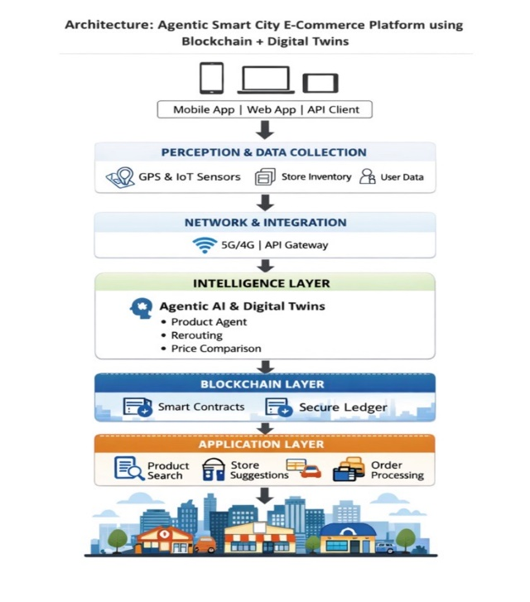
Fig 3: Architecture of Smart city E-commerce platform using blockchain and DTs technologies

A. User Layer:
The user interacts through a mobile or web application to search for products (e.g., pack of pens).
B. Perception Layer:
The system gathers location data, inventory availability, pricing, and user preferences from smart devices and connected store systems.
C. Network Layer:
Enables communication between system components via internet connectivity and APIs.
D. Support Layer (Agentic + Digital Twin Intelligence):
Agentic AI automatically makes decisions such as: Finding nearby shops, comparing rerouting requests when a shop is out of stock. Digital twins (DTs) simulate real word stores to predict inventory availability and optimize recommendations.
E. Blockchain Layer:
Ensures secure, transparent transactions, tamper-proof order records and trusted supply chain verification.
F. Application Layer:
Displays recommendations, price ranges, alternative shops and allows users to place orders.
G. Smart City Service Layer:
Integrates urban retailers, logistics services and digital payment infrastructure.

Agentic DT for Consumer
AI Agents for Merchants
Interactions between Consumer and Merchant

