An Agentic Smart City E-commerce Platform using Blockchain and Digital Twin Technology
  - Design, architecture and implementation of AfriSmart for inclusive access to goods in sub-Saharan African cities
Olayinka Sulaiman Huzain
October 2026
Table of Contents

1 Abstract
Low-resource African cities face persistent barriers to reliable access to everyday goods. Retail is fragmented across neighbourhood kiosks, markets and small chains; inventory is invisible outside each shop; prices vary without explanation; and a preferred store that is out of stock forces another costly trip. These frictions waste time and transport money, weaken local merchants, and leave urban “smart city” programmes without a working marketplace of last-mile suppliers.
This dissertation motivates, designs and implements AfriSmart: an agentic smart-city e-commerce platform that combines digital twins, large language model (LLM) agents with tool calling, and tamper-evident blockchain-style order hashing. Each physical store is modelled as an Access Point Digital Twin (APDT)—location, hours, live stock and prices, and demand signals. Each shopper is modelled as an Adaptive Human Digital Twin (AHDT)—identity, consented device location, current need, preferences, order history and conversation memory. Agentic AI sits between the twins: it searches nearby stocked shops, compares prices, reroutes when the preferred shop is empty, and places orders only after explicit confirmation. Every order is sealed with a SHA-256 ledger hash ready for later public-ledger anchoring.
The platform is delivered on a Spring Boot (Java 21) and React stack with a seven-layer application architecture (user, perception, network, agentic + digital twin support, blockchain/trust, application, and smart-city service layers). Evaluation on seeded Lagos data (Yaba, Surulere, Ikeja) shows that a consumer searching for a “pack of pens” is not routed to Surulere Stationers (zero stock) but to Yaba Campus Mart (~1.1 km, ₦750), with Ikeja as a farther alternative; role-filtered tools prevent a merchant from placing consumer orders; warm-path tool latency is 5–15 ms (median) on a commodity laptop; and 29 automated tests pass, including a scripted agent loop without a live LLM key.
Keywords: smart city, e-commerce, digital twin, cognitive digital twin, agentic AI, blockchain, sub-Saharan Africa, tool calling, geospatial search, Lagos.

2 Introduction

2.1 Background
Sub-Saharan Africa is urbanising rapidly. Cities such as Lagos concentrate demand for stationery, food staples, household goods and other everyday products, yet the supply side remains a dense mosaic of independent shops whose stock and prices are known only inside the shop. Consumers typically rely on a small set of nearby stores. When those stores stock out—or never stocked the item in the first place—the consumer walks further, pays more, or abandons the purchase. Merchants, for their part, lack demand signals beyond what they sell over the counter, so restocking is reactive and wasteful.
These are not only retail problems; they are smart-city problems. A smart city is often defined as an urban system that uses information and communication technologies to improve services, efficiency and quality of life (Batty et al., 2012; Chourabi et al., 2012). In African cities, “smart” must mean inclusive and resource-aware: solutions that work on mobile networks, do not require every shop to run a data centre, and reduce wasted trips rather than adding another opaque marketplace. Mobile-phone ownership and mobile data coverage have expanded substantially across the region (GSMA, 2023), creating a realistic channel for location-aware commerce if the information about inventory can be made trustworthy and actionable.
Two technology trajectories now make that possible. Digital twins (DTs) provide continuously synchronised virtual representations of physical assets—here, shops and, at a bounded level, shoppers (Grieves & Vickers, 2017; Kritzinger et al., 2018; Batty, 2018). Agentic AI—LLMs that plan and call external tools—can act over those twins: search, compare, decide and request confirmation before irreversible actions (Yao et al., 2023; OpenAI, 2023; Wang et al., 2024). Blockchain and related cryptographic hashing supply tamper evidence for orders and a path to multiparty trust without requiring every transaction to settle on a public chain from day one (Nakamoto, 2008; Mettler, 2016).
AfriSmart brings these together as an agentic smart-city e-commerce platform for low-resource African environments. The motivating scenario from the architecture design is concrete: a consumer near Yaba / UNILAG needs a pack of pens; Surulere Stationers (the preferred shop) has none; the agent finds Yaba Campus Mart in stock at a lower price than Ikeja Computer Village Mart and completes a hash-sealed order after confirmation.

2.2 Research questions
The overarching question is: how can an agentic smart-city e-commerce platform, powered by digital twins and blockchain, benefit people in sub-Saharan Africa? It is decomposed as follows:
- RQ1 (Access and discovery). How can the platform connect consumers to the nearest shops that actually have a product in stock, under urban geospatial constraints and without specialised spatial databases?
- RQ2 (Agency and continuity). How can agentic AI autonomously search, compare prices and reroute purchase requests when a preferred store is out of stock, while keeping humans in control of checkout and stock changes?
- RQ3 (Twin synchronisation). How can store digital twins (APDTs) and adaptive human twins (AHDTs) stay consistent with physical stock and consumer context in real time on commodity infrastructure?
- RQ4 (Trust and inclusion). How can orders be made tamper-evident, and how can the platform be delivered so that small merchants can participate without heavy local IT—thereby supporting inclusive urban digital economies?

2.3 Aim and objectives
Aim. To design, architect, implement and evaluate an agentic smart-city e-commerce platform (AfriSmart) that uses digital twins and blockchain-oriented trust mechanisms to improve access to goods for consumers and operational visibility for merchants in sub-Saharan African cities, using Lagos as the case study.
Objectives.
- Review the historical development of digital twins (DTs → cognitive DTs → agentic DTs) and related work on smart cities, e-commerce, agents and blockchain (Section 3).
- Elicit functional and non-functional requirements for the platform (Section 4.1).
- Specify use cases and narratives, message sequence charts, the complete software framework, application architecture, and class diagrams (Sections 4.2–4.5).
- Implement the platform (backend, agentic tools, real-time sync, trust hashing, consumer and merchant UI) and evaluate it (Section 5).
- Answer RQ1–RQ4 from the implementation evidence (Section 5).
- Provide recommendations and future directions (Section 6).

2.4 Scope and contribution
In scope: identity and roles (consumer / merchant); store and inventory twins; geospatial offer search; agentic tools and chat loop; WebSocket and REST APIs; SHA-256 order hashing; consumer search/cart/orders UI; merchant inventory/orders/assistant dashboard; Lagos demonstration data.
Out of scope (future work): full public-chain settlement, payments, last-mile logistics, IoT shelf sensors, multi-city deployment studies, and large-scale field trials with real merchants.
Contributions: (i) a master-level design linking smart-city e-commerce needs in SSA to agentic DTs; (ii) a seven-layer application architecture mapped to a running Spring Modulith system; (iii) a reproducible pack-of-pens / reroute implementation with automated tests and measured tool latency.

2.5 Structure of the report
Section 3 is the literature review. Section 4 presents analysis and design, including application architecture. Section 5 describes implementation, UI/UX and answers the research questions. Section 6 concludes.

3 Literature Review

3.1 Origins of the digital twin
The idea of pairing a physical object with a virtual counterpart that tracks it through its life is usually traced to Michael Grieves’s work on product lifecycle management: a “mirrored spaces” model with a real space, a virtual space and the linking information flows (Grieves, 2014; Grieves & Vickers, 2017). NASA’s roadmaps popularised the term digital twin (Shafto et al., 2012). Glaessgen and Stargel (2012) gave an influential aerospace definition emphasising multiphysics simulation of an as-built vehicle that mirrors its flying twin. In this first generation, the twin’s purpose is to mirror and simulate: data flows from the physical asset to the model for monitoring, prediction and what-if analysis (Boschert & Rosen, 2016).
Kritzinger et al. (2018) clarified maturity by data-flow automation. A digital model has manual links both ways; a digital shadow automates physical→virtual flows; a digital twin automates both directions so the virtual object can also change the physical one. Surveys catalogue DT components (physical entity, virtual entity, connection, data, services) and enablers such as IoT, cloud and machine learning (Tao et al., 2019; Jones et al., 2020; Fuller et al., 2020). Urban DTs differ from engineering twins because people and institutions are part of the “physical” system (Batty, 2018)—a point that matters when twinning shops and shoppers rather than turbines.

3.2 Digital twins for cities and commerce
Smart-city research frames ICT as a means to improve urban services and governance (Batty et al., 2012; Chourabi et al., 2012). Digital twins of cities have been proposed for planning, mobility and infrastructure (Kamel Boulos & Zhang, 2021). E-commerce in emerging markets, meanwhile, has long struggled with trust, last-mile logistics and the dominance of informal retail (UNCTAD, 2021). Platform approaches that merely list products without live availability recreate the empty-shelf trip. Store-level twins that expose stock and hours address that gap: the twin is not a marketing page but an operational mirror of the shelf.

3.3 Cognitive digital twins
Cognitive digital twins (CDTs) add semantic models, knowledge graphs and learning so a twin can reason, predict and explain (Lu et al., 2020; Zheng, Lu & Kiritsis, 2022). For retail access, cognition turns raw quantities into decisions: which shop can fulfil a quantity now; which items are selling down; what restock target covers recent demand. AfriSmart implements a deliberately explainable slice of cognition: seven-day sales tallies and a transparent restock heuristic, plus agent-visible tool results rather than opaque embeddings.

3.4 Agentic digital twins
Agency means setting goals, planning and acting under human oversight (Wooldridge & Jennings, 1995; Russell & Norvig, 2021). LLM agents revitalised this agenda: ReAct interleaves reasoning with actions (Yao et al., 2023); Toolformer showed models can learn to call tools (Schick et al., 2023); function-calling APIs standardise structured tool requests (OpenAI, 2023). Surveys describe profile, memory, planning and action modules (Wang et al., 2024; Xi et al., 2023).
An agentic digital twin exposes twin state as tools an agent may call, so the agent queries and changes the physical world through the twin (cf. Xia et al., 2023 on production twins). Risks—hallucination (Ji et al., 2023), prompt injection (OWASP, 2023), loss of human control (Shneiderman, 2020)—drive design rules: facts must come from tools; tools are role-filtered; device location beats model-supplied coordinates; checkout and stock updates require explicit confirmation.

3.5 Blockchain and tamper-evident commerce
Blockchain introduced append-only, cryptographically linked ledgers (Nakamoto, 2008). Healthcare and supply-chain literature proposed related trust benefits (Mettler, 2016). For early-stage African city commerce, a staged approach is pragmatic: seal each order with a SHA-256 hash over a canonical payload (ids, amounts, lines, timestamp), show the hash as a receipt, and reserve public-ledger anchoring for a later phase. Merchants and consumers gain immediate tamper evidence without paying gas fees on every biro pack.

3.6 Comparison of DT generations
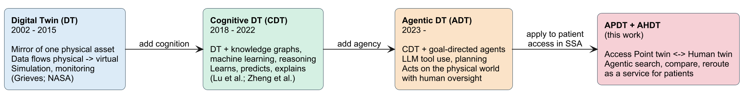
Figure 3.1 Evolution from digital twins to cognitive and agentic twins, applied in AfriSmart as APDT + AHDT.
Table 3.1 Generations of digital twins and their role in AfriSmart.
Generation | Capability | AfriSmart mapping
DT | Synchronised mirror of an asset | Store APDT: location, hours, stock, price
CDT | Learn, predict, explain | Demand signals; restock suggestion; ranked offers
Agentic DT | Goal-directed tool use under oversight | LLM agents calling search, compare, reroute, order, inventory tools
Application | Inclusive urban commerce | Consumer AHDT + merchant APDT on AfriSmart

4 Analysis and Design

4.1 Functional and non-functional requirements

4.1.1 Functional requirements
Table 4.1 Selected functional requirements.
ID | Requirement | Primary twin / layer
FR1 | Consumers register/login; merchants register/login with separate roles | AHDT / identity
FR2 | Merchants create and update stores (geo, hours, delivery radius) | APDT
FR3 | Merchants upsert inventory (quantity, unit price in kobo) | APDT
FR4 | Consumers search by free text / aliases within a radius of their location | Application + APDT
FR5 | Results exclude shops with insufficient stock; sort by distance then price | Application
FR6 | Consumers compare price range and cheapest / nearest / best-value picks | Agentic tools
FR7 | Consumers inspect a preferred store; if out of stock, system supports reroute | Agentic tools
FR8 | Consumers place multi-line orders that atomically reserve stock | Trust + APDT
FR9 | Each order receives a SHA-256 ledger hash | Blockchain / trust
FR10 | Merchants list incoming orders and accept them | Application
FR11 | Merchants obtain low-stock lists with sales velocity and suggested restock | CDT-lite
FR12 | Role-specific AI assistants call only permitted tools; stream progress | Agentic layer
FR13 | Stock and order changes push to connected clients in real time | Network + twins
FR14 | Conversations and tool invocations persist for memory and audit | AHDT

4.1.2 Non-functional requirements
Table 4.2 Non-functional requirements.
ID | Requirement | Design response
NFR1 | Work without PostGIS; portable SQL | H2 PostgreSQL mode / any JDBC; Java haversine
NFR2 | Low-end laptop / pilot hosting | In-memory H2 for demos; file profile for persistence
NFR3 | Clear module boundaries | Spring Modulith + architecture test
NFR4 | Stateless API security | JWT; BCrypt passwords
NFR5 | LLM provider swappable | OpenAI-compatible engine; empty key degrades chat only
NFR6 | Human control of irreversible actions | Prompt rules + confirmation before PLACE_ORDER / UPDATE_STOCK
NFR7 | Privacy of location | Device location wins; session-scoped consent model
NFR8 | Observable assistant | ai.progress events over WebSocket
NFR9 | Testability without paid LLM | Scripted model engine in integration tests

4.2 Use cases and use case narratives
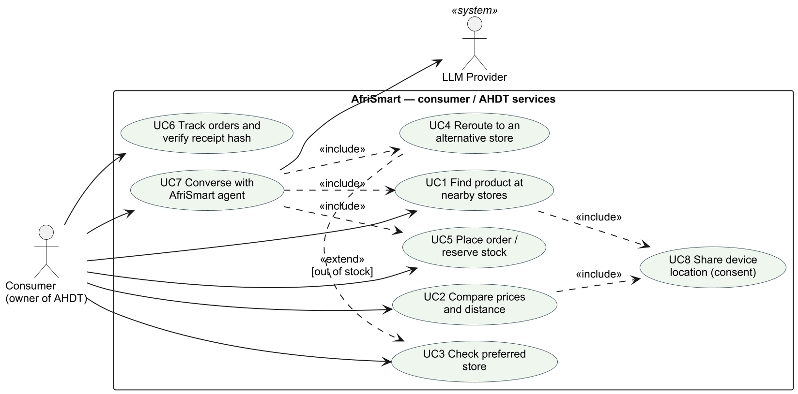
Figure 4.1 Consumer (AHDT) use cases.
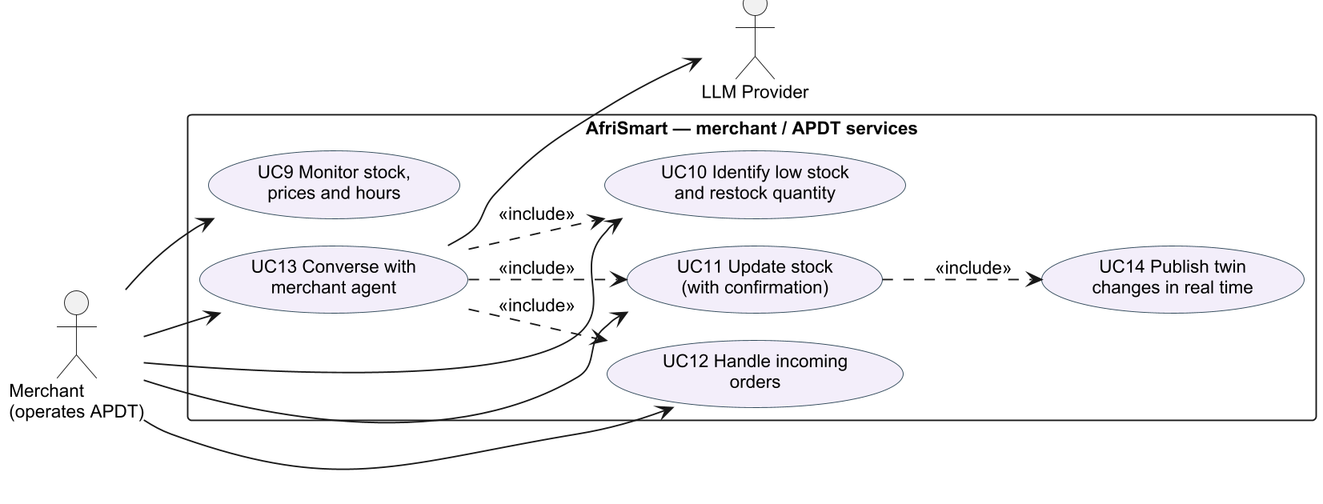
Figure 4.2 Merchant (APDT) use cases.

4.2.1 Narrative: UC4 Reroute when preferred store is out of stock (hero scenario)
- Primary actor: Consumer (Ada), near Yaba (6.5158° N, 3.3791° E).
- Goal: Obtain a pack of pens without a wasted trip to Surulere Stationers.
- Preconditions: Ada is authenticated; location is available; Surulere is seeded with zero pens; Yaba and Ikeja have stock.
- Main flow: (1) Ada asks the assistant for pens at her usual Surulere shop. (2) GET_STORE_DETAILS reports quantity 0 and advises FIND_ALTERNATIVE_STORES. (3) The agent excludes Surulere and searches a doubled radius. (4) Yaba Campus Mart is recommended (~1.1 km, ₦750) ahead of Ikeja (~10 km, ₦900). (5) Ada confirms; PLACE_ORDER reserves stock and returns a ledger hash. (6) The merchant dashboard receives order.placed; inventory decrements via twin sync.
- Postconditions: Order status PLACED; Surulere still empty; Yaba stock reduced; hash stored.

4.2.2 Narrative: UC10 / UC11 Merchant low stock and update
- Primary actor: Merchant of Yaba Campus Mart.
- Main flow: Ask “what should I restock?” → GET_LOW_STOCK_ITEMS → agent proposes quantity → merchant confirms → UPDATE_STOCK → stock.changed broadcast.

4.3 Message sequence charts
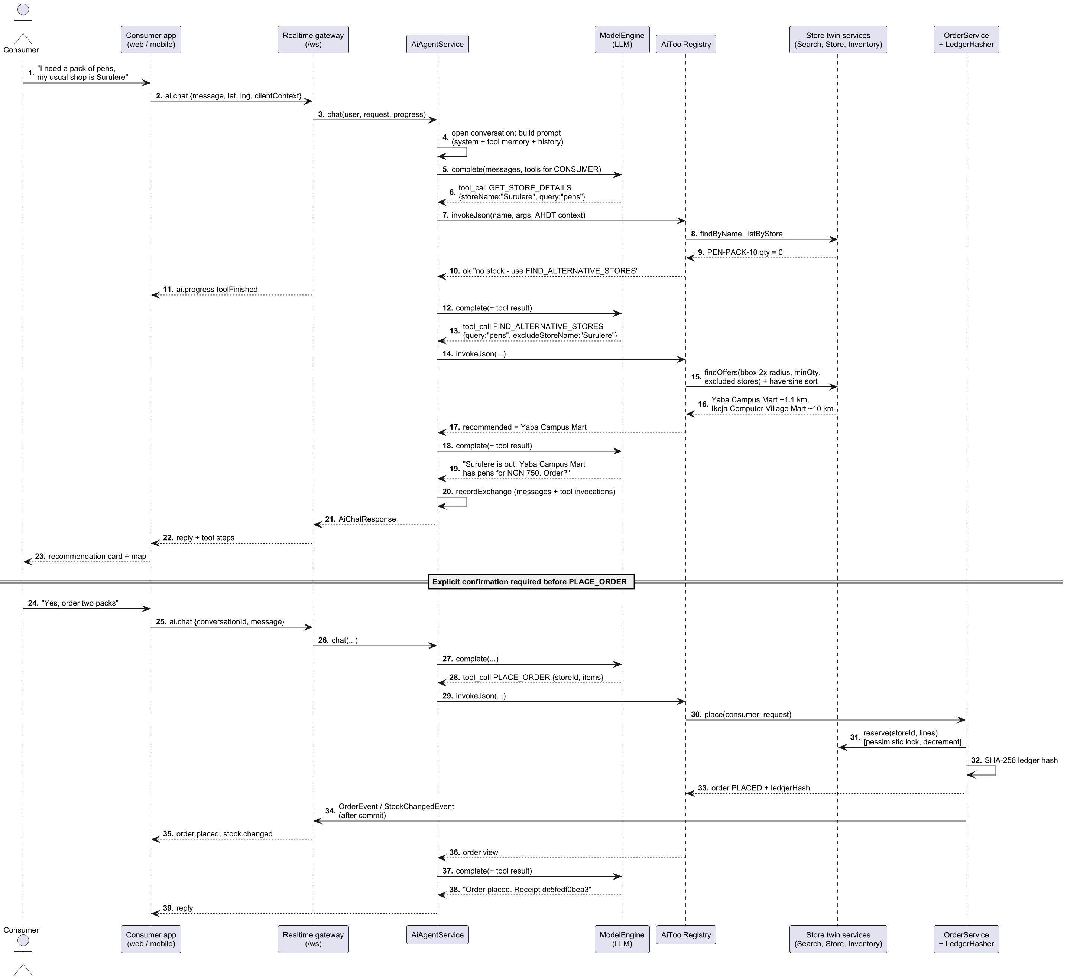
Figure 4.3 MSC: consumer reroute and confirmed order (pack of pens).
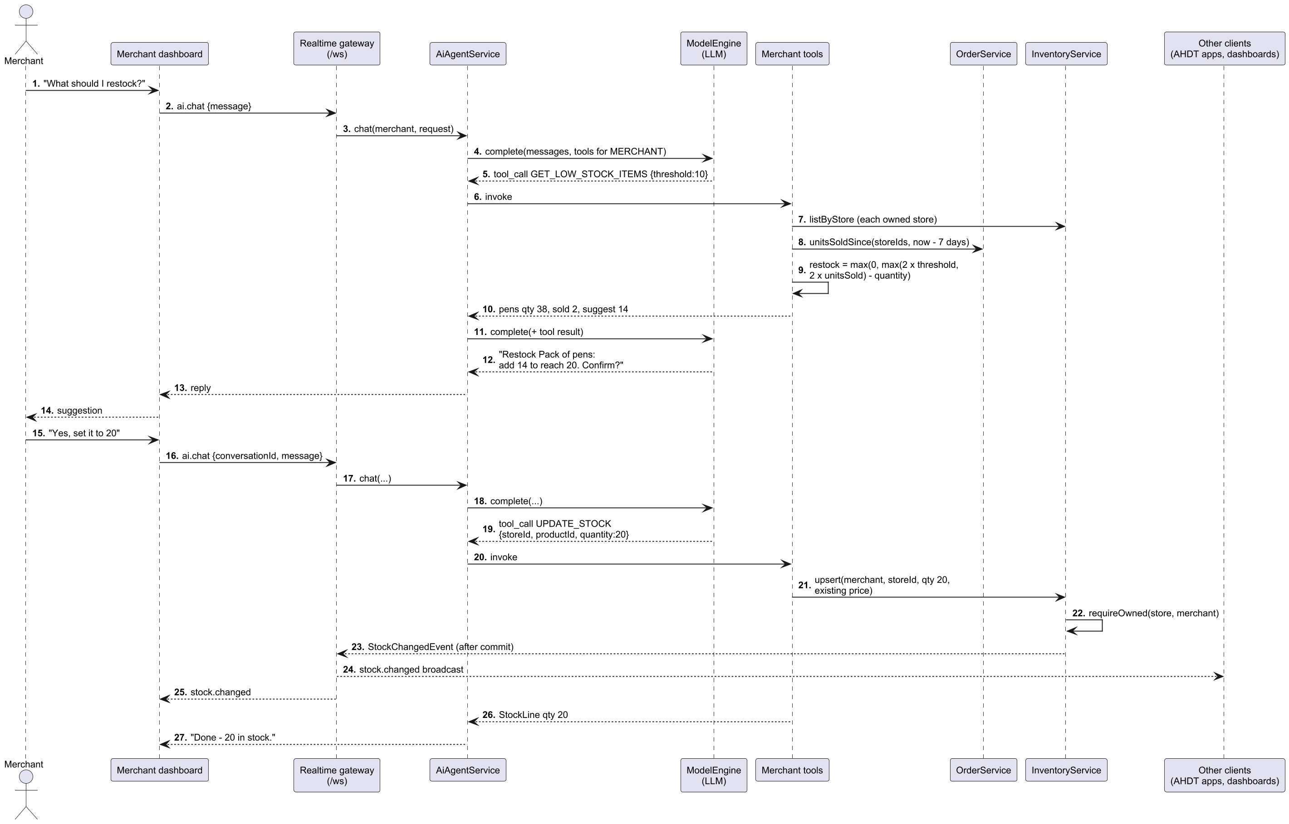
Figure 4.4 MSC: merchant restock via the APDT agent.
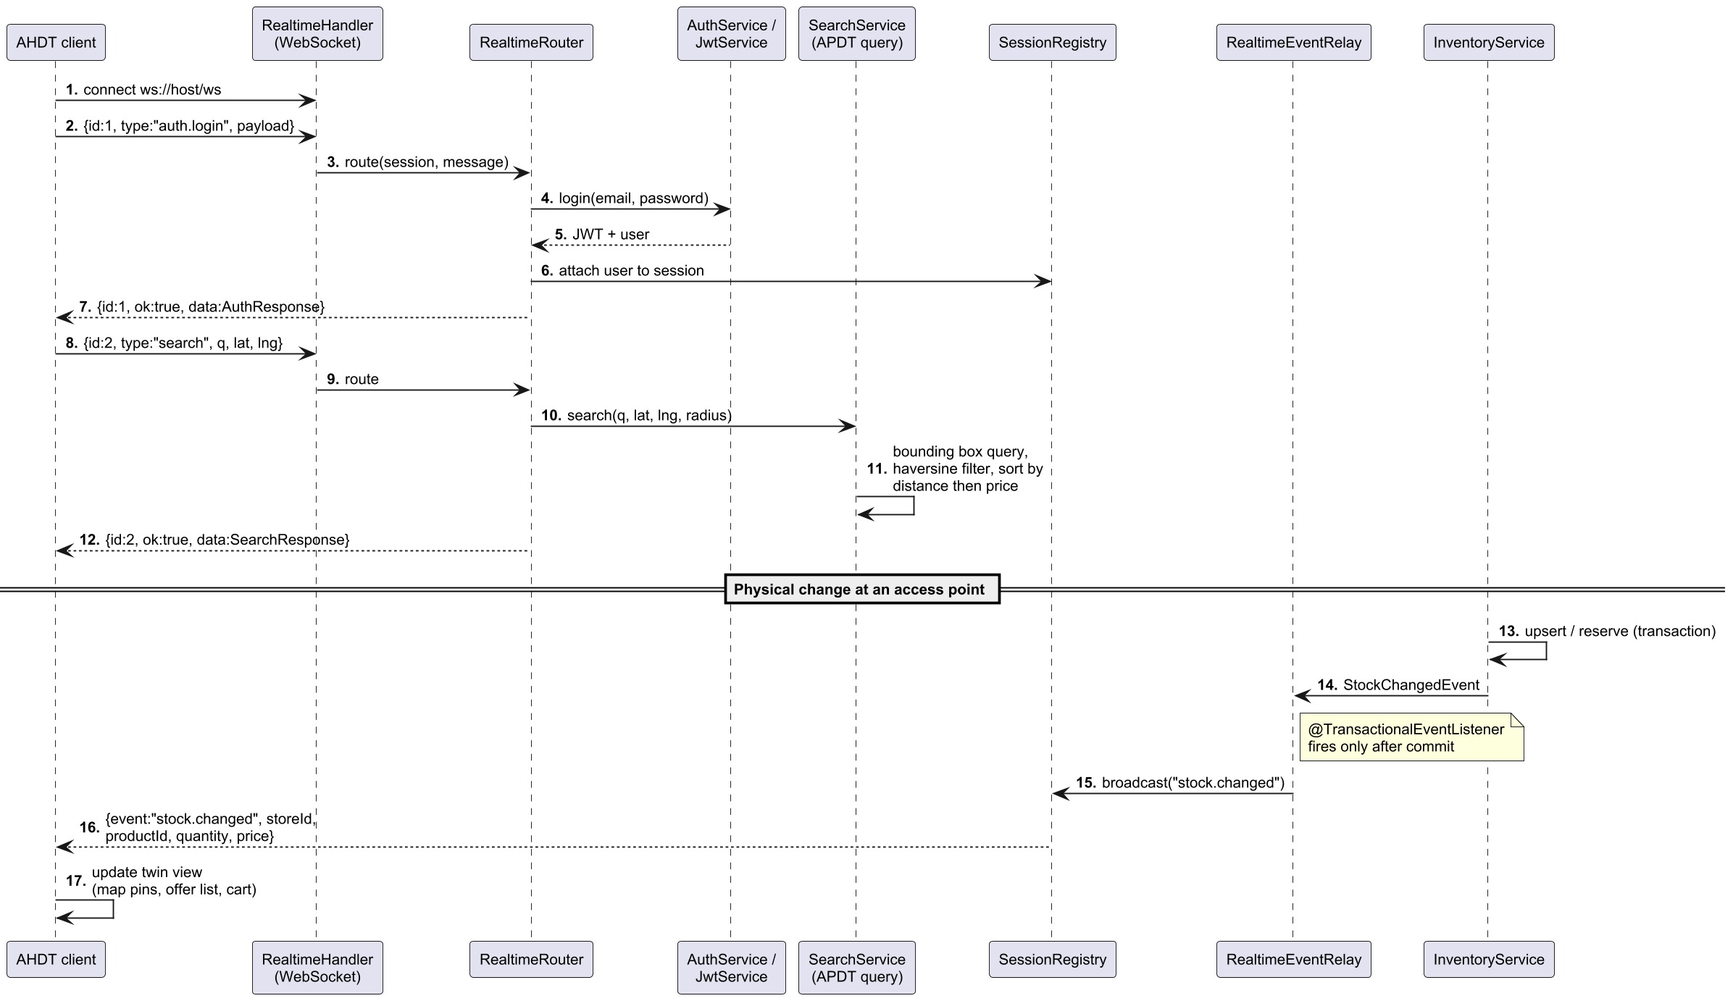
Figure 4.5 MSC: real-time twin synchronisation over the WebSocket gateway.

4.4 Complete software framework and application architecture

4.4.1 Application architecture (AfriSmart layers A–G)
The architecture design document specifies a layered smart-city e-commerce stack. Figure 4.6 renders that stack as implemented.
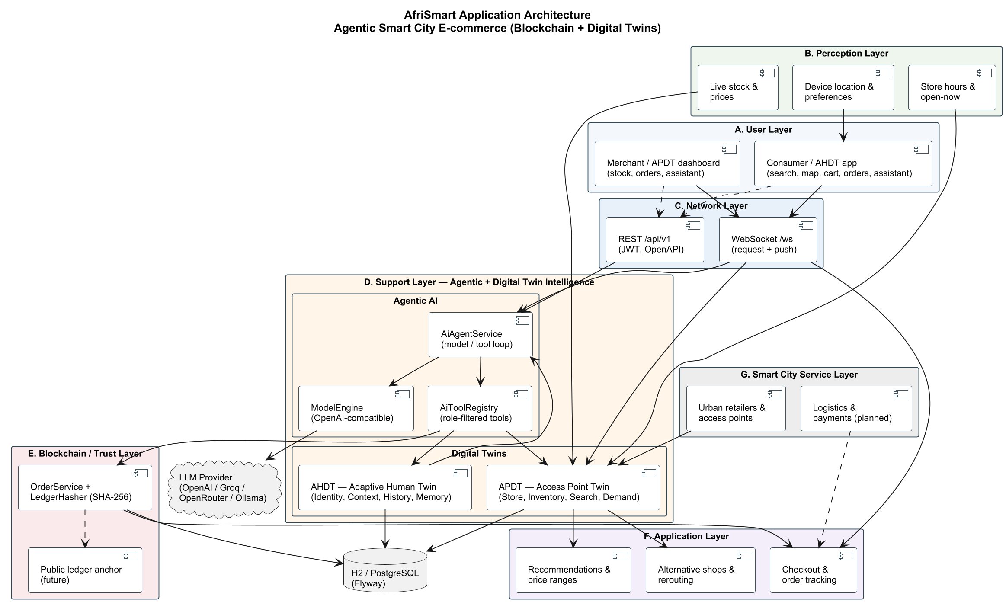
Figure 4.6 AfriSmart application architecture: agentic smart-city e-commerce with blockchain and digital twins.
A. User layer. Consumers use the web (and potentially mobile) application to search, view a map, manage a cart, track orders and chat with the assistant. Merchants use the APDT dashboard for inventory, incoming orders and the merchant assistant. Both UIs are thin clients over a shared realtime gateway.
B. Perception layer. Inputs that keep twins honest: device location and preferences (AHDT), store hours / open-now computation, and live stock and prices (APDT). In the pilot these are entered through APIs and dashboards; IoT shelf sensors are a future perception source.
C. Network layer. Dual transports: REST /api/v1 (JWT, OpenAPI) for integrations and HTTP clients; WebSocket /ws for multiplexed request/response (search, ai.chat, orders.place, …) and server push (stock.changed, order.placed, ai.progress).
D. Support layer — Agentic + Digital Twin Intelligence. The cognitive and agentic core:
- Agentic AI: AiAgentService (model/tool loop), AiToolRegistry (role-filtered tools), ModelEngine (OpenAI-compatible providers: OpenAI, Groq, OpenRouter, Ollama, …), prompts and conversation memory.
- Digital twins: APDT (store, inventory, geo search, demand) and AHDT (identity, context, history, memory).
E. Blockchain / trust layer. OrderService + LedgerHasher (SHA-256) produce tamper-evident receipts. A dashed public ledger anchor is reserved for future work.
F. Application layer. User-visible capabilities realised by services and tools: recommendations and price ranges; alternative shops and rerouting; checkout and order tracking.
G. Smart city service layer. Urban retailers and access points onboard into the platform; logistics and digital payments are planned integrations that plug into checkout without changing the twin core.

4.4.2 Software framework (module view)
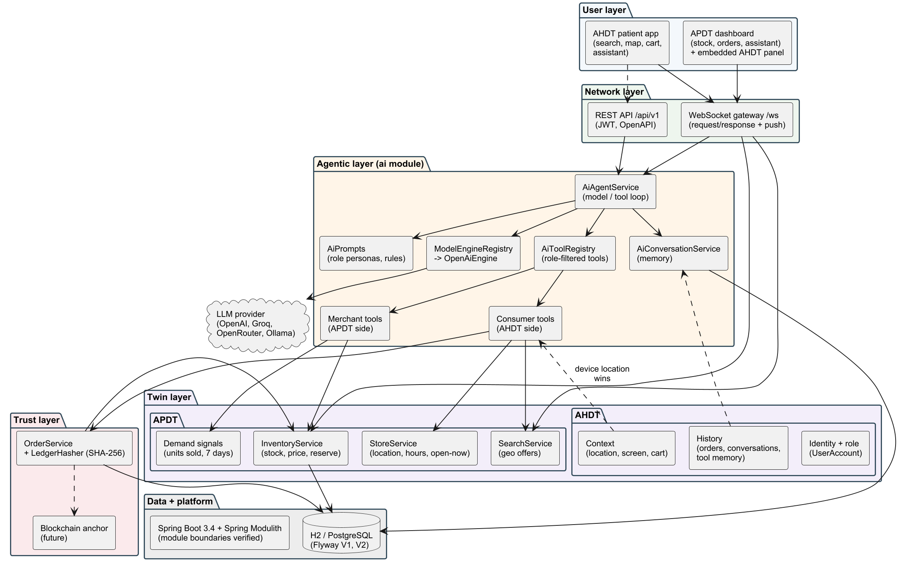
Figure 4.7 Software framework mapping modules to twins and agents.
Table 4.3 Mapping architecture layers to implementation.
Layer | Responsibility | Implemented by
User | Consumer app; merchant dashboard | React 19 + TypeScript (web/)
Perception | Location, hours, stock, prices | Client context; StoreService; InventoryService
Network | APIs and realtime | realtime module; REST controllers; JWT security
Support (Agentic + DT) | Agents and twins | ai, stores, catalog, inventory, marketplace, identity
Blockchain / trust | Tamper-evident orders | orders (LedgerHasher)
Application | Search, compare, reroute, checkout UX | Tools + UI pages
Smart city services | Retailer network; future logistics/payments | Store onboarding; extension points
Delivery model. A merchant registers, creates a store and publishes inventory; the APDT, agent tools and dashboard appear without local servers. Multi-tenancy is enforced with requireOwned checks on every merchant mutation—critical for onboarding the long tail of small African retailers.

4.5 Class diagrams
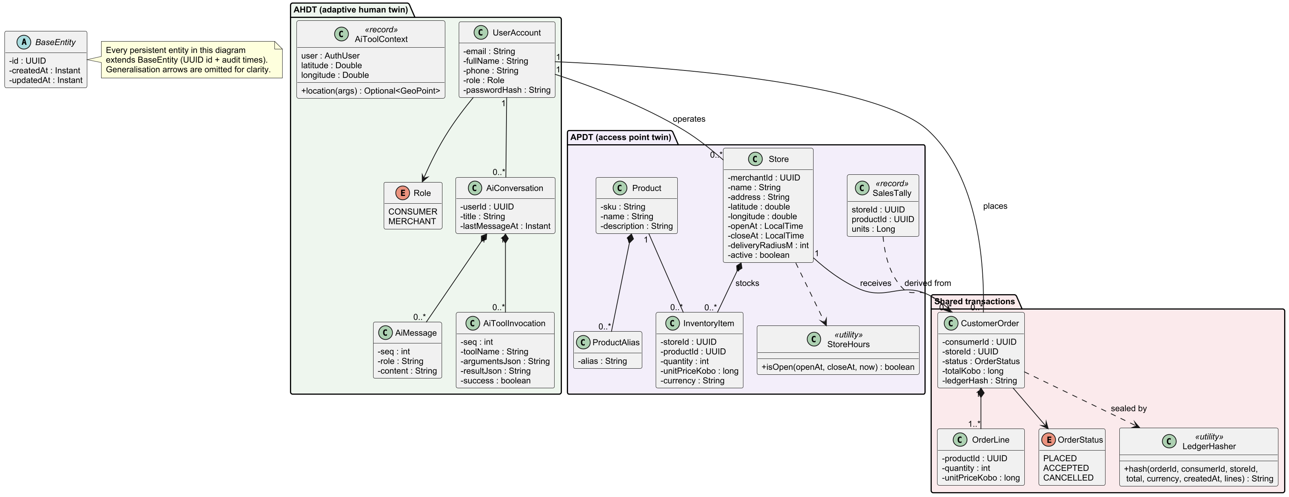
Figure 4.8 Class diagram: APDT and AHDT domain model.
The APDT is composed of Store, InventoryItem, Product / ProductAlias, StoreHours and derived SalesTally. The AHDT comprises UserAccount / Role, request-scoped AiToolContext, and conversational memory (AiConversation, AiMessage, AiToolInvocation). CustomerOrder / OrderLine couple the twins and are sealed by LedgerHasher.
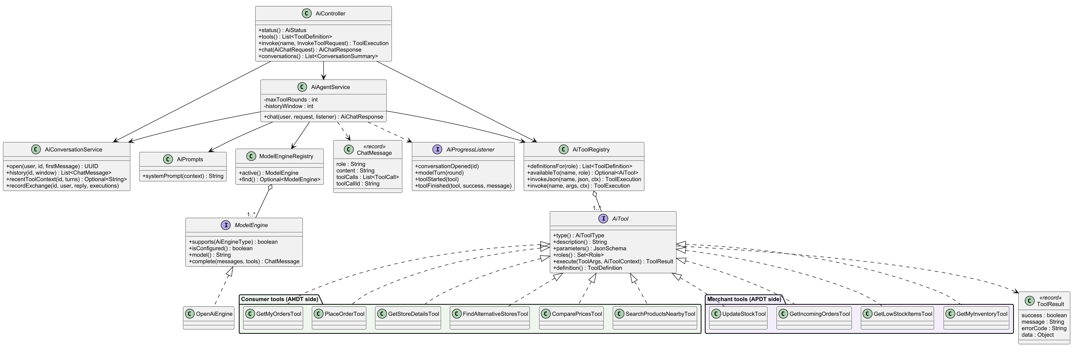
Figure 4.9 Class diagram: agentic layer.
AiController / realtime router expose status, tools, invoke, chat and conversations. AiAgentService loops up to maxToolRounds. Consumer tools: search, compare, find alternatives, store details, place order, my orders. Merchant tools: inventory, low stock, incoming orders, update stock.

5 Implementation

5.1 Technology stack
Table 5.1 Technology stack.
Concern | Technology
Runtime | Java 21
Backend | Spring Boot 3.4 (Web, JPA, Security, Validation, WebSocket, Actuator)
Modularity | Spring Modulith
Persistence | Hibernate; Flyway; H2 (PostgreSQL mode) or JDBC URL override
Security | JWT (jjwt), BCrypt; roles CONSUMER, MERCHANT
AI | OpenAI-compatible Chat Completions + tools
Frontend | React 19, Vite, Tailwind, TanStack Query, Zustand, Leaflet
Tests | JUnit 5, MockMvc, scripted ModelEngine, Modulith verify()

5.2 APDT (store twin) implementation
Stores hold geocoordinates, hours and ownership. Inventory quantities and prices are stored in kobo (integer minor units). reserve uses a pessimistic lock, checks quantity and decrements atomically. After commit, StockChangedEvent is broadcast so every client’s twin view updates—satisfying Kritzinger’s bidirectional twin criterion at the commerce layer.
Geospatial search avoids PostGIS:
- Bounding box around $\left(φ,λ\right)$ with radius $r$.
- JPQL filter by box, minQuantity, text/SKU/alias or productId, optional exclusions.
- Haversine distance filter and sort by distance then price.
Default radius is 15 km (so Ikeja remains reachable from the Yaba test point).
Best-value comparison minimises $s=0.6 \hat{p}+0.4 \hat{d}$ after min–max normalisation of price and distance.

5.3 AHDT (consumer twin) implementation
The AHDT is purpose-bounded: identity/role, device location, screen/cart context (AiClientContext), orders, and conversation/tool memory. Device coordinates always override model-supplied ones. Recent successful tool results are reinjected so the model reuses store and product ids instead of inventing them.

5.4 Agentic layer
Table 5.2 Agent tools.
Tool | Role | Purpose
SEARCH_PRODUCTS_NEARBY | Consumer | Nearest in-stock offers
COMPARE_PRICES | Consumer | Range + cheapest / nearest / best value
FIND_ALTERNATIVE_STORES | Consumer | Reroute excluding failed shops
GET_STORE_DETAILS | Both | Hours, distance, stock (optional product filter)
PLACE_ORDER | Consumer | Reserve + hash (after confirmation)
GET_MY_ORDERS | Consumer | Recent orders
GET_MY_INVENTORY | Merchant | Stock across owned stores
GET_LOW_STOCK_ITEMS | Merchant | Threshold + 7-day sales + suggested restock
GET_INCOMING_ORDERS | Merchant | Orders by status
UPDATE_STOCK | Merchant | Set quantity/price (after confirmation)
Without OPENAI_API_KEY, /ai/status reports unconfigured and chat returns 503 AI_NOT_CONFIGURED; direct tool invoke still works, which keeps the twin API usable in constrained environments.

5.5 Trust layer
LedgerHasher computes SHA-256 over canonical order fields (order id, consumer, store, total, currency, created time, lines). The hex digest is stored and shown as a receipt prefix in the UI—blockchain-ready integrity for the pilot.

5.6 UI/UX dashboards
The consumer UI implements the AHDT-facing application layer: search with location presets (Yaba / UNILAG, Surulere, Ikeja, Lekki), radius control, suggestion chips, map pins, cart and assistant panel. The merchant UI implements the APDT dashboard: orders (with hash prefix and Accept), inventory editing, and assistant.
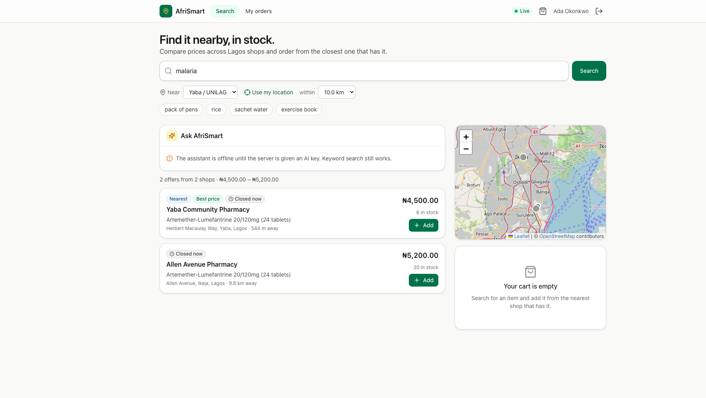
Figure 5.1 Consumer search / discovery UI (AHDT view of the marketplace).

Figure 5.2 Consumer order confirmation with ledger-hash receipt.

Figure 5.3 Merchant APDT dashboard — incoming orders.
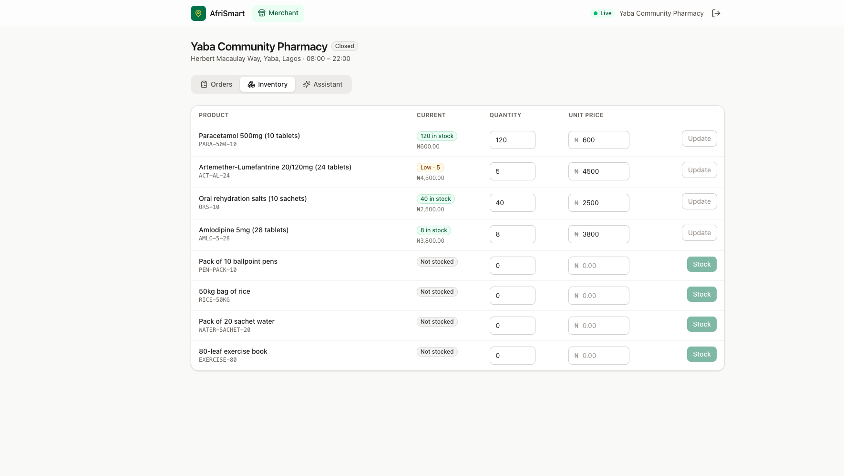
Figure 5.4 Merchant APDT dashboard — inventory twin.
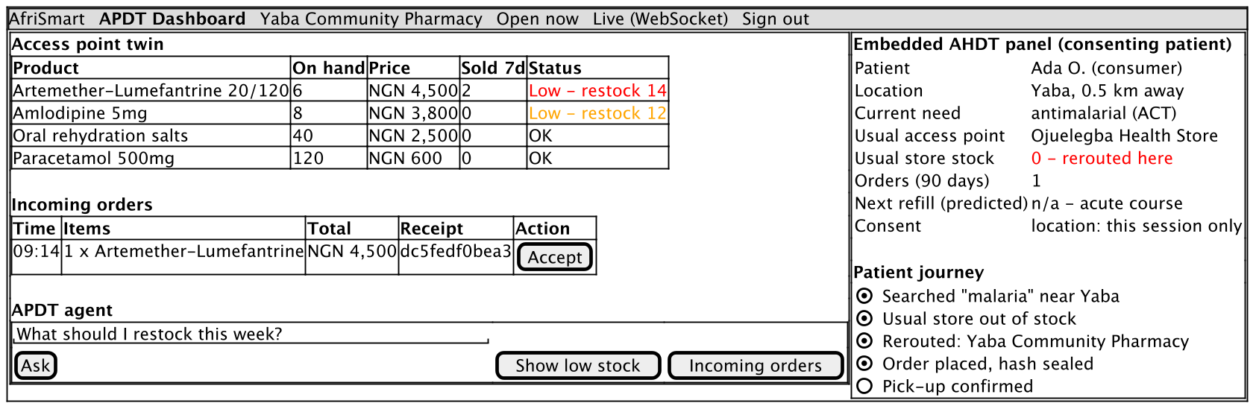
Figure 5.5 Design wireframe: APDT dashboard with embedded consented AHDT summary panel (future UX).
Figure 5.5 shows the intended embedded AHDT panel beside merchant inventory: when a consumer consents, the merchant sees why demand arrived (e.g. preferred shop out of stock, distance, current need)—turning an opaque order into a smart-city service interaction. The panel is designed; full embed is future work.

5.7 Testing and evaluation
Automated tests. 29 tests pass, including Modulith architecture verification, geo utilities (Yaba–Ikeja ≈ 10.5 km), order service unit tests, realtime integration tests, and AfriSmartIntegrationTest covering: public search prefers Yaba and excludes Surulere for pens; store details on Surulere report zero pens; FIND_ALTERNATIVE_STORES recommends Yaba; merchant invoking PLACE_ORDER is forbidden; scripted chat loop persists messages and tool memory; order flow updates merchant incoming orders and low-stock sales figures.
Hero scenario (pack of pens). From the seeded demo and integration tests:
Table 5.3 Pack-of-pens scenario (Lagos seed).
Step | Result
Search “pack of pens” near Yaba | Yaba Campus Mart first; Surulere excluded (qty 0); Ikeja available farther / dearer
Surulere details | Pens quantity 0; message suggests FIND_ALTERNATIVE_STORES
Reroute excluding Surulere | Recommended: Yaba Campus Mart (~1.1 km, ₦750)
Compare | Cheapest and nearest align on Yaba when both stocked options are considered
Place order (2 packs) | Total ₦1,500.00; ledger hash returned; stock reserved
Merchant tools | Incoming PLACED order; low-stock reflects units sold
Performance. Warm-path HTTP tool latency on Intel Core i7-1068NG7, 16 GB RAM, in-memory H2 (n = 30 after warm-up): search ≈ 8 ms median; store details ≈ 15 ms; alternatives ≈ 9 ms; compare ≈ 5–6 ms. LLM latency dominates conversational turns and is provider-dependent.

5.8 Answering the research questions
RQ1 (Access and discovery). Implemented geospatial offer search (bounding box + haversine) returns only shops that can fulfil the quantity, sorted by distance then price, without PostGIS. The pack-of-pens evaluation shows Yaba preferred over empty Surulere and distant Ikeja. Benefit for SSA users: fewer wasted trips and clearer nearest-available options on mobile-class clients.
RQ2 (Agency and continuity). The agentic loop with role-filtered tools autonomously checks the preferred shop, reroutes on stockout, compares prices and only then places orders after confirmation. Scripted tests prove the loop and tool protocol; live tool invokes prove the twin APIs. Benefit: continuity of access when the usual shop fails—the core agentic promise in the architecture document.
RQ3 (Twin synchronisation). APDT updates flow through locked inventory operations and post-commit WebSocket events; AHDT context (location, screen, memory) is attached to every agent turn. UI “Live” connectivity and stock badges reflect twin freshness. Benefit: consumers and merchants share one operational truth under low-resource hosting (H2/Postgres).
RQ4 (Trust and inclusion). SHA-256 ledger hashes provide immediate tamper evidence; public anchoring remains a staged future. Merchants onboard via accounts and APIs with no local server—APDT-as-a-service. Role separation prevents cross-role abuse (merchant cannot PLACE_ORDER). Benefit: trust scaffolding for informal-to-formal retail participation in African smart cities.

6 Conclusion
AfriSmart demonstrates that an agentic smart-city e-commerce platform combining digital twins and blockchain-oriented hashing can be designed and built for sub-Saharan urban contexts. Store twins (APDT) and adaptive consumer twins (AHDT), coordinated by LLM tool agents atop a seven-layer application architecture, make inventory searchable, stockouts recoverable through rerouting, and orders verifiable. The Lagos pack-of-pens scenario—preferred shop empty, nearest alternative fulfilled and hash-sealed—embodies the architecture’s motivating claim: agentic systems can reduce time waste, transport cost and market opacity while strengthening local merchants.

6.1 Recommendations
- Pilot with real neighbourhood merchants in one Lagos corridor (e.g. Yaba–Surulere) before multi-city rollout; measure trip avoidance and stockout recovery rate.
- Keep irreversible actions behind confirmation in both prompts and product UX (order review screens, stock-update previews).
- Treat the LLM as replaceable infrastructure—retain direct tool APIs so commerce continues when models are offline or unaffordable.
- Stage blockchain adoption: hash now, anchor later; do not block checkout on chain latency.
- Invest in alias-rich catalogues (local language and brand names) so search matches how people actually ask.
- Enforce location privacy as a first-class consent artefact (session vs persistent sharing).
- Use Modulith (or equivalent) boundaries so twin, agent and trust layers can evolve independently.

6.2 Future directions
- Public ledger anchoring of ledgerHash (e.g. daily Merkle roots on a low-cost chain).
- Payments and logistics in the smart-city service layer (mobile money, motorcycle delivery ETAs as twin attributes).
- IoT perception (smart shelves, POS feeds) to reduce manual stock updates.
- Richer AHDT (refill prediction for staples, accessibility preferences) with strict purpose limitation.
- Embedded merchant AHDT panel (Figure 5.5) for consented consumer context.
- Offline-tolerant clients and SMS/USSD fallbacks for intermittent connectivity.
- Field evaluation with quantitative KPIs: time-to-fulfilment, kilometres avoided, merchant restock accuracy, trust perception of hash receipts.
- Multi-agent negotiation (consumer agent ↔ merchant agent) for substitutions and bulk institutional buyers (schools, clinics).

7 References
Abburu, S. et al. (2020) ‘COGNITWIN – Hybrid and cognitive digital twins for the process industry’, IEEE International Conference on Engineering, Technology and Innovation.
Anthropic (2024) Model Context Protocol. Available at: https://modelcontextprotocol.io/ (Accessed: October 2026).
Batty, M. (2018) ‘Digital twins’, Environment and Planning B, 45(5), pp. 817–820.
Batty, M. et al. (2012) ‘Smart cities of the future’, European Physical Journal Special Topics, 214, pp. 481–518.
Boschert, S. and Rosen, R. (2016) ‘Digital twin—the simulation aspect’, in Hehenberger, P. and Bradley, D. (eds) Mechatronic Futures. Springer, pp. 59–74.
Chourabi, H. et al. (2012) ‘Understanding smart cities: An integrative framework’, 45th Hawaii International Conference on System Sciences, pp. 2289–2297.
Fuller, A. et al. (2020) ‘Digital twin: Enabling technologies, challenges and open research’, IEEE Access, 8, pp. 108952–108971.
Glaessgen, E. and Stargel, D. (2012) ‘The digital twin paradigm for future NASA and U.S. Air Force vehicles’, 53rd AIAA/ASME/ASCE/AHS/ASC Structures, Structural Dynamics and Materials Conference.
Grieves, M. (2014) Digital Twin: Manufacturing Excellence through Virtual Factory Replication. White paper.
Grieves, M. and Vickers, J. (2017) ‘Digital twin: Mitigating unpredictable, undesirable emergent behavior in complex systems’, in Kahlen, F.-J., Flumerfelt, S. and Alves, A. (eds) Transdisciplinary Perspectives on Complex Systems. Springer, pp. 85–113.
GSMA (2023) The Mobile Economy: Sub-Saharan Africa. London: GSMA.
ISO (2021) ISO 23247: Automation systems and integration — Digital twin framework for manufacturing. Geneva: ISO.
Ji, Z. et al. (2023) ‘Survey of hallucination in natural language generation’, ACM Computing Surveys, 55(12), pp. 1–38.
Jones, D. et al. (2020) ‘Characterising the Digital Twin: A systematic literature review’, CIRP Journal of Manufacturing Science and Technology, 29, pp. 36–52.
Kamel Boulos, M.N. and Zhang, P. (2021) ‘Digital twins: From personalised medicine to precision public health’, Journal of Personalized Medicine, 11(8), 745.
Kritzinger, W. et al. (2018) ‘Digital Twin in manufacturing: A categorical literature review and classification’, IFAC-PapersOnLine, 51(11), pp. 1016–1022.
Lu, Y. et al. (2020) ‘Digital Twin-driven smart manufacturing: Connotation, reference model, applications and research issues’, Robotics and Computer-Integrated Manufacturing, 61, 101837.
Mell, P. and Grance, T. (2011) The NIST Definition of Cloud Computing. NIST Special Publication 800-145.
Mettler, M. (2016) ‘Blockchain technology in healthcare: The revolution starts here’, IEEE 18th International Conference on e-Health Networking, Applications and Services.
Nakamoto, S. (2008) Bitcoin: A Peer-to-Peer Electronic Cash System.
OpenAI (2023) Function calling and other API updates. OpenAI Blog.
OWASP (2023) OWASP Top 10 for Large Language Model Applications.
Park, J.S. et al. (2023) ‘Generative agents: Interactive simulacra of human behavior’, UIST ’23.
Rasheed, A., San, O. and Kvamsdal, T. (2020) ‘Digital twin: Values, challenges and enablers from a modeling perspective’, IEEE Access, 8, pp. 21980–22012.
Russell, S. and Norvig, P. (2021) Artificial Intelligence: A Modern Approach. 4th edn. Pearson.
Schick, T. et al. (2023) ‘Toolformer: Language models can teach themselves to use tools’, NeurIPS.
Shafto, M. et al. (2012) Modeling, Simulation, Information Technology & Processing Roadmap. NASA.
Shneiderman, B. (2020) ‘Human-centered artificial intelligence: Reliable, safe & trustworthy’, International Journal of Human–Computer Interaction, 36(6), pp. 495–504.
Sinnott, R.W. (1984) ‘Virtues of the Haversine’, Sky and Telescope, 68(2), p. 159.
Tao, F. et al. (2019) ‘Digital twin in industry: State-of-the-art’, IEEE Transactions on Industrial Informatics, 15(4), pp. 2405–2415.
UNCTAD (2021) Digital Economy Report. Geneva: United Nations.
Wang, L. et al. (2024) ‘A survey on large language model based autonomous agents’, Frontiers of Computer Science, 18, 186345.
Wooldridge, M. and Jennings, N.R. (1995) ‘Intelligent agents: Theory and practice’, Knowledge Engineering Review, 10(2), pp. 115–152.
Xi, Z. et al. (2023) ‘The rise and potential of large language model based agents: A survey’, arXiv:2309.07864.
Xia, Y. et al. (2023) ‘Towards autonomous system: Flexible modular production system enhanced with large language model agents’, IEEE ETFA.
Yao, S. et al. (2023) ‘ReAct: Synergizing reasoning and acting in language models’, ICLR.
Zheng, X., Lu, J. and Kiritsis, D. (2022) ‘The emergence of cognitive digital twin: Vision, challenges and opportunities’, International Journal of Production Research, 60(24), pp. 7610–7632.

