## Galaxy AI is here

Welcome to the era of mobile AI. With Galaxy S24 | S24+ in your hands, you can unleash whole new levels of creativity, productivity and possibility — starting with the most important device in your life. Your smartphone.

## Embrace every curve

Easy to grip. Satisfying to hold. With their unified design and satin finish, Galaxy S24 and S24+ feel as smooth as they look.

## Big, bigger and faster[5](https://www.samsung.com/africa_en/smartphones/galaxy-s24/#desc-section)

They're the upgrades you've waited for. More screen. More battery. More processing power.[6](https://www.samsung.com/africa_en/smartphones/galaxy-s24/#desc-section) There's so much more to love about Galaxy S24 and S24+. Especially now that Galaxy S24+ comes with the highest screen resolution on a Galaxy device: QHD+.

## 50MP. Mega Mega Pixels

A true pixel powerhouse that will not disappoint. Ever. Snap high-res pics for that will no doubt withstand the test of time for years to come.

## Shoot far. Even in the dark

## Get closer with every pinch

Just keep pinching. Go from 1x to 2x or even 3x.[11](https://www.samsung.com/africa_en/smartphones/galaxy-s24/#desc-section),[12](https://www.samsung.com/africa_en/smartphones/galaxy-s24/#desc-section) AI keeps pictures high-quality: crisp, clear and super sharp — without losing much detail.[14](https://www.samsung.com/africa_en/smartphones/galaxy-s24/#desc-section),[15](https://www.samsung.com/africa_en/smartphones/galaxy-s24/#desc-section)

## Make room for epic AI Zoom

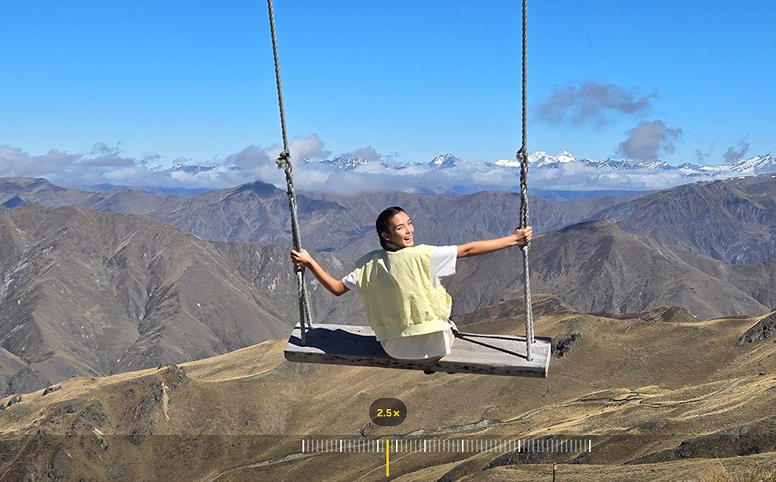

The view finder of the Camera app shows a woman posing in front of a scenic background. The camera zooms in from 1x to 2x and then 3x. Next, a clear photo of a subject with a scenic background at 2.5x zoom appears.

Captured by Galaxy S24+ #withGalaxy

Capture stunning shots with vivid detail at more zoom distances than before.[6](https://www.samsung.com/africa_en/smartphones/galaxy-s24/#desc-section) Zoom in on the action and capture enhanced details thanks to the new AI Zoom solution.[14](https://www.samsung.com/africa_en/smartphones/galaxy-s24/#desc-section),[15](https://www.samsung.com/africa_en/smartphones/galaxy-s24/#desc-section)

## Resize it, retouch it. Just like that

Unlock the magic of AI-powered photo editing.[4](https://www.samsung.com/africa_en/smartphones/galaxy-s24/#desc-section) Now you can effortlessly perfect your photos, ensuring every image shines. But that's not all, even if you couldn't capture the shot you wanted, Generative Edit can fill in backgrounds and make unwanted objects *poof* disappear.

## Touch and hold for Slow-mo

Capture the action, add epic slow-motion effects later. Instant Slow-mo puts AI-generated images between the frames of regular videos from your Gallery or your downloads. All it takes is a simple touch and hold.[36](https://www.samsung.com/africa_en/smartphones/galaxy-s24/#desc-section)

## Super HDR previews. AI-enhanced before you even snap

With our latest Super HDR upgrade, you can capture vivid shots the way you see them, from preview to posting.[16](https://www.samsung.com/africa_en/smartphones/galaxy-s24/#desc-section) And it even works when you shoot with Instagram.[17](https://www.samsung.com/africa_en/smartphones/galaxy-s24/#desc-section)

See a Super HDR preview before you even hit the shutter. Keep it in your Gallery, or upload it to your feed — either way you'll see the same show-stopping HDR quality.

## Your must-haves are at your fingertips

Customize your daily experience with widgets on your lock screen and Always On Display. From important reminders to your local air quality, get the info you need at a glance.[19](https://www.samsung.com/africa_en/smartphones/galaxy-s24/#desc-section)

## Pick the right tone for your text with Chat Assist

Add a whole new layer of expression to your messages through Chat Assist.[20](https://www.samsung.com/africa_en/smartphones/galaxy-s24/#desc-section) It works across email and on social media to make chatting quick and easy!

## Our brightest adaptive mobile display under the sun

Level up your game with these two massive screens. Thanks to their increased display size and ultra-slim bezels, Galaxy S24's 6.2" FHD+ display and Galaxy S24+'s 6.7" QHD+ display offer more screen real estate than ever before, delivering the most immersive viewing experience.[7](https://www.samsung.com/africa_en/smartphones/galaxy-s24/#desc-section),[22](https://www.samsung.com/africa_en/smartphones/galaxy-s24/#desc-section) Plus, you can enjoy optimal colour and contrast with Vision Booster on both displays.