## Super vivid and bright display

The Galaxy A15's 6.5-inch Super AMOLED display boasts vibrant clarity even in direct sunlight with Vision Booster, smooth-scrolling with improved 90Hz refresh rate, enhanced brightness up to 800 nits, and all-day comfort with reduced blue light thanks to Eye Comfort Shield.

## Pick your lens. Find your angle.

Go on and express your world. The Galaxy A15 boasts a 50MP Main camera for your masterpiece, 5MP Ultra Wide and 2MP Macro cameras for landscapes and close-ups, and a 13MP Front camera for profile-worthy selfies.

## Get it done with boosted performance

Your day runs smoother with an octa-core processor for powerful performance while spacious memory and storage options keep your data and contents ready at hand.

## Stay in the zone with a 2-day battery

More time to get productive with a 5,000mAh (typical) battery that lasts for 2 days and recharges rapidly with Super Fast Charging.

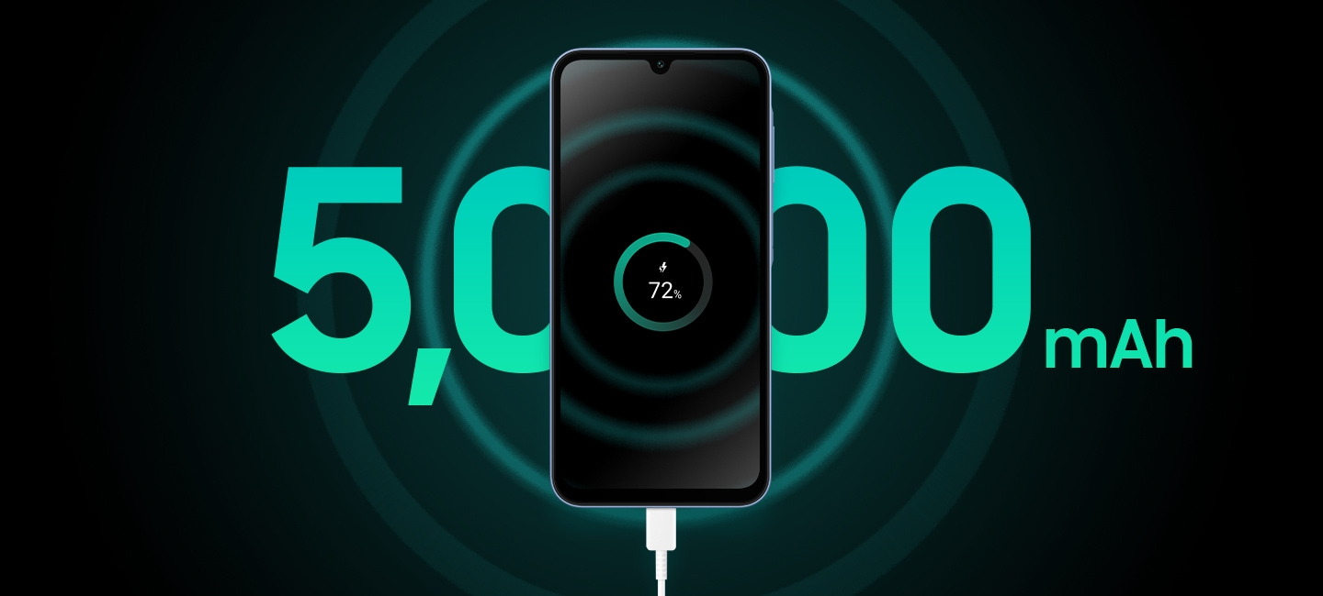

* Actual UI may be different. Image simulated for illustrative purposes.  
 ** The Wall Charger for Super Fast Charging (25W) sold separately.  
 *** Typical value tested under third-party laboratory conditions. Typical value is the estimated average value considering the deviation in battery capacity among battery samples tested under the IEC 61960 standard. Rated capacity is 4,900mAh.  
 **** Estimated against the usage profile of an average/typical user. Independently assessed by UX Connect Research between 2023.11.30-2023.12.08 in the UK with pre-release versions of SM-A155 under default setting using Wi-Fi and LTE. Actual battery life varies by network environment, features and apps used, frequency of calls and messages, number of times charged, and many other factors.

## Trust in Samsung Knox Vault

Certified EAL5+, Samsung Knox Vault is designed to safeguard your sensitive data, such as PINs, passwords and patterns, in a separate tamper-resistant storage for protection against software and hardware threats involving voltage, glitches, high temperature and laser.

* EAL: Evaluation Assurance Level (CC, Common Criteria).

## Unlock with your fingerprint

Double-checked by the side fingerprint sensor, your security is designed to be accessible only by your fingerprint.