Brazzein (4HE7)

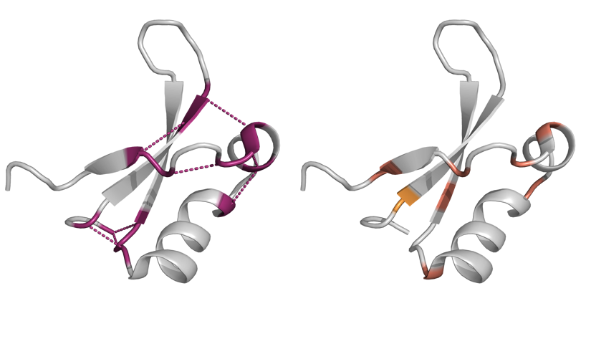
MNEI (1IV7)

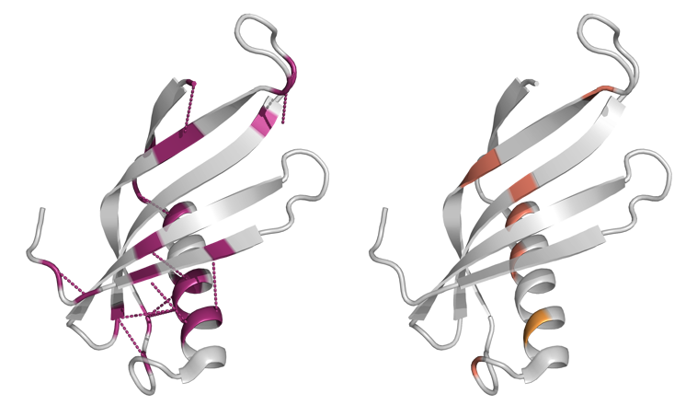
Thaumatin-II (3AOK)
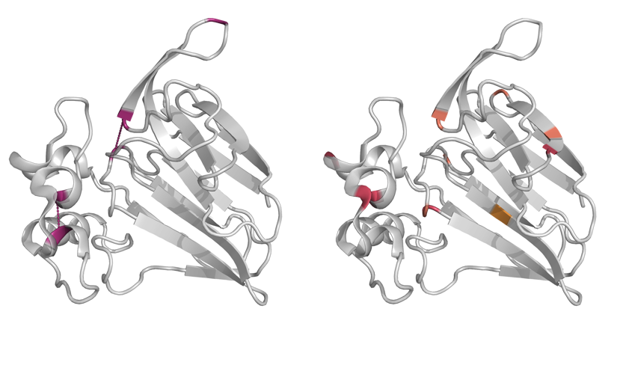
Design strategy

Disulfide bridge
Consensus mutagenesis
Bibliography
Rosetta

Fig X: The figure shows the native structures for Brazzein, MNEI, and Thaumatin-II with the induced variants highlighted in different colours based on the design strategy. The variant positions including disulfide bridges are shown on the left, and each pair of cysteines is connected by a line, representing the disulfide bridge formed by the induced variants. The rest of the variants from the three other sources (consensus mutagenesis, bibliography, and Rosetta) are visualized on the right.

Computational analyses

To computationally predict the variants’ effects on sweet protein stability, DynaMut 2 web server (https://biosig.lab.uq.edu.au/dynamut/) and Rosetta CartesianDDG protocol were used to predict ΔΔG caused by each variant. [1,2] For DynaMut 2, the PDB files 4HE7, 1IV7, and 3AOK were uploaded to the web server for Brazzein, MNEI, and Thaumatin-II, respectively, together with the associated variant lists. The same PDB files were used for Rosetta CartesianDDG protocol, and the PDB structures were first relaxed using the following Rosetta Relax command:

$ROSETTABIN/rosetta_scripts.static.linuxgccrelease -in:file:s $pdb \
-in:file:fullatom \
-run:constant_seed true \
-run:jran 1111112 \
-default_max_cycles 200 \
-missing_density_to_jump \
-ignore_zero_occupancy false \
-fa_max_dis 9 \
-nstruct 20 \
-out:path:pdb "${output}" \
-out:path:score "${output}" \
-parser:protocol “./cartesianrelaxprep.xlm”

Where the protocol (cartesianrelaxprep.xlm) was defined as follows:

<ROSETTASCRIPTS>
<SCOREFXNS>
<ScoreFunction name="fullatom" weights="ref2015_cart" symmetric="0">
</ScoreFunction>
</SCOREFXNS>
<MOVERS>
<FastRelax name="fastrelax" scorefxn="fullatom" cartesian="1" repeats="4"/>
</MOVERS>
<PROTOCOLS>
<Add mover="fastrelax"/>
</PROTOCOLS>
<OUTPUT scorefxn="fullatom"/>
</ROSETTASCRIPTS>

The Relax protocol produced 20 relaxed .PDB structures, and the CartesianDDG protocol was then applied on the structure with the lowest energy, using the following command:

$ROSETTABIN/cartesian_ddg.static.linuxgccrelease \
-database $ROSETTADB \
-s $PDB \
-run:constant_seed true \
-run:jran 1111111 \
-ddg:mut_file $MUTFILE \
-ddg:iterations 5 \
-force_iterations false \
-optimize_proline true \
-ddg::score_cutoff 1.0 \
-ddg::cartesian \
-ddg::dump_pdbs true \
-fa_max_dis 9.0 \
-score:weights ref2015_cart

To see whether experimentally measured values of protein stability and expression correlate with computational descriptors of protein sequence and structure, several methods were applied. Firstly, the sequence-based features were computed using modlAMP package in Python. [3] The included sequence-level features covered a range of global and local descriptors, that were averaged into a single value for each variant. The features included simple descriptors of peptide hydrophobicity, instability, polarity, and charge, as well as custom descriptors based on modlAMP’s inhouse scales (e.g. PPCALI and PEPCATS).

Secondly, to computationally assess the structural effects of the variants, AlphaFold 2, version 2.3.1(AF2) was used to generate template-free structures of all produced sweet protein variants. [4] For each generated structure, the prediction quality was calculated as the average predicted local distance difference test (pLDDT) score, ranging from 0 to 100. The total, apolar, and polar solvent accessible surface area (SASA) was also calculated on the AF2 predicted structures using a Python implentation of FreeSASA C library to assess potential variant effects on protein surface. [5] To further analyse the protein surface features, the pre-processing pipeline of MaSIF-site (https://github.com/LPDI-EPFL/masif/blob/master/data/masif_site/data_prepare_one.sh) with the default settings was run on the predicted AF2 structures. [6] The preparation script decomposes the full protein structure into discretized surface patches with a radius of 9 Å, producing a .ply file for each variant. For each vertex in the surface mesh, a set of surface features are computed. Here, only computed Poisson–Boltzmann continuum electrostatics (charge), locations of free electrons and proton donors (hbond), and Kyte and Doolittle hydropathy [7] were used. To gain a global descriptor score for each protein structure, the computed values were averaged over all surface vertices.

The sequence and structure-based features, together with computational predictions of ΔΔG were then tested for correlations against the experimental measures of protein yield and stability. The correlation analysis was conducted for each sweet protein separately using Spearman’s rank correlation coefficient in R v. 4.3.1 (hmisc package), and the p-values were adjusted for False Discovery Rate (FDR) using Benjamini-Hochberg (BH) method. [8, 9, 10] The correlations were then plotted as a cluster map for each protein separately, and only the correlations significant at BH-adjusted p < .05 were shown.

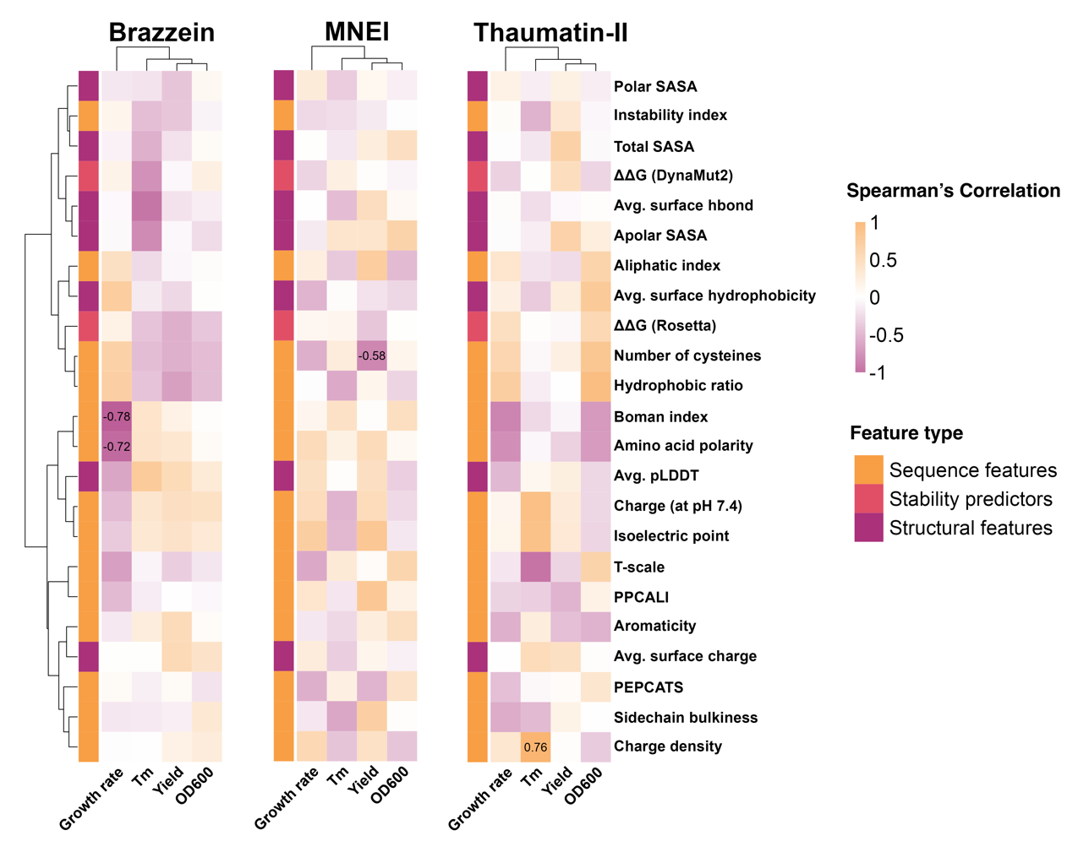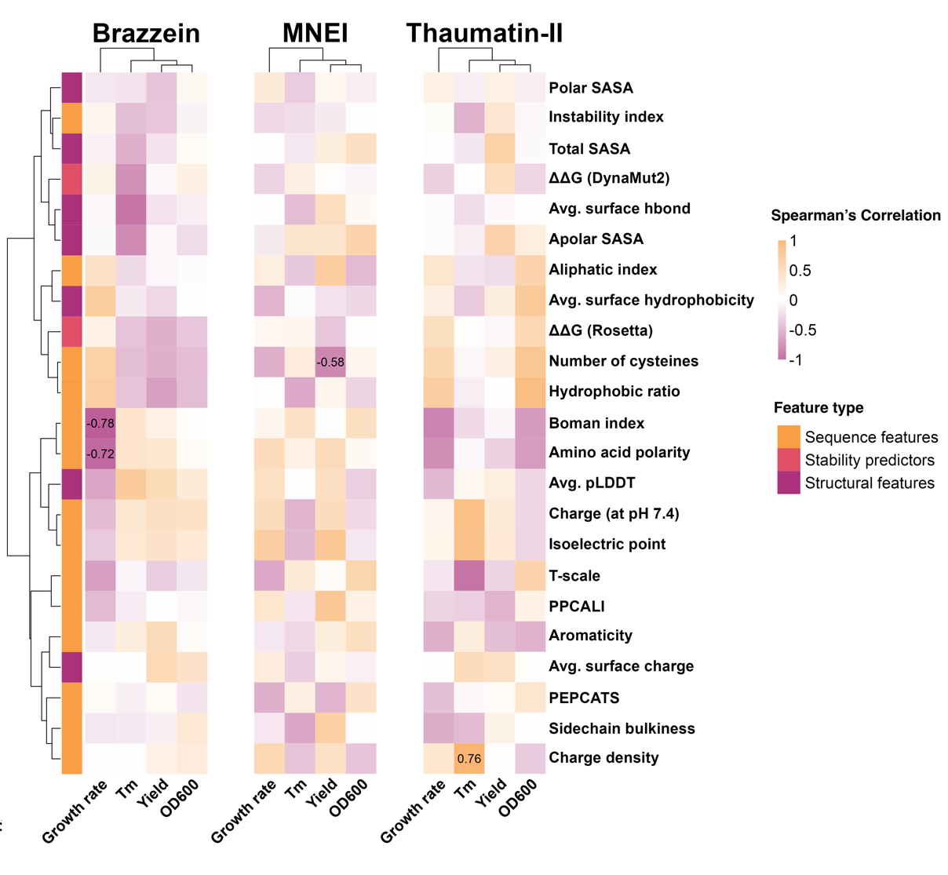
Fig X. The figure shows the Spearman’s rank correlation of experimental features of protein stability and expression against computational descriptors of protein sequence and structures as well as the predicted ΔΔG of each variant. The dendrogram shows the hierarchical clustering based on the correlations from Brazzein, and the same clustering of experimental and computational features were used for MNEI and Thaumatin-II to facilitate comparisons of correlation patterns across the three proteins. The correlations display notable differences between sweet proteins, and only few of the computational protein descriptors correlate significantly (at BH-adjusted p < .05) with the experimentally measured variables.

NOTE: Alex asked for the unadjusted p-values for the above correlations. They are the following:

Thaumatin-II
Charge density vs TM: 0.00101204135922561

Brazzein
Boman index vs Growth rate: 2.95795441718205e-05
Amino acid polarity vs Growth rate: 0.000242815639286853

MNEI
Yield vs Number of cysteines: 0.00459335965633745"

Predicted complex structures

To see how the variants are located with regard to the potential binding interface between each sweet protein and the sweet taste receptor dimer (T1R2+T1R3), AFsample was used to generate 2,000 complex predictions, half of which were generated using templates. [11] AFsample can improve AF2 prediction quality by aggressively increasing the sampling, and therefore generating more diverse set of predictions, which has proven to be a successful strategy for increasing prediction quality for difficult prediction targets. [11] However, due to run-time limitations of the available computing cluster, AFsample pipeline applied here was modified to exclude the generation of models with increased levels of recycling and 1,000 models were generated with and without templates instead of default 2,000. The sequences for the human sweet taste receptor subunits (T1R2+T1R3) (retrieved from UniProt without the annotated signal sequences) and native sweet protein sequences were used to predict the structures using AFsample.

The generated 2,000 predicted complexes were then analysed by calculating the pairwise root mean square deviation (RMSD) of all pairs of predicted structures per sweet protein using only C-α atom coordinates. Hierarchical clustering was then applied on the calculated pairwise RMSD matrix using the Ward variance minimization algorithm. [12] This was done to identify potential clusters of complexes in which the predicted binding interface was in high agreement with other predictions belonging to the same cluster. For each sweet protein, five clusters were extracted from the dendrogram based on the pairwise RMSD. The largest cluster was then chosen for further analyses, as this was considered to be the consensus prediction by AFsample. From the largest cluster, the prediction with the highest prediction quality, as measured by iPTM+PTM score calculated by AF2, was then visualized in PyMOL. (13)

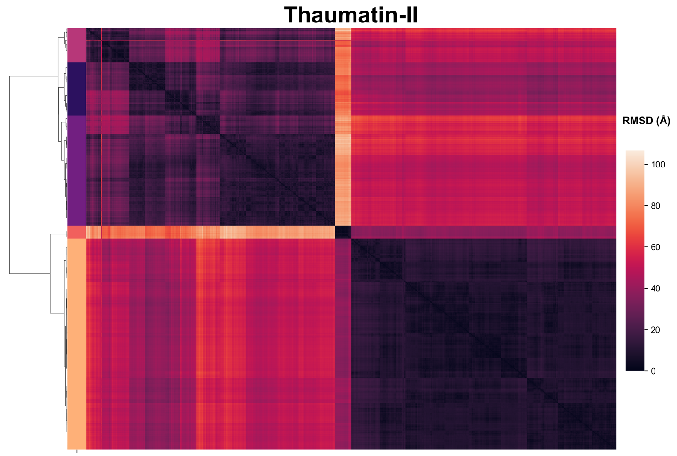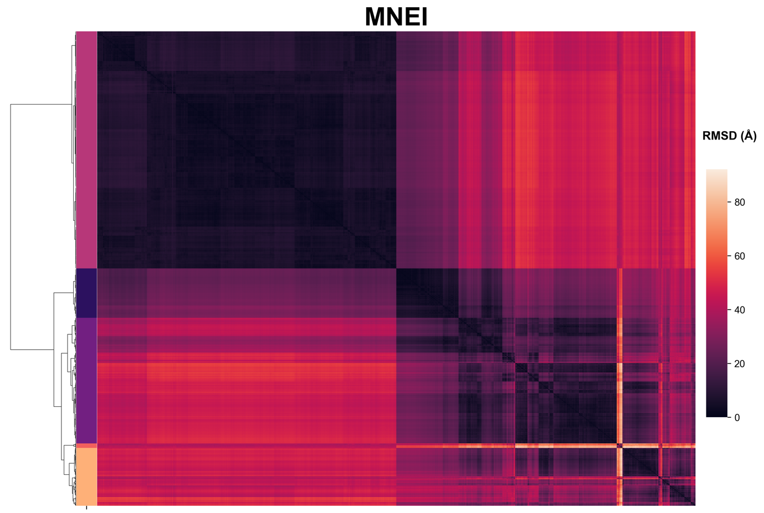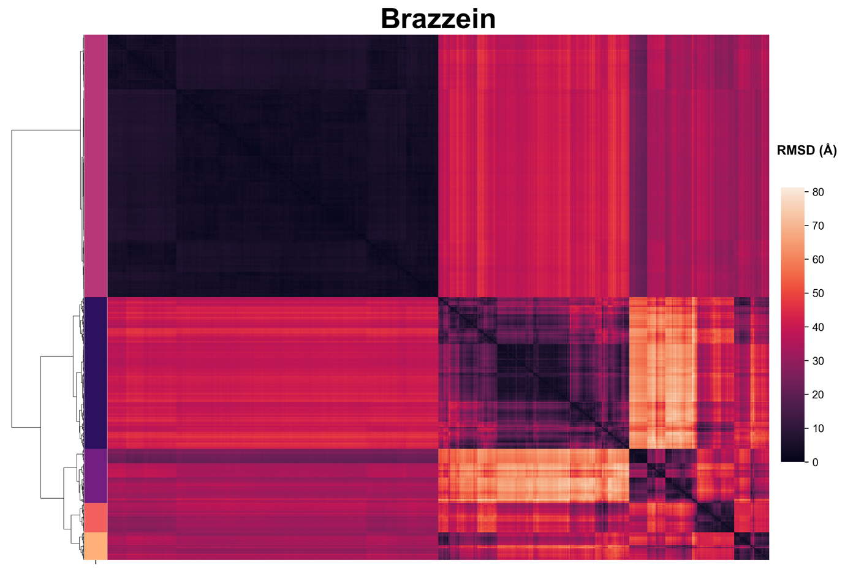

Fig X. The heatmaps visualize the pairwise RMSD of all 2,000 predicted sweet protein and sweet taste receptor complexes. The darker color implies higher similarity between two structures, as measured by RMSD. For each sweet protein, 2,000 generated predictions contain one large cluster of predictions with high pairwise similarity, while smaller clusters of predictions are produced for each sweet protein.

Brazzein | MNEI | Thaumatin-II
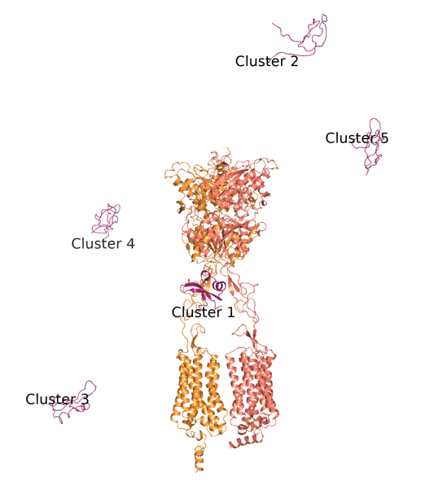 | 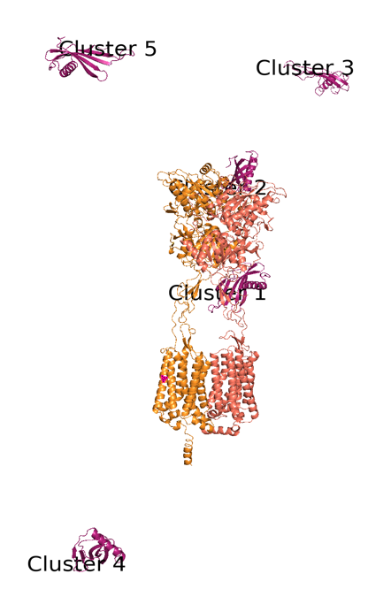 | 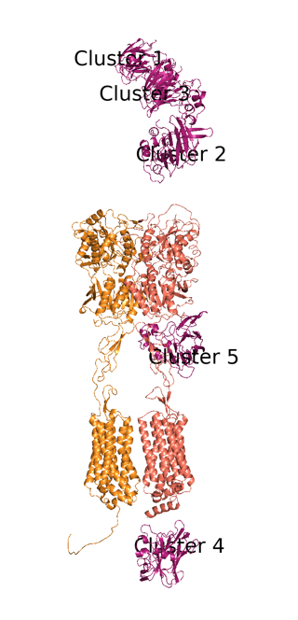

NOTE: I made the above figure to show how AFsample placed the sweet protein in different clusters. In all cases, the “correct” placement came from the cluster with the most predictions. However, these predictions had sometimes lower prediction scores (iPTM+PTM), so choosing the best model of all 2,000 predictions was sometimes one belonging to a cluster where the positioning was completely off. The iPTM+PTM score also represents the prediction quality of the interface between the two taste receptors, so I am assuming that iPTM+PTM is more affected by slight changes in this rather than the sweet protein positioning, since the sweet proteins are really small compared to the receptors. This figure is a quick draft, and I can make an improved one if you think this would be good for the paper. Here, T1R3 is on the left and T1R2 is on the right.

Sweet Proteins in Complex with the Sweet Taste Receptor (T1R2 and T1R3)

Brazzein | MNEI | Thaumatin-II
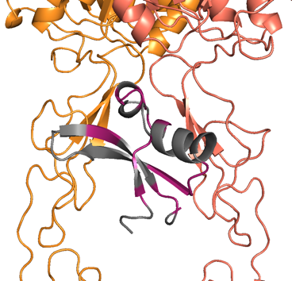 | 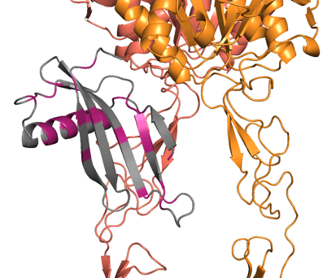 | 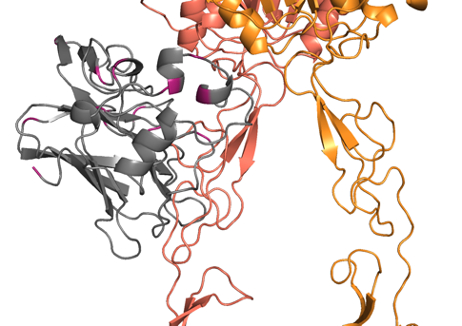
Fig X: The figure shows the highest quality prediction from the chosen clusters for each sweet protein. As described earlier, 2,000 structure predictions produced by AFsample were clustered into five clusters using pairwise RMSD. The largest cluster was then chosen for each sweet protein, and the highest quality predictions were extracted from the largest clusters for each sweet protein. For all three sweet proteins, AFsample placed the sweet protein near the cysteine rich domain (CRD) of the receptor complex. T1R2 is shown in salmon, T1R3 in orange, and the sweet proteins are shown in grey with the variant positions highlighted in purple.

References

- Park, Hahnbeom, Philip Bradley, Per Greisen Jr, Yuan Liu, Vikram Khipple Mulligan, David E. Kim, David Baker, and Frank DiMaio. "Simultaneous optimization of biomolecular energy functions on features from small molecules and macromolecules." Journal of chemical theory and computation12, no. 12 (2016): 6201-6212.
- Rodrigues, Carlos HM, Douglas EV Pires, and David B. Ascher. "DynaMut2: Assessing changes in stability and flexibility upon single and multiple point missense mutations." Protein Science 30, no. 1 (2021): 60-69.
- Müller, Alex T., Gisela Gabernet, Jan A. Hiss, and Gisbert Schneider. "modlAMP: Python for antimicrobial peptides." Bioinformatics 33, no. 17 (2017): 2753-2755.
- Jumper, John, Richard Evans, Alexander Pritzel, Tim Green, Michael Figurnov, Olaf Ronneberger, Kathryn Tunyasuvunakool et al. "Highly accurate protein structure prediction with AlphaFold." Nature 596, no. 7873 (2021): 583-589.
- Mitternacht, Simon. "FreeSASA: An open source C library for solvent accessible surface area calculations." F1000Research 5 (2016).
- Gainza, Pablo, Freyr Sverrisson, Frederico Monti, Emanuele Rodola, D. Boscaini, M. M. Bronstein, and B. E. Correia. "Deciphering interaction fingerprints from protein molecular surfaces using geometric deep learning." Nature Methods 17, no. 2 (2020): 184-192.
- Kyte, Jack, and Russell F. Doolittle. "A simple method for displaying the hydropathic character of a protein." Journal of molecular biology 157, no. 1 (1982): 105-132.
- R Core Team (2023). _R: A Language and Environment for Statistical Computing_. R Foundation for Statistical Computing, Vienna, Austria. <https://www.R-project.org/>.
- Harrell Jr, Frank E., and Maintainer Frank E. Harrell Jr. "Package ‘hmisc’." CRAN2018 2019 (2019): 235-236.
- Benjamini, Y., & Hochberg, Y. (1995). Controlling the false discovery rate: a practical and powerful approach to multiple testing. Journal of the Royal statistical society: series B (Methodological), 57(1), 289-300.
- Wallner, B. (2023). AFsample: improving multimer prediction with AlphaFold using massive sampling. Bioinformatics, 39(9), btad573.
- Ward Jr, J. H. (1963). Hierarchical grouping to optimize an objective function. Journal of the American statistical association, 58(301), 236-244.
- DeLano, W. L. (2002). Pymol: An open-source molecular graphics tool. CCP4 Newsl. Protein Crystallogr, 40(1), 82-92

Corrections to the mutations in the shared Excel file:
In the Excel file (240117_SP-variants.xlsx), some of the variants were incorrectly listed in the column containing the variant string (“mutation”). I assumed that the sequence column is correct for native proteins and the variants.

Also, I used a different PDB file for MNEI, as the 1MOL pdb file doesn’t have a perfectly matching sequence to the one that was in the excel file, so if I had plotted the variants in 1MOL, the positions would have been slightly off (1MOL has a slightly different linker between A and B chains).

MNEI:
ST0134: contains variants ['T12A', 'G16A', 'C41A', 'Y60F'] and not only “T12A/ G16A/ C41A/”
ST0136: contains variants ['T12A', 'G16A', 'Y29F', 'C41A', 'M42Q', 'Y47Q', 'Y60F'], and not T12A/ G16A/ Y29F/ C41A/ M42Q/ M47Q/ Y60F

Thaumatin-II
ST0089: V184P instead of V148P

