CYCLE-2

1. Create a three dimensional array specifying float data type and print it.

PROGRAM:
import numpy as np
arr = np.array([[[1, 2, 3], [4, 5, 6],[4, 5, 6]], [[1, 2, 3], [4, 5, 6],[4, 5, 6]],[[1, 2, 3], [4, 5, 6],[4, 5, 6]]], dtype='f')
print(arr)

OUTPUT:
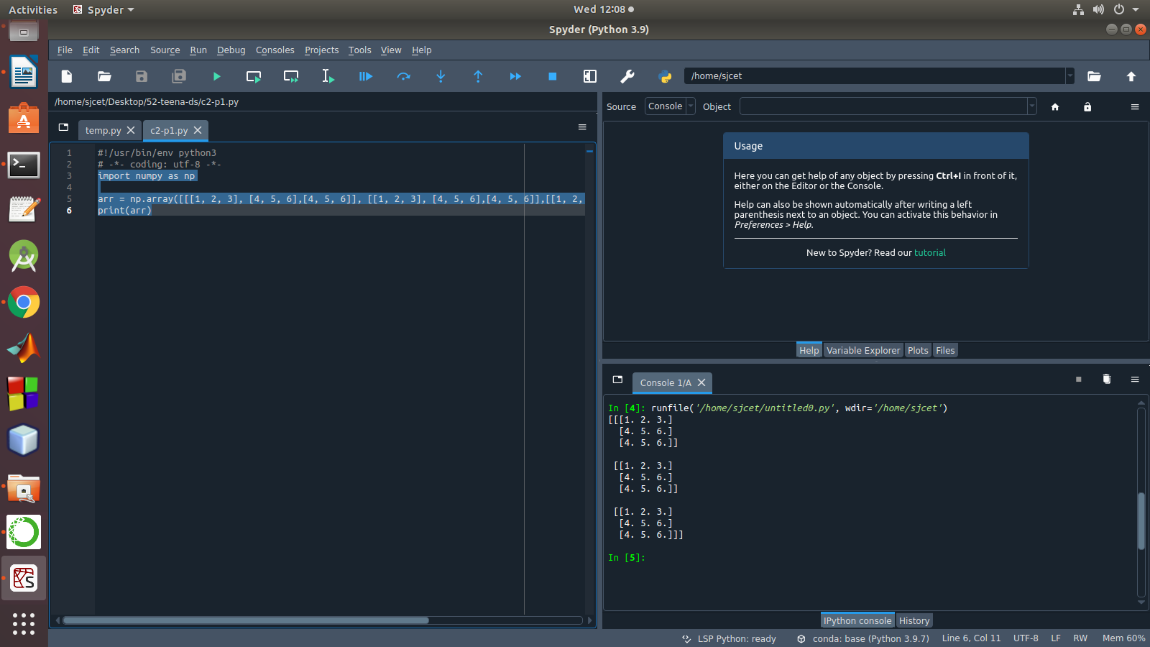

2. Create a 2 dimensional array (2X3) with elements belonging to complex data
type and print it. Also display
a. the no: of rows and columns
b. dimension of an array
c. reshape the same array to 3X2

PROGRAM:

import numpy as np

arr = np.array([[[1, 2, 3], [4, 5, 6]]])
print(arr)
#a
numOfRows = np. size(arr, 0)
print("rows:",numOfRows)
numOfColumns = np. size(arr, 1)
print("columns:",numOfColumns)
#b
print("Dimension",arr.shape)
#c
rs=np.reshape(arr, (3, 2))
print(rs)

OUTPUT:

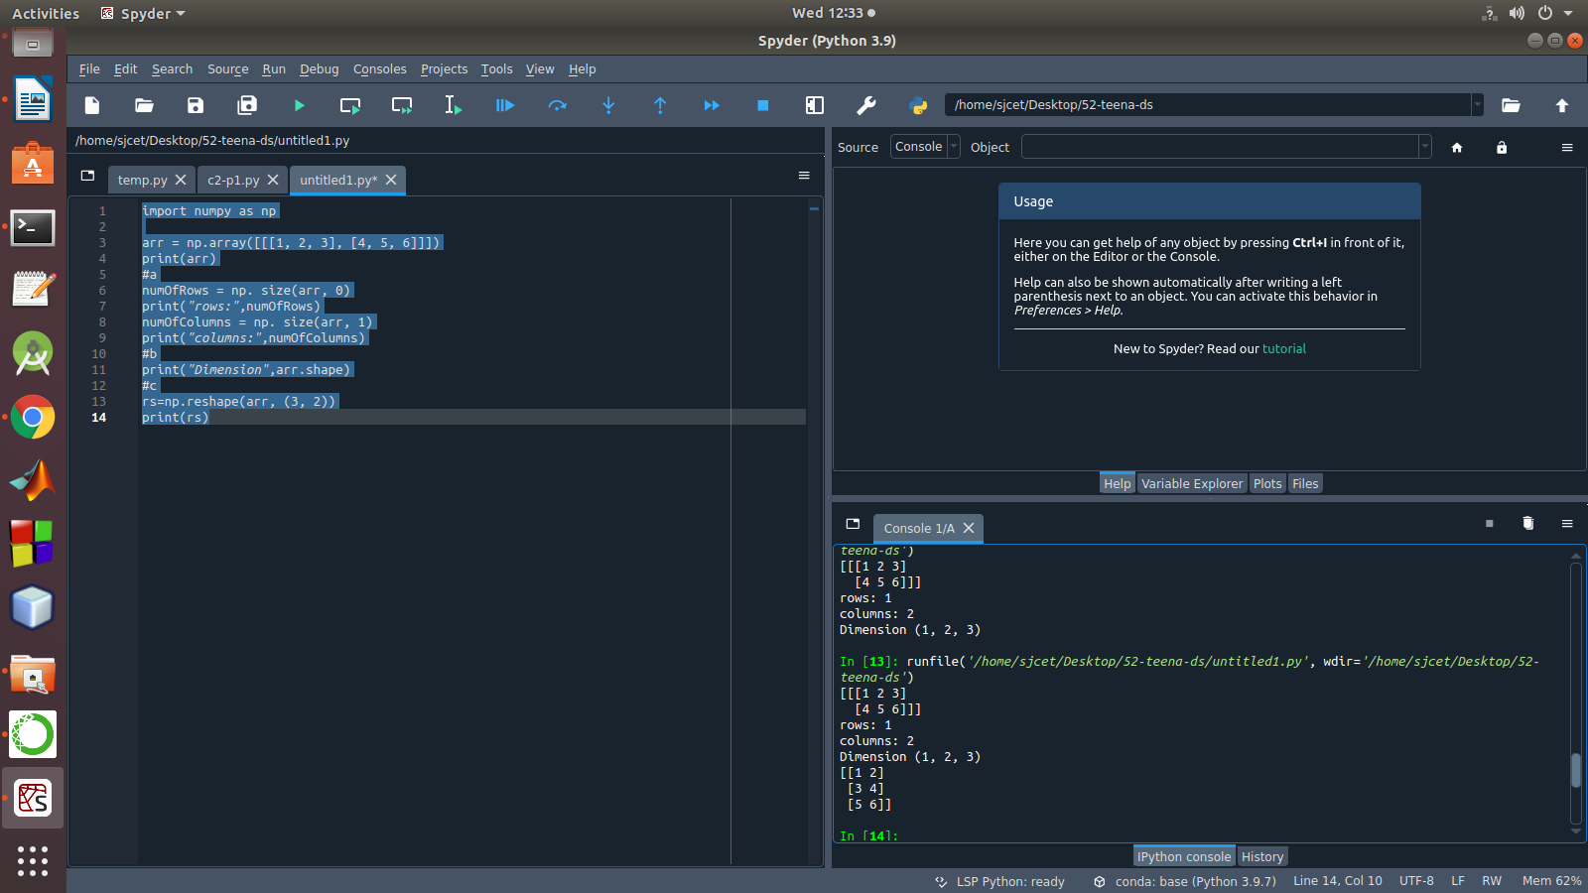

3. Familiarize with the functions to create
a) an uninitialized array
b) array with all elements as 1,
c) all elements as 0

PROGRAM:
import numpy as np
x = np.empty([2,2])
print("uninitialized array:",x)
y=np.full([2,2],1)
print("array with all elements as 1:",y)
z=np.full([2,2],0)
print("array with all elements as 0:",z)

OUTPUT:
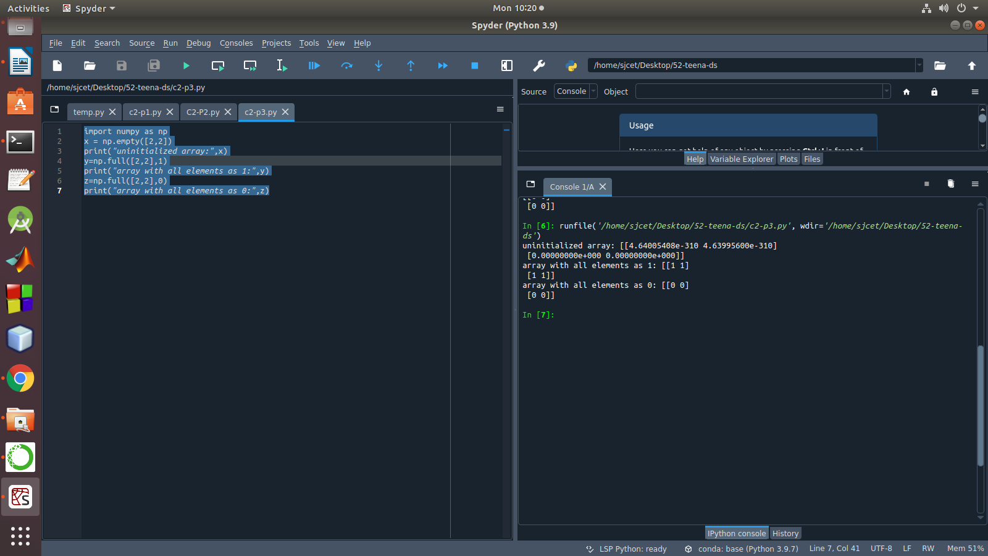

4. Create an one dimensional array using arange function containing 10 elements.
Display
a. First 4 elements
b. Last 6 elements
c. Elements from index 2 to 7

PROGRAM:
import numpy as np
a=np.arange(1,11,1)
print(a)
a1=a[:4]
print("First 4 elements:",a1)
a2=a[6:]
print("Last 6 Elements:",a2)
a3=a[2:7]
print("Elements from index 2 to 7:",a3)
OUTPUT:
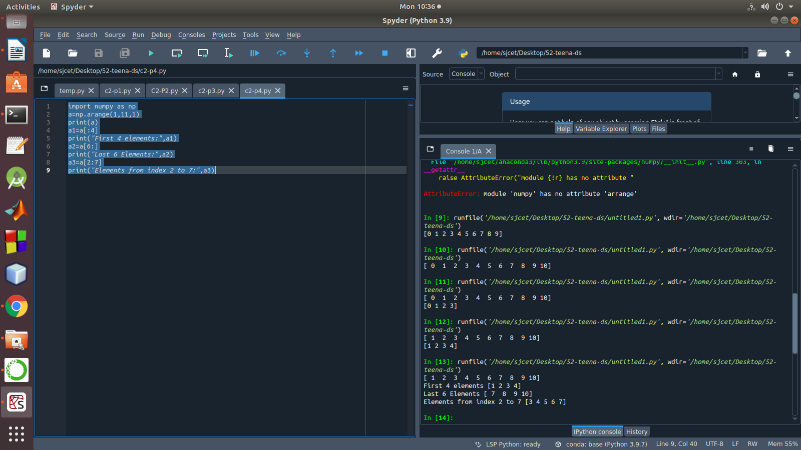

5. Create an 1D array with arange containing first 15 even numbers as elements
a. Elements from index 2 to 8 with step 2(also demonstrate the same
using slice function)
b. Last 3 elements of the array using negative index
c. Alternate elements of the array
d. Display the last 3 alternate elements

PROGRAM:
import numpy as np
a=np.arange(1,16,1)
print("Arange:",a[2:8])
arr=np.array([1,2,3,4,5,6,7,8,9,10,11,12,13,14,15])
print("Slicing:",arr[2:8])
print("Last 3 Elements:",a[-3:])
a1=a=np.arange(1,16,2)
print("Alternate Numbers:",a1)
print("Last 3 Alternate Numbers:",a1[-3:])

OUTPUT:
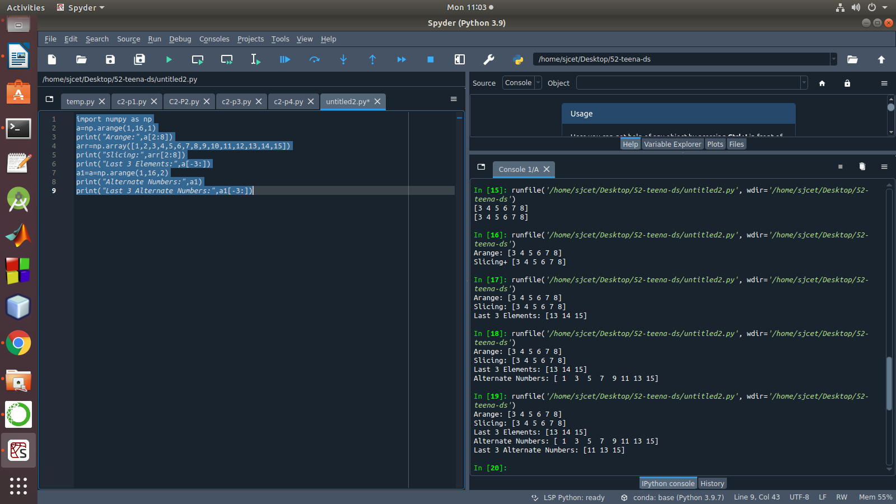

6. Create a 2 Dimensional array with 4 rows and 4 columns.
a. Display all elements excluding the first row
b. Display all elements excluding the last column
c. Display the elements of 1 st and 2 nd column in 2 nd and 3 rd row
d. Display the elements of 2 nd and 3 rd column
e. Display 2 nd and 3 rd element of 1 st row
f. Display the elements from indices 4 to 10 in descending order(use
–values)
PROGRAM:
import numpy as np
a = np.array([[1, 2, 3,4], [4, 5, 6,5], [7, 8, 9,6], [10, 11, 12,7]])
print(a)
print("elements excluding the first row:\n",a[1:])
print("elements excluding the first Column:\n",a[:,:3])
print("elements of 2 nd and 3 rd column:\n",a[:,1:3])
print("2 nd and 3 rd element of 1 st row:",a[0,1],a[0,2])
OUTPUT:
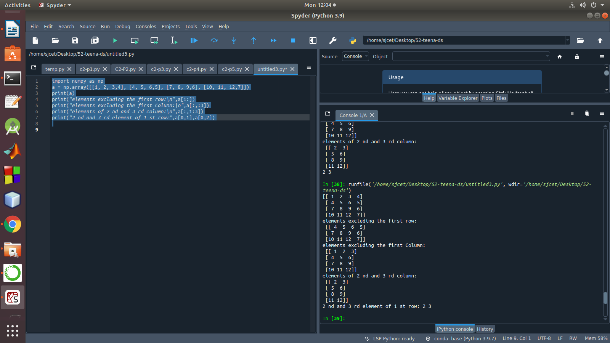

7. Create two 2D arrays using array object and
a. Add the 2 matrices and print it
b. Subtract 2 matrices
c. Multiply the individual elements of matrix
d. Divide the elements of the matrices
e. Perform matrix multiplication
f. Display transpose of the matrix
g. Sum of diagonal elements of a matrix

PROGRAM:
import numpy as np
a = np.array([[1, 2, 3,4], [4, 5, 6,5], [7, 8, 9,6], [10, 11, 12,7]])
b = np.array([[1, 2, 3,4],[7, 8, 9,6] , [4, 5, 6,5], [10, 11, 12,7]])
print("Addition:\n",np.add(a,b))
print("Subtraction:\n",np.subtract(a,b))
print("Multiply the individual elements:\n",np.multiply(a,b))
print("Divide:\n",np.divide(a,b))
print("Multiply:\n",np.dot(a,b))
print("Transpose:\n",np.transpose(a))
print("Sum of Diagonal Elements:\n",np.trace(a))

OUTPUT:
