Solution Design Document
DataOps Dashboard and Agent Platform
Version 1.0
Date: 2026-05-05

Table of Contents
1. Publication Version Control
2. Approvers
3. Purpose and Scope of Project
4. Architecture Design
5. Detailed Solution Architecture
5.1 Solution Overview
5.2 Solution Flow Diagram
5.3 Solution Execution Steps
5.4 Solution Infrastructure
5.5 Component List
5.6 API and Data Stores
5.7 Deployment and Operations
6. Project Specific Additional Details
7. Application Notes
7.1 Notes and Assumptions
7.2 Contact Details

1. Publication Version Control
Version | Date | Author | Remarks
1.0 | 2026-05-05 | GitHub Copilot | Initial project architecture document

2. Approvers
Role | Name | Status
Project Owner | TBD | Pending
Architecture Reviewer | TBD | Pending

3. Purpose and Scope of Project
This project delivers a unified DataOps operations platform with domain dashboards and AI-assisted chat for ServiceNow, ESP, DMF, Talend, and Snowflake. The solution combines a React frontend, an Express API layer, PostgreSQL-backed operational queries, and DynamoDB chat session persistence.
Scope includes executive dashboards, per-domain widgets, floating and full-screen agent chat panels, query-backed APIs, session persistence, local development workflows, and AWS-oriented deployment artifacts included in the repository.

4. Architecture Design
The application follows a two-tier web architecture with supporting data services. The browser hosts the React and TypeScript frontend. The backend is a Node.js and Express service that exposes JSON APIs, executes SQL against the edoops schema, coordinates chat requests, and persists session history to DynamoDB.

5. Detailed Solution Architecture

5.1 Solution Overview
The frontend provides dashboards, filters, tables, charts, and chat panels. The backend aggregates operational data for each domain and standardizes responses for the UI. Chat sessions are persisted separately from dashboard data so users can reload chat history without impacting dashboard query behavior.

5.2 Solution Flow Diagram
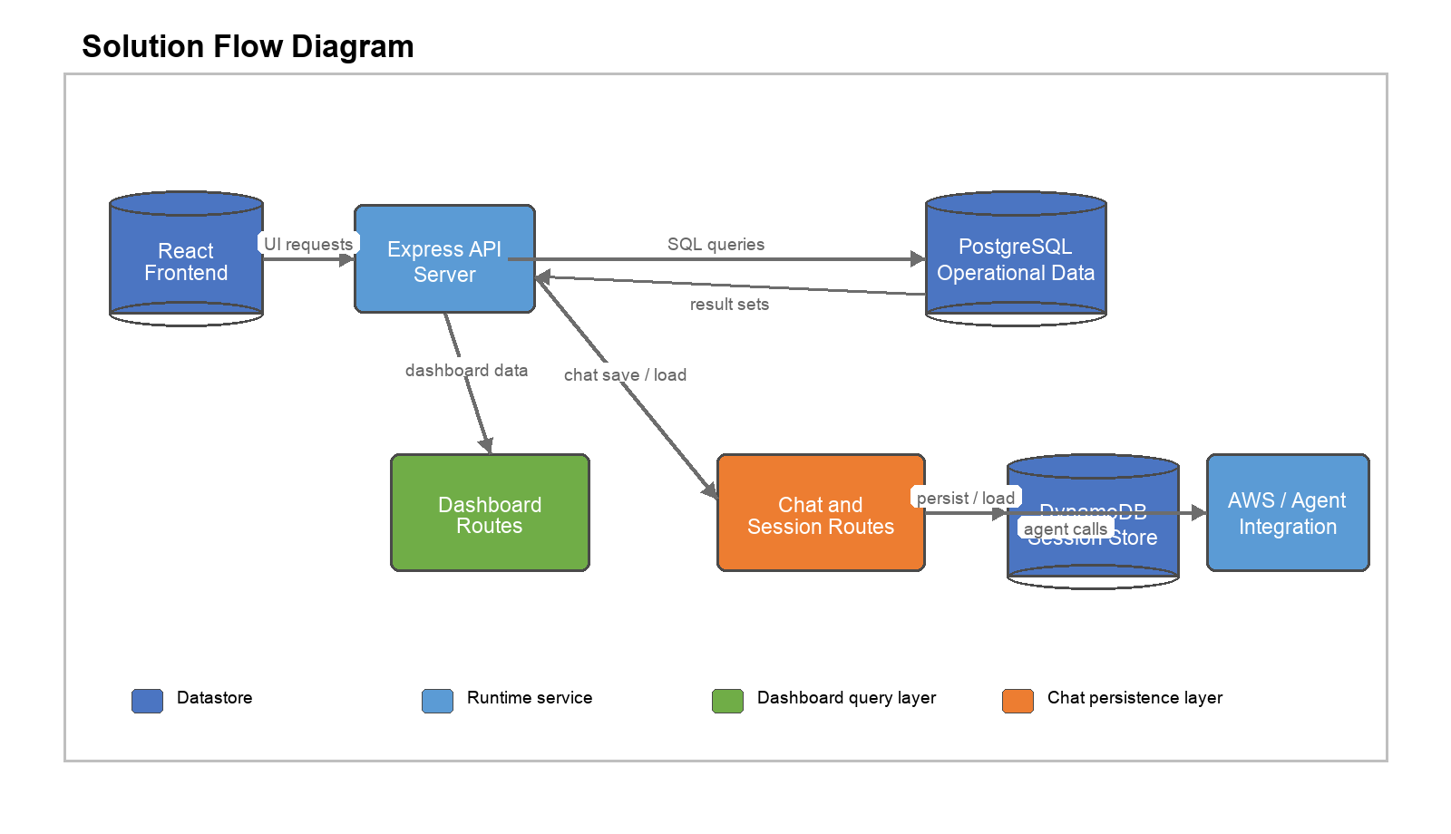
Figure 1. Runtime architecture flow for frontend, API services, data stores, and chat/session integrations.

5.3 Solution Execution Steps
- User opens the React frontend and selects a dashboard tab or agent chat.
- Frontend calls backend REST endpoints for widget data or session hydration.
- Express routes execute PostgreSQL queries for ServiceNow, ESP, DMF, Talend, and Snowflake datasets.
- Chat interactions call agent endpoints and asynchronously save the updated message history.
- Session history is persisted to DynamoDB by session and agent for later retrieval.
- Frontend renders the returned data as charts, tables, KPI cards, and chat history.

5.4 Solution Infrastructure
- Frontend: React, TypeScript, Vite, Material UI.
- Backend: Node.js, Express, TypeScript.
- Operational data store: PostgreSQL tables in the edoops schema.
- Session persistence: DynamoDB session store.
- Deployment artifacts: AWS SAM template, Lambda handlers, deployment script.
- Development model: local client and server processes with concurrent startup scripts.

5.5 Component List
Component | Location | Responsibility
Frontend shell | client/src/App.tsx | Top-level navigation, dashboard selection, fullscreen chat routing
Navigation | client/src/components/layout/Navigation.tsx | Sidebar navigation and mode access
Chat panel | client/src/components/chat/ChatPanel.tsx | Floating and full-screen chat UX and session save triggers
Server entry | server/src/index.ts | Express app, CORS, middleware, route mounting
Domain routes | server/src/routes/*.ts | SQL-backed dashboard APIs and chat/session endpoints
AWS artifacts | template.yaml and lambdas/ | Serverless deployment path and handlers

5.6 API and Data Stores
Primary backend route groups:
- /api/servicenow/* for incident and change widgets
- /api/esp/* for platform, application, SLA, and run-trend widgets
- /api/dmf/* for summary, trends, lineage, and analytics widgets
- /api/talend/* for execution, error, and engine/workspace summaries
- /api/snowflake/* for cost, performance, reliability, and storage metrics
- /api/sessions/* for chat session persistence and diagnostics
Data stores used by the project:
- PostgreSQL operational datasets in the edoops schema
- DynamoDB session table for chat histories
- Browser local storage for UI preferences and some chat/session restoration state

5.7 Deployment and Operations
The repository supports local development and AWS-oriented deployment. Local development runs the frontend on port 3000 and the backend on port 3001. Deployment artifacts include a SAM template, Lambda handlers, and a deployment shell script. Diagnostic endpoints are available for session persistence validation and DynamoDB schema checks.

6. Project Specific Additional Details
Domain dashboards included in the current solution are ServiceNow, ESP, DMF, Talend, and Snowflake. The platform also supports a global knowledge assistant and mock-data workflows for demos or local development. Query behavior is largely server-side so the UI remains responsive for large operational datasets.

7. Application Notes

7.1 Notes and Assumptions
- Authentication and enterprise authorization are not fully hardened in the current implementation and can be layered later.
- Session persistence assumes the backend has valid AWS credentials and access to the configured DynamoDB table.
- Some route modules include both live-query and compatibility or mock endpoints.
- The document reflects the repository state as of 2026-05-05.

7.2 Contact Details
Project contact: TBD
Architecture owner: TBD
Repository location: /Users/saviodawson/workspace/project

