**INTRODUCTION TO THE PATENT COOPERATION TREATY**

**submitted by**

**Teena Thomas**

**Roll no:62**

**MCA**

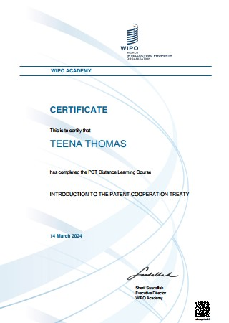

**SUMMARY**

The PCT is an international treaty which provides a system for filing patent applications and assists you in seeking patents in multiple countries around the world on the basis of a single patent application. The PCT was signed in June 1970, in Washington, D.C., and became operational in June1978 with 18 Contracting States

The Patent Cooperation Treaty (PCT) stands as a cornerstone in the realm of international intellectual property law, offering inventors a streamlined and cost-effective means to seek patent protection across multiple jurisdictions. Administered by the World Intellectual Property Organization (WIPO), the PCT has significantly simplified the process of obtaining patent rights internationally since its inception in 1970.

**The PCT process is comprised of the following main steps:**

**International Phase**

* Filing of a PCT application
* International search
* International publication
* Supplementary international search (optional)
* International preliminary examination (optional)

**National Phase**

* Processing of the PCT application before national and/or regional patent

Offices

**The PCT is the cornerstone of the international patent system. It provides you with a worldwide system for the simplified filing of patent applications that:**

• brings the world within reach;

• postpones major costs and provides you with additional time to consider your various

patenting options;

• provides a strong basis for patenting decisions; and

• is used by the world’s major corporations, universities and research institutions when they seek international patent protection.

A major feature of the PCT system is that it delays (and in some cases saves) various costs associated with seeking patents in multiple countries .File a PCT application with `our local or national patent Office, or directly with the International Bureau of WIPO if permitted by the national security provisions in your national law. Both the national patent Office and the International Bureau of WIPO (RO/IB) act as PCT “receiving Offices” because they receive PCT applications. If there is more than one applicant, the PCT application may be filed with the receiving Office that is competent for any of the applicants

The primary objectives of the PCT are to streamline the patent application process, reduce administrative burdens and costs for applicants, enhance the quality of patent examination through international cooperation, and promote the dissemination of technical information.

Participants learn about the structure and functions of the international patent system, including the roles of WIPO, national patent offices, and international authorities such as the International Searching Authority (ISA) and International Preliminary Examining Authority (IPEA).

**Importance of Patent Protection**

The course highlights the significance of patent protection in fostering innovation, stimulating economic growth, and promoting technological advancement. It explores how patents incentivize research and development efforts by granting inventors exclusive rights to exploit their inventions for a limited period.

**Cost-Saving Benefits of the PCT**

The course highlights the cost-saving benefits of the PCT compared to filing separate national applications in multiple countries. Participants learn about the fees associated with filing PCT applications and entering the national phase and how these costs compare to the expenses incurred in the traditional filing approach.

**Time-Saving Advantages of the PCT**

Participants explore the time-saving advantages of the PCT's unified procedure and streamlined processes. They learn how the PCT enables applicants to defer the decision on where to seek patent protection until after the international search and preliminary examination, thereby saving time and resources.

**Strategies for Maximizing Efficiency**

The course provides participants with practical strategies for maximizing cost and time efficiency when using the PCT system. They learn about best practices for selecting receiving and designated offices, managing deadlines, and optimizing the international search and preliminary examination process.

The following are general principles governing third party access to the file of a PCT application:

* All documents contained in the file of the PCT application remain secret until
* publication;
* Applicant or anyone authorized by the applicant always has access to the file of the PCT application;
* All documents in the file are available after 30 months from the priority date, provided that the PCT application was published;
* Before 30 months, national Offices have access to the files held by the International Bureau and the International Searching Authority (ISA);
* The file of the International Preliminary Examining Authority (IPEA) is available to other national Offices once the international preliminary report on patentability has been established; and
* certain sensitive information may be omitted from public file access

In conclusion, the Patent Cooperation Treaty offers a comprehensive framework for simplifying and harmonizing the process of seeking patent protection internationally. Through its unified filing procedure, international search and preliminary examination, and cost-saving mechanisms, the PCT facilitates global innovation and encourages participation in the international patent system. This detailed distance course equips participants with the knowledge, skills, and practical insights needed to navigate the complexities of international patent protection effectively and maximize the benefits of the PCT system.