**Software Requirement Specification**

**1. INTRODUCTION**

This document aims at defining overall software requirement for Online Auction and Renting system.

**1.1 Purpose**

Main purpose of this project is to develop a system where user can trade online. This project will help the user to buy, sell and rent any item with maximum profit. Purpose is to design a system which perform all the required operations related to Online Auction and Renting system and other section of SRS specifies the functionalities of the software.

**1.2 Scope**

The application will generate the interest of user towards the online shopping which will increases the profit in e-commerce sector. This application will provide full user ( both seller or buyer) satisfaction by providing them with maximum profit. Since the system is dependent on bidding, therefore the seller is bound to set the price which is best suited and attractive to buyer.

**1.3 Acronyms**

SRS- Software Requirement Specifications

O.S.-Operating System

**2. Overall Description**

**2.1 Product perspective:** This product will automate various services like buy, sell, or rent **.** Online Auction and Renting system is intended to remove the burden of going to various stores in search of particular product. Since this is a data-centric project it will need somewhere to store the data. For that, a database will be used that will store the information of user detail, product detail, and auction detail.

**2.1.1 System Interface:**

System interface includes the hardware interface, software interface and user interface of the system and software.

**2.1.2 User Interface:**

In our project we develop some human friendly user interfaces by which interaction with the system will be easy for the user

**2.1.3 Hardware Configuration:**

1. Operating System: Windows 7/8/10

2. RAM: 1 GB or more

3. Hard Drive: 10 GB or more

**2.1.4 Software Configuration:**

Operating system: - Windows 10

Language: - HTML, CSS, javascript

IDE: - sublime text editor

Database: - Google Firebase

**2.1.5 Product Function:** The system performs the following functions: -

1. Login
2. Add product for Auction
3. Edit/delete/add/ view record
4. Send user the product detail
5. Set base price
6. Maximum bid

**2.2 User Characteristics:**

There are three types of users that interact with the system: admin, buyer, and seller. Each of these three types of users has different use of the system so each of them has their own requirements.

**2.3 Constraints**

The language for the project will be HTML, Bootstrap, javascript. The system can support any number of users at the same time.

**3. Specific Requirements**

**3.1 Eternal Interface Requirements**

The system takes input from keyboard and from files in the memory. The system generates output on screen.

**3.2 Performance Requirements**

The system is required to support multiple task simultaneously. The system should handle reasonable number of users without break or inconsistency.

**3.3 Quality Requirements**

3.3.1. **Availability**: - The entire system should be available 24X7 round the year except for periodic maintenance. The maintenance period should be pre-scheduled and short.

3.3.2 **Security**: - The system at any time should be accessed by the authenticated users. Many people worry about hackers accessing their bank accounts. Also, family or friends could steal your password

and access your account information.

3.3.3 **Usability**: - The GUI should be easy to learn and use by users of any technical background. A built-in help feature should be available in all pages, to guide the users with the available functions on that page. An easy to understand documentation should be provided with the system.

Use Case diagram

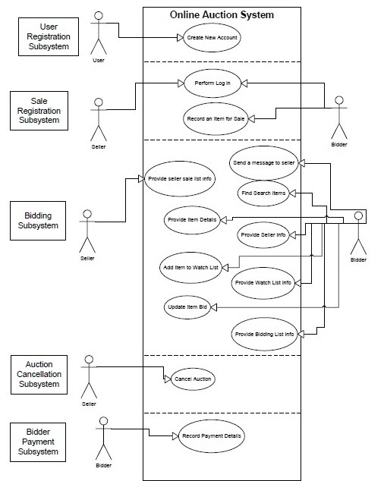

Actor – User, Bidder, Seller

Use cases – Signup, Login, Logout, Provide seller sale list info, Provide item details, Update item bid, Provide seller info, Find search option, Provide bidding list option, cancle Auction, Payment Details

Class Diagram

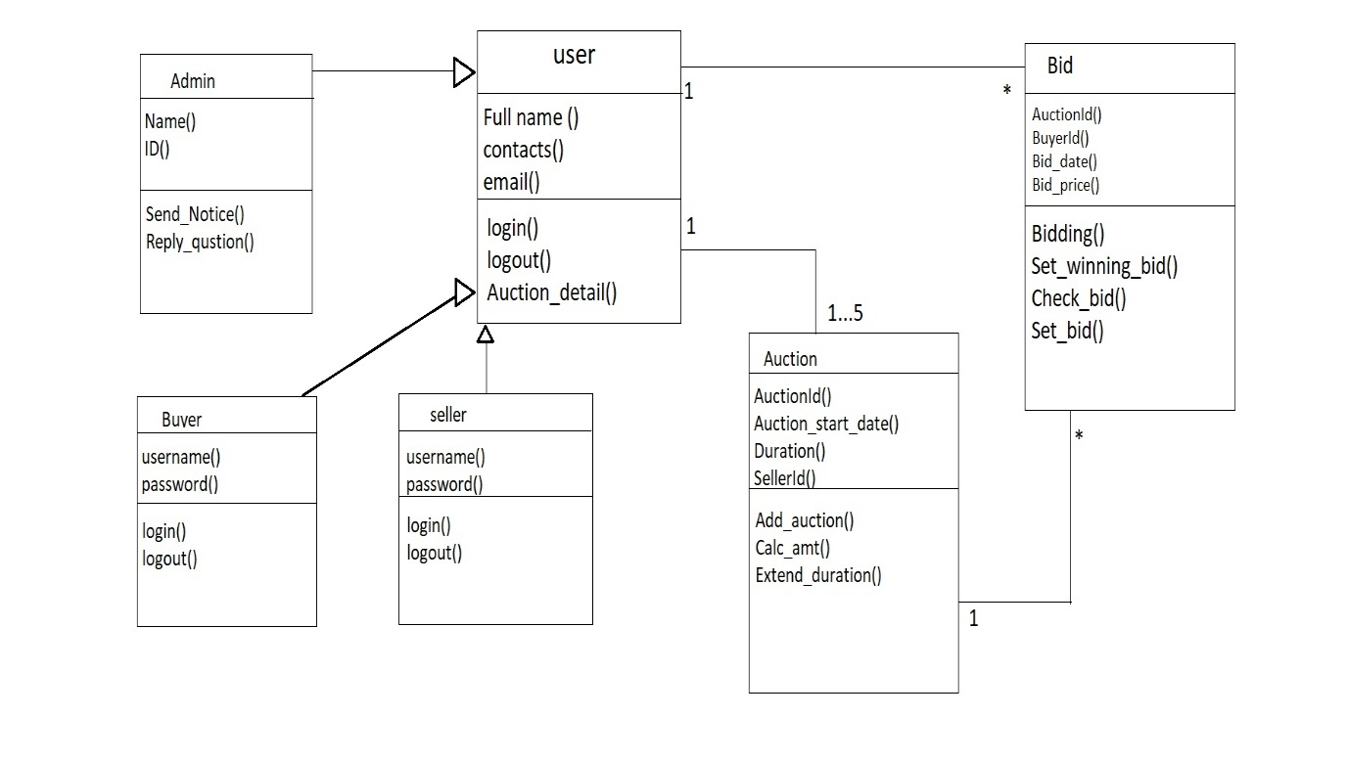

Data Flow Diagram

Level 0

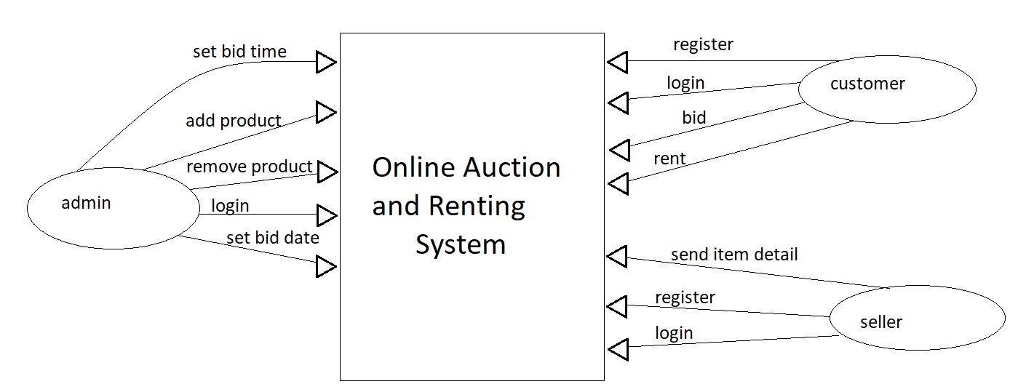

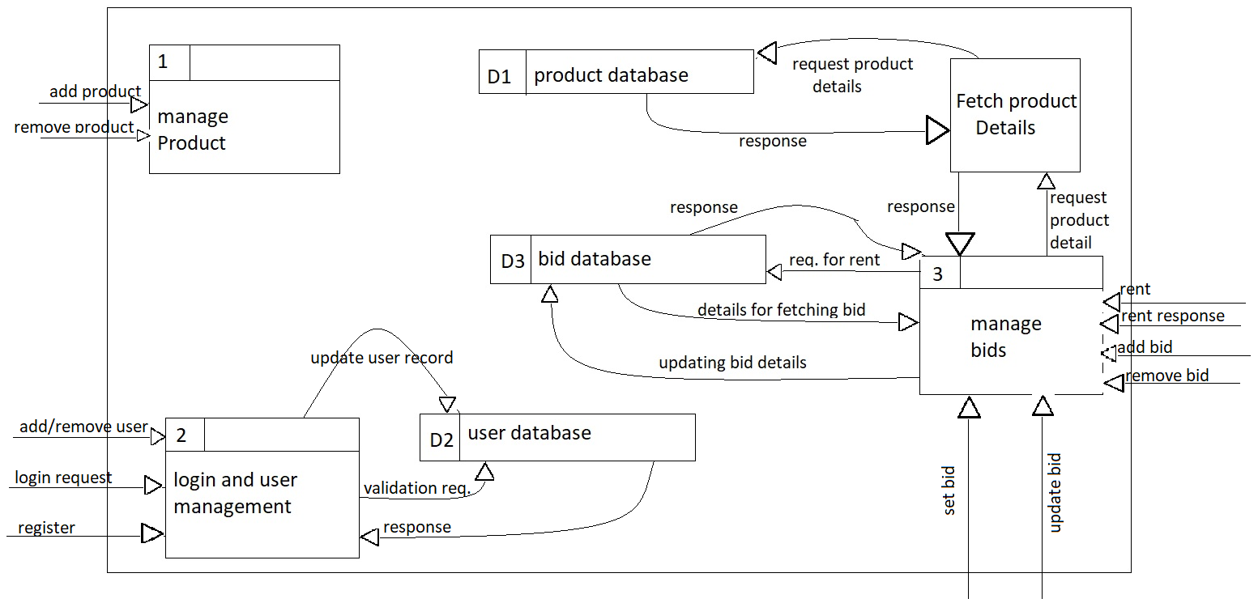Level 1

**MINOR PROJECT FILE**

Group no. - 15

Project name – Online Auction and Renting System

Group Member – Ajay Kumar

Vineet Kumar singh

Shikhar Tiwari

Project Mentor – Mr. Amit Kelotra



JUL-DEC@2018

**DEPARTMENT OF COMPUTER SCIENCE AND ENGINEERING**

**JAYPEE UNIVERSITY OF ENGINEERING AND TECHNOLOGY,**

**GUNA, MP**