Polar Continuum Engine

World Runtime Architecture

STATUS  PROPOSED |  | OWNER  TEERTH SHARMA |  | LAST UPDATED  JULY 12, 2026

Authors | Teerth Sharma with Codex
Reviewers | Independent visual, UX, accessibility, performance, and systems panels
Related docs | Awwwards cumulative benchmark; Antarctic biome world theory
Scope | Traversal, rendering, lifecycle, fallbacks, evidence, and award release gates

1. Abstract
Polar Continuum Engine is the client-side runtime for Teerth Sharma's Antarctic portfolio. It makes one continuous XZ world the primary interface while keeping the evidence archive, safe gate, quality controls, and semantic navigation fully usable outside WebGL. One traversal authority owns pose; every camera, mascot, station, shader, and HUD response is derived from its snapshot.
Integrated foundations are the fixed-step traversal path, topological seal with permanent breath and station halo, instanced-brick dome, cinematic postprocess, and visibility suspension. The 35 x 27 C8 map, three-draw ambient field, two-nearest biome compositor, explicit context teardown, and full station mechanisms are planned contracts until production traces prove integration.

2. Goals and Non-Goals
Goals | Non-goals
One canonical 35 x 27 C8 XZ schema for eight non-collinear stations. | Copy reference assets or compositions; all geometry and shaders stay original.
Continuous fixed-step travel from 30-144 Hz with no dual pose writer. | Render while the world is offscreen or retain disposable GPU buffers.
Add exactly three ambient-fill draws and blend only two nearest biomes. | Require WebGPU or hide work behind a canvas-only interaction path.
Preserve safe, reduced, mobile, archive, and honest API fallback paths. | Claim award quality before the independent score and evidence gates pass.

3. Background and Problem Statement
The rescue build has carried competing coordinate scales, duplicate motion filters, early semantic selection, an oversized sparse world, and monuments that can read as one recolored rail. Those defects cause teleport-like movement, redundant travel, weak station identity, UI-object collisions, and unnecessary GPU retention after the world leaves the viewport.
The boundary is a browser-only Three.js runtime plus a crawlable DOM evidence plane. The invariant is strict: simulation owns pose; proximity owns visual emphasis; docking owns semantic focus. The world must remain legible with HUD hidden, and every planned effect must degrade by capability without removing content or control.

4. Proposed Architecture

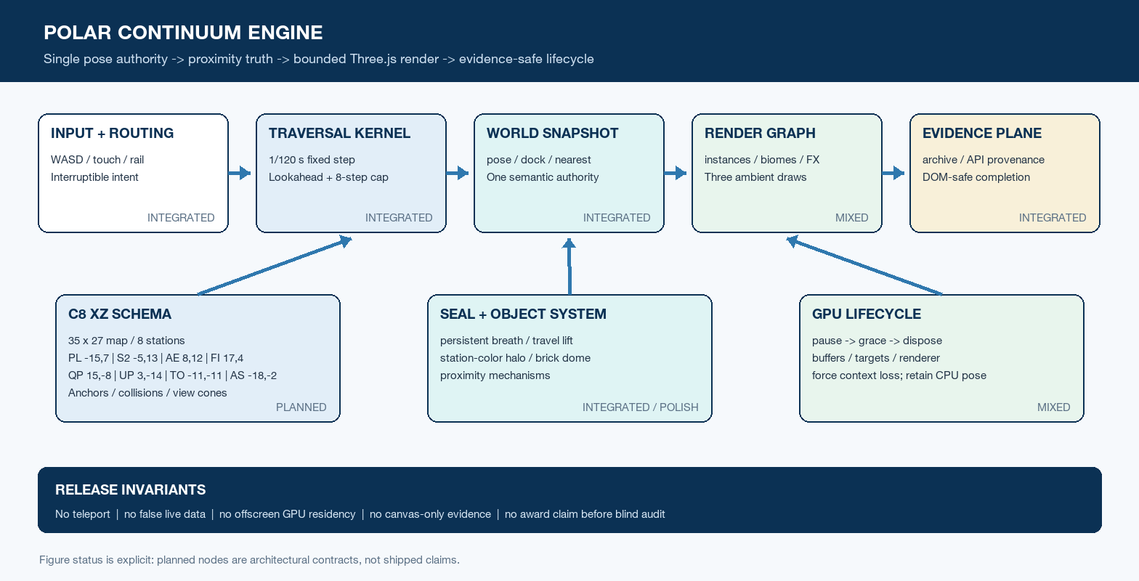
Figure 1. Polar Continuum Engine control, render, and lifecycle boundaries.

Core components

Component | Responsibility | Primary storage | Failure behavior
C8 World Schema  PLANNED | 35 x 27 XZ anchors, docks, collisions, view cones, biome IDs. | Immutable versioned config | Reject drift; expose archive-safe navigation.
Traversal Kernel  INTEGRATED | Fixed step, lookahead, routes, manual input, authoritative snapshot. | Refs plus 10 Hz semantic state | Cap eight steps; cancel route; retain pose.
Three.js Render Graph  MIXED | Three ambient draws: ice, signals, atmosphere; two-biome uniforms and post. | GPU buffers, programs, targets | Quality ladder; then safe DOM fallback.
Seal + World Objects  INTEGRATED / POLISH | Pose, breath, lift, halo, instanced per-brick dome, mechanisms. | Transient uniforms and springs | Static pose and labels under reduced motion.
Lifecycle + Evidence  MIXED | Suspend, release GPU, restore pose; archive and honest GitHub radar. | CPU pose, public API, static evidence | Dispose context; remount or use fallback index.

5. Request Lifecycle
- Accept WASD, tap-drag, station-rail, or archive intent without mutating focus.
- Normalize input, cancel conflicting routes, and apply safe, motion, and quality policy.
- Load one versioned 35 x 27 C8 schema with XZ anchors, collisions, and view cones.
- Advance a 1/120 s fixed step with lookahead collision and at most eight catch-up steps.
- Publish pose, velocity, heading, two-nearest weights, and dock state from one snapshot.
- Render seal lift and halo, active mechanisms, ambient instances, biome field, and post FX.
- Commit focus only after arrival; emit evidence state, metrics, or an honest fallback.

6. API and Data Contracts

Primary runtime snapshot

Field | Type | Required | Description
pose | vec2 + f32 | Yes | XZ position, heading, and velocity; traversal-owned.
stationId | enum | null | Yes | Focus changes only after dock and dwell.
nearest | pair<id,f32> | Yes | Two IDs plus normalized biome weights.
route | target + mode | No | Interruptible guided or manual mode.
capability | flags | Yes | Quality, safe, motion, touch, contrast flags.
lifecycle | state | Yes | Visible through disposed lifecycle.
evidence | source record | Yes | Live/fallback provenance and timestamp.

Contract guarantees

- Only the traversal kernel mutates pose; camera, seal, HUD, and stations consume it.
- Simulation uses 1/120 s steps, an eight-step spike cap, and lookahead collision.
- Station focus changes only at dock threshold and dwell; route clicks never teleport.
- The snapshot is transient UI truth; the evidence archive remains independently usable.
The versioned runtime contract is colocated with the implementation and this design record.

7. Consistency, Idempotency, and Replay

A frame-rate change must not alter the route or station outcome. Inputs are sampled into the fixed-step accumulator; a schema version is pinned for the route; semantic state is published at a lower cadence than pose. Remount reuses the retained CPU pose without replaying a dock or fabricating evidence.
Scenario | Expected behavior | Reasoning
Repeated input / frame replay | Same schema and samples produce the same route outcome. | Fixed step isolates simulation from refresh rate.
Frame spike / long task | Run at most eight steps, clamp debt, keep input responsive. | Bounds catch-up work and prevents visible teleport.
Offscreen / context loss | Suspend, unmount, dispose GPU, retain CPU pose, remount without drift. | Releases memory without replaying arrival state.
API or schema changes | Use honest fallback; pin route schema or cancel safely. | No false live data or mid-route coordinate shift.

8. Security and Privacy Considerations

- Fetch only public GitHub data for the hard-coded portfolio identity teerthsharma.
- Label live and fallback states; never synthesize activity or expose private payloads.
- Ship no client secret or token; validate and bound external labels and URLs.
- Keep safe mode, archive, keyboard, touch, and reduced-motion paths first-class.
- Collect no navigation telemetry by default; document any later opt-in retention.

9. Operational Readiness
Signal | SLO or alert | Owner | Launch gate
Main jury | Trimmed >= 8.77; D 8.70, U 8.60, C 9.10, Content 8.80. | Independent 18-person panel | REQUIRED
Developer jury | Weighted >= 8.98; every published internal category target passes. | Six specialist reviewers | REQUIRED
Frame pacing | p95 settled <= 16.7 ms; travel <= 20 ms on declared desktop. | Runtime / graphics | REQUIRED
Web vitals | LCP <= 2.5 s; INP <= 200 ms; CLS <= 0.10, three-run median. | Performance | REQUIRED
Memory + access | 10 min: no monotonic GPU growth; axe zero serious/critical; all paths traced. | Performance + accessibility | REQUIRED
Rollout: freeze one production commit; test all eight stations, desktop/mobile, safe/reduced/archive, API failure, context release, and a second blind audit before submission.

10. Alternatives Considered

Alternative | Why it was considered | Why it was not selected
One monolithic RAF scene | Simple local animation access. | Invites dual writers, coupling, and unmanaged lifetime.
DOM-only scroll portfolio | Fast, semantic, and easy to index. | Loses the physical Antarctic world; retained only as fallback.
Asset-heavy GLB / PBR world | Immediate surface richness. | Large payload, weak originality, and unstable mobile cost.
Hue-only shared monuments | Cheap reuse and simple uniforms. | Fails silhouette, content meaning, and creativity gates.

11. Open Questions
- Decision: 35 x 27 C8 XZ placement is canonical; coordinate changes bump schemaVersion.
- Open: biome shader and monument mechanism tuning awaits visual approval and integration.
- Open: freeze reference desktop and mid-tier mobile hardware before WPO sign-off.
- Open: prefer a local profiler; any anonymous metrics require explicit opt-in review.

12. Decision and Next Steps
Adopt the single-authority runtime and stage the contracted world systems behind evidence gates. Integrated subsystems remain provisional until one frozen production build passes all eight stations, lifecycle traces, fallbacks, and an independent blind audit. Award-ready is an audited result, not an implementation claim.
Milestone | Deliverable | Exit criteria
M1 | Integrated traversal, seal, dome, post FX, and offscreen suspension. | No runtime errors; route, collision, return, and pose tests pass.
M2 | C8 map, three ambient draws, two-nearest biomes, mechanisms, explicit disposal. | Eight distinct worlds; no leak or semantic drift in visual traces.
M3 | Mobile, safe, reduced, archive, API fallback, and production instrumentation. | All developer evidence gates pass on frozen hardware profiles.
M4 | Independent blind audit, correction round, and submission freeze. | Main >= 8.77; DEV >= 8.98; every category and hard gate passes.

Status: INTEGRATED = exercised; MIXED = unfinished; PLANNED = contracted, not shipped.

