LexMate Case Management System
Complete Non-Technical System Documentation

Introduction

What is LexMate?
LexMate is a complete legal practice and case management system designed for law ﬁrms, notaries, legal consultants, and legal service providers.
The platform helps legal professionals manage:

  - Clients
  - Legal cases
  - Appointments
  - Court dates
  - Legal documents
  - Invoices and payments
  - Lawyer assignments
  - Tasks
  - Client communication

The system is web-based, meaning users can access it through a browser from a computer or laptop.

Purpose of the System
The goal of LexMate is to centralize all legal operations into one secure platform. Instead of managing information through:
  - paper ﬁles,
  - spreadsheets,
  - WhatsApp messages,
  - emails,
  - or multiple software tools,

LexMate allows everything to be managed in a single organized environment.

Main Types of Users
The system contains three different user portals, each with different permissions and access levels.

Admin / Staff Portal

Who Uses This?
  - Law ﬁrm owners
  - Administrators
  - Ofﬁce staff
  - Secretaries
  - Operations teams

This is the main management area of the system.

Main Features Available to Admins

Dashboard
The dashboard gives a quick overview of the business. Admins can see:
  - Total number of legal cases
  - Active cases
  - Closed cases
  - Upcoming appointments
  - Pending appointments
  - Recent activities
  - New clients
  - Financial summaries

This helps management monitor daily operations easily.

Client Management

What It Does
The system allows admins to create and manage client proﬁles. Each client proﬁle can include:
  - Full name
  - Phone number
  - Email address
  - Address
  - Notes
  - Linked legal cases

Client Portal Access
Clients can optionally receive their own login credentials. With client access, they can:
  - View their cases
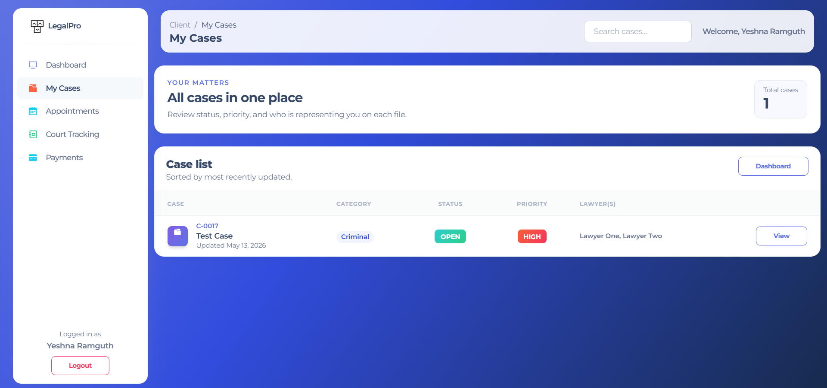
Figure 1: Client Cases

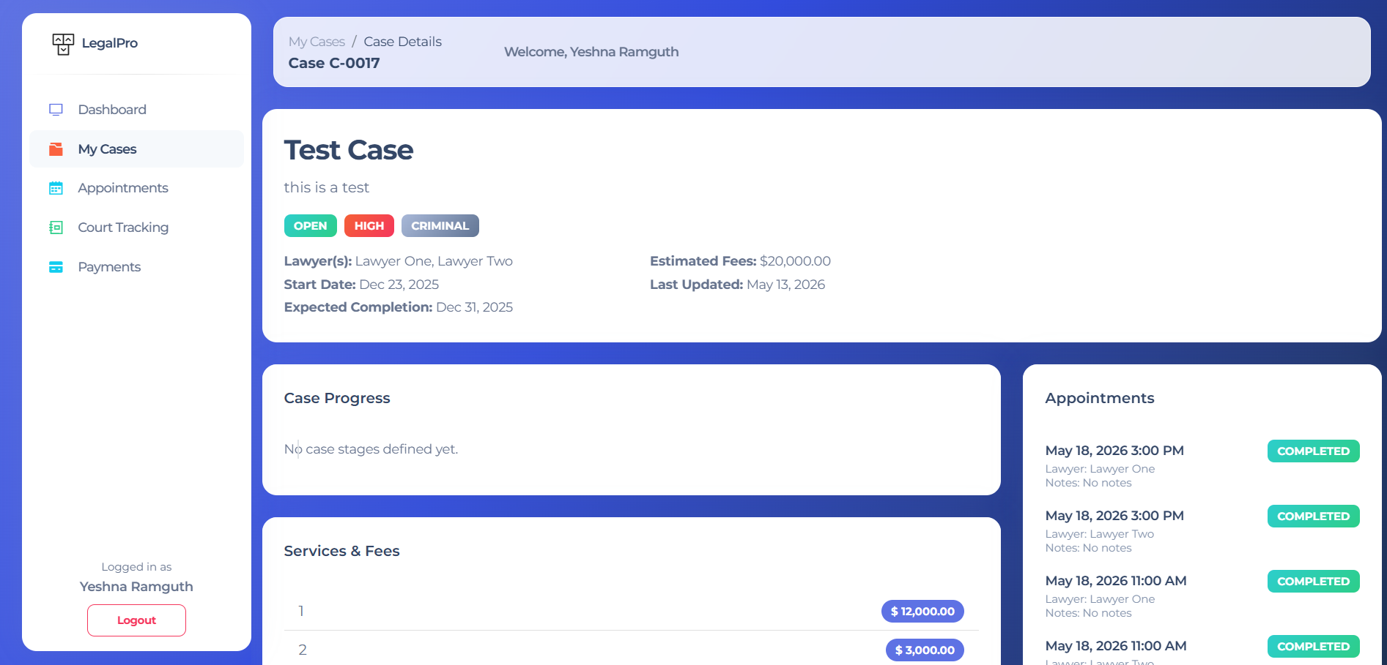
Figure 2: Client detail cases page

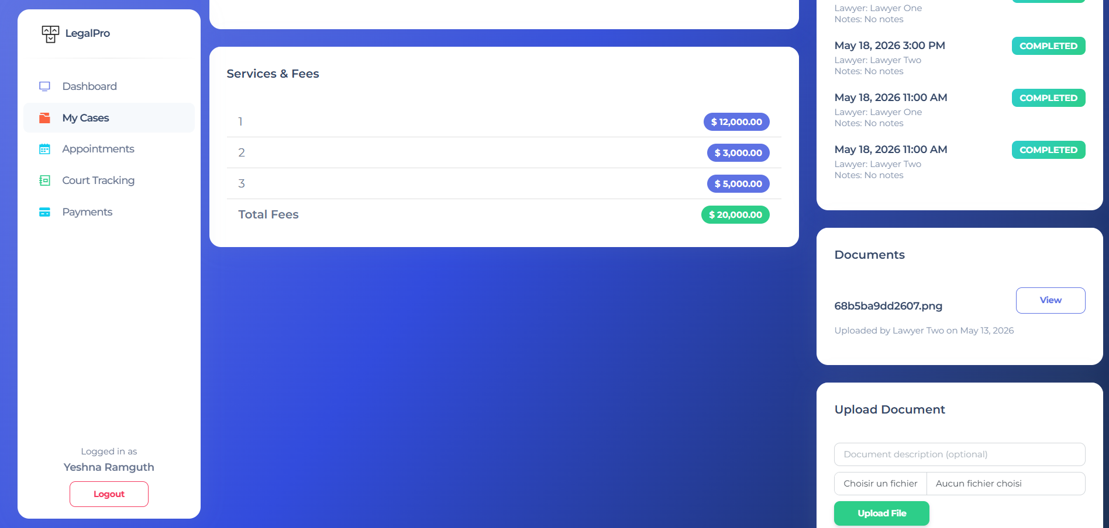

Figure 3:Client detail cases page (middle of the page)

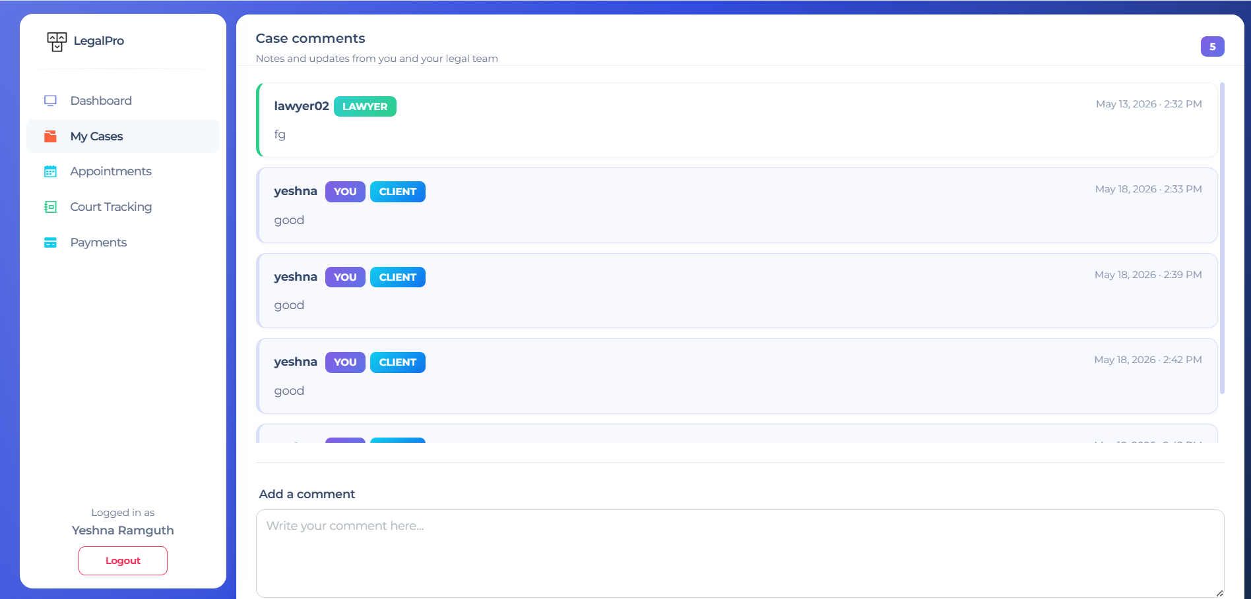

Figure 4: Client detail cases page (bottom of the page)

  - Check appointments
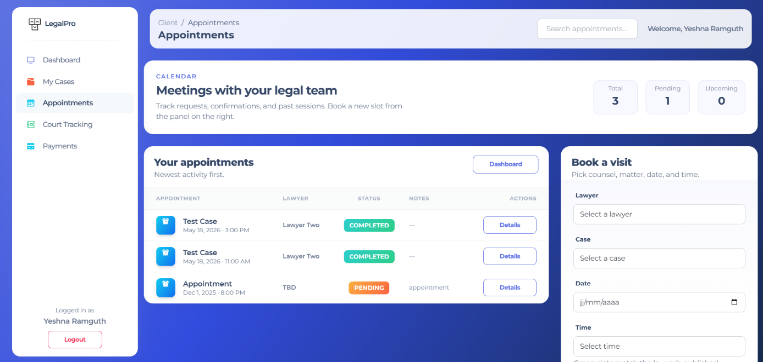
Figure 5: Client appointments pages

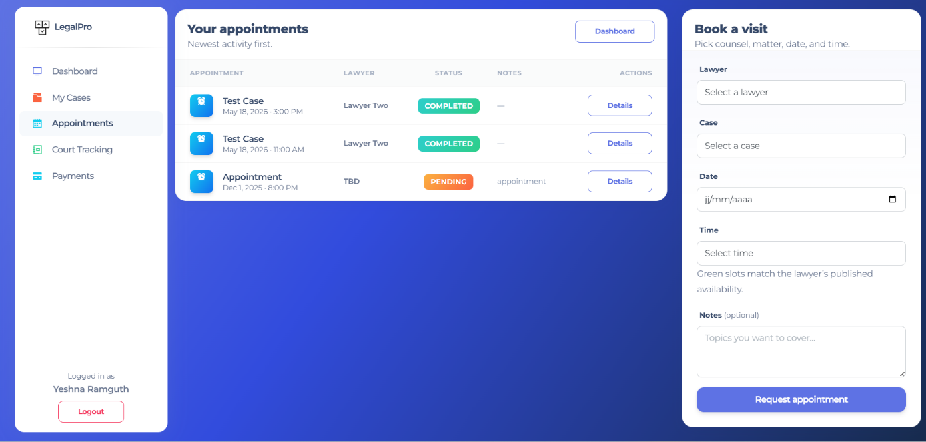

  - See invoices

  - Track payments
  - Follow court dates

This improves transparency and reduces manual communication.

Case Management

Core Functionality
Case management is the heart of the platform.

Admins can create legal cases and assign them to lawyers.

Information Stored in a Case
Each case can contain:

General Information
- Case title
- Description
- Category
- Priority level
- Current status

Financial Information
- Estimated legal fees
- Services provided
- Payments received
- Remaining balance

Timeline Information
- Start date
- Expected completion date
- Court dates
- Case stages

Team Assignment
- Assigned lawyers
- Primary lawyer

Case Statuses
Cases can move through different stages such as:

- New
- Active
- Pending
- In Progress
- Completed
- Closed

This allows ﬁrms to monitor case progress clearly.

Lawyer Management

What the System Supports
The platform includes a lawyer directory. Admins can:
  - Add lawyers
  - Edit lawyer information
  - Assign lawyers to cases
  - Manage lawyer schedules
  - Track lawyer workload

Lawyer Portal
Lawyers receive their own login portal. Inside the lawyer portal, they can:
  - View assigned cases
  - Update tasks
  - Manage appointments
  - Track court dates
  - View assigned clients

This separates lawyer workspaces from admin operations.

Appointment Management

Purpose
The appointment system helps coordinate meetings between:

  - clients,
  - lawyers,
  - and legal staff.

Features
Admins and clients can:

  - Create appointments
  - Select lawyers
  - Choose dates and times
  - Link appointments to speciﬁc legal cases

Appointment Workﬂow
Lawyers can:

  - Accept appointments
  - Reject appointments Appointment statuses include:
  - Pending
  - Accepted
  - Rejected

Court Date Tracking

Purpose
The court tracking module helps legal teams manage hearings and court appearances.

Features
Users can:

  - Add court dates
  - Assign court locations
  - Track hearing status
  - Link court dates to cases

Beneﬁts
This reduces the risk of:

  - missed hearings,
  - scheduling conﬂicts,
  - and manual diary management.

Task Management

Purpose
Tasks help organize legal work internally.

Examples of Tasks
  - Prepare legal documents
  - Contact client
  - Submit court ﬁling
  - Review contracts
  - Follow up on payment

Features
Tasks can include:

  - Assigned lawyer
  - Due date
  - Priority level
  - Completion status

Lawyers can update task statuses themselves.

Document Management

Purpose
The system includes a centralized legal document repository.

Features
Admins can:

  - Upload ﬁles
  - Attach documents to cases
  - Store PDFs and Word documents
  - Organize legal records

Supported File Types
Examples:

  - PDF
  - DOC
  - DOCX
  - Images

Document Templates
The system also supports reusable templates. Examples:
  - Contracts
  - Legal notices
  - Engagement letters
  - Standard forms

This reduces repetitive work.

Financial Management

Invoices
Admins can generate invoices for legal services. Invoices can contain:
  - Service descriptions
  - Amounts
  - Dates
  - Payment status

Payments
Payments can be recorded manually. Information stored includes:
  - Payment method
  - Reference number
  - Payment date
  - Amount paid

Financial Summary
The system automatically calculates:
  - Total fees
  - Amount paid
  - Outstanding balances

This gives management ﬁnancial visibility.

Contracts & Agreements
The platform can generate printable contracts related to legal cases. Examples:
  - Client engagement agreements
  - Service contracts
  - Fee agreements

These can be downloaded or printed.

Activity Timeline / Audit Trail

What It Does
The system records activities performed inside each case. Examples:
  - Case updates
  - Payments added
  - Documents uploaded
  - Comments posted
  - Appointments scheduled

Beneﬁts
This creates a full historical timeline for accountability and tracking.

Client Portal

Purpose
The client portal improves communication with clients.

Clients Can View
  - Their legal cases
  - Case progress
  - Appointments
  - Court dates
  - Payments
  - Invoices

Beneﬁts
This reduces:

  - unnecessary phone calls,
  - repeated email requests,
  - and administrative workload.

Lawyer Portal

Purpose
The lawyer portal gives lawyers a dedicated workspace.

Lawyers Can
  - View assigned cases
  - Manage tasks
  - Accept/reject appointments
  - Track hearings
  - Review client information

System Settings
The system includes basic conﬁguration settings.

Current Available Settings

Currency Settings
Supported currencies include:

  - USD
  - EUR
  - MUR

Branding Settings
Some branding options exist in the interface, including:

  - business name,
  - logo,
  - and display settings.

However, some branding features are still partially implemented.

AI Chatbot (Placeholder)
The platform includes a chatbot interface. At present:
  - it is mostly a placeholder/demo feature,
  - and does not yet contain real AI functionality.

This can later be integrated with:

  - ChatGPT,
  - AI assistants,
  - or legal automation tools.

Security & Access Control

Existing Security
The platform includes:

  - password-based login,
  - separate user portals,
  - role-based access.

Passwords are designed to be encrypted.

Important Limitation
Some admin pages currently require additional security improvements. This means:
  - certain pages may not fully validate user permissions,
  - and access control should be strengthened before large-scale deployment.

Recommended improvements include:

  - centralized authentication,
  - permission management,
  - and stronger session protection.

File Storage
Uploaded documents are stored securely inside server folders. Examples:
  - legal documents,
  - client ﬁles,
  - court attachments,
  - contracts.

Folders are automatically created when needed.

Current State of the System

Fully Working Features
The following areas are already operational:
✅ Multi-user login system
✅ Client management
✅ Case management
✅ Lawyer assignment
✅ Appointments
✅ Court tracking
✅ Task management
✅ Documents & uploads
✅ Invoices & payments
✅ Financial summaries
✅ Client portal
✅ Lawyer portal
✅ Event tracking

Partially Completed / Demo Features
The following areas are currently basic or incomplete:
⚠ Reports section
⚠ Staff directory
⚠ AI chatbot backend
⚠ Some branding settings
⚠ Certain demo pages

Recommended Future Improvements
To make the platform enterprise-ready, future improvements could include:

  - Stronger security
  - Mobile responsiveness optimization
  - Email notiﬁcations
  - SMS reminders
  - Calendar integrations
  - Online payment gateways
  - AI legal assistant
  - Advanced reporting
  - Multi-branch support
  - Role permission customization
  - Electronic signatures
  - Client messaging system
  - Cloud backup system

Overall Summary
LexMate is a comprehensive legal operations platform designed to simplify and centralize the management of legal services.
The system already provides:

  - case management,
  - appointment scheduling,
  - lawyer collaboration,
  - ﬁnancial tracking,
  - document management,
  - and client communication tools.

It is suitable for:

  - law ﬁrms,
  - notary ofﬁces,
  - legal consultants,
  - and legal service organizations looking to digitize operations.

The platform combines operational management, ﬁnancial management, and legal workﬂow tracking into one centralized environment.

FAQs and Blog Ideas

case management system
What are the 7 steps of case management?
What are the steps of case management?
What are the 7 strategic management processes?
What are the 5 stages of case management?
What are the 5 stages of case management?
What is a case management system used for?
What is the purpose of a case management system?
What are examples of case management systems?
What is the difference between a CRM and a case management system?
What are the 4 pillars of case management?
What are the 5 principles of case management?
What are the ﬁve key principles of clinical case management?
What are the principles of case management?
What are the 5 qualities of a good case manager?
What are the 5 steps of case management?
What are the principles of case management?
What are the 4 levels of case management?
What are the four types of case management?
What are the 4 steps of case management?
What are the levels of case management?

What are the levels of case management?
What are the top-rated case management systems for legal ﬁrms in the UK?

Compare top cloud case management platforms for UK legal practices

Which case management system offers the best integration with Microsoft Ofﬁce?

Deﬁnition and core functions of a case management system

Average cost for a new case management solution for UK non-proﬁts Best legal software for small law ﬁrms in the UK
Best practice management software for small law ﬁrms How to choose legal practice management software Cloud-based legal case management systems reviews Top-rated legal billing software for UK solicitors
Compare features of popular legal case management tools Top document automation tools for solicitors
Where to download legal document automation software Beneﬁts of using legal tech for client intake

What is the most popular legal software?
What is the most common legal software?
What software do UK law ﬁrms use?
What not to tell the attorney?
What software do UK law ﬁrms use?

What software do solicitors use?
What software do most law ﬁrms use?
Do lawyers use Microsoft Word?
What is the B word for lawyer?
What is simple legal software?
What is SimpleLegal?
Is Claude or ChatGPT better for lawyers?
Is Claude better than ChatGPT for law?
Is Claude safe for lawyers to use?
What is the best AI software for lawyers?
Is Claude safe for lawyers?
When to use Claude vs ChatGPT?

