LIBRARY INVENTORY



SUBJECT:- PROGRAMMING FOR PROBLEM SOLVING USING PYTHON
SUBMITTED TO:- DR. SAMEER FAROOQ
COURSE CODE:- ETCCPP102
MADE BY:- TANISHKA
COURSE:- B.TECH CSE (AI ML)
SECTION:- C
ROLL NO :- 2501730034

INTRODUCTION
Libraries store a large number of books, and managing them manually often leads to confusion, mistakes, and loss of records. To solve this, digital library systems are used.
In this project, I have developed a Library Inventory Management System using Python. The main idea is to automate the basic operations like adding books, searching for books, issuing them, returning them, and maintaining their status.
The system uses Object-Oriented Programming (OOP) and JSON file handling for storing data permanently. Logging is also added to record each activity for safety. This project helped me understand how Python can be used to create real-world applications in a simple and efficient way.

OBJECTIVES
- To build a simple Python program that manages library books effectively.
- To store book details permanently using JSON.
- To implement functions for issuing and returning books safely.
- To allow users to easily search for books using title or ISBN
- To learn file handling, classes, objects, and logging in Python.

WORKING DESCRIPTION
The project Library Inventory is divided into 3 Python files.
- book.py

This file contains the Book class, which stores details of each books such as:
- Title
- Author
- ISBN
- Status (available/ issued)
It also includes methods for issuing, returning, and converting the book object into dictionary for saving in JSON.
- inventory.py

This file contains the LibraryInventory class, which manages a list of Book objects.
Major functions include:
- add_book() → Adds a new book while preventing duplicate ISBNs.
- issue_book() → Issues a book if available.
- return_book() → Marks a book as returned
- search_by_title() → Searches based on title keywords
- search_by_isbn() → Searches using ISBN
- save_catalog() / load_catalog() → Saves and loads book data in books_catalog.json
This class acts as the “database” and main controller of the system.
- main.py
This is the user interface file.
It shows a simple menu:
- Add Book
- Issue Book
- Return Book
- View All Books
- Search Book
- Exit
The user selects an option, enters the requested details, and the program performs the operations using the LibrayInventory class.
- JSON & Logging
All books are saved in books_catalog.json so that data remains even after the program closes. Every important action (add, issue, return, error) is saved in library.log with timestamps.
OUTPUT SCREENSHOTS
- Adding a Book
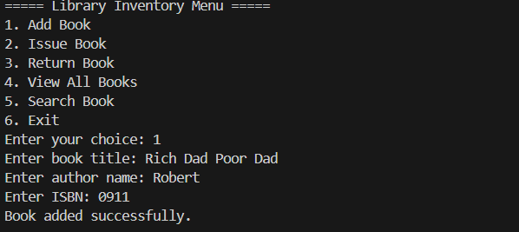
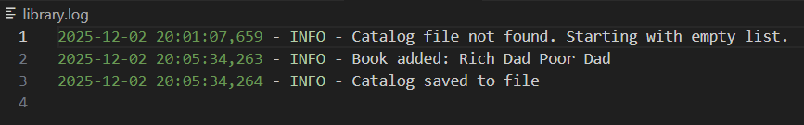
- Issue Book
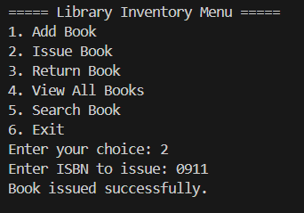
- Return Book
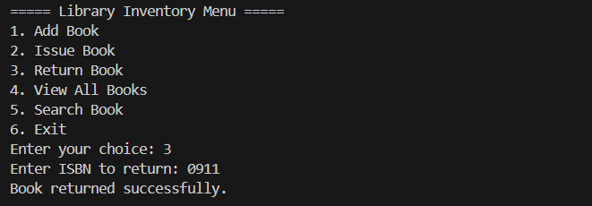

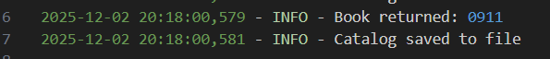

- View All Books

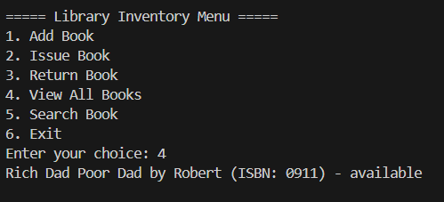

- Search Book

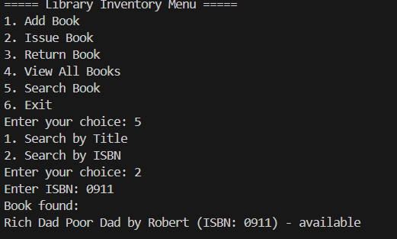

- JSON FILE STORAGE

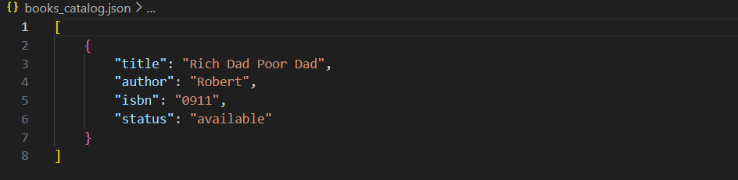

REFLECTION
Working on this Python mini-project helped me understand how modules, packages, and file structures work together in real programs. While building the library manager, I initially faced issues with imports, especially when the script could not recognize modules from another directory. Fixing this taught me the importance of running Python from the correct project root and keeping a clean folder structure.
I also improved my understanding of classes, object-oriented design, and how individual components such as Book, Inventory, and CLI scripts interact with each other. Overall, this project strengthened my confidence in organizing Python code and solving small debugging problems that appear in real development workflows.

CONCLUSION
This project gave me hands-on experience in building a real-world Python application. I learned how to use classes and objects, how to store data using JSON, and how to maintain logs for system activities.
The Library Inventory Management System works smoothly for adding, issuing, returning, and searching books. It also ensures that data is saved safely and can be retrieved anytime.
Overall, this project helped me understand the importance of structured coding and data management, and it gave me confidence in applying Python to practical problems.

--------------------------------------------------------------------------------------------------------------------------------------------------------------------------------------------------------------------------------

