1.Write a socket program in python using TCP :Client shouldsend anumberto the server. Server should find the reverse of that number and return the reversed number to the client.

./q1/client.py

import socket
host = socket.gethostname()
port = 2001
with socket.socket(socket.AF_INET, socket.SOCK_STREAM) as s:
s.connect((host, port))
n = int(input("Enter a number : "))
s.sendall(bytes(str(n), 'utf-8'))
print("Reversed Number recieved from server : "+str(s.recv(1024).decode()))
s.close()

./q1/server.py
import socket

def revNumber(number):
rev = 0
while (number > 0):
remainder = number % 10
rev = (rev * 10) + remainder
number = number // 10
return rev

s = socket.socket(socket.AF_INET, socket.SOCK_STREAM)
print("Socket successfully created")
port = 2001
host = socket.gethostname()
s.bind((host, port))
print("Socket binded to", port)
s.listen(5)
print("Socket is listening")
while True:
conn, addr = s.accept()
print('Got connection from', addr)
data = int(conn.recv(1024).decode())
print("Number recieved from client : "+str(data))
data = revNumber(data)
if not data:
break
conn.sendall(bytes(str(data), 'utf-8'))
print("Reversed number sent to client : "+str(data))
conn.close()

Test case 1

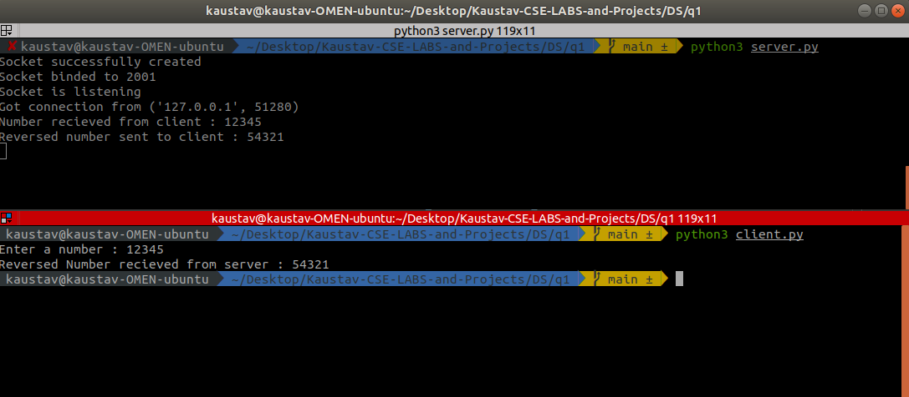
Test Case 2

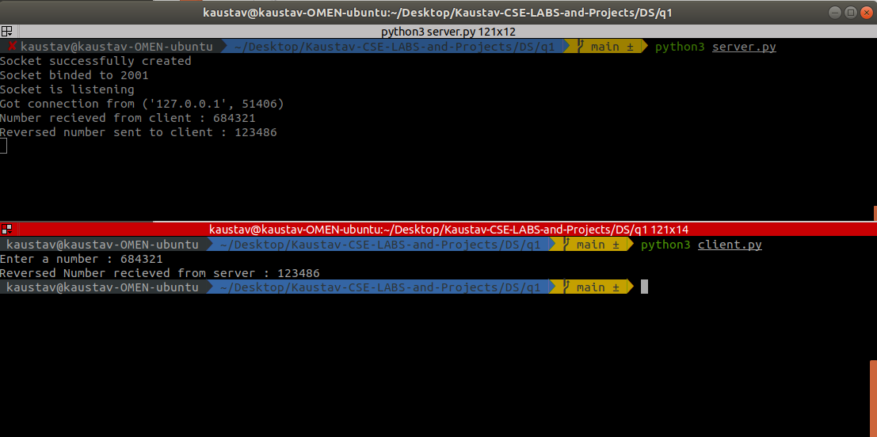

2.Write a map reduce program that returns the highest number of population, for each countryin the dataset countries.csv

./q2/mapper.py
import fileinput

for line in fileinput.input():
data = line.strip().split(",")
if len(data) == 6:
country, continent, year, lifeExpectancy, population, gdpPerCapita = data
if country != "country":
print("{0}\t{1}".format(country, int(population)))

./q2/reducer.py
import fileinput

maximum = 0
old_key = None

for line in fileinput.input():

data = line.strip().split("\t")

if len(data) != 2:
# Something has gone wrong. Skip this line.
continue

current_key, current_value = data

# Refresh for new keys (i.e. locations in the example context)
if old_key and old_key != current_key:
print(old_key, "\t", maximum)
old_key = current_key
maximum = 0

old_key = current_key
if float(current_value) > float(maximum):
maximum = float(current_value)

if old_key != None:
print(old_key, "\t", maximum)

