**Complete the following tasks to successfully complete the project**

1. Name of Project

Greetings

1. Record the URL of your GitHub page for this project

<https://github.com/python/javascriptexample>

1. Develop a flowchart showing how your program will operate.

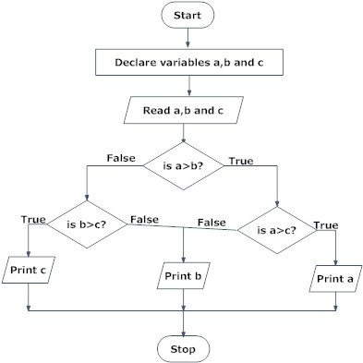

1. Keep a record of your testing. Do this by copying your JavaScript code and pasting it below. Annotate your code to clearly highlight errors. Explain what the problem is and what you will do to solve the problem. Repeat this process as you continue to identify errors.

There is only one possible outcome that can be displayed. Else statements need to be included to display the other options

The three options are now displaying correctly.

1. Evaluate your solution in terms of risk, sustainability and potential for innovation and enterprise.

This program displays the appropriate greeting for the time of day. There are no risks for either the user of the website or the owner of the website from using this program as it simply obtains the time from the user’s computer and displays the appropriate greeting. No information is stored and the user is not prompted to enter any personal information.

This JavaScript and HTML page could be improved by adding more information and including the greeting as part of a welcome to the website. Because the greeting would not add any substantial features to a website that would benefit users there is no real potential for enterprise.

The program is sustainable as runs as intended and there is no need to update the program as it runs as intended.