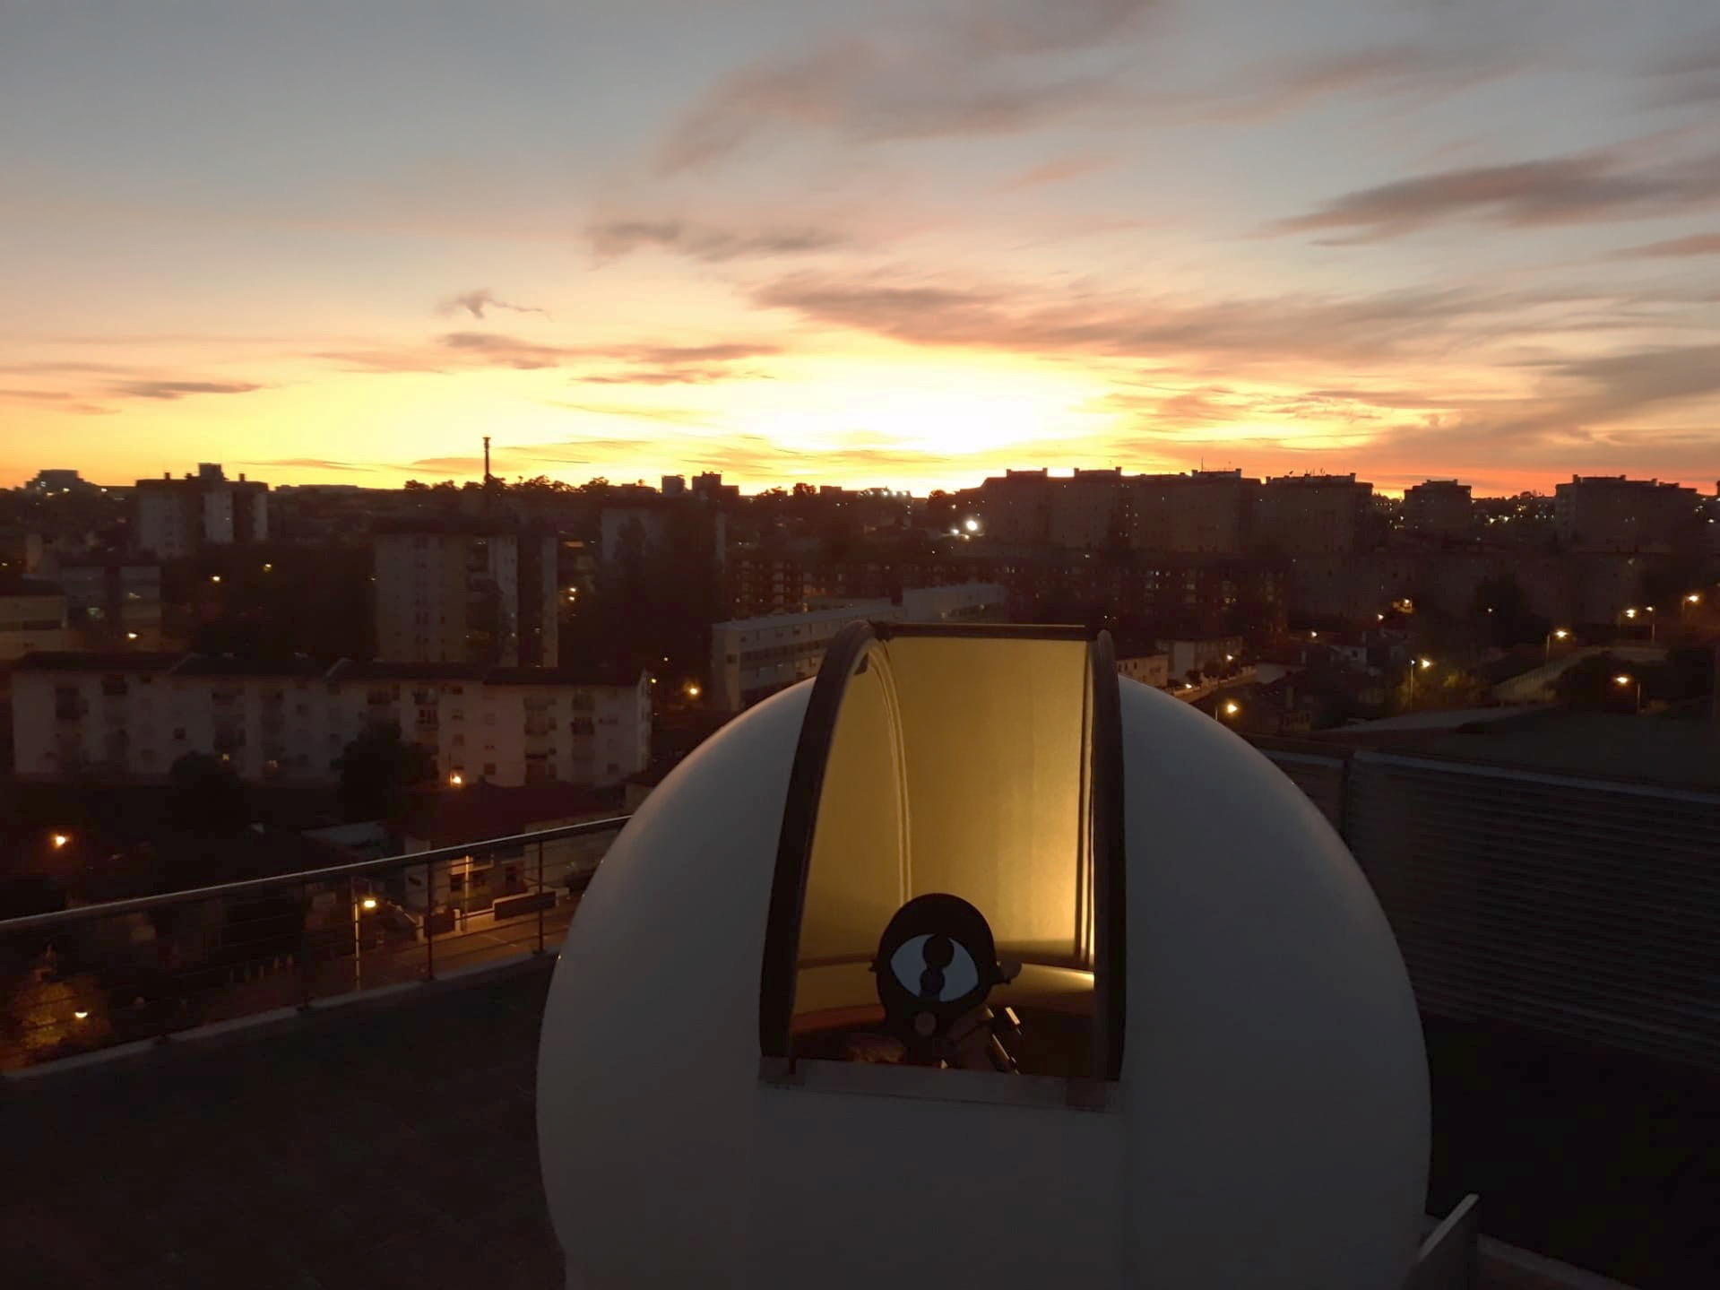

CIGeoE Telescope
Application for observing time

Period: 2025B

TITLE
Broadband Imaging and Photometric Study of the Planetary Nebula M27

ABSTRACT (max. 100 words)
The study of planetary nebulae is essential for comprehending the final phases of stellar evolution. The Dumbbell Nebula (M27) is bright and well-placed for a comprehensive CCD study. We aim to obtain broadband B, V, and R FITS images to characterise its surface brightness, radial profile, colour variation maps, and the photometry of its central white dwarf. Radial profiles and colour maps will provide insights into its shell structure and ionisation, while the central star photometry links to stellar evolution. A total of 3.5 hours of integration will secure the required SNR under Lisbon sky conditions.
y
3.5

Total time requested (hrs):

Moon conditions (‘d’,’g’,’n’):
n

Camera requirement (‘y’ or ‘n’):
B, V, R
Filters required (BVR):

Investigators
Jan Wiegand
Jonathan Bauer
Vasco Soares
Scientific Rationale (max. 450 words)
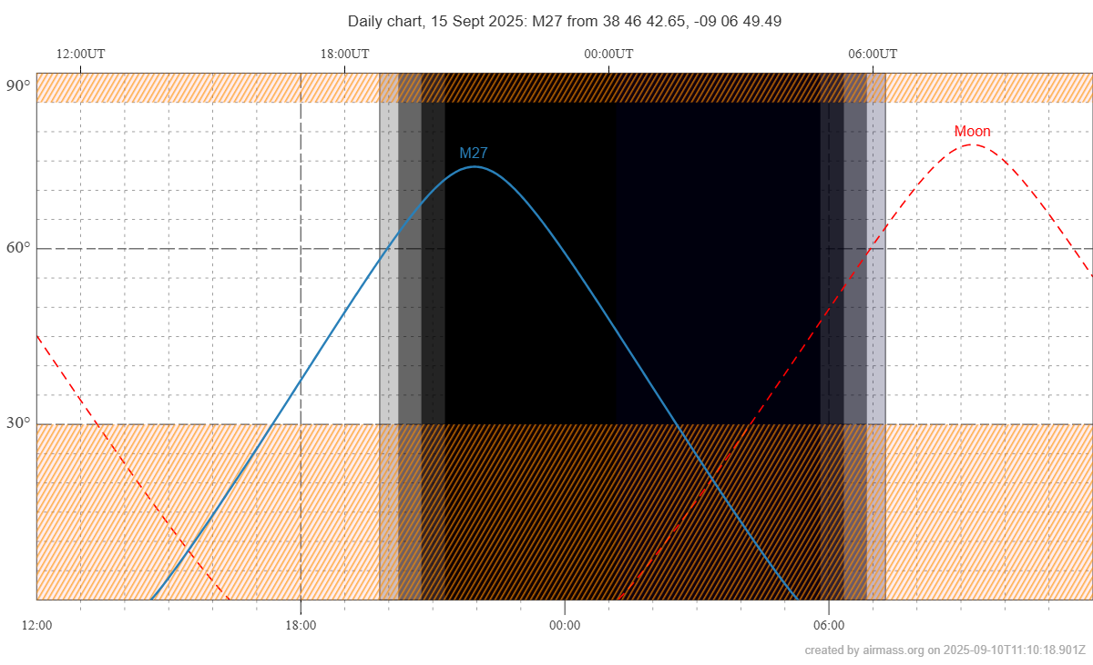
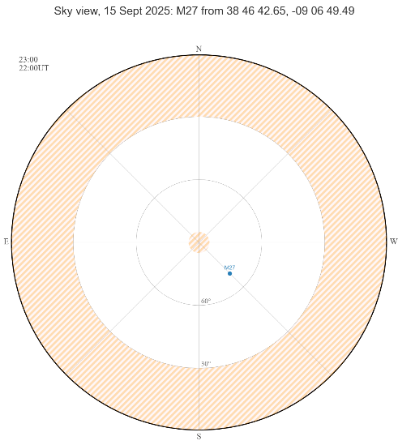
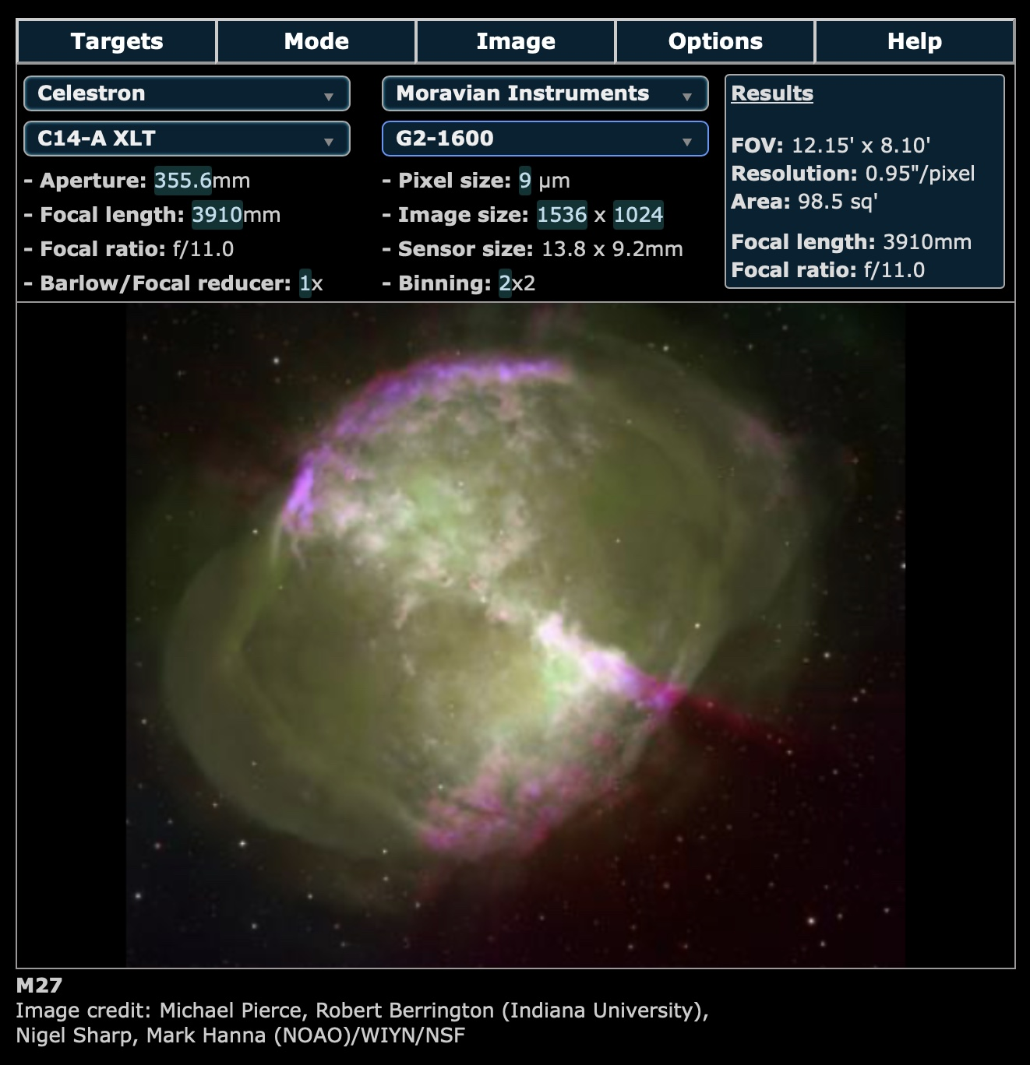
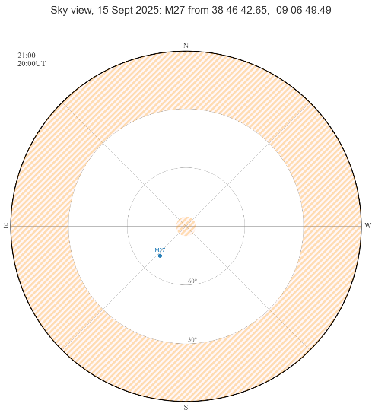
Figure 4- Sky view map for M27 at 11pm
Figure 3-M27 in the CCD FOV
Figure 1-Daily sky chart for M27 and Moon positions
Figure 2-Sky view map for M27 at 9pm

The observation of the planetary nebula M27 was chosen because it is a bright and well-placed target during our September observing window.
M27 has two main aspects of observational interest: the extended ionized gas shell and the faint central white dwarf. This makes it an ideal target for practicing both extended-source imaging (surface brightness profiles, color composite mapping, etc.) and stellar photometry.
As shown in the figure 1 on September 15 the M27 will be located high enough in the sky during the observation time, avoiding the city and river light pollution. Another important factor is the position of the nebula with respect to the local environment, especially the airport. It can be seen in the figures 2 and 4, that during the observation time window, the M27 is lies between southeast and southwest. Therefore, the airport light pollution will little interfere with our observations.
As shown in Figure 3, the angular apparent size of the nebula (~8′ × 6′) fits well within the field of view of our CCD (9′ × 9′). This allows us to capture the entire nebula in a single frame and additional stars within the FOV for the magnitude calibration.

Targets
NAME | α (J2000) | δ (J2000) | Time on target | Mag | Additional info
M27 | 19h 59min 36s | 22° 43’ 16’’ | 180min | 12.60

Observing plan suggestion and time justification (max 150 words, figures allowed)

Our observing session for M27 starts at 19:00 with setup preparation and CCD cooling. From 19:25–20:40, we will acquire the calibration frames with the cold CCD (30 bias and 10 flats frames per filter and without). At 20:40, we focus at 14 Vulpeculae (15 min). The science frames can begin at ~21:00. We want to take light frames with and without filters. Each image with filter requires 30 s exposure + 3 s download + 1 s filter change = 34 s (no filter change for sequences within the same filter). Thus, around 30 images per filter take ~1000 s (≈17 min). For the 30 images without filter the exposure time will be 8 s to avoid oversaturating the CCD (~312 s ≈ 6min). With 3 sets (U, B, V) and the set without filter, total science time is ≈60 min. Including verification after the first set (~5 min), total M27 data collection takes ≈65 min, finishing around 22:05. Remaining time until 23:00 will be reserved for repeating exposures if needed, additional calibration, and backups before shutdown.

Reference
https://airmass.org
https://simbad.u-strasbg.fr/simbad/sim-id?Ident=m27
https://www.mirametrics.com/sn_calculator_mvn.php
https://www.sky-map.org/starview?object_type=3&object_id=6#Images
https://www.lightpollutionmap.info/#zoom=4.00&lat=45.8720&lon=14.5470&state=eyJiYXNlbWFwIjoiTGF5ZXJCaW5nUm9hZCIsIm92ZXJsYXkiOiJ3YV8yMDE1Iiwib3ZlcmxheWNvbG9yIjpmYWxzZSwib3ZlcmxheW9wYWNpdHkiOiI2MCIsImZlYXR1cmVzb3BhY2l0eSI6Ijg1In0=
https://science.nasa.gov/mission/hubble/science/explore-the-night-sky/hubble-messier-catalog/messier-27
https://www.x2r.uk/fovcalc.php
https://www.ipma.pt/pt/otempo/prev.localidade.hora/index.jsp#Lisboa&Lisboa

Panel Evaluation (leave blank):
Abstract (20%):
Scientific rationale (40%):
Observing plan and time justification: (40%):

