# Regression Models Project Executive Summary

The goal of this study is to determine the difference in miles per gallon in automatic versus manual transmission vehicles. To estimate this, we will use linear regression models. The overall conclusion is that we cannot definitevely say whether the type of transmission affects MPG.

# Preprocesing and Data Exploration

data(mtcars)  
dim(mtcars)

## [1] 32 11

sum(is.na(mtcars))

## [1] 0

The mtcars dataset has 32 observations and 11 variables. There is no missing data. Looking at the summary statistics (see appendix), 41% of the observations are vehicles with automatic transmissions. the average MPG is approximately 20 MPG. Further, we observe that automatic vehicles get more MPG (see appendix box plot). Finally, with mean > median MPG shows a right skew.

# Modeling, Model #1

model <- lm(mpg ~ am, data = mtcars)  
summary(model)

##   
## Call:  
## lm(formula = mpg ~ am, data = mtcars)  
##   
## Residuals:  
## Min 1Q Median 3Q Max   
## -9.3923 -3.0923 -0.2974 3.2439 9.5077   
##   
## Coefficients:  
## Estimate Std. Error t value Pr(>|t|)   
## (Intercept) 17.147 1.125 15.247 1.13e-15 ***  
## am 7.245 1.764 4.106 0.000285 ***  
## ---  
## Signif. codes: 0 '***' 0.001 '**' 0.01 '*' 0.05 '.' 0.1 ' ' 1  
##   
## Residual standard error: 4.902 on 30 degrees of freedom  
## Multiple R-squared: 0.3598, Adjusted R-squared: 0.3385   
## F-statistic: 16.86 on 1 and 30 DF, p-value: 0.000285

The first model built is a simple linear regression, with AM as the independent variable. The result indicates that automatic vehicles get 7.245 more MPG than manual transmission vehicles.  
#Modeling, Model #2

model2 <- lm(log(mpg) ~ am + wt + cyl + hp, data = mtcars)  
summary(model2)

##   
## Call:  
## lm(formula = log(mpg) ~ am + wt + cyl + hp, data = mtcars)  
##   
## Residuals:  
## Min 1Q Median 3Q Max   
## -0.14658 -0.07827 -0.03107 0.07064 0.24430   
##   
## Coefficients:  
## Estimate Std. Error t value Pr(>|t|)   
## (Intercept) 3.8375665 0.1374861 27.912 < 2e-16 ***  
## am 0.0266911 0.0638171 0.418 0.679077   
## wt -0.1645318 0.0407323 -4.039 0.000399 ***  
## cyl -0.0307380 0.0258070 -1.191 0.243991   
## hp -0.0011682 0.0006043 -1.933 0.063755 .   
## ---  
## Signif. codes: 0 '***' 0.001 '**' 0.01 '*' 0.05 '.' 0.1 ' ' 1  
##   
## Residual standard error: 0.1111 on 27 degrees of freedom  
## Multiple R-squared: 0.8787, Adjusted R-squared: 0.8608   
## F-statistic: 48.91 on 4 and 27 DF, p-value: 5.498e-12

vif(model2)

## am wt cyl hp   
## 2.546159 3.988305 5.333685 4.310029

The second model uses am, wt, and hp as the independent variables and the dependent variable uses a natrual log to help address the right skew. Variable selection is based on the variables with the strongest covariance with MPG (see appendix). I chose to omit many to avoid multicollinearity. This model has an adj. r-squared of .8267 and shows that am is insignificant, and that only the wt variable is significant with a -16.4% change with each 1000 pound increase. The VIF doesn't indicate that multicollinearity is a concern. Finally, the fitted vs. residual plot (see appendix) shows a little evidence of heteroskedasticity.

# Conclusion

After fitting two models, this study did not observe a statistically significant difference in MPG for automatic and manual transmissions. As such, one cannot quantify the difference. The best one could estimate is ~ +7 MPG for automatics, not controlling for other variables.

# Appendix

#Summary Stats  
summary(mtcars)

## mpg cyl disp hp   
## Min. :10.40 Min. :4.000 Min. : 71.1 Min. : 52.0   
## 1st Qu.:15.43 1st Qu.:4.000 1st Qu.:120.8 1st Qu.: 96.5   
## Median :19.20 Median :6.000 Median :196.3 Median :123.0   
## Mean :20.09 Mean :6.188 Mean :230.7 Mean :146.7   
## 3rd Qu.:22.80 3rd Qu.:8.000 3rd Qu.:326.0 3rd Qu.:180.0   
## Max. :33.90 Max. :8.000 Max. :472.0 Max. :335.0   
## drat wt qsec vs   
## Min. :2.760 Min. :1.513 Min. :14.50 Min. :0.0000   
## 1st Qu.:3.080 1st Qu.:2.581 1st Qu.:16.89 1st Qu.:0.0000   
## Median :3.695 Median :3.325 Median :17.71 Median :0.0000   
## Mean :3.597 Mean :3.217 Mean :17.85 Mean :0.4375   
## 3rd Qu.:3.920 3rd Qu.:3.610 3rd Qu.:18.90 3rd Qu.:1.0000   
## Max. :4.930 Max. :5.424 Max. :22.90 Max. :1.0000   
## am gear carb   
## Min. :0.0000 Min. :3.000 Min. :1.000   
## 1st Qu.:0.0000 1st Qu.:3.000 1st Qu.:2.000   
## Median :0.0000 Median :4.000 Median :2.000   
## Mean :0.4062 Mean :3.688 Mean :2.812   
## 3rd Qu.:1.0000 3rd Qu.:4.000 3rd Qu.:4.000   
## Max. :1.0000 Max. :5.000 Max. :8.000

#Box Plot  
ggplot(mtcars, aes(x = factor(am), y = mpg)) + geom_boxplot()

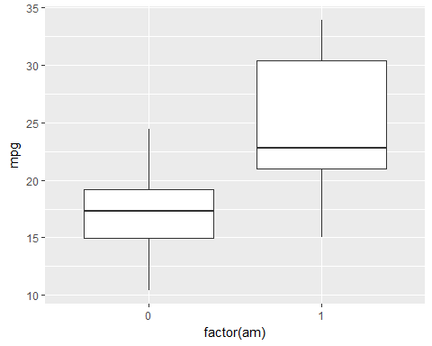

#Correlations  
corrplot(cor(mtcars))

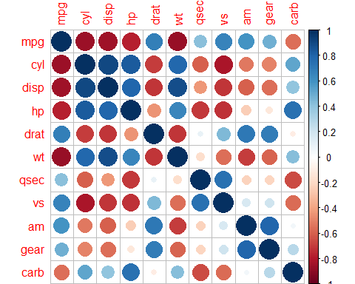

#Model 2 Plots  
par(mfrow = c(2,2))  
plot(model2)

