1. Задача

Составьте список пользователей users, которые осуществили хотя бы один заказ orders в интернет магазине.

INSERT INTO orders (user_id) VALUES (6), (4);

SELECT * FROM users;

SELECT * FROM orders;

1 вариант

SELECT name FROM users WHERE users.id IN (SELECT orders.user_id FROM orders);

2 вариант

SELECT u.name, o.user_id FROM users AS u JOIN orders AS o ON u.id = o.user_id;

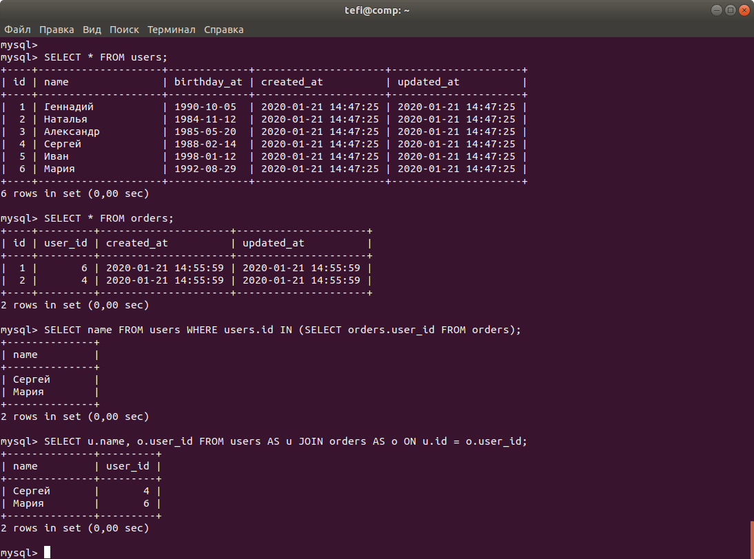

1. Задача

Выведите список товаров products и разделов catalogs, который соответствует товару.

SELECT id, name, price, catalog_id FROM products;

SELECT * FROM catalogs;

вариант 1

SELECT products.name, catalogs.name FROM products, catalogs WHERE products.catalog_id = catalogs.id;

вариант 2

SELECT p.name, c.name FROM products AS p JOIN catalogs AS c WHERE p.catalog_id = c.id;

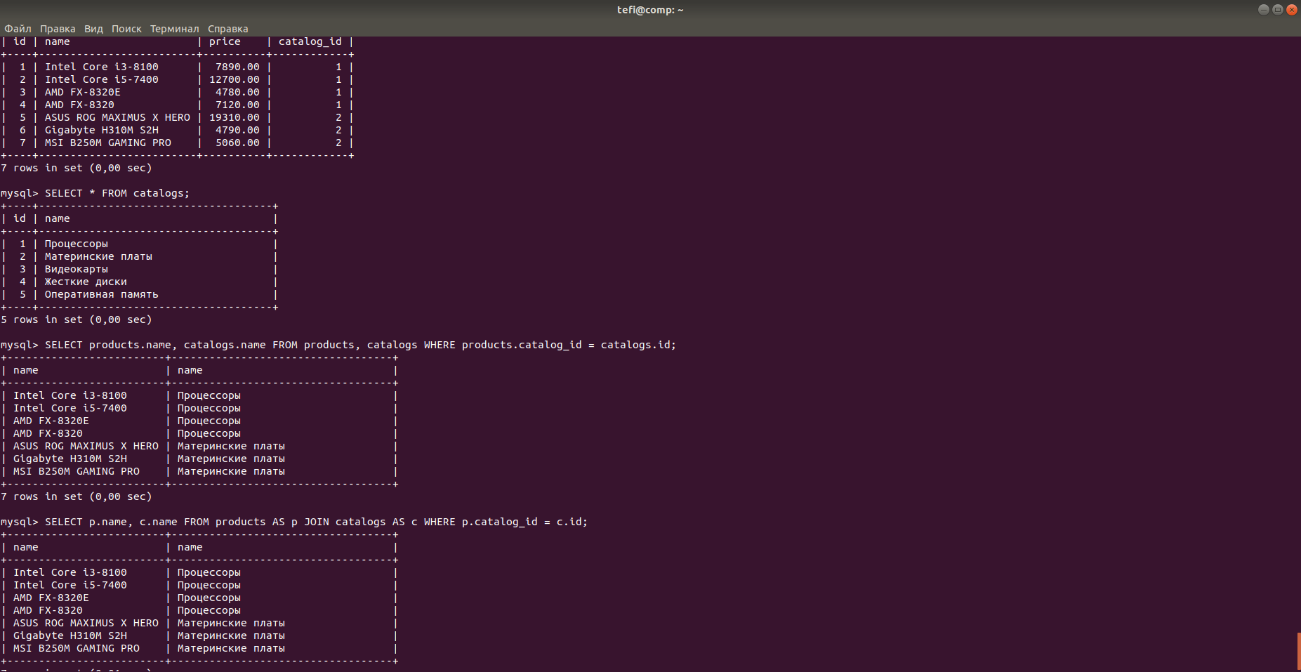

1. Задача

Пусть имеется таблица рейсов flights (id, from, to) и таблица городов cities (label, name). Поля from, to и label содержат английские названия городов, поле name — русское. Выведите список рейсов flights с русскими названиями городов.

CREATE DATABASE path_city;

USE path_city;

CREATE TABLE flights (id INT UNSIGNED NOT NULL PRIMARY KEY AUTO_INCREMENT, from_city VARCHAR(255) , to_city VARCHAR(255));

CREATE TABLE cities (label VARCHAR(255), name VARCHAR(255));

INSERT INTO flights (from_city, to_city) VALUES ('moscow', 'omsk'), ('novgorod', 'kazan'), ('irkutsk', 'moscow'), ('omsk', 'irkutsk'), ('moscow', 'kazan');

INSERT INTO cities (label, name) VALUES ('moscow', 'Москва'), ('novgorod', 'Новгород'), ('omsk', 'Омск'), ('kazan', 'Казань'), ('Irkutsk', 'Иркутск');

SELECT * FROM flights;

SELECT * FROM cities;

SELECT cities.name FROM cities, flights WHERE cities.label = flights.from_city;

SELECT cities.name FROM cities, flights WHERE cities.label = flights.to_city;

Не могу объединить эти 2 работающих запроса в 1:

SELECT f.id, c.name FROM flights AS f JOIN cities AS c WHERE c.label = f.from_city;

SELECT f.id, c.name FROM flights AS f JOIN cities AS c WHERE c.label = f.to_city

***правильно

DROP TABLE IF EXISTS flights;

CREATE TABLE flights (

id SERIAL PRIMARY KEY,

`from` VARCHAR(255) COMMENT 'Город отравления',

`to` VARCHAR(255) COMMENT 'Город прибытия'

) COMMENT = 'Рейсы';

INSERT INTO flights (`from`, `to`) VALUES

('moscow', 'omsk'),

('novgorod', 'kazan'),

('irkutsk', 'moscow'),

('omsk', 'irkutsk'),

('moscow', 'kazan');

DROP TABLE IF EXISTS cities;

CREATE TABLE cities (

id SERIAL PRIMARY KEY,

label VARCHAR(255) COMMENT 'Код города',

name VARCHAR(255) COMMENT 'Название города'

) COMMENT = 'Словарь городов';

INSERT INTO cities (label, name) VALUES

('moscow', 'Москва'),

('irkutsk', 'Иркутск'),

('novgorod', 'Новгород'),

('kazan', 'Казань'),

('omsk', 'Омск');

SELECT

f.id,

cities_from.name AS `from`,

cities_to.name AS `to`

FROM flights AS f

LEFT JOIN cities AS cities_from

ON f.from = cities_from.label

LEFT JOIN cities AS cities_to

ON f.to = cities_to.label;