1. задание

SHOW TABLES;

DESC profiles;

ALTER TABLE profiles MODIFY COLUMN photo_id INT(10) UNSIGNED;

ALTER TABLE profiles

ADD CONSTRAINT profiles_user_id_fk

FOREIGN KEY (user_id) REFERENCES users(id)

ON DELETE CASCADE,

ADD CONSTRAINT profiles_photo_id_fk

FOREIGN KEY (photo_id) REFERENCES media(id)

ON DELETE SET NULL;

DESC users;

DESC media;

DESC media_types;

ALTER TABLE media MODIFY COLUMN user_id INT(10) UNSIGNED;

ALTER TABLE media MODIFY COLUMN media_type_id INT(10) UNSIGNED;

ALTER TABLE media

ADD CONSTRAINT media_user_id_fk

FOREIGN KEY (user_id) REFERENCES users(id)

ON DELETE SET NULL,

ADD CONSTRAINT media_media_type_id_fk

FOREIGN KEY (media_type_id) REFERENCES media_types(id)

ON DELETE SET NULL;

DESC communities;

DESC communities_users;

ALTER TABLE communities_users

ADD CONSTRAINT communities_users_user_id_fk

FOREIGN KEY (user_id) REFERENCES users(id)

ON DELETE CASCADE,

ADD CONSTRAINT communities_users_community_id_fk

FOREIGN KEY (community_id) REFERENCES communities(id)

ON DELETE CASCADE;

DESC friendship;

DESC friendship_statuses;

ALTER TABLE friendship MODIFY COLUMN status_id INT(10) UNSIGNED;

ALTER TABLE friendship

ADD CONSTRAINT friendship_user_id_fk

FOREIGN KEY (user_id) REFERENCES users(id)

ON DELETE CASCADE,

ADD CONSTRAINT friendship_friend_id_fk

FOREIGN KEY (friend_id) REFERENCES users(id)

ON DELETE CASCADE,

ADD CONSTRAINT friendship_status_id_fk

FOREIGN KEY (status_id) REFERENCES friendship_statuses(id)

ON DELETE SET NULL;

DESC likes;

DESC target_types;

ALTER TABLE likes MODIFY COLUMN user_id INT(10) UNSIGNED;

ALTER TABLE likes MODIFY COLUMN target_type_id INT(10) UNSIGNED;

ALTER TABLE likes

ADD CONSTRAINT likes_user_id_fk

FOREIGN KEY (user_id) REFERENCES users(id)

ON DELETE SET NULL,

ADD CONSTRAINT likes_target_id_fk

FOREIGN KEY (target_id) REFERENCES users(id)

ON DELETE CASCADE,

ADD CONSTRAINT likes_target_type_id_fk

FOREIGN KEY (target_type_id) REFERENCES target_types(id)

ON DELETE SET NULL;

DESC meetings;

DESC meetings_users;

ALTER TABLE meetings_users

ADD CONSTRAINT meetings_users_user_id_fk

FOREIGN KEY (user_id) REFERENCES users(id);

ALTER TABLE meetings

ADD CONSTRAINT meetings_user_id_fk

FOREIGN KEY (user_id) REFERENCES users(id);

DESC messages;

DESC posts;

ALTER TABLE messages MODIFY COLUMN to_user_id INT(10) UNSIGNED;

ALTER TABLE messages MODIFY COLUMN from_user_id INT(10) UNSIGNED;

ALTER TABLE messages

ADD CONSTRAINT messages_from_user_id_fk

FOREIGN KEY (from_user_id) REFERENCES users(id)

ON DELETE SET NULL,

ADD CONSTRAINT messages_to_user_id_fk

FOREIGN KEY (to_user_id) REFERENCES users(id)

ON DELETE SET NULL;

ALTER TABLE posts MODIFY COLUMN user_id INT(10) UNSIGNED;

ALTER TABLE posts MODIFY COLUMN media_id INT(10) UNSIGNED;

ALTER TABLE posts

ADD CONSTRAINT posts_user_id_fk

FOREIGN KEY (user_id) REFERENCES users(id)

ON DELETE SET NULL,

ADD CONSTRAINT posts_media_id_fk

FOREIGN KEY (media_id) REFERENCES media(id)

ON DELETE SET NULL;

1. задание

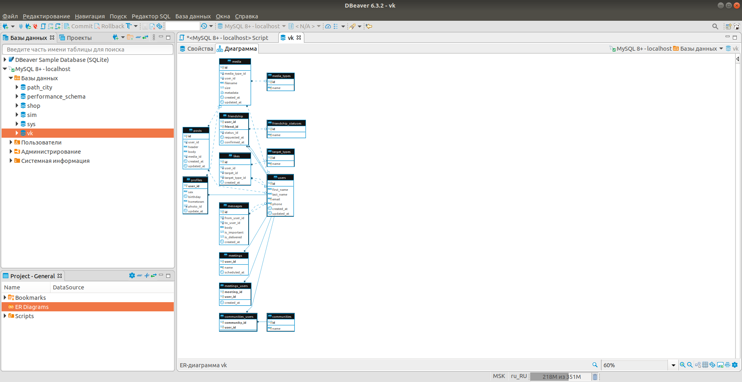

1. 3.1. Задание.

Пусть задан некоторый пользователь.

Из всех друзей этого пользователя найдите человека, который больше всех общался с нашим пользователем.

-- Выберем id друзей

SELECT * FROM friendship WHERE user_id = 3 OR friend_id = 3;

-- В один столбец

SELECT friend_id AS id FROM friendship WHERE user_id = 3

UNION

SELECT user_id AS id FROM friendship WHERE friend_id = 3;

-- Выбираем id отправителей сообщений

SELECT from_user_id FROM messages

WHERE to_user_id = 3

AND from_user_id IN (

SELECT friend_id AS id FROM friendship WHERE user_id = 3

UNION

SELECT user_id AS id FROM friendship WHERE friend_id = 3

);

-- Добавляем имя

SELECT (SELECT CONCAT(first_name, ' ', last_name) FROM users WHERE id = from_user_id) AS friend

FROM messages

WHERE to_user_id = 3

AND from_user_id IN (

SELECT friend_id AS id FROM friendship WHERE user_id = to_user_id

UNION

SELECT user_id AS id FROM friendship WHERE friend_id = to_user_id

);

-- Добавляем подсчёт и сортировку

SELECT (SELECT CONCAT(first_name, ' ', last_name) FROM users WHERE id = from_user_id) AS friend,

COUNT(*) AS total_messages

FROM messages

WHERE to_user_id = 3

AND from_user_id IN (

SELECT friend_id AS id FROM friendship WHERE user_id = to_user_id

UNION

SELECT user_id AS id FROM friendship WHERE friend_id = to_user_id

)

GROUP BY messages.from_user_id

ORDER BY total_messages DESC

LIMIT 1;

* 1. Задание.

Подсчитать общее количество лайков, которые получили 10 самых молодых пользователей.

-- Смотрим типы для лайков

SELECT * FROM target_types;

-- Выбираем профили с сортировкой по дате рождения

SELECT * FROM profiles ORDER BY birthday DESC LIMIT 10;

-- Выбираем лайки по типу пользователь

SELECT * FROM likes WHERE target_type_id = 2;

-- Объединяем, но так не работает

SELECT * FROM likes WHERE target_type_id = 2

AND target_id IN (

SELECT user_id FROM profiles ORDER BY birthday DESC LIMIT 10

);

-- Идём обходным путём

SELECT target_id, COUNT(*) FROM likes

WHERE target_type_id = 2

AND target_id IN (SELECT * FROM (

SELECT user_id FROM profiles ORDER BY birthday DESC LIMIT 10

) AS sorted_profiles )

GROUP BY target_id;

-- Суммируем для всех пользователей

SELECT SUM(likes_per_user) AS likes_total FROM (

SELECT COUNT(*) AS likes_per_user

FROM likes

WHERE target_type_id = 2

AND target_id IN (

SELECT * FROM (

SELECT user_id FROM profiles ORDER BY birthday DESC LIMIT 10

) AS sorted_profiles

)

GROUP BY target_id

) AS counted_likes;

* 1. Задание.

Определить кто больше поставил лайков (всего) - мужчины или женщины?

SELECT CASE(sex)

WHEN 'm' THEN 'man'

WHEN 'f' THEN 'woman'

END AS sex,

COUNT(*) as likes_count

FROM (

SELECT

user_id as user,

(SELECT sex FROM profiles WHERE user_id = user) as sex

FROM likes) dummy_table

GROUP BY sex

ORDER BY likes_count DESC

LIMIT 1;

* 1. Задание.

Найти 10 пользователей, которые проявляют наименьшую активность в использовании социальной сети.

SELECT CONCAT(first_name, ' ', last_name) AS user,

(SELECT COUNT(*) FROM likes WHERE likes.user_id = users.id) +

(SELECT COUNT(*) FROM media WHERE media.user_id = users.id) +

(SELECT COUNT(*) FROM messages WHERE messages.from_user_id = users.id)

AS overall_activity

FROM users

ORDER BY overall_activity

LIMIT 10;