**REQUIREMENT**

Software and hardware requirement for xPC Target Connection in Simulink Real Time

|  |  |  |
| --- | --- | --- |
|  | Software | Note |
| Software | Matlab/Simulink r2020a |  |
| Visual Studio C++ 2019 Compiler |  |
| Rufus | Create bootble USB |
|  | | |
| Hardware | PC | For run FreeDOS |
| Ethernet Cable | Connect between Laptop and PC |
| USB | Contain file booting |
|  | | |
| Other | FreeDOS image file | File booting FreeDOS into PC |

1. Matlab r2020a

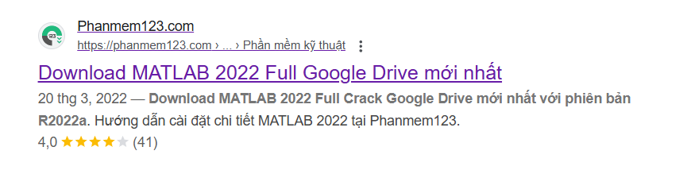

Link: <https://phanmem123.com/download-matlab-2020/>

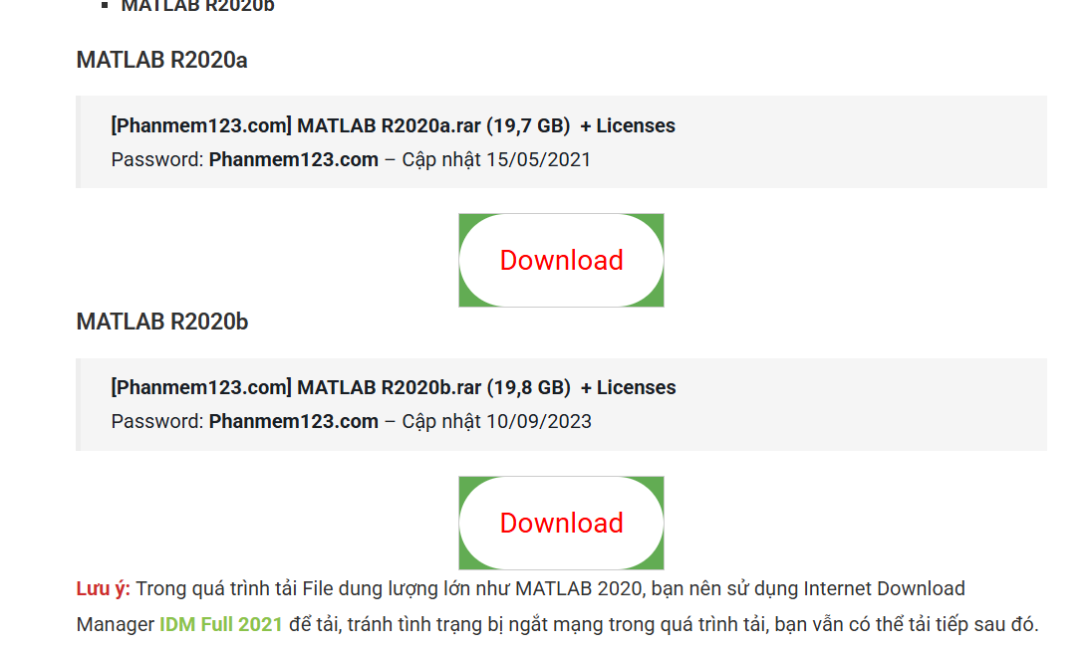

1. Visual Studio C++ 2019 Compiler



Link: <https://isangtao.com/download-visual-studio-2019-full-crack-huong-dan-cai-dat-chi-tiet/>



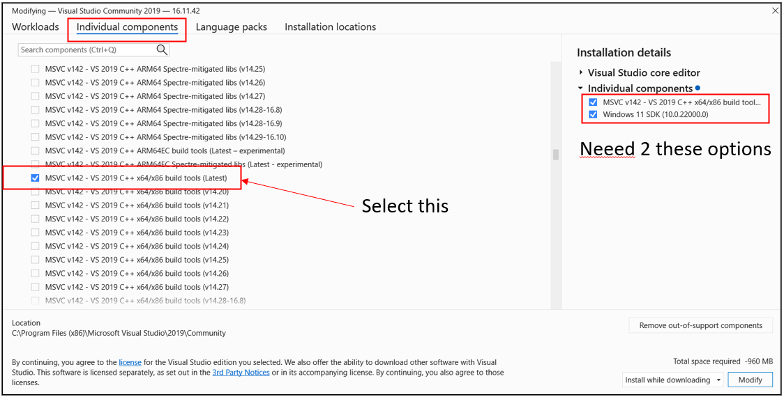

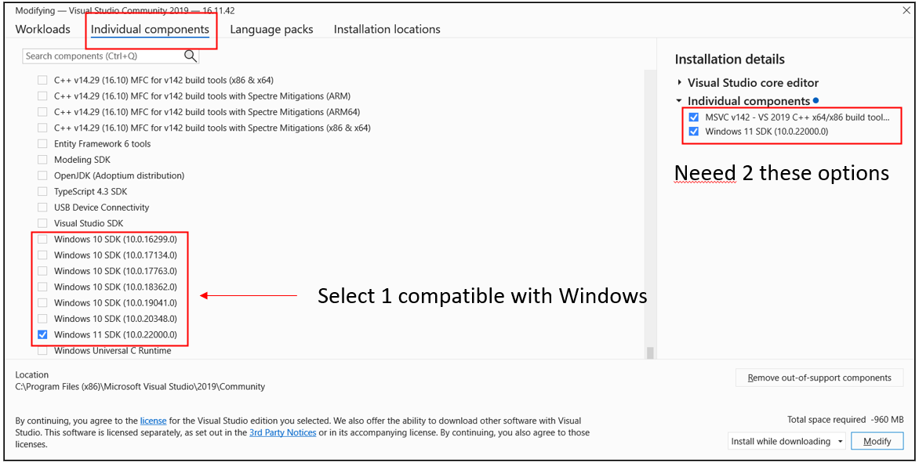

1. Rufus

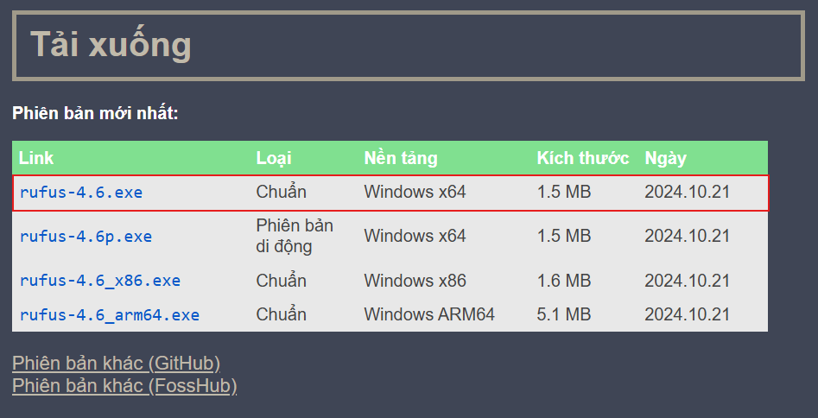

Link: <https://rufus.ie/vi/>

1. Target PC

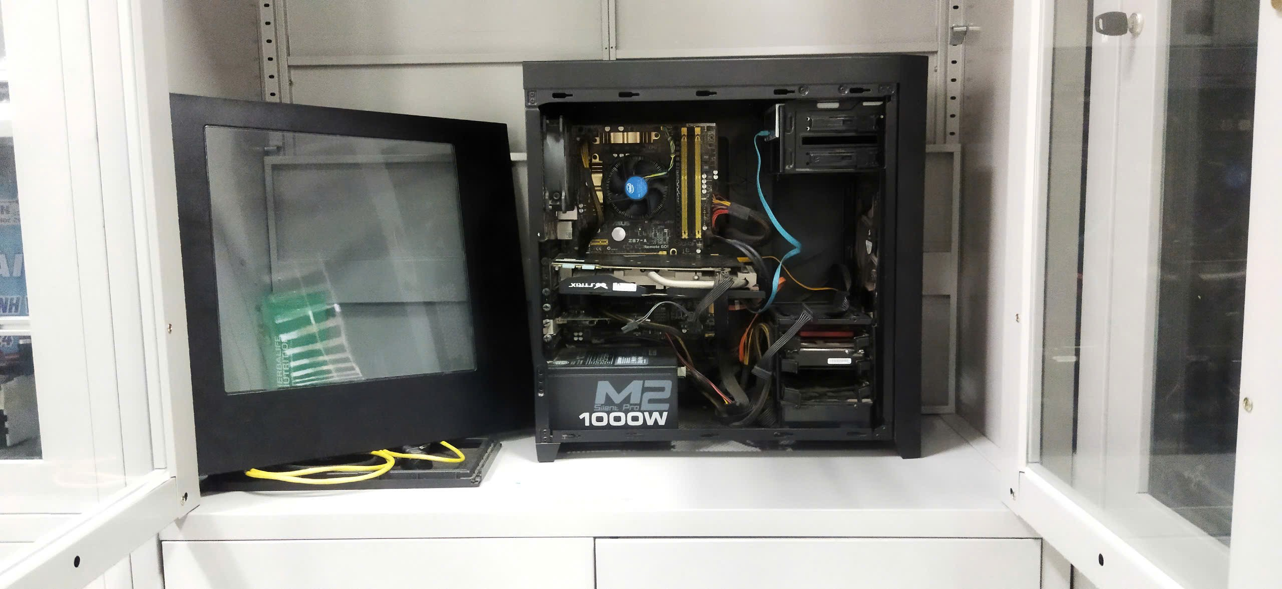

1. Ethernet cable
2. USB
3. FreeDOS image file

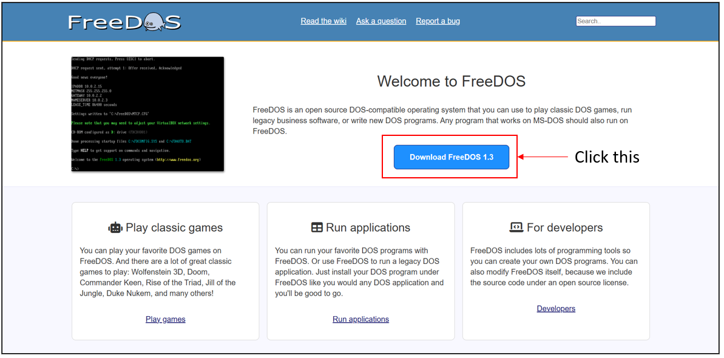

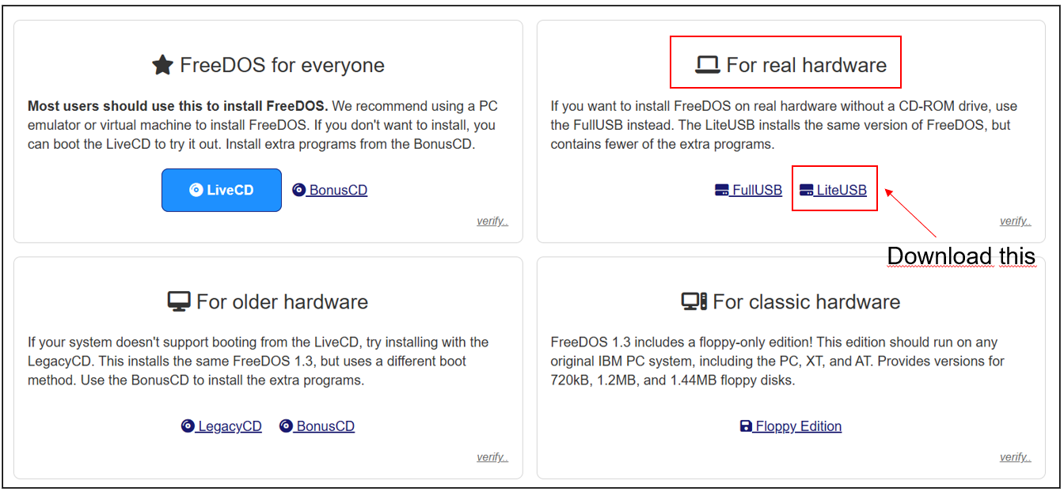

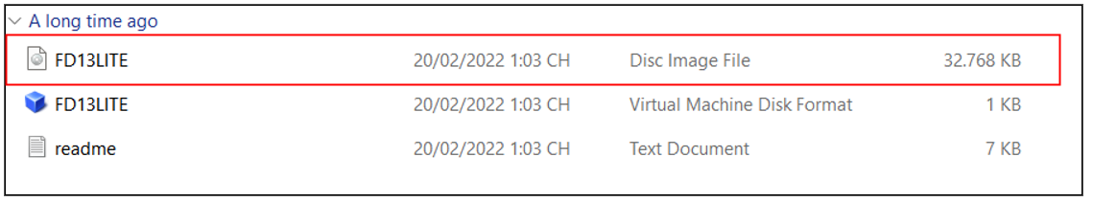

Link: <https://www.freedos.org/download/>