REQUIREMENT
Software and hardware requirement for xPC Target Connection in Simulink Real Time

 | Software | Note
Software | Matlab/Simulink r2020a
 | Visual Studio C++ 2019 Compiler
 | Rufus | Create bootble USB
Hardware | PC | For run FreeDOS
 | Ethernet Cable | Connect between Laptop and PC
 | USB | Contain file booting
Other | FreeDOS image file | File booting FreeDOS into PC

- Matlab r2020a
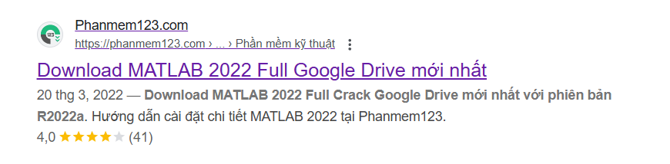
Link: https://phanmem123.com/download-matlab-2020/
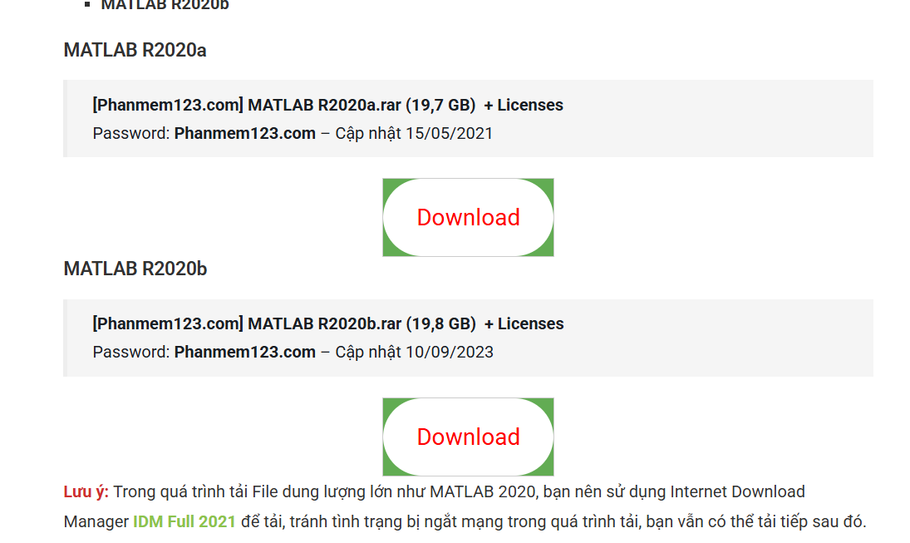

- Visual Studio C++ 2019 Compiler

Link: https://isangtao.com/download-visual-studio-2019-full-crack-huong-dan-cai-dat-chi-tiet/

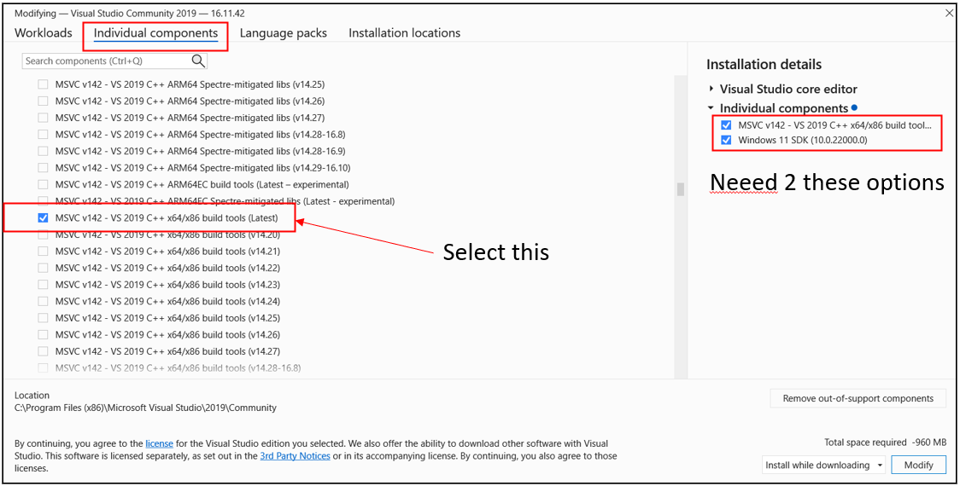
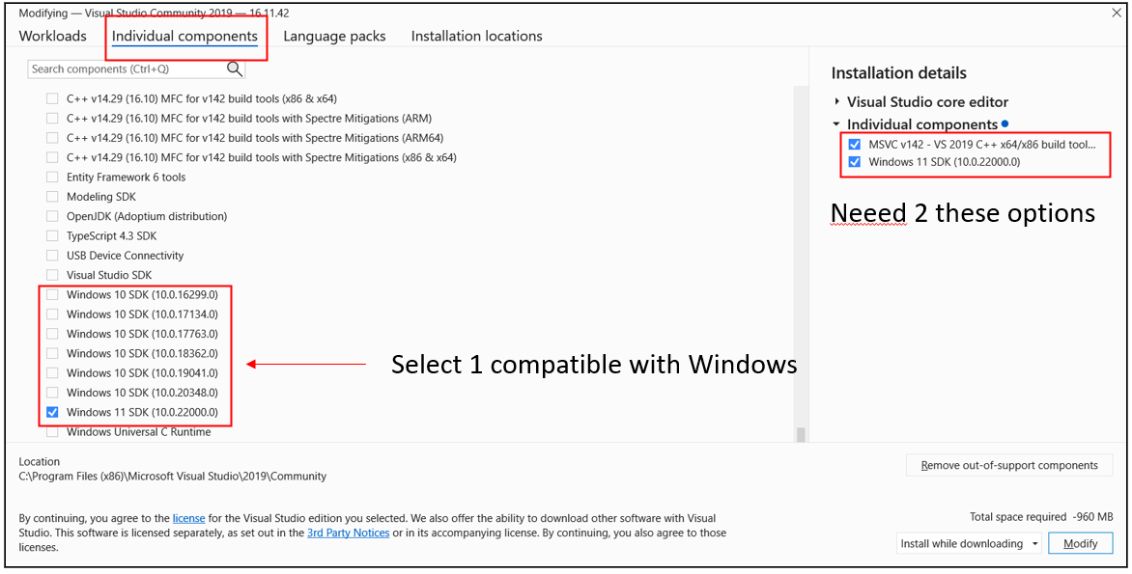

- Rufus
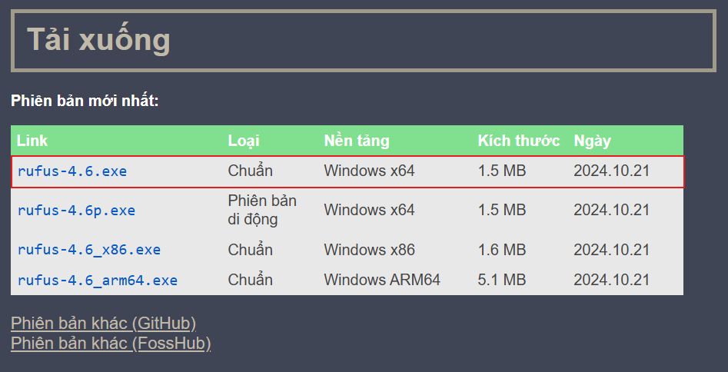
Link: https://rufus.ie/vi/
- Target PC
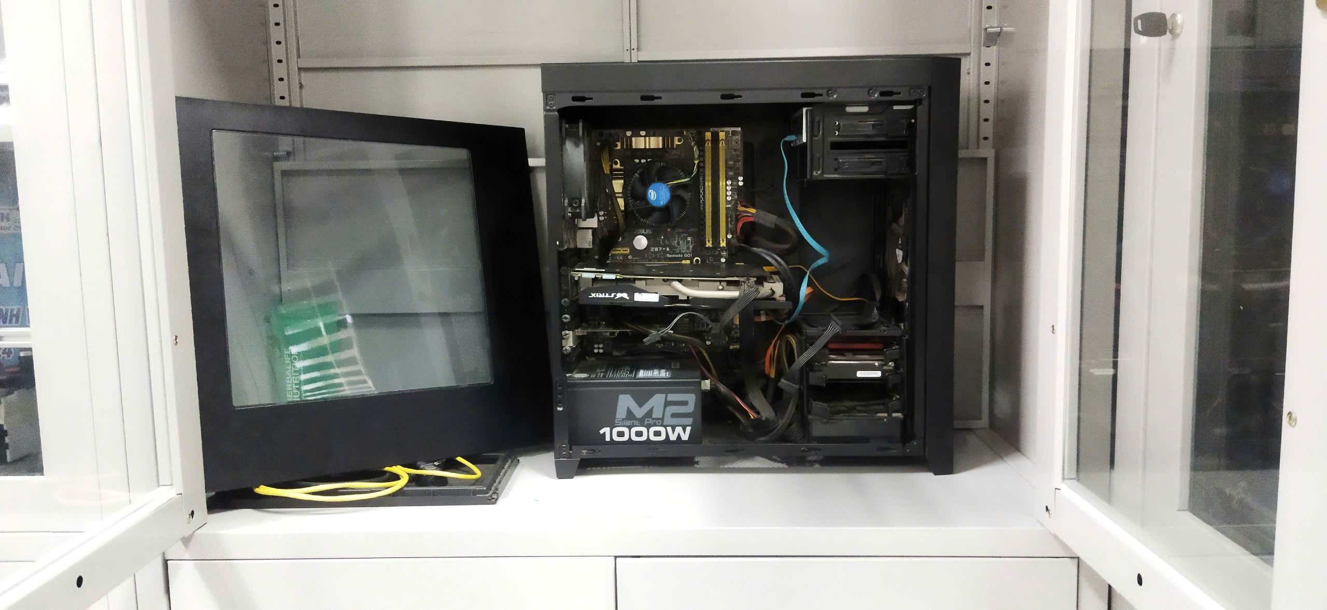

- Ethernet cable
- USB
- FreeDOS image file
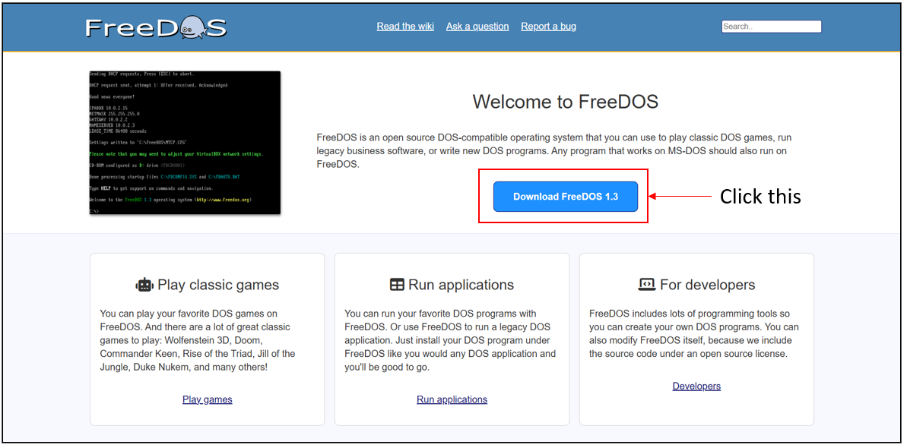
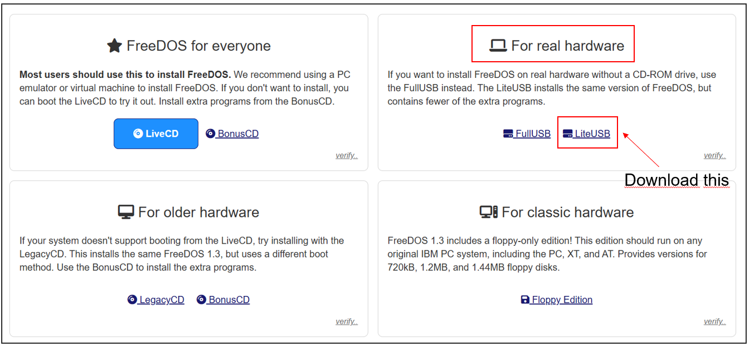
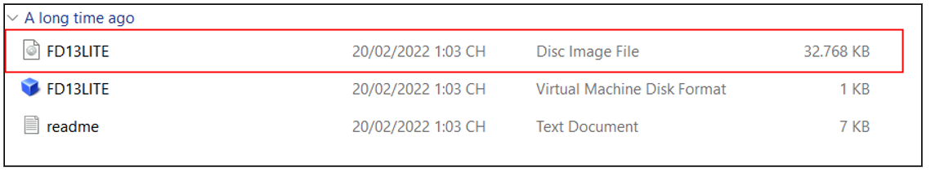
Link: https://www.freedos.org/download/

